JobSeek AI Project Specification Report
This report provides an exhaustive technical and functional overview of the JobSeek AI Platform, a minimalist, high-performance job aggregator engineered for modern technical professionals.

1. Introduction to the Project

What it Does
JobSeek AI is a centralized, "Search-First" platform that aggregates real-time job listings from Indeed and LinkedIn into a single, standardized interface. By integrating Gemini 1.5 Flash, the system analyzes unstructured resume data to automatically suggest optimized technical search keywords.

Problem Statement
- Fragmentation: Job seekers must navigate multiple platforms, leading to fragmented results and increased time-to-hire.
- Keyword Optimization: Identifying which specific technical terms in a resume will trigger the most relevant results is often a manual, "trial and error" process.
- Duplicate Listings: Redundant postings across different job boards clutter results and create operational friction for the user.

The Solution
- Centralized Search: A high-speed, single-page hub that executes parallel API calls to major platforms.
- AI Resume Analysis: Leveraging Gemini 1.5 Flash to extract high-value technical keywords from PDF or DOCX files.
- Intelligent Deduplication: A backend service utilizing 95% fuzzy matching logic to identify and merge identical postings.

2. How it Works (System Lifecycle)
The platform operates through a streamlined, five-stage lifecycle designed for sub-2-second responsiveness:
- Input Acquisition: The user enters keywords manually or utilizes the drag-and-drop resume upload zone.
- AI Keyword Extraction: If a resume is provided, the Gemini LLM parses the text and generates five editable "Keyword Chips" based on the user's technical profile.
- Parallel Aggregation: The Python backend executes concurrent asynchronous API calls to Indeed and LinkedIn.
- Deduplication & Normalization: Results are cleaned using Pandas-based deduplication logic and mapped to a standard schema.
- Secure Redirect: Users click "Apply" and are securely redirected to the original source in a new browser tab.

3. System Architecture and Technical Diagrams
The architecture is built on a modular blueprint to ensure security, high concurrency, and scalability.

3.1 C4 Context & High-Level Design
The system acts as an intermediary bridge between the Job Seeker and External API providers. The frontend is a minimalist React/Astro UI, while the backend is a Python FastAPI service managing the AI Module and Job Aggregator Service.

3.2 Activity Flow: Manual Search & Aggregation

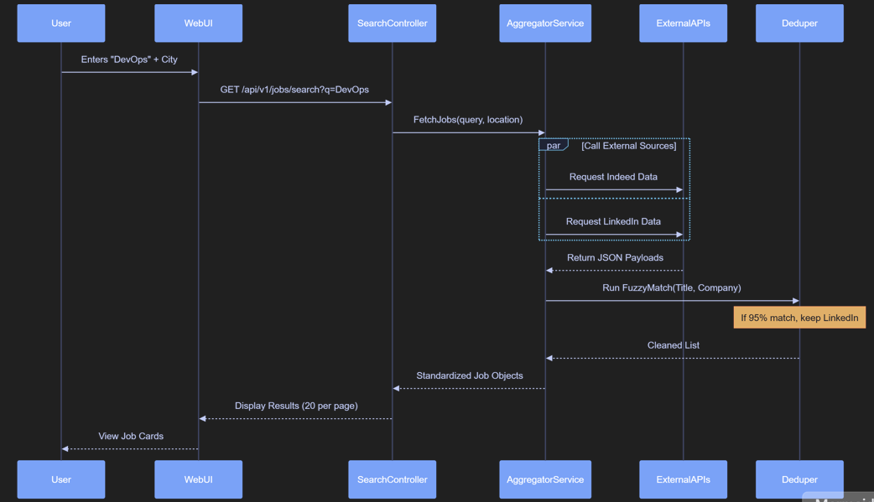
The following diagram illustrates the parallel fetching mechanism and the fuzzy-match deduplication process used during a standard search.
• The "Double Call": Instead of checking one site at a time, the system asks Indeed and LinkedIn for jobs at exactly the same time. This is called "parallel fetching" and it makes the site very fast.
• The 95% Clean-up: Sometimes the same company posts the exact same job on both sites. Our system is smart enough to look at the title and company. If they are a 95% match, the "Deduper" removes the extra one.
• The Final List: You only see a clean list of unique jobs, so you don't waste time looking at the same role twice.

3.3 Activity Flow: AI Resume Analysis
The diagram below depicts the data flow when a user uploads a resume for skill extraction.
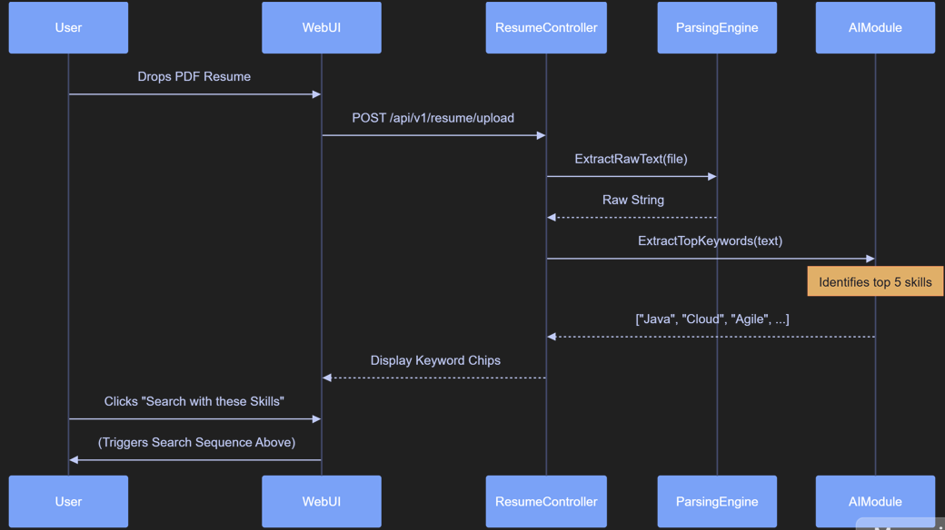
• Reading the File: When you drop your PDF or Word resume, the system first turns the document into plain text that a computer can read.
• Gemini AI at Work: The system sends that text to the Gemini AI. It asks the AI, "Based on this person's experience, what are their top 5 technical skills?".
• Skill Chips: Those 5 skills appear on your screen as little "chips" or tags. You can click them to start a search instantly without having to type anything yourself.

3.4 Internal Class Structure

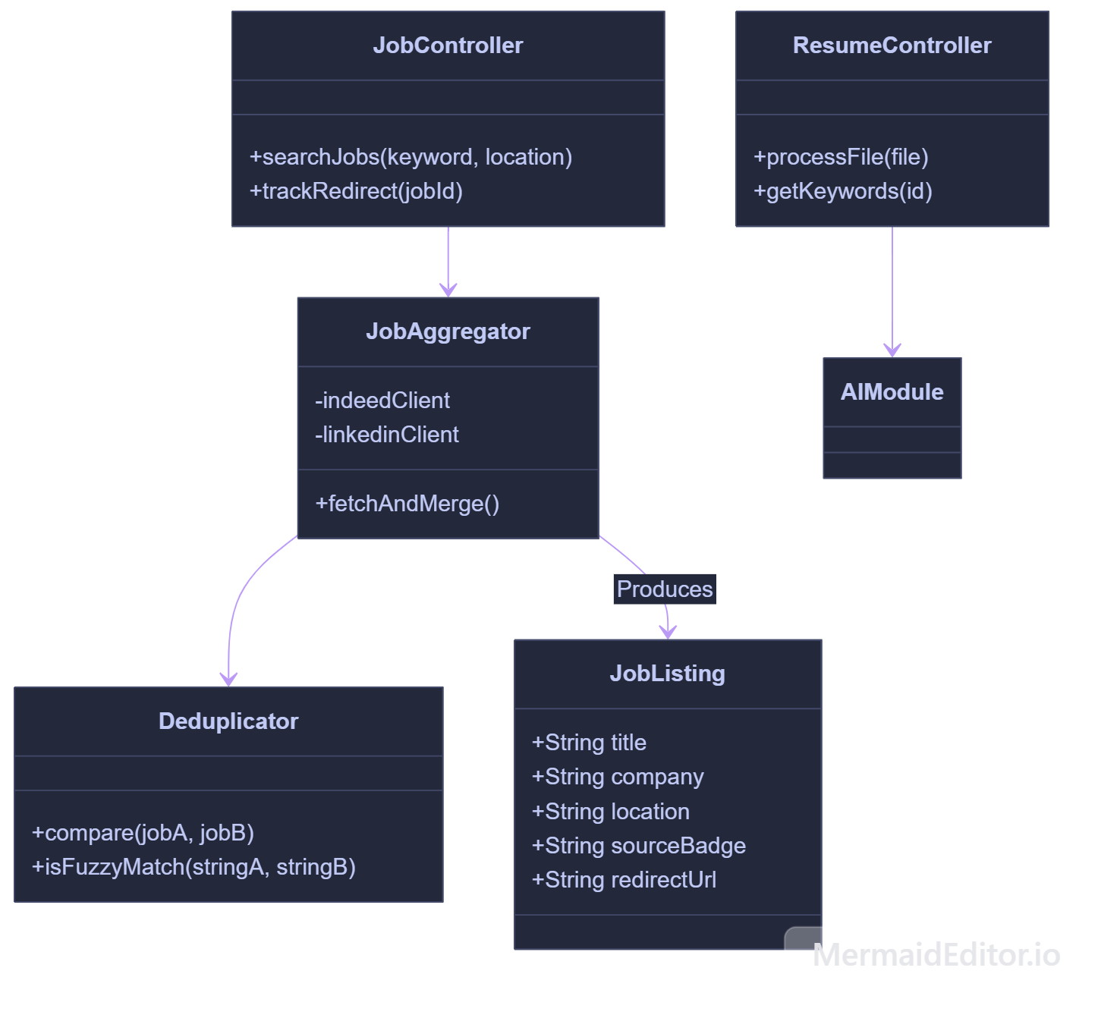
This diagram defines how internal controllers and services interact to produce standardized job listings.
- Structural Highlights:
- • The Controllers (The Receptionists): We have two main "receptionists"—one for Jobs and one for Resumes. They take your requests and pass them to the right team.
- • The Aggregator (The Manager): This part of the code is responsible for talking to Indeed and LinkedIn. It gathers all the raw data and brings it back to the system.
- • The Deduplicator (The Quality Control): This is the "filter". It makes sure no two jobs are the same before they are sent to your screen.
- • The JobListing (The Final Product): This is the standardized format for every job you see. It ensures that whether a job came from Indeed or LinkedIn, it looks clean and professional on our site.

4. Platform Functions (Product Roadmap)
The project is governed by five core Epics, each with strict Acceptance Criteria (AC) for development:
Epic | Core Functional Requirement | Key Acceptance Criteria
Epic 1: External Aggregation | Connect to Indeed/LinkedIn APIs and standardize data. | Status code 200 OK on search; full payload received under 3000ms.
Epic 2: Keyword Interface | Manage search bar, location filters, and empty states. | Search bar must gain auto-focus; "No Results" message must suggest broader terms.
Epic 3: AI Resume Tool | Secure document upload and keyword extraction. | Block files over 5MB; Gemini must return exactly 5 technical tags.
Epic 4: Job Listings | Standardized job cards and secure redirects. | Redirects must use https:// and whitelist only indeed.com or linkedin.com.
Epic 5: System Performance | Fast load times and mobile responsiveness. | Interactive search in <1.5s; mobile touch targets must be at least 44x44 pixels.

5. Technical Implementation Details
- Python & FastAPI: Chosen for its native asynchronous support, allowing the system to query multiple external APIs without blocking the main thread.
- Gemini 1.5 Flash: Acts as the "Expert Career Agent." It is prompted to extract technical keywords from unstructured text and return them in a standardized JSON format.
- Pandas: Leveraged for high-speed data frame manipulation, specifically for cleaning and deduplicating cross-platform job records.
- Tailwind CSS: Used to build a "zero-fluff" minimalist UI that prioritizes readability and search speed.

6. Operational Scenarios
- Scenario A: The AI-Assisted User: A candidate uploads a PDF; the system validates the size (<5MB) and format; Gemini suggests "Python, AWS, FastAPI"; the user triggers a search with one click.
- Scenario B: Mobile Optimization: On a mobile device, job cards stack vertically, and the search bar spans 100% width. All buttons are optimized for thumb-tapping (44x44px).
- Scenario C: Resilience (Fallback Mode): If LinkedIn's API is unresponsive (500 Error), a yellow banner appears to notify the user, while the system continues serving live Indeed results seamlessly.

7. Lessons Learned & Architectural Insights
- Fuzzy Matching vs. Exact Matching: Standard string comparison is insufficient for job data. A 95% similarity threshold is required to catch identical roles that have minor variations in title or company spelling.
- Asynchronous AI Latency: To maintain a 1.5-second load time, AI parsing must be handled as a concurrent task so it does not stall the initial UI rendering.
- The "Secure Handshake": Outbound redirects are protected by a verification layer that enforces HTTPS and domain whitelisting, preventing phishing attacks via third-party listings.

