INTERNSHIP REPORT
ON
JOBSEEK-AI

COMPANY NAME
ALRIGHT SOLUTION

Prepared by:
YASH SINGH

[B.TECH IT Semester - 4]
Roll Number: 67 PRN No.: 2543110400

Submitted for Partial Fulfillment of
B.TECH IT Degree 2025-2026

External Guide Internal Guide

Submitted to

BHARATI VIDYAPEETH (DEEMED TO BE UNIVERSITY)
DEPARTMENT OF ENGINEERING & TECHNOLOGY
KHARGHAR, NAVI MUMBAI



CERTIFICATE

Declaration
I declare that this written submission represents my ideas in my own words and where others’ ideas or words have been included, I have adequately cited and referenced the original sources. I also declare that I have adhered to all principles of academic honesty and integrity and have not misrepresented or fabricated or falsified any idea/data/fact/source in my submission. I understand that any violation of the above will be cause for disciplinary action by the Institute and can also evoke penal action from the sources which have thus not been properly cited or from whom proper permission has not been taken when needed.
Yash Singh 2543110400 _________________
Signature
Date:

Acknowledgement
We wish to express our deep sense of gratitude and thanks to our Internal Guide and Project coordinator, _______ for his/her guidance, help and useful suggestions, which helped in completing our project work in time.

Project Team
Yash Singh
Roll No: 67
PRN No: 2543110400

Abstract
JOBSEEK-AI is an AI-powered job aggregation and resume analysis platform developed using Python, Streamlit, and Gemini LLM. The project aims to simplify the job searching process by aggregating job listings from multiple platforms and providing intelligent filtering and resume-based recommendations. The system extracts skills from uploaded resumes using AI-based text analysis and automatically searches relevant job opportunities from multiple sources.
The application integrates backend APIs, asynchronous search processing, and duplicate removal mechanisms to provide clean and optimized job listings. The platform also implements resume parsing using PyPDF2 and utilizes Gemini LLM for identifying relevant skills and keywords. The frontend interface was developed using Streamlit with Python backend integration.

Contents
Chapters | Content
Chapter 1 | Introduction
 | 1.1 What it Does
 | 1.2 Problem Statement
 | 1.3 The Solution
 | 1.4 Gantt Chart
Chapter 2 | Objectives
 | 2.1 Project Objectives
 | 2.2 Proposed System
 | 2.3 Component of the system
Chapter 3 | System Architecture
 | 3.1 System Architecture
 | 3.2 Methodology
Chapter 4
 | 4.1 Testing
 | 4.2 Result
 | 4.3 Conclusion

1. Introduction to the Project
1.1 What it Does
JobSeek AI is a centralized, "Search-First" platform that aggregates real-time job listings from Indeed and LinkedIn into a single, standardized interface. By integrating Gemini 1.5 Flash, the system analyzes unstructured resume data to automatically suggest optimized technical search keywords.
1.2 Problem Statement
- Fragmentation: Job seekers must navigate multiple platforms, leading to fragmented results and increased time-to-hire.
- Keyword Optimization: Identifying which specific technical terms in a resume will trigger the most relevant results is often a manual, "trial and error" process.
- Duplicate Listings: Redundant postings across different job boards clutter results and create operational friction for the user.
1.3 The Solution
- Centralized Search: A high-speed, single-page hub that executes parallel API calls to major platforms.
- AI Resume Analysis: Leveraging Gemini 1.5 Flash to extract high-value technical keywords from PDF or DOCX files.
- Intelligent Deduplication: A backend service utilizing 95% fuzzy matching logic to identify and merge identical postings.

1.4 Gantt Chart

2. Objectives

2.1 Project Objectives
- To provide a centralized platform for searching jobs from multiple job portals.
- It can reduce the time required for job searching and filtering.
- It use AI for extracting important technical skills from resumes.
- To recommend optimized keywords for better job search results.

2.2 Proposed System
The proposed system is an AI-powered job aggregation platform that integrates multiple technologies for intelligent job searching. The system accepts user search queries and resume uploaded.
The uploaded resume is processed using PyPDF2 and DOCX parsers to extract textual information. Gemini 2.5 Flash analyzes the extracted content and identifies technical skills, keywords, and relevant job roles.
The backend simultaneously fetches job listings from Indeed and LinkedIn APIs. The collected results are normalized into a standard format and passed through a fuzzy matching algorithm to remove duplicate entries.

2.3 Components of the System
Component | Description
Frontend Interface | Developed using Streamlit for user interaction
Resume Parser | Extracts text from PDF and DOCX resumes
Gemini AI Module | Generates keywords and skill analysis
Job Aggregation Module | Fetches jobs from LinkedIn and Indeed
Deduplication Engine | Removes duplicate job postings
Backend Processing | Handles API requests and processing
Database/Storage | Stores temporary search data and results

3. System Architecture

3.1 System Architecture

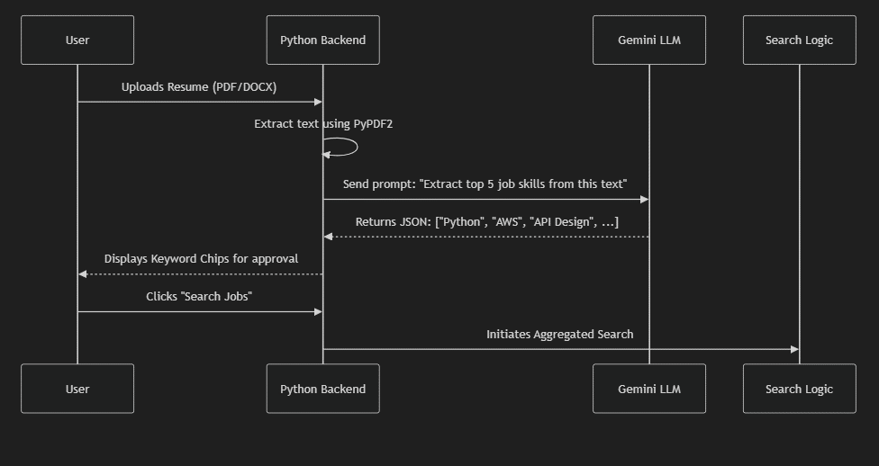
- This diagram shows the workflow of resume analysis and AI-based keyword extraction in the JOBSEEK-AI system.
- The user uploads a resume, and the Python backend extracts text and sends it to Gemini LLM for identifying important job skills.
- After receiving the generated keywords, the system starts the aggregated job search process for the user.

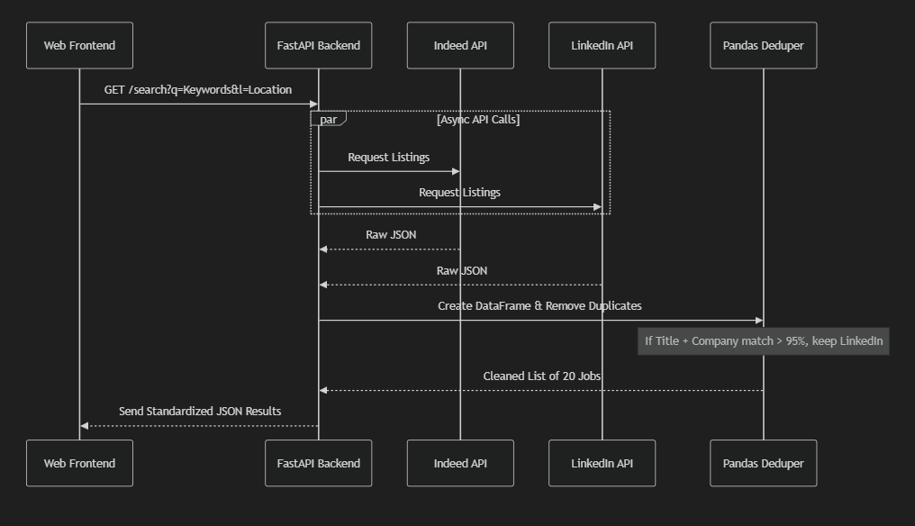
- This diagram shows the job aggregation and duplicate removal process used in the JOBSEEK-AI system.
- The FastAPI backend sends parallel API requests to Indeed and LinkedIn and collects job listings in JSON format.
- The Pandas Deduper removes duplicate jobs and returns a clean, standardized list of results to the frontend.

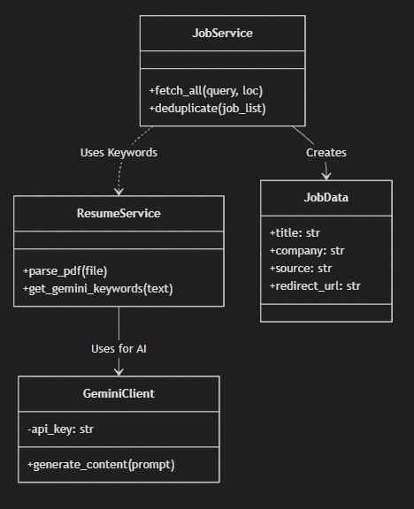
- This diagram represents the interaction between the main components of the JOBSEEK-AI system.
- ResumeService extracts resume text and communicates with GeminiClient to generate AI-based keywords.
- JobService uses these keywords to fetch job listings and stores the final job information inside the JobData component.

3.2 Methodology
- The development of JOBSEEK-AI started with requirement analysis to understand the problems faced by job seekers.
- The system was designed using Python, Streamlit, FastAPI, and Gemini LLM for AI-powered resume analysis.
- Resume data was extracted from PDF and DOCX files and processed to identify important technical skills and keywords.
- Job listings were collected from multiple platforms, and duplicate entries were removed using fuzzy matching techniques.
- Finally, the complete system was tested to ensure accurate job searching, keyword extraction, and smooth user interaction.

