**Pre-Requisites: Docker,Node js**

**Steps:**

**Create a Node js application**

**Steps:**

1. **Open cmd**
2. **To create basic node js project make dir using command mkdir raman on desktop**
3. **Go inside this folder and initialize npm using command npm init**

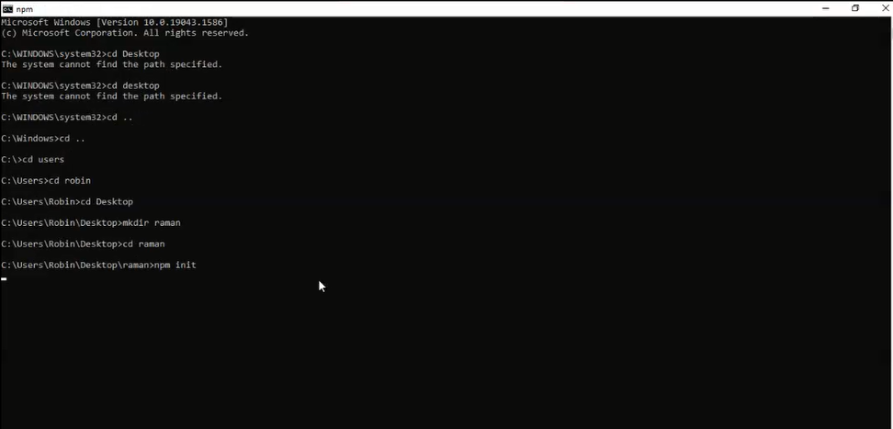

1. **Initialize the settings for package.json**

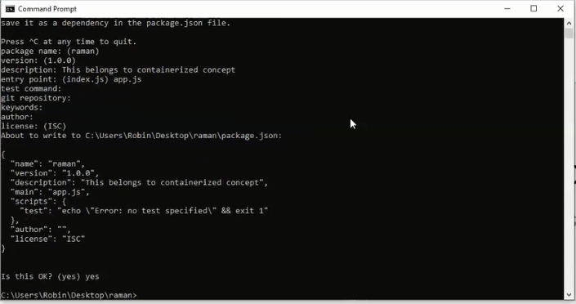

1. **To open the code in visual studio give command code .**

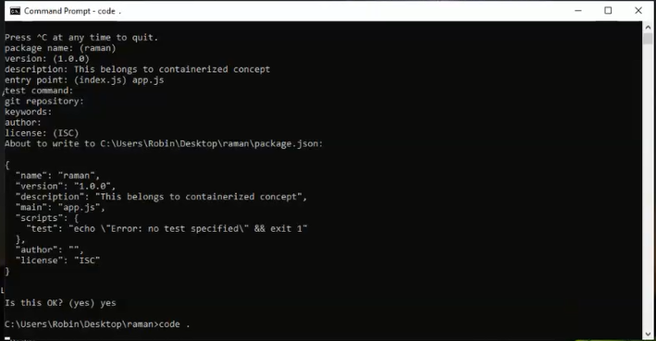

1. **Open Visual Studio**

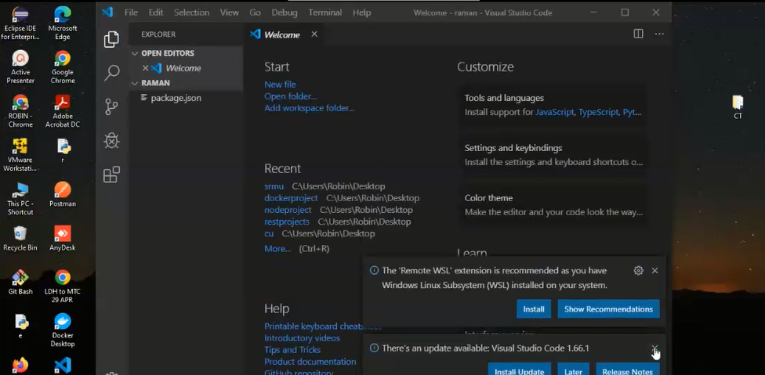

1. **Open package.json**

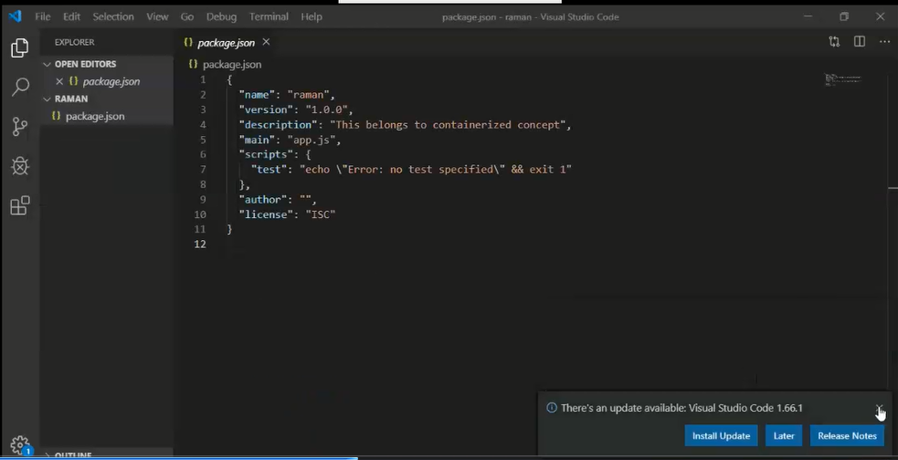

1. **Open terminal and create new file through command or create new file through option available inside raman folder**

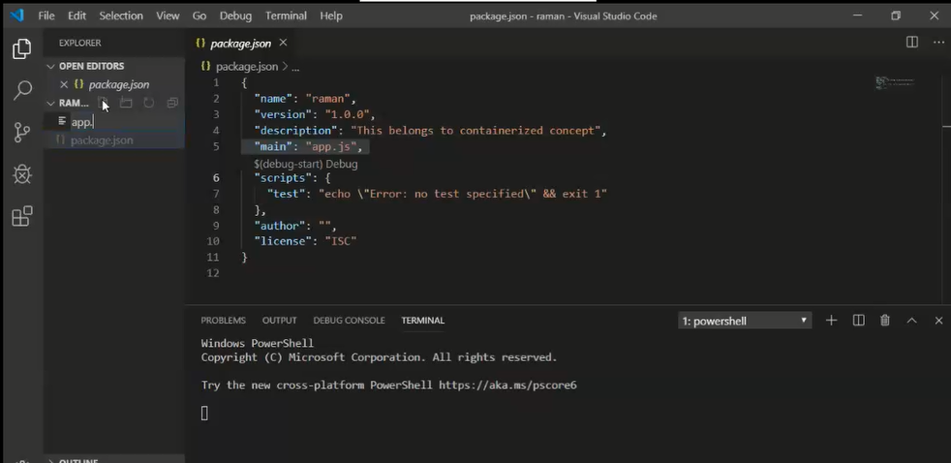

1. **Put sample express code in app.js**

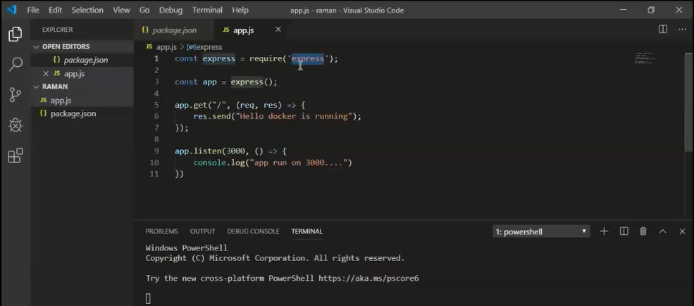

1. **Test sample app without container concept initially**

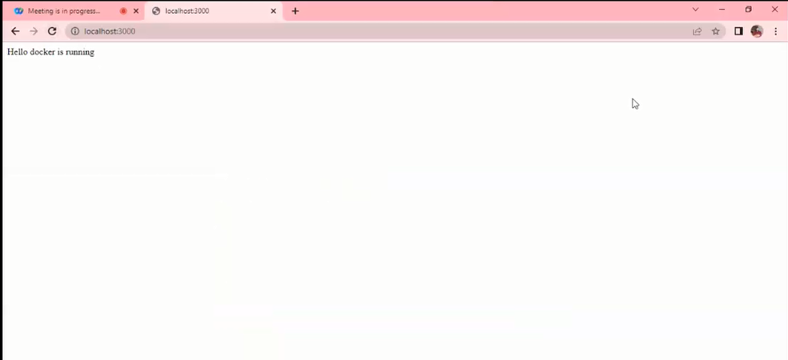

1. **Create Dockerfile**

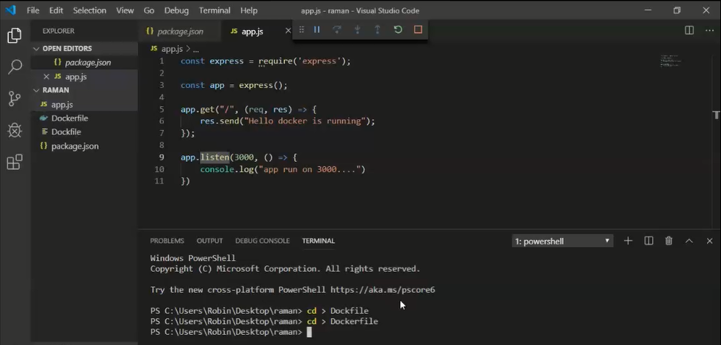

1. **Example Dockerfile**

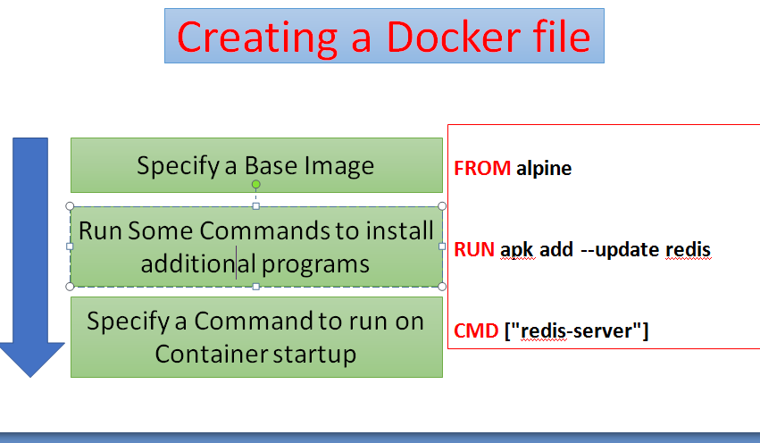

**Dockerfile commands to create image from app.js**

1. **Run command to check for present docker images**

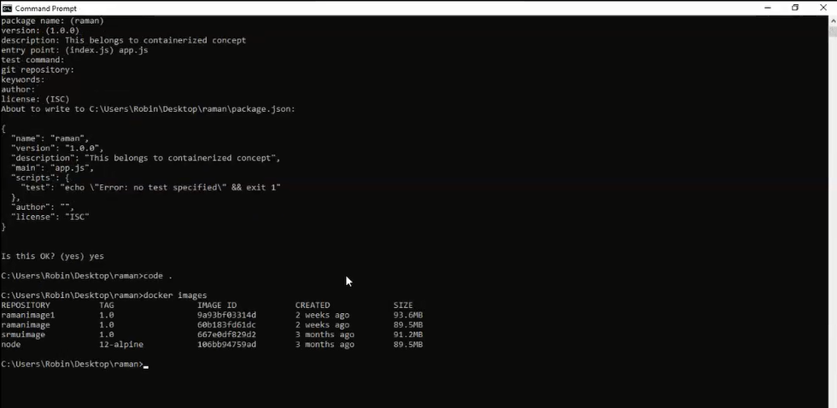

1. **Run command to create an image using docker file**

# Base Image

FROM node:14-alpine

# Create app directory

WORKDIR /usr/src/app

# Install app dependencies

COPY package*.json ./

RUN npm install

# Bundle app source

COPY . .

EXPOSE 8080

CMD [ "node", "server.js" ]

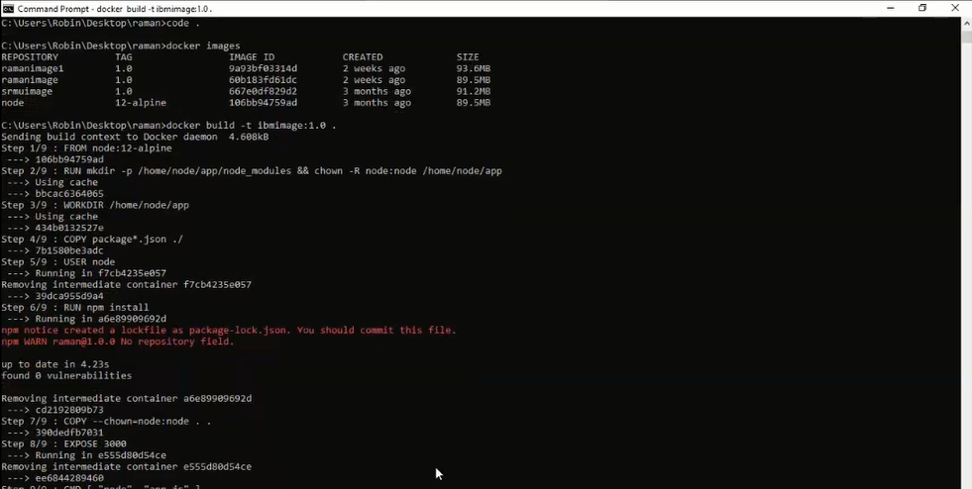

**15.)Again check if the image is created**

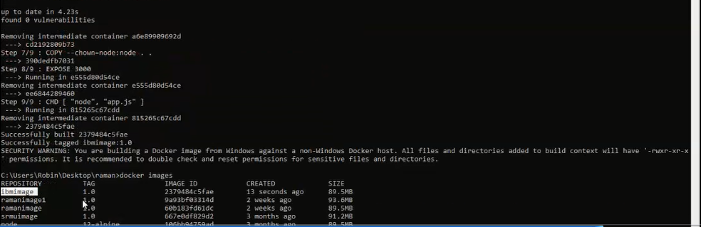

1. **Create container for the image file to deploy it**

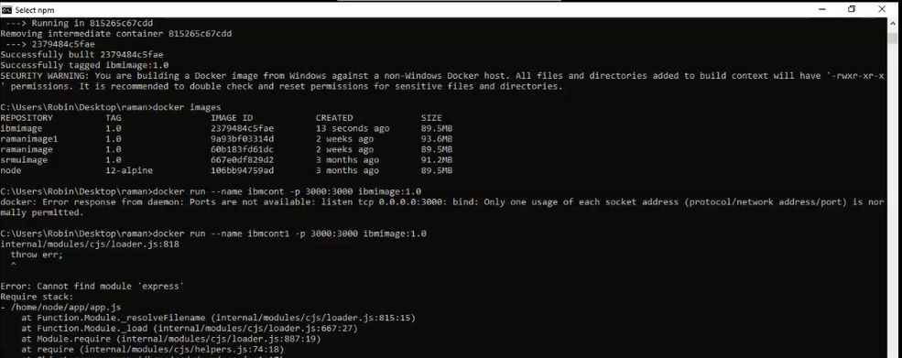

1. **Check for the container**

