 | Project ID: 260086  24-06-2026 | 

Interim Report of
Transcriptome Sequencing
On Illumina Novaseq X Plus Platform
Submitted to:
Minnu Jose
University of Calicut

Submitted by:
Unigenome
A life sciences division of Unipath Specialty Laboratory Ltd.
3rd Floor, PASL House | Beside Sahjanand College | Panjara pol, Ambawadi,
Ahmedabad – 380015 | Gujarat, India Tel :- +91-79-66197701
genomics@unipath.in | www.unigenome.in

Unigenome | Confidential Restricted use only | 1

Table of Contents
1. | Project Details & Sample Details | Page 3
2. | Methods | Page 4
3. | Results (RNA QC & Qubit) | Page 5
4. | Library QC (TapeStation) | Page 6
5. | Conclusions | Page 7

1. Project Details & Sample Details
This interim report outlines the status of RNA extraction, quality control, and library preparation for the project 260086.
Parameter | Value
Service Type | Transcriptome Sequencing
Platform | Illumina Novaseq X Plus
Read Length | 2 X 150 bp PE
Data Throughput | ~08-09GB / Sample
Type of Sample | Tissue
No. of Samples | 11
Samples ID of Libraries Prepared | Control Brain, Control Heart, Control Muscle, Test Brain, Test Heart, Test Muscle
Shipping Condition | Dry Ice
No. of Libraries Prepared | 11

2. Methods

2.1 Isolation and Quantitative analysis of RNA:
RNA sample was extracted from tissue sample using QIAGEN RNeasy mini kit (CAT.NO:74106). RNA quantity was measured using Qubit® 4.0 fluorometer and quality were analyzed by using 1% agarose gel.

2.2 Preparation of library:
The paired-end sequencing library was prepared using NEBNext® Ultra™ RNA Library Prep Kit for Illumina. (NEB #E7770). The library preparation process was initiated with 100 ng input. Ribosomal RNA was removed using depletion was carried out using ribodepletion kit KAPA RNA HyperPrep Kit with RiboErase (HMR), Cat no: KK8561) as per user manual. Ribo-depleted RNA was subjected to fragmentation, first & second-strand cDNA synthesis, end-repair, 3´ adapter ligation, selective enrichment of adapter-ligated DNA fragments through PCR amplification, followed by validation of Library on Agilent 4150 tape station. The final library was pooled with other samples, denatured & loaded on to flow cell. On the flowcell, cluster generation & sequencing was performed using Illumina Novaseq X plus platform to generate 2×150bp paired-end (PE) reads.

2.3 Quantity and quality check (QC) of library on Agilent Tape Station 4150:
The amplified library analyzed on TapeStation 4150 (Agilent Technologies) using High Sensitivity D1000 ScreenTape® as per manufacturer's instructions.

2.4 Cluster Generation and Sequencing:
After obtaining the Qubit concentration for the library and the mean peak size from Tape Station profile, library will be loaded onto Illumina Novaseq X Plus for cluster generation and sequencing. Paired-End sequencing allows the template fragments to be sequenced in both the forward and reverse directions. The library molecules will bind to complementary adapter oligos on paired-end flow cell. The adapters are designed to allow selective cleavage of the forward strands after re-synthesis of the reverse strand during sequencing. The copied reverse strand is then used to sequence from the opposite end of the fragment.

3. Results (RNA QC & Qubit)

3.1 RNA QC using Agarose Gel
RNA quality was validated using 1% Agarose Gel electrophoresis to ensure intact ribosomal RNA bands (28S and 18S).
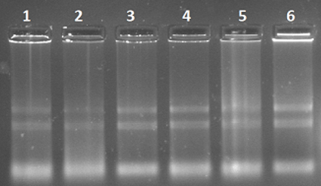
Figure 1: RNA QC on Agarose Gel
Lane ID to Sample Name Mapping:
Lane id | Sample name | Lane id | Sample name | Lane id | Sample name
1 | Control Brain | 2 | Control Heart | 3 | Control Muscle
4 | Test Brain | 5 | Test Heart | 6 | Test Muscle

3.2 Qubit Quantification Data
Table 3.2 outlines the quantitative analysis of the RNA samples as measured by Qubit fluorometer:
S.N. | Sample ID | Conc. (ng/µL) | Volume (µL) | Yield (µg) | Remarks
1 | Control Brain | 43 | 50 | 2.15 | QC PASS
2 | Control Heart | 20.2 | 50 | 1.01 | QC PASS
3 | Control Muscle | 25.2 | 50 | 1.26 | QC PASS
4 | Test Brain | 69.6 | 50 | 3.48 | QC PASS
5 | Test Heart | 114 | 50 | 5.7 | QC PASS
6 | Test Muscle | 45 | 50 | 2.25 | QC PASS

4. Quantity and quality check (QC) of library on Agilent Tape Station 4150

4.1 TapeStation 4150 Profiles of Library:
Agilent High Sensitivity D1000 ScreenTape® profiles for prepared libraries are shown below:
Sample Profile: Control Brain
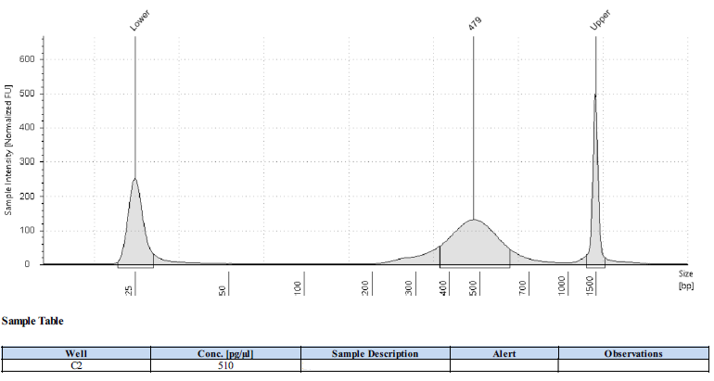
Figure 2: Agilent TapeStation Size Distribution Profile for sample Control Brain
Sample Profile: Control Heart
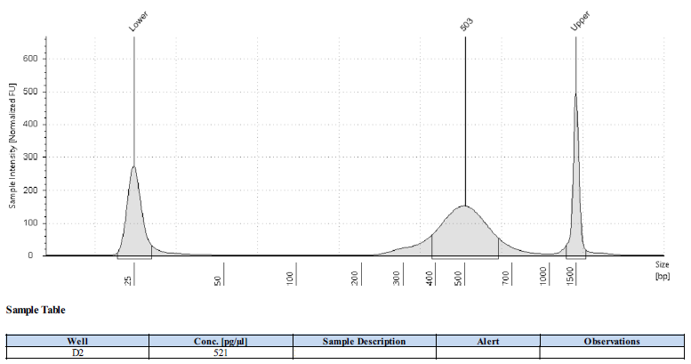
Figure 3: Agilent TapeStation Size Distribution Profile for sample Control Heart
Sample Profile: Control Muscle
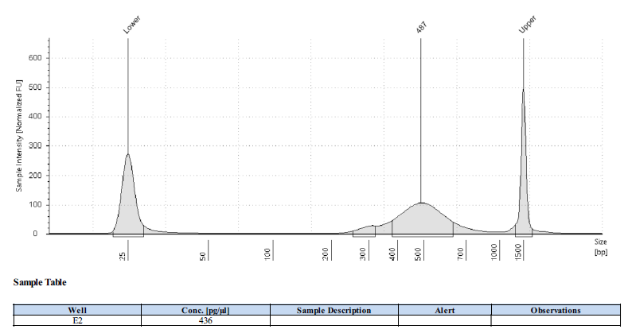
Figure 4: Agilent TapeStation Size Distribution Profile for sample Control Muscle
Sample Profile: Test Brain
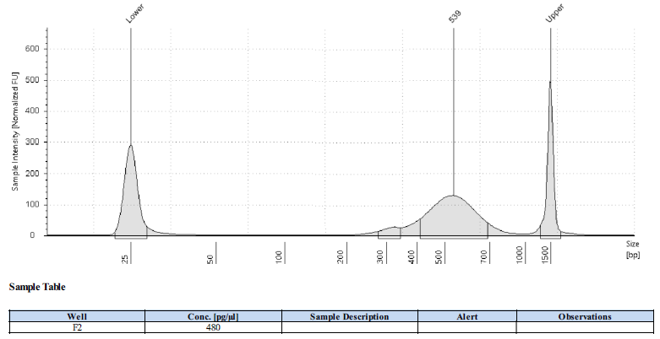
Figure 5: Agilent TapeStation Size Distribution Profile for sample Test Brain

5. Conclusions:
• - The library was prepared from the samples using KAPA RNA HyperPrep Kit with RiboErase (HMR), Cat no: KK8561.
- The average size of library is 342bp.
- The library will be sequenced on Illumina Novaseq X plus platform using 2x150 bp PE chemistry.

[END OF INTERIM REPORT]

