Final Report of
Whole Transcriptome Sequencing
& Analysis
On Illumina Novaseq X Plus Platform

Submitted to:

Dr. Ankita Singh
Scientific Affairs
ICGA Foundation
India

Submitted by:
Unigenome
A life sciences division of Unipath Specialty Laboratory Ltd.
3rd Floor, PASL House | Beside Sahjanand College | Panjara pol, Ambawadi,
Ahmedabad – 380015 | Gujarat, India
Tel :- +91-79-66197701
genomics@unipath.in | www.unigenome.in
Table of Contents
1. Project Details 3
2. Sample Details 3
3. Methods 3
3.1. Isolation and Quantitative analysis of RNA: 3
3.2. Preparation of Library 3
3.3. Quantity and quality check (QC) of library on Agilent Tape Station 4150 4
3.4. Cluster Generation and Sequencing 4
3.5. Results: RNA QC on 1% agarose gel 4
3.6. Quantification using Qubit 4.0 Fluorometer 5
4. Quantity and quality check (QC) of library on Agilent Tape Station 4150 5
4.1. TapeStation 4150 profiles of library loaded in Agilent High Sensitivity D1000ScreenTape®: 5
4.2. Wet Lab Inferences 7
5. Bioinformatics Analysis 8
5.1. Bioinformatics Workflow 8
5.2. Detail of Software used for analysis 9
5.3. Data statistics 10
5.4. Reference genome information 11
5.5. Mapping to reference genome 12
5.6. Transcript assembly 12
5.7. Comparison of assembled transcripts with reference transcripts 15
5.7.1. Identification of novel isoform transcripts 16
5.8. Differential expression analysis 17
5.8.1. MA Plot for differentially expressed genes 20
5.8.2. Volcano plot for differentially expressed genes 21
5.8.3. Heatmap for significantly differential expressed genes 22
5.8.4. Gene Ontology (GO) analysis for significant DEG 23
5.8.5. Pathway analysis for significant DGE 24
5.8.6. Over-representation (or enrichment) analysis 28
6. Deliverables 31

Project Details
Service Type | RNA Sequencing
Platform | Illumina Novaseq X Plus
Read Length | 2 X 150 PE
Data | ~ 18-20 Gb/Sample

Sample Details
Type of Sample | Frozen Tissue
No. of Samples | 8
Sample Name  Shipping condition  No. of Libraries prepared | ICGA_BC_NT_125, ICGA_BC_TT_125, ICGA_BC_NT_126, ICGA_BC_TT_126, ICGA_BC_NT_127, ICGA_BC_TT_127, ICGA_BC_NT_129, ICGA_BC_TT_129
 | NA
 | 8

Methods

Isolation and Quantitative analysis of RNA:
RNA sample was extracted from tissue sample using QIAGEN RNeasy mini kit (CAT.NO:74106). RNA quantity was measured using Qubit® 4.0 fluorometer and quality were analyzed by using 1% agarose gel.

Preparation of Library
The paired-end sequencing library was prepared using NEBNext® Ultra™ RNA Library Prep Kit for Illumina. (NEB #E7770). The library preparation process was initiated with 100 ng input. Ribosomal RNA was removed using depletion was carried out using ribodepletion kit KAPA RNA HyperPrep Kit with RiboErase (HMR), Cat no: KK8561) as per user manual. Ribo-depleted RNA was subjected to fragmentation, first & second-strand cDNA synthesis, end-repair, 3´ adapter ligation, selective enrichment of adapter-ligated DNA fragments through PCR amplification, followed by validation of Library on Agilent 4150 tape station. The final library was pooled with other samples, denatured & loaded on to flow cell. On the flowcell, cluster generation & sequencing was performed using Illumina Novaseq X plus platform to generate 2×150bp paired-end (PE) reads.

Quantity and quality check (QC) of library on Agilent Tape Station 4150
The amplified libraries were analyzed on TapeStation 4150 (Agilent Technologies) using High Sensitivity D1000 ScreenTape® as per manufacturer's instructions.

Cluster Generation and Sequencing
After obtaining the Qubit concentration for the library and the mean peak size from Tape Station profile, library will be loaded onto illumine Novaseq X Plus for cluster generation and sequencing. Paired-End sequencing allows the template fragments to be sequenced in both the forward and reverse directions. The library molecules will bind to complementary adapter oligos on paired-end flow cell. The adapters are designed to allow selective cleavage of the forward strands after re-synthesis of the reverse strand during sequencing. The copied reverse strand is then used to sequence from the opposite end of the fragment.

Results: RNA QC on 1% agarose gel

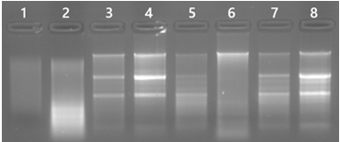

Figure 1: QC on 1.0% agarose gel.

Lane id | Sample name
1 | ICGA_BC_NT_125
2 | ICGA_BC_TT_125
3 | ICGA_BC_NT_126
4 | ICGA_BC_TT_126
5 | ICGA_BC_NT_127
6 | ICGA_BC_TT_127
7 | ICGA_BC_NT_129
8 | ICGA_BC_TT_129

Quantification using Qubit 4.0 Fluorometer

S. N | Sample ID | Concentration (ng/µl) | Volume (µl) | Yield (µg) | Remarks
1 | ICGA_BC_NT_125 | 8.34 | 20 | 0.17 | QC PASS
2 | ICGA_BC_TT_125 | 8.8 | 20 | 0.18 | QC PASS
3 | ICGA_BC_NT_126 | 89.8 | 20 | 1.80 | QC PASS
4 | ICGA_BC_TT_126 | 88.6 | 20 | 1.77 | QC PASS
5 | ICGA_BC_NT_127 | 88.4 | 20 | 1.77 | QC PASS
6 | ICGA_BC_TT_127 | 32.8 | 20 | 0.66 | QC PASS
7 | ICGA_BC_NT_129 | 89 | 20 | 1.78 | QC PASS
8 | ICGA_BC_TT_129 | 90 | 20 | 1.80 | QC PASS

Quantity and quality check (QC) of library on Agilent Tape Station 4150

TapeStation 4150 profiles of library loaded in Agilent High Sensitivity D1000ScreenTape®:
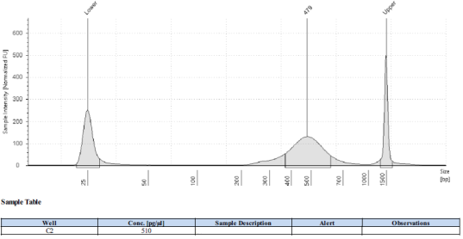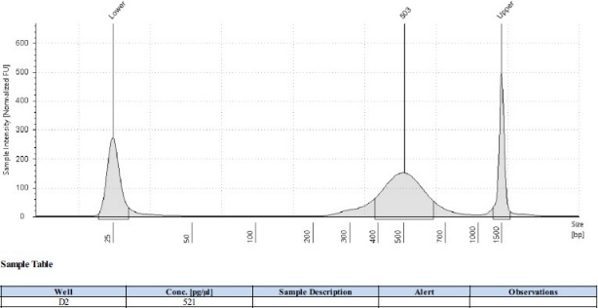

Figure 2: ICGA_BC_NT_125 Figure 3: ICGA_BC_TT_125

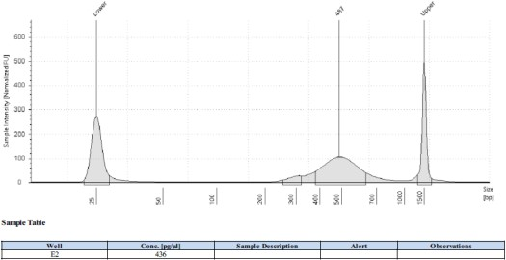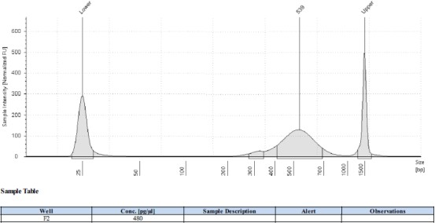

Figure 4: ICGA_BC_NT_126 Figure 5: ICGA_BC_TT_126

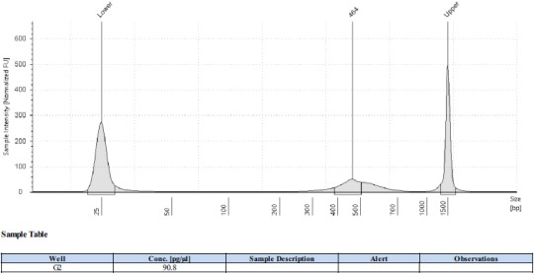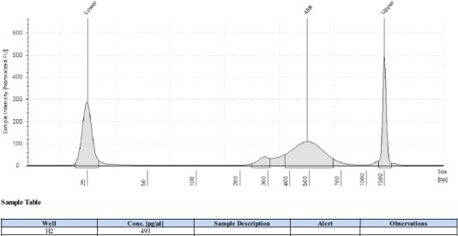

Figure 6: ICGA_BC_NT_127 Figure 7: ICGA_BC_TT_127

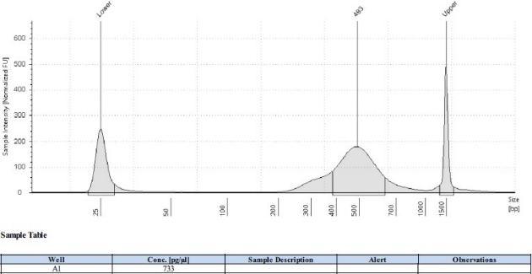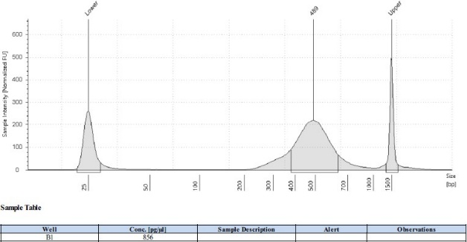

Figure 8: ICGA_BC_NT_129 Figure 9: ICGA_BC_TT_12

Wet Lab Inferences
- The libraries were prepared from the samples by KAPA mRNA Hyper Prep Kit for Illumina (CAT #KK8581).
- The average size of libraries is 479bp, 503bp, 487bp, 539bp, 464bp, 488bp, 493bp, 489bp, for ICGA_BC_NT_125
- ICGA_BC_TT_125, ICGA_BC_NT_126, ICGA_BC_TT_126, ICGA_BC_NT_127, ICGA_BC_TT_127, ICGA_BC_NT_129 and ICGA_BC_TT_129.The libraries were sequenced on Illumina Novaseq X Plus platform using 2-x 150 bp chemistry to generate ~18-20 Gb/Sample.

Bioinformatics Analysis

Bioinformatics Workflow

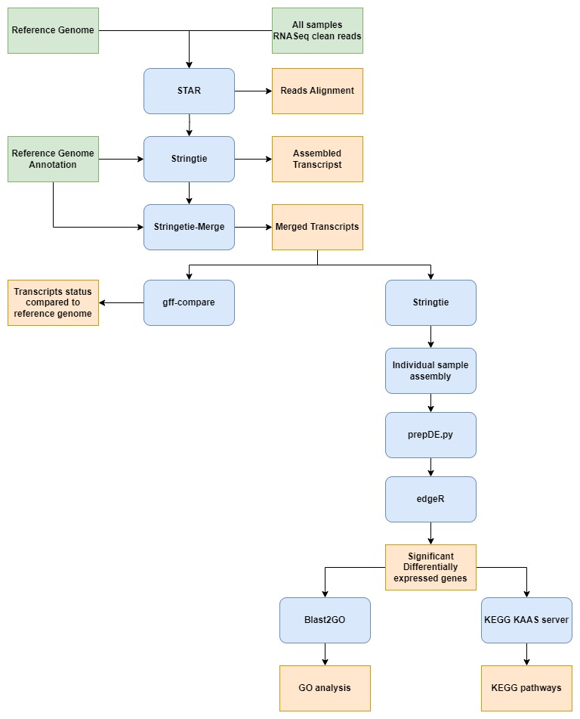
Figure 10: Bioinformatics Analysis Workflow
Workflow overview: Raw data was filtered to remove adapters and low-quality bases. Clean reads thus produced were used for analysis. Reference guided transcript assembly was performed for samples first by mapping clean reads on reference genome using STAR (v2.7.10a) aligner and then performing transcript assembly by StringTie (v 2.2.1). A consensus set of transcripts was obtained using SringTie merge function which merges together all the gene structures found in any of the samples. Transcript abundance was then estimated for individual sample using merged transcript consensus again using StringTie and read counts thus obtained for each transcript were taken as input for differential expression analysis using edgeR package. Gene Ontology and pathway analysis of the significantly differentially expressed transcripts were performed using Blast2go cli and KEGG-KAAS server respectively. Overall bioinformatics workflow is graphically represented in figure above and software version along with its use in table below.

Detail of Software used for analysis
Software | Version | Application
Trim Galore | 0.6.4 | Adapter and low-quality data removal
STAR | 2.7.10 | Mapping of reads to reference genome
Stringtie | 2.2.1 | Reference based assembly
gffcompare | 0.12.6 | Comparing reference genome gff with merged gff file generated from stringtie
gffread | 0.12.7 | Fetching fasta sequences corresponding to gff file generated after reference-based assembly by stringtie
Blastx | 2.30.0+ | Similarity search against NCBI NR database
Blast2go cli | 1.5 | GO mapping and annotation
edgeR | 3.6.2 | Differential expression analysis and its visualization
KEGG KAAS | Webserver | Pathway analysis
clusterProfiler | 4.12.6 | Over-representation (or enrichment) analysis

Data statistics
The next generation sequencing for these samples were performed on the Illumina Novaseq plus X platform. Statistics of raw data is shown in Table below:
Table 1: Data statistics
Sample | Reads in R1 | Reads in R2 | Total Reads  (R1+R2) | Total Bases (R1+R2) | Total Data  (GB)
ICGA-BC-NT-125 | 72417882 | 72417882 | 144835764 | 23028886476 | 23.03
ICGA-BC-NT-126 | 72545812 | 72545812 | 145091624 | 23069568216 | 23.07
ICGA-BC-NT-127 | 79142618 | 79142618 | 158285236 | 25167352524 | 25.17
ICGA-BC-NT-129 | 76856474 | 76856474 | 153712948 | 24440358732 | 24.44
ICGA-BC-TT-125 | 74210455 | 74210455 | 148420910 | 23598924690 | 23.6
ICGA-BC-TT-126 | 72602199 | 72602199 | 145204398 | 23087499282 | 23.09
ICGA-BC-TT-127 | 75547160 | 75547160 | 151094320 | 24023996880 | 24.02
ICGA-BC-TT-129 | 70056690 | 70056690 | 140113380 | 22278027420 | 22.28

The raw data has been provided in data deliverables folder entitled “01_Raw_Data”. These reads were subjected to adapter filtration and low quality bases filtration before analysis to generate clean/high quality (HQ) reads.

Reference genome information
Based on information received from client, the reference genome of Homo sapiens (human) (GCF_000001405.40) and its corresponding GFF file was downloaded from (https://ftp.ncbi.nlm.nih.gov/genomes/all/GCF/000/001/405/GCF_000001405.40_GRCh38.p14/).
Table 2: Reference genome stats
Description | Stats
Total Chromosomes/Scaffolds | 705
Total genome length (bp) | 3,298,430,636
Mean chromosome/scaffold size | 4,678,625
Max chromosome/scaffold size (bp) | 248,956,422
Min chromosome/scaffolds size (bp) | 970

The reference GFF file contains genome annotation. It includes information (locus and description) regarding genes and proteins. The fasta sequence of the reference genome along with the corresponding GFF file is provided with the deliverables in the folder named "02_reference_genome_and_gff" for client’s reference.
Table 3: Detail Information of GFF file
Genome elements | # Sequences
mRNA | 144447
CDS | 1836136
exon | 2301289
gene | 47876

Mapping to reference genome
Indexing of the reference genome was carried out using STAR genomeGenerate mode option. Then the input reads, in FASTQ format, along with the indexed reference genome generated in previous step was given to the STAR aligner. The analysis begins by mapping HQ reads against the reference genome to identify the positions from where the reads originated. This mapping information allows us to collect subsets of the reads corresponding to each gene, and then to assemble and quantify transcripts represented by those reads. Hence, the high-quality reads were mapped to reference genome using STAR aligner to create alignment in BAM format for each sample with default parameters. The mapping statistics are provided in the table below:
Table 4: Mapping Statistics
Sample Name | Total clean Reads | No. of Mapped Reads | % of mapped read | # uniquely mapped reads | % uniquely mapped reads
ICGA-BC-NT-125 | 72149275 | 37104104 | 51.43 | 33677874 | 46.68
ICGA-BC-NT-126 | 72286617 | 63654339 | 88.06 | 54524678 | 75.43
ICGA-BC-NT-127 | 78835961 | 70381220 | 89.28 | 60746952 | 77.05
ICGA-BC-NT-129 | 76538753 | 75296646 | 98.38 | 64338373 | 84.06
ICGA-BC-TT-125 | 73965951 | 49678232 | 67.16 | 15945694 | 21.56
ICGA-BC-TT-126 | 72221778 | 70916221 | 98.19 | 55033379 | 76.2
ICGA-BC-TT-127 | 75102744 | 69862954 | 93.02 | 46717111 | 62.2
ICGA-BC-TT-129 | 69702563 | 68143610 | 97.76 | 53526342 | 76.79

Note: Mapping for sample ICGA-BC-NT-125 and ICGA-BC-TT-125 was less than optimum which may indicate presence of reads originating from other organism.

Transcript assembly
StringTie assembles transcripts from RNA-seq reads that have been aligned to the genome, first grouping the reads into distinct gene loci and then assembling each locus into as many isoforms as are needed to explain the data. Following this, StringTie simultaneously assembles and quantify the final transcripts by using network flow algorithm and starting from most highly abundant transcripts. The reference genome GFF annotation files, containing exon structures of "known" genes, are then used to annotate the assembled transcripts and quantify the expression of known genes as well derive clues if a novel transcript has been found in the sample.
After assembling each sample, the full set of assemblies is passed to StringTie’s merge function, which merges together all the gene structures found in any of the samples. This step is required because transcripts in some of the samples might only be partially covered by reads, and as a consequence only partial versions of them will be assembled in the initial StringTie run. The merge step creates a set of transcripts that is consistent across all samples, so that the transcripts can be compared in subsequent steps in figure below:

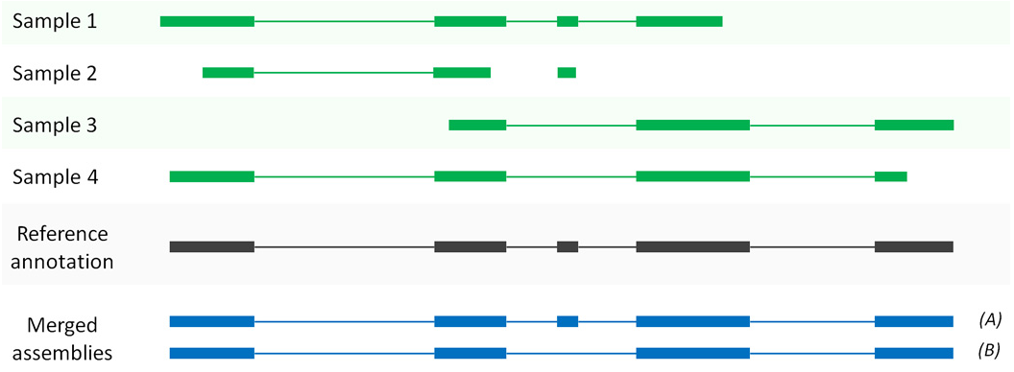
Figure 11: Explanation of merging transcript assemblies using StringTie’s merge function. In this example, four partial assemblies from four different samples are merged into two transcripts A and B. Samples 1 and 2 are both consistent with the reference annotation, which is used here to merge and extend them to create transcript A. Samples 3 and 4 are consistent with each other but not with the annotation, and these are merged to create transcript B. Please note that the 4 samples shown here are for example purpose only (Ref: Micheal P et al., 2016).

The statistics of merged transcripts and individual transcript assembly is provided in the table below:

Table 5: Transcript assembly statistics
Sample Name | # assembled transcripts | Total assembled (bp) | Mean transcript size (bp) | Max transcript size (bp)
merged.fasta | 6,53,846 | 98,30,19,883 | 1,503 | 1,55,532
ICGA-BC-NT-125 | 4,84,292 | 35,52,47,280 | 733.5 | 1,55,532
ICGA-BC-NT-126 | 3,09,175 | 61,03,86,499 | 1,974.20 | 1,55,532
ICGA-BC-NT-127 | 3,04,981 | 59,83,56,143 | 1,961.90 | 1,55,532
ICGA-BC-NT-129 | 3,21,143 | 61,65,35,962 | 1,919.80 | 1,55,532
ICGA-BC-TT-125 | 4,16,107 | 41,76,51,182 | 1,003.70 | 1,55,532
ICGA-BC-TT-126 | 2,55,210 | 56,41,16,378 | 2,210.40 | 1,55,532
ICGA-BC-TT-127 | 2,82,706 | 50,90,91,759 | 1,800.80 | 1,55,532
ICGA-BC-TT-129 | 2,69,530 | 57,79,75,701 | 2,144.40 | 1,55,532

The output consists of assembled gene/transcript GTF file for all samples and another GTF file resulting from the merge step as described above. These files have been provided along with the deliverables in the folder named "03_transcript_assembly_gtf". In addition, the transcript sequences derived from these individual assembly is provided in folder "04_transcript_sequences_fasta".

Note: “MSTRG" in output files generated from stringtie stands for "Merged StringTie Transcripts," followed by a unique number. This identifier is created by StringTie merged step to label transcript isoforms that were not previously annotated in the reference genome used.

Comparison of assembled transcripts with reference transcripts
For comparison of assembled transcripts with reference transcripts, Gffcompare utility was run taking the reference GTF and the string-tie merged GTF file. This produces an output file, which adds to each transcript a "class code" and the name of the transcript from the reference annotation file to check how the predicted transcripts relate to an annotation file. Meaning of each class code is depicted in figure below:
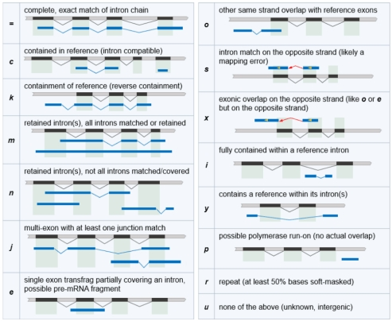
Figure 12: Different class codes and their descriptions
(https://ccb.jhu.edu/software/stringtie/gffcompare.shtml)

Identification of novel isoform transcripts
To identify novel isoform transcripts not present in the reference GTF file, gffcompare utility was ran taking the reference GTF and the string-tie merged GTF file. This produces an output file, which adds to each transcript a "class code" and the name of the transcript from the reference annotation file to check how the predicted transcripts relate to an annotation file. Class code "j" means that predicted transcript is a potential novel isoform that shares at least one splice junction with a reference transcript. A total of 3,096 novel isoforms with the class code "j" were extracted and are provided with the deliverables in a file named novel.isoforms.gtf in the folder "03_transcript_assembly_gff". A brief description of the column names in the GTF file is provided in the same folder in the file named ReadMe.txt.

Differential expression analysis
Abundances of the transcripts in all samples were estimated using StringTie with the help of merged transcripts generated from merge stringtie step. A python program (prepDE.py) was used to extract the read count information directly from the files generated by StringTie. For differential expression analysis, sample comparison was made according to grouping information provided by client:

Comparison information
Comparison | Description
TT-125 v/s NT-125 | Comparison 1 [TT-125 (ICGA-BC-TT-125) Vs NT-125 (ICGA-BC-NT-125)]
TT-126 v/s NT-126 | Comparison 2 [TT-126 (ICGA-BC-TT-126) Vs NT-126 (ICGA-BC-NT-126)]
TT-127 v/s NT-127 | Comparison 3 [TT-127 (ICGA-BC-TT-127) Vs NT-127 (ICGA-BC-NT-127)]
TT-129 v/s NT-129 | Comparison 4 [TT-129 (ICGA-BC-TT-129) Vs NT-129 (ICGA-BC-NT-129)]
TT v/s NT | Comparison 5 [TT (ICGA-BC-TT-125+ICGA-BC-TT-126+ICGA-BC-TT-127+ICGA-BC-TT-129) Vs NT (ICGA-BC-NT-125+ICGA-BC-NT-126+ICGA-BC-NT-127+ICGA-BC-NT-129)]

Group wise sample information
Table 6: Sample description

Group Name | Sample Name
NT-125 | ICGA-BC-NT-125
NT-126 | ICGA-BC-NT-126
NT-127 | ICGA-BC-NT-127
NT-129 | ICGA-BC-NT-129
TT-125 | ICGA-BC-TT-125
TT-126 | ICGA-BC-TT-126
TT-127 | ICGA-BC-TT-127
TT-129 | ICGA-BC-TT-129
NT | ICGA-BC-NT-125
NT | ICGA-BC-NT-126
NT | ICGA-BC-NT-127
NT | ICGA-BC-NT-129
TT | ICGA-BC-TT-125
TT | ICGA-BC-TT-126
TT | ICGA-BC-TT-127
TT | ICGA-BC-TT-129

Differential gene expression was inferred between samples by applying the R package edgeR It is Bioconductor package based on negative binomial distribution method. The analysis provides tabular result along with the normalized i.e., Counts Per Million mapped reads (CPM) for each involved sample. The description of selected result columns has been given in below mentioned table:

Table 7: Column description of edgeR output
Column Name | Feature identifier
logFC | log2FoldChange: the logarithm (base 2) of the fold change (Test/Control)
logCPM | Log10 of CPM value
pval | pvalue for the statistical significance of this change
FDR | FDR adjusted pvalue (q-value)

The criterion used to identify upregulated and downregulated transcripts along with the significance is provided in the below table:

Table 8: Criteria used to identify upregulated and downregulated genes and assigning the significance
Condition | Status
log2FC > 0 | Up regulated
log2FC < 0 | Down regulated
log2FC > 0 and q-value <0.05 | Significantly up regulated
log2FC < 0 and q-value <0.05 | Significantly down regulated

Differential expression analysis statistics is provided in table below and the data deliverable are given in the folder "05_differential_expression_analysis" which contains the Differential gene expression (DGE) analysis results.
Table 9: Differential gene expression statistics
DGE Combination | Total DEGs | Down  Regulated | Up  Regulated | Significant  Downregulated | Significant  Upregulated | # Significant  DGE
Comparison1 | 9160 | 4590 | 4570 | 493 | 768 | 1261
Comparison2 | 36826 | 18306 | 18520 | 2666 | 2481 | 5147
Comparison3 | 28797 | 14251 | 14546 | 3678 | 3923 | 7601
Comparison4 | 37177 | 18706 | 18471 | 2228 | 2467 | 4695
Comparison5 | 68563 | 30178 | 38385 | 127 | 61 | 188

Annotation for differentially expressed transcripts is provided based on blastX result obtained by similarity search against NCBI’s NR database followed by gene ontology analysis using blast2GO.

Note: We recommend a minimum of triplicates per group in RNA-Seq experiments to obtain statistically significant results in differential expression analysis. However, as there are no replicates in this study, we performed DEG analysis using edgeR, which is capable of producing reasonable results in single-sample comparisons.

MA Plot for differentially expressed genes
The plot visualizes the differences between measurements taken in two samples, by transforming the data onto M (log ratio) and A (mean average) scales, then plotting these values. For illustration purpose, MA plot for Comparison1 has been depicted below:
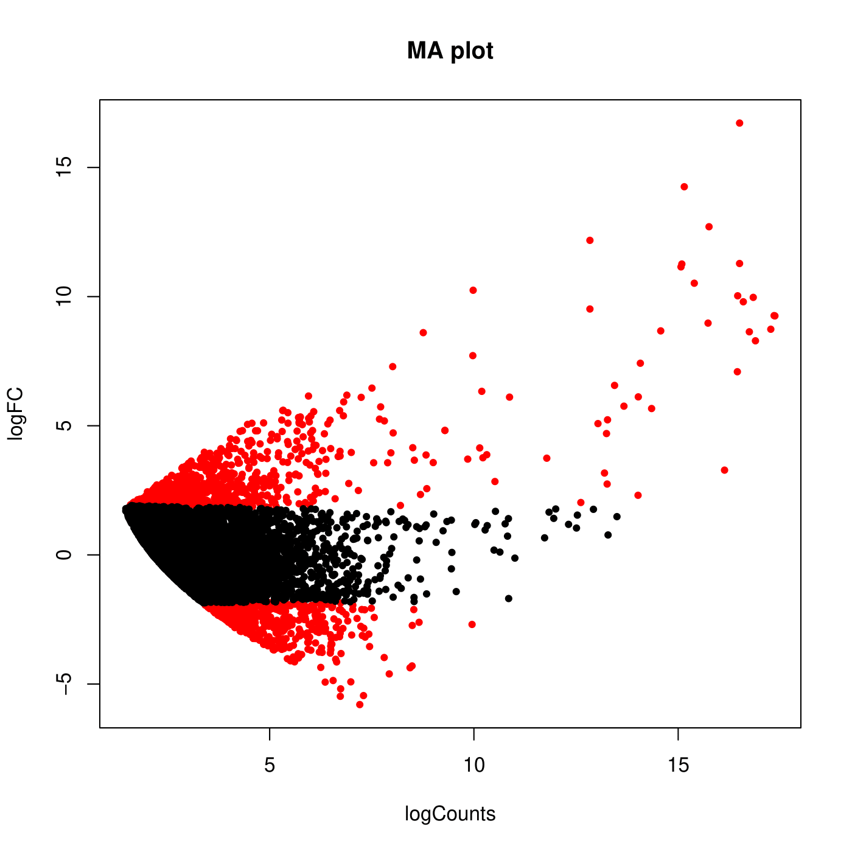
Figure 13: MA plot showing differentially expressed transcripts in Comparison-1. On X-axis normalized counts for all the samples and on Y-axis log2foldchange are plotted. Points colored are with red if the q-value is less than 0.05 and black if the q-value is greater than 0.05.

Note: MA plot for only one comparison has been shown above, however plots for all other combinations have been provided as a part of data deliverables “05_differential_expression_analysis”.

Volcano plot for differentially expressed genes
The "volcano plot" arranges expressed genes along dimensions of biological as well as statistical significance. For illustration purpose, Volcano plot for Comparison1 has been depicted below:
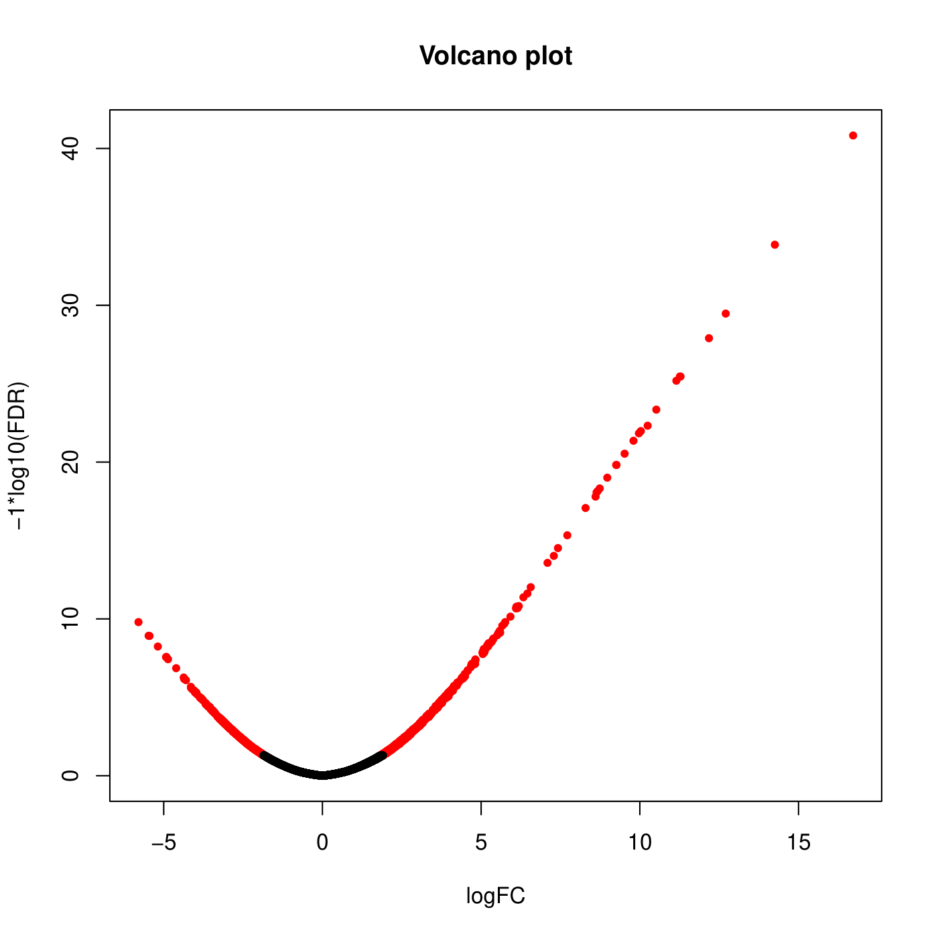
Figure 14: Volcano plot showing differentially expressed transcripts in Comparison-1. X-axis represents the log2fold change values and Y-axis represents log10 of q-value (FDR corrected p-value. Points are colored red if the q-value is less than 0.05 and black if the q-value is greater than 0.05.
Note: Volcano plot for only one comparison has been shown above, however plots for all other combinations has been provided as a part of data deliverables “05_differential_expression analysis”.

Heatmap for significantly differential expressed genes
List of transcripts were selected for heatmap generation based on following criteria:
- 25 transcripts (downregulated) and 25 transcripts (upregulated) having lowest FDR/adjusted pvalue
- Transcripts must have proper annotations.
pheatmap package from R software was used for producing heatmap. The colour coding ranges from red to blue where shades of red represent high transcripts expression and shades of blue represents low transcript expression.
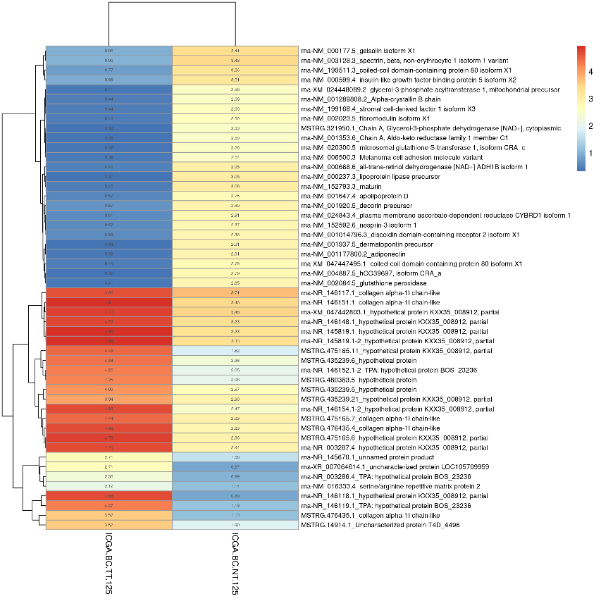
Figure 15: Heatmap representing most significant genes expressed in the samples was plotted using log10 of normalized read count values (CPM) for Comparison-1, where shades of blue represent downregulated genes and shades of red represents highly expressed genes.

Note: Heatmap plot for only one comparison has been shown above, however plots for all other combinations have been provided as a part of data deliverables “05_differential_expression_analysis”.

Gene Ontology (GO) analysis for significant DEG
The Gene Ontology project provides controlled vocabularies of defined terms representing gene product properties. These cover three domains: Cellular Component, the parts of a cell or its extracellular environment; Molecular Function, the elemental activities of a gene product at the molecular level, such as binding or catalysis; and Biological Process, operations or sets of molecular events with a defined beginning and end, pertinent to the functioning of integrated living units: cells, tissues, organs, and organisms. GO was assigned to significant differentially expressed transcripts using Blast2go cli. Single gene can be assigned with multiple GO categories and hence multiple GO terms. The GO domain distribution is shown in table below:
Table 10: GO Distribution of Significantly Differential expression transcripts
Sample  Name | Significant  DGE | # Seq with  GO | Biological  Process | Cellular  Component | Molecular  Function
Comparison1 | 1261 | 504 | 445 | 463 | 450
Comparison2 | 5147 | 2291 | 2041 | 2127 | 2091
Comparison3 | 7601 | 3008 | 2644 | 2774 | 2677
Comparison4 | 4695 | 2137 | 1877 | 1975 | 1929
Comparison5 | 188 | 70 | 62 | 67 | 62

Assigned Gene Ontology are also provided in deliverables "06_Significant_DGE_GO".

Pathway analysis for significant DGE
Ortholog assignment and mapping of Significant differentially expressed transcripts to the biological pathways were performed using KEGG automatic annotation server (KAAS). Significant differentially expressed transcripts were compared against the KEGG database using BLASTX with threshold bit-score value of 60 (default). Pathway analysis was performed using all differentially expressed transcripts. The mapped transcripts represented metabolic pathways of major biomolecules such as carbohydrates, lipids, nucleotides, amino acids, glycans, etc. The mapped transcripts also represented the genes involved in metabolism, genetic information processing, and environmental information processing, cellular processes and organismal systems. Detail of the transcripts following in particular pathway along with the pathway images is given in data deliverables entitled "07_Significant_DGE_pathways". Respective pathway images are also provided in the same folder. Pathway statistics for one of the comparisons and one representative pathway image have been given below for illustration purpose.
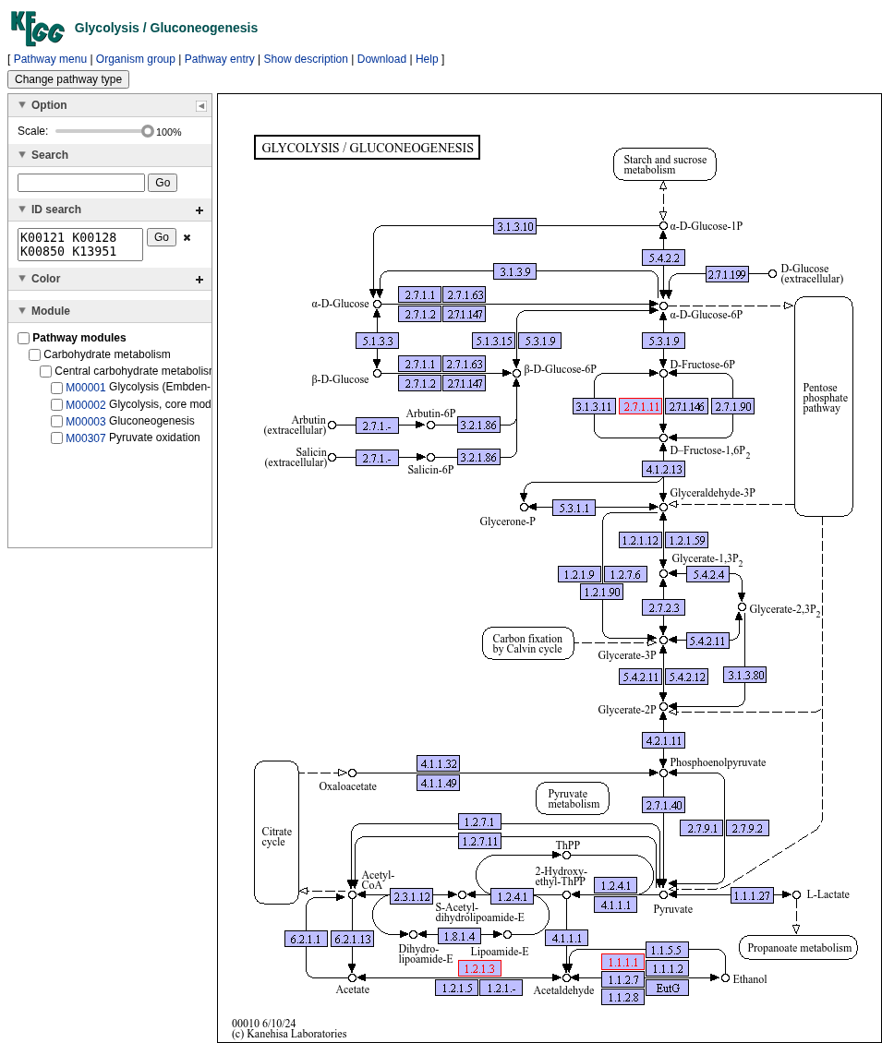
Figure 16: Example of Glycolysis for Comparison-1 DGE: Purple color entry has been assigned to at least one gene entry whereas a pink color entry corresponds to an ortholog table entry, which corresponds to a gene that is a part of a functional unit on the pathway.

Table 11: KEGG pathway statistics for Significant differentially expressed transcripts for Comparison-1
#Level 1 | Level 2 | Counts
09100 Metabolism | 09101 Carbohydrate metabolism | 37
09100 Metabolism | 09102 Energy metabolism | 18
09100 Metabolism | 09103 Lipid metabolism | 34
09100 Metabolism | 09104 Nucleotide metabolism | 3
09100 Metabolism | 09105 Amino acid metabolism | 32
09100 Metabolism | 09106 Metabolism of other amino acids | 14
09100 Metabolism | 09107 Glycan biosynthesis and metabolism | 20
09100 Metabolism | 09108 Metabolism of cofactors and vitamins | 9
09100 Metabolism | 09109 Metabolism of terpenoids and polyketides | 2
09100 Metabolism | 09110 Biosynthesis of other secondary metabolites | 2
09100 Metabolism | 09111 Xenobiotics biodegradation and metabolism | 25
09120 Genetic Information Processing | 09121 Transcription | 18
09120 Genetic Information Processing | 09122 Translation | 17
09120 Genetic Information Processing | 09123 Folding, sorting and degradation | 36
09120 Genetic Information Processing | 09124 Replication and repair | 12
09120 Genetic Information Processing | 09125 Information processing in viruses | 20
09120 Genetic Information Processing | 09126 Chromosome | 17
09130 Environmental Information Processing | 09132 Signal transduction | 375
09130 Environmental Information Processing | 09133 Signaling molecules and interaction | 61
09140 Cellular Processes | 09141 Transport and catabolism | 95
09140 Cellular Processes | 09142 Cell motility | 71
09140 Cellular Processes | 09143 Cell growth and death | 94
09140 Cellular Processes | 09144 Cellular community - eukaryotes | 71
09140 Cellular Processes | 09145 Cellular community - prokaryotes | 2
09150 Organismal Systems | 09149 Aging | 26
09150 Organismal Systems | 09151 Immune system | 200
09150 Organismal Systems | 09152 Endocrine system | 226
09150 Organismal Systems | 09153 Circulatory system | 28
09150 Organismal Systems | 09154 Digestive system | 56
09150 Organismal Systems | 09155 Excretory system | 14
09150 Organismal Systems | 09156 Nervous system | 82
09150 Organismal Systems | 09157 Sensory system | 27
09150 Organismal Systems | 09158 Development and regeneration | 46
09150 Organismal Systems | 09159 Environmental adaptation | 34
09160 Human Diseases | 09161 Cancer: overview | 208
09160 Human Diseases | 09162 Cancer: specific types | 145
09160 Human Diseases | 09163 Immune disease | 29
09160 Human Diseases | 09164 Neurodegenerative disease | 174
09160 Human Diseases | 09165 Substance dependence | 26
09160 Human Diseases | 09166 Cardiovascular disease | 107
09160 Human Diseases | 09167 Endocrine and metabolic disease | 73
09160 Human Diseases | 09171 Infectious disease: bacterial | 123
09160 Human Diseases | 09172 Infectious disease: viral | 228
09160 Human Diseases | 09174 Infectious disease: parasitic | 68
09160 Human Diseases | 09176 Drug resistance: antineoplastic | 28
09180 Brite Hierarchies | 09181 Protein families: metabolism | 134
09180 Brite Hierarchies | 09182 Protein families: genetic information processing | 586
09180 Brite Hierarchies | 09183 Protein families: signaling and cellular processes | 370
09190 Not Included in Pathway or Brite | 09191 Unclassified: metabolism | 3
09190 Not Included in Pathway or Brite | 09192 Unclassified: genetic information processing | 2
09190 Not Included in Pathway or Brite | 09193 Unclassified: signaling and cellular processes | 22

Note:
- Non-specific organism pathway hits are obtained in pathway results due to lenient threshold (bit score: 60) applied in KAAS webserver.
- Pathway stats for only one comparison has been shown above, however stats and images for all other combinations has been provided as a part of data deliverables “07_Significant_DGE_pathways”.

Over-representation (or enrichment) analysis
Over-representation (enrichment) analysis is a statistical approach used to identify biological functions, pathways, or processes that are significantly over-represented among a given list of genes compared to a reference background. This helps in interpreting large-scale transcriptomic data by linking differentially expressed genes (DEGs) to specific molecular mechanisms and biological pathways.
Functional enrichment analysis was performed using the clusterProfiler R package to identify over-represented Gene Ontology (GO) terms and Kyoto Encyclopedia of Genes and Genomes (KEGG) pathways among the significantly differentially expressed genes (DEGs). The functions enrichGO and enrichKEGG were applied independently to both up-regulated and down-regulated gene sets.
Multiple hypothesis testing correction was performed using the Benjamini–Hochberg (BH) method, and GO and KEGG terms with pvalueCutoff = 0.05, and qvalueCutoff = 0.2 were considered statistically significant.
The results of the enrichment analyses were visualized using dot plots and bar plots, highlighting the most significantly enriched GO terms and KEGG pathways that may represent key biological processes and molecular mechanisms underlying the observed expression changes.
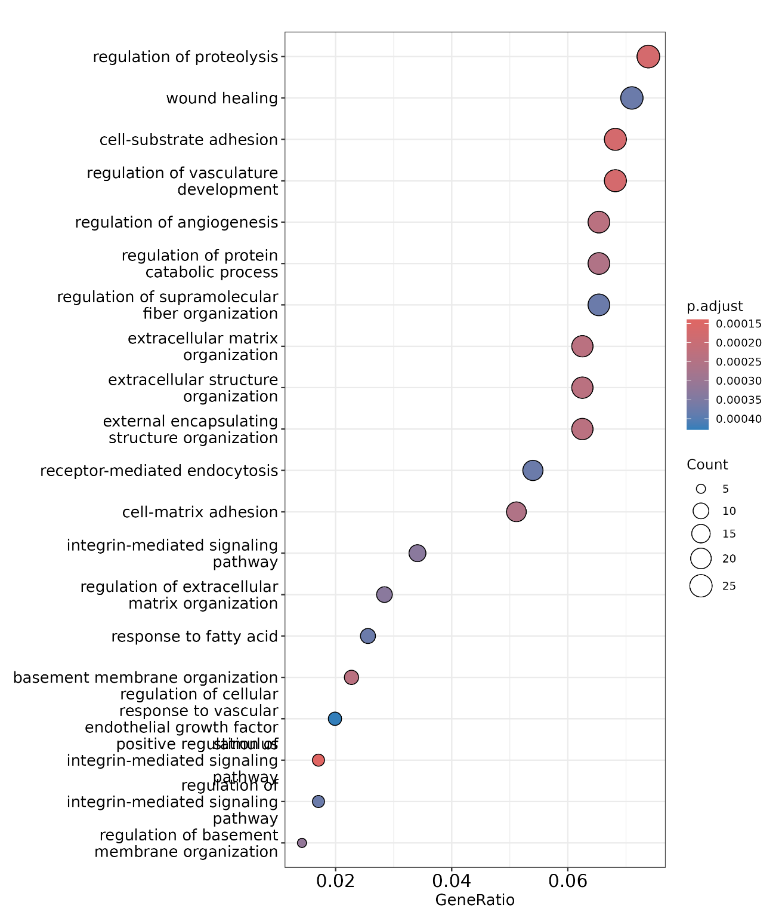
Figure 17: Dot plot of GO enrichment for Comparison1 of down-regulated genes showing the most significantly enriched Gene Ontology (GO) terms in the differentially expressed genes (DEGs).
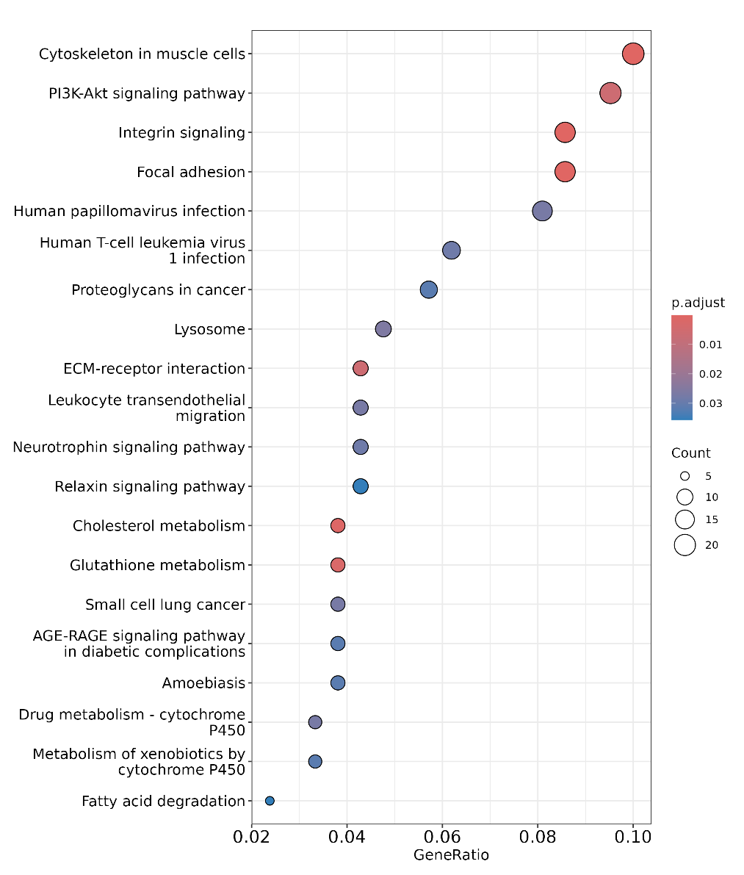

Figure 18: Dot plot of KEGG pathway enrichment for Comparison1 of down-regulated genes, highlighting the most significantly enriched KEGG pathways in the differentially expressed genes (DEGs).

Note: Dot plot for only one comparison has been shown above, however plots for upregulated genes as well as all other combinations have been provided as a part of data deliverables “08_Significant_DGE_Enrichment/”.
Please note: No enrichment was obtained for the following comparisons: C5_up_KEGG.

Deliverables
├── 01_Raw_Data
│ ├── ICGA-BC-NT-125_S182_L006_R1_001.fastq.gz
│ ├── ICGA-BC-NT-125_S182_L006_R2_001.fastq.gz
│ ├── ICGA-BC-NT-126_S184_L006_R1_001.fastq.gz
│ ├── ICGA-BC-NT-126_S184_L006_R2_001.fastq.gz
│ ├── ICGA-BC-NT-127_S186_L006_R1_001.fastq.gz
│ ├── ICGA-BC-NT-127_S186_L006_R2_001.fastq.gz
│ ├── ICGA-BC-NT-129_S188_L006_R1_001.fastq.gz
│ ├── ICGA-BC-NT-129_S188_L006_R2_001.fastq.gz
│ ├── ICGA-BC-TT-125_S183_L006_R1_001.fastq.gz
│ ├── ICGA-BC-TT-125_S183_L006_R2_001.fastq.gz
│ ├── ICGA-BC-TT-126_S185_L006_R1_001.fastq.gz
│ ├── ICGA-BC-TT-126_S185_L006_R2_001.fastq.gz
│ ├── ICGA-BC-TT-127_S187_L006_R1_001.fastq.gz
│ ├── ICGA-BC-TT-127_S187_L006_R2_001.fastq.gz
│ ├── ICGA-BC-TT-129_S189_L006_R1_001.fastq.gz
│ ├── ICGA-BC-TT-129_S189_L006_R2_001.fastq.gz
│ ├── NGS_240592_md5sum.txt
│ └── NGS_240592_Raw_Stats.txt
├── 02_reference_genome_and_gff
│ ├── GCF_000001405.40_GRCh38.p14_genomic.fna
│ └── GCF_000001405.40_GRCh38.p14_genomic.gff
├── 03_transcript_assembly_gtf
│ ├── gffcompare_results.gtf
│ ├── merged_transcripts.gtf
│ ├── NGS_240592_ICGA-BC-NT-125Aligned_1.gtf
│ ├── NGS_240592_ICGA-BC-NT-126Aligned_1.gtf
│ ├── NGS_240592_ICGA-BC-NT-127Aligned_1.gtf
│ ├── NGS_240592_ICGA-BC-NT-129Aligned_1.gtf
│ ├── NGS_240592_ICGA-BC-TT-125Aligned_1.gtf
│ ├── NGS_240592_ICGA-BC-TT-126Aligned_1.gtf
│ ├── NGS_240592_ICGA-BC-TT-127Aligned_1.gtf
│ ├── NGS_240592_ICGA-BC-TT-129Aligned_1.gtf
│ ├── novel.isoforms.gtf
│ ├── ReadMe.txt
│ └── sed1Jy5Yk
├── 04_transcript_sequences_fasta
│ ├── Merged.fasta
│ ├── NGS_240592_ICGA-BC-NT-125Aligned_transcript.fasta
│ ├── NGS_240592_ICGA-BC-NT-126Aligned_transcript.fasta
│ ├── NGS_240592_ICGA-BC-NT-127Aligned_transcript.fasta
│ ├── NGS_240592_ICGA-BC-NT-129Aligned_transcript.fasta
│ ├── NGS_240592_ICGA-BC-TT-125Aligned_transcript.fasta
│ ├── NGS_240592_ICGA-BC-TT-126Aligned_transcript.fasta
│ ├── NGS_240592_ICGA-BC-TT-127Aligned_transcript.fasta
│ └── NGS_240592_ICGA-BC-TT-129Aligned_transcript.fasta
├── 05_differential_expression_analysis
│ ├── Comparison1_DGE.xlsx
│ ├── Comparison1_Heatmap.png
│ ├── Comparison1_MA_and_Volcano.pdf
│ ├── Comparison2_DGE.xlsx
│ ├── Comparison2_Heatmap.png
│ ├── Comparison2_MA_and_Volcano.pdf
│ ├── Comparison3_DGE.xlsx
│ ├── Comparison3_Heatmap.png
│ ├── Comparison3_MA_and_Volcano.pdf
│ ├── Comparison4_DGE.xlsx
│ ├── Comparison4_Heatmap.png
│ ├── Comparison4_MA_and_Volcano.pdf
│ ├── Comparison5_DGE.xlsx
│ ├── Comparison5_Heatmap.png
│ └── Comparison5_MA_and_Volcano.pdf
├── 06_Significant_DGE_GO
│ ├── Comparison1_Significant_DGE_with_GO.xlsx
│ ├── Comparison2_Significant_DGE_with_GO.xlsx
│ ├── Comparison3_Significant_DGE_with_GO.xlsx
│ ├── Comparison4_Significant_DGE_with_GO.xlsx
│ └── Comparison5_Significant_DGE_with_GO.xlsx
├── 07_Significant_DGE_pathways
│ ├── Comparison1_Significant_DGE_Pathway_images
│ ├── Comparison1_Significant_DGE_Pathways.xlsx
│ ├── Comparison2_Significant_DGE_Pathway_images
│ ├── Comparison2_Significant_DGE_Pathways.xlsx
│ ├── Comparison3_Significant_DGE_Pathway_images
│ ├── Comparison3_Significant_DGE_Pathways.xlsx
│ ├── Comparison4_Significant_DGE_Pathway_images
│ ├── Comparison4_Significant_DGE_Pathways.xlsx
│ ├── Comparison5_Significant_DGE_Pathway_images
│ └── Comparison5_Significant_DGE_Pathways.xlsx
├── 08_Significant_DGE_Enrichment
│ ├── C1_down_barplot_GO_enrichment.png
│ ├── C1_down_barplot_KEGG_enrichment.png
│ ├── C1_down_dotplot_GO_enrichment.png
│ ├── C1_down_dotplot_KEGG_enrichment.png
│ ├── C1_down_GO_enrichment_results.xlsx
│ ├── C1_down_KEGG_enrichment_results.xlsx
│ ├── C1_up_barplot_GO_enrichment.png
│ ├── C1_up_barplot_KEGG_enrichment.png
│ ├── C1_up_dotplot_GO_enrichment.png
│ ├── C1_up_dotplot_KEGG_enrichment.png
│ ├── C1_up_GO_enrichment_results.xlsx
│ ├── C1_up_KEGG_enrichment_results.xlsx
│ ├── C2_down_barplot_GO_enrichment.png
│ ├── C2_down_barplot_KEGG_enrichment.png
│ ├── C2_down_dotplot_GO_enrichment.png
│ ├── C2_down_dotplot_KEGG_enrichment.png
│ ├── C2_down_GO_enrichment_results.xlsx
│ ├── C2_down_KEGG_enrichment_results.xlsx
│ ├── C2_up_barplot_GO_enrichment.png
│ ├── C2_up_barplot_KEGG_enrichment.png
│ ├── C2_up_dotplot_GO_enrichment.png
│ ├── C2_up_dotplot_KEGG_enrichment.png
│ ├── C2_up_GO_enrichment_results.xlsx
│ ├── C2_up_KEGG_enrichment_results.xlsx
│ ├── C3_down_barplot_GO_enrichment.png
│ ├── C3_down_barplot_KEGG_enrichment.png
│ ├── C3_down_dotplot_GO_enrichment.png
│ ├── C3_down_dotplot_KEGG_enrichment.png
│ ├── C3_down_GO_enrichment_results.xlsx
│ ├── C3_down_KEGG_enrichment_results.xlsx
│ ├── C3_up_barplot_GO_enrichment.png
│ ├── C3_up_barplot_KEGG_enrichment.png
│ ├── C3_up_dotplot_GO_enrichment.png
│ ├── C3_up_dotplot_KEGG_enrichment.png
│ ├── C3_up_GO_enrichment_results.xlsx
│ ├── C3_up_KEGG_enrichment_results.xlsx
│ ├── C4_down_barplot_GO_enrichment.png
│ ├── C4_down_barplot_KEGG_enrichment.png
│ ├── C4_down_dotplot_GO_enrichment.png
│ ├── C4_down_dotplot_KEGG_enrichment.png
│ ├── C4_down_GO_enrichment_results.xlsx
│ ├── C4_down_KEGG_enrichment_results.xlsx
│ ├── C4_up_barplot_GO_enrichment.png
│ ├── C4_up_barplot_KEGG_enrichment.png
│ ├── C4_up_dotplot_GO_enrichment.png
│ ├── C4_up_dotplot_KEGG_enrichment.png
│ ├── C4_up_GO_enrichment_results.xlsx
│ ├── C4_up_KEGG_enrichment_results.xlsx
│ ├── C5_down_barplot_GO_enrichment.png
│ ├── C5_down_barplot_KEGG_enrichment.png
│ ├── C5_down_dotplot_GO_enrichment.png
│ ├── C5_down_dotplot_KEGG_enrichment.png
│ ├── C5_down_GO_enrichment_results.xlsx
│ ├── C5_down_KEGG_enrichment_results.xlsx
│ ├── C5_up_barplot_GO_enrichment.png
│ ├── C5_up_barplot_KEGG_enrichment.png
│ ├── C5_up_dotplot_GO_enrichment.png
│ ├── C5_up_dotplot_KEGG_enrichment.png
│ ├── C5_up_GO_enrichment_results.xlsx
│ └── C5_up_KEGG_enrichment_results.xlsx
└── Readme.txt
└──NGS_240592_Final_Report_RNASeq_09.12.2025.pdf

[END OF REPORT]

