Social Network Analysis Journal

M.Sc Part I Computer Science

Yash Salvi 548

March 21, 2023



R.J. College of Arts, Science & Commerce Social network analysis

Seat number: 548

# Contents

1. Practical 01 1
   1. Aim: Write a program to compute the following for a given a network: (i) number of edges, (ii) number of nodes; (iii) degree of node; (iv) node with lowest degree; (v)

the adjacency list; (vi) matrix of the graph. 1

* + 1. 1)no of edges 2
    2. 2)no of nodes 2
    3. 3)Degree Of nodes 3
    4. 4) a) Node with lowest degree 4
    5. 4) b) Node with lowest degree 4
    6. 5) To find neighbours / adjacency list: 4
    7. 6)Adjacency Matrix 4

1. Practical 02 5
   1. Aim: 5
2. Practical 03 7
   1. Aim: 7
      1. 1)Density 8
      2. 2) Degree 8
      3. 3)Reciprocity 8
      4. Formula 9
      5. 4)Transitivity 10
      6. 5)Centralization 11
   2. 6) Clustering 13
3. Practical 04 14

4.1 Aim: 14

* + 1. (i) Length of the shortest path from a given node to another node; 14
    2. (ii) the density of the graph 16

1. Practical 05 17

5.1 Aim: 17

5.1.1 (i) Length of the shortest path from a given node to another node; 18

1. Practical 05 20

6.1 Aim: 20

6.1.1 (i) i) structural equivalence 21

* 1. ii) automorphic equivalence, 22
  2. 3) regular equivalence from a network. 23

1. Practical 07 24

7.1 Aim: 24

1. Practical 08 26

8.1 Aim: 26

[1]:

# Practical 01

## Aim: Write a program to compute the following for a given a network: (i) number of edges, (ii) number of nodes; (iii) degree of node; (iv) node with lowest degree; (v) the adjacency list; (vi) matrix of the graph.

library(igraph)

Attaching package: ‘igraph’

The following objects are masked from ‘package:stats’: decompose, spectrum

The following object is masked from ‘package:base’: union

[2]:

g <- graph.formula(1-2, 1-3, 2-3, 2-4, 3-5, 4-5, 4-6,4-7, 5-6, 6-7)

[3]:

plot(g)

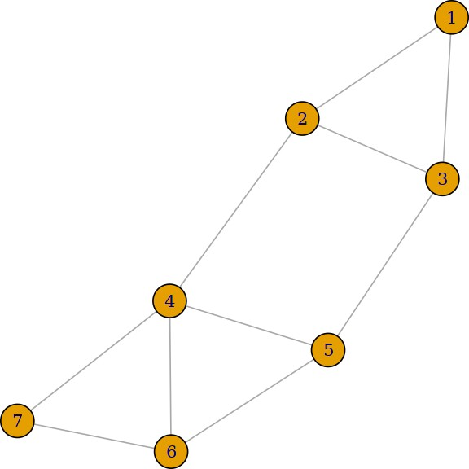

[4]:

[5]:

### 1)no of edges

ecount(g)

10

### 2)no of nodes

vcount(g)

7

[6]:

[7]:

### 3)Degree Of nodes

degree(g)

**1** 2 **2** 3 **3** 3 **4** 4 **5** 3 **6** 3 **7** 2

[8]:

dg <- graph.formula(1-+2, 1-+3, 2++3)

plot(dg)

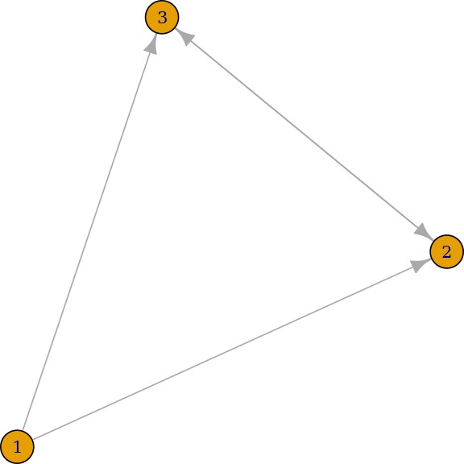

[9]:

degree(dg, mode="in")

**1** 0 **2** 2 **3** 2

[10]:

[11]:

[12]:

[13]:

[14]:

[15]:

degree(dg, mode="out")

**1** 2 **2** 1 **3** 1

### 4) a) Node with lowest degree

V(dg)$name[degree(dg)==min(degree(dg))]

’1’

### 4) b) Node with lowest degree

V(dg)$name[degree(dg)==max(degree(dg))]

1. ’2’ 2. ’3’

### 5) To find neighbours / adjacency list:

neighbors(g,5)

+ 3/7 vertices, named, from 881bcb9: [1] 3 4 6

get.adjlist(dg)

$`1`

+ 2/3 vertices, named, from d90acba: [1] 2 3

$`2`

+ 3/3 vertices, named, from d90acba: [1] 1 3 3

$`3`

+ 3/3 vertices, named, from d90acba: [1] 1 2 2

### 6)Adjacency Matrix

get.adjacency(g)

7 x 7 sparse Matrix of class "dgCMatrix"

|  |  |  |  |
| --- | --- | --- | --- |
| 1 | 2 | 3 | 4 5 6 7 |
| 1 . | 1 | 1 | . . . . |
| 2 1 | . | 1 | 1 . . . |
| 3 1 | 1 | . | . 1 . . |
| 4 . | 1 | . | . 1 1 1 |
| 5 . | . | 1 | 1 . 1 . |

6 . . . 1 1 . 1

7 . . . 1 . 1 .

# Practical 02

## Aim:

Perform following tasks:

1. View data collection forms and/or import onemode/two-mode datasets;
2. Basic Networks matrices transformations

[1]:

library(igraph)

Attaching package: ‘igraph’

The following objects are masked from ‘package:stats’: decompose, spectrum

The following object is masked from ‘package:base’: union

[2]:

nodes <- read.csv("/kaggle/input/network-analysis-data-from-various-sources/

*‹→*InputFileNodes.csv", header=T, , as.is=T)

[3]:

head(nodes)

A data.frame: 6 × 5

id

media

<chr> <chr>

1 s01

2 s02

3 s03

4 s04

5 s05

6 s06

media.type type.label audience.size

<int> <chr> <int>

NY Times 1 Newspaper 20

Washington Post 1 Newspaper 25

Wall Street Journal 1 Newspaper 30

USA Today 1 Newspaper 32

LA Times 1 Newspaper 20

New York Post 1 Newspaper 50

[4]:

links <- read.csv("/kaggle/input/network-analysis-data-from-various-sources/

*‹→*InputFileEdges.csv", header=T, as.is=T)

[5]:

head(links)

A data.frame: 6 × 4

from to

weight type

<chr> <chr> <int> <chr>

1. s01 s02 10 hyperlink
2. s01 s02 12 hyperlink
3. s01 s03 22 hyperlink
4. s01 s04 21 hyperlink
5. s04 s11 22 mention
6. s05 s15 21 mention

[6]:

net <- graph.data.frame(d=links, vertices=nodes, directed=T)

[7]:

net <- graph.data.frame(d=links, vertices=nodes, directed=T) m=as.matrix(net)

g <- graph.adjacency(m, mode="directed")

*# Get adjacency matrix*

A <- as.matrix(get.adjacency(g)) A

A matrix: 17 × 17 of type dbl

|  |  |  |  |  |  |  |  |  |  |  |  |  |  |  |
| --- | --- | --- | --- | --- | --- | --- | --- | --- | --- | --- | --- | --- | --- | --- |
|  | s01 | s02 | s03 | s04 | s05 | s06 | s07 | s08 | s09 | s10 | s11 | s12 | s13 | s14 |
| s01 | 0 | 2 | 1 | 1 | 0 | 0 | 0 | 0 | 0 | 0 | 0 | 0 | 0 | 0 |
| s02 | 1 | 0 | 1 | 0 | 0 | 0 | 0 | 0 | 1 | 1 | 0 | 0 | 0 | 0 |
| s03 | 1 | 0 | 0 | 1 | 1 | 0 | 0 | 1 | 0 | 1 | 1 | 1 | 0 | 0 |
| s04 | 0 | 0 | 1 | 0 | 0 | 1 | 0 | 0 | 0 | 0 | 1 | 1 | 0 | 0 |
| s05 | 1 | 1 | 0 | 0 | 0 | 0 | 0 | 0 | 1 | 0 | 0 | 0 | 0 | 0 |
| s06 | 0 | 0 | 0 | 0 | 0 | 0 | 0 | 0 | 0 | 0 | 0 | 0 | 0 | 0 |
| s07 | 0 | 0 | 1 | 0 | 0 | 0 | 0 | 1 | 0 | 1 | 0 | 0 | 0 | 1 |
| s08 | 0 | 0 | 1 | 0 | 0 | 0 | 1 | 0 | 2 | 0 | 0 | 0 | 0 | 0 |
| s09 | 0 | 0 | 0 | 0 | 0 | 0 | 0 | 0 | 0 | 1 | 0 | 0 | 0 | 0 |
| s10 | 0 | 0 | 1 | 0 | 0 | 0 | 0 | 0 | 0 | 0 | 0 | 0 | 0 | 0 |
| s11 | 0 | 0 | 0 | 0 | 0 | 0 | 0 | 0 | 0 | 0 | 0 | 0 | 0 | 0 |
| s12 | 0 | 0 | 0 | 0 | 0 | 1 | 0 | 0 | 0 | 0 | 0 | 0 | 1 | 1 |
| s13 | 0 | 0 | 0 | 0 | 0 | 0 | 0 | 0 | 0 | 0 | 0 | 1 | 0 | 0 |
| s14 | 0 | 0 | 0 | 0 | 0 | 0 | 0 | 0 | 0 | 0 | 1 | 0 | 1 | 0 |
| s15 | 2 | 0 | 0 | 1 | 0 | 1 | 0 | 0 | 0 | 0 | 0 | 0 | 0 | 0 |
| s16 | 0 | 0 | 0 | 0 | 0 | 1 | 0 | 0 | 0 | 0 | 0 | 0 | 0 | 0 |
| s17 | 0 | 0 | 0 | 1 | 0 | 0 | 0 | 0 | 0 | 0 | 0 | 0 | 0 | 0 |

[8]:

plot(net)

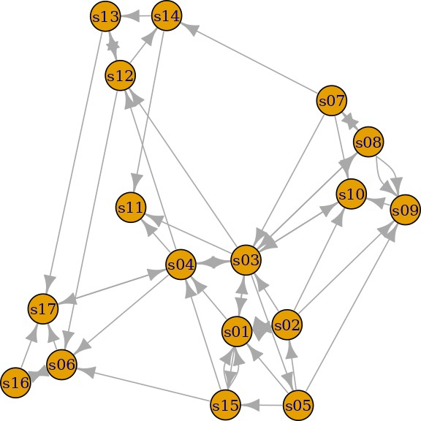

[ ]:

# Practical 03

## Aim:

Compute the following node level measures: (i) Density; (ii) Degree; (iii) Reciprocity; (iv) Tra

[1]:

library(igraph)

Attaching package: ‘igraph’

The following objects are masked from ‘package:stats’: decompose, spectrum

The following object is masked from ‘package:base’: union

### 1)Density

[2]:

g <- graph.formula(1-2, 1-3, 2-3, 2-4, 3-5, 4-5, 4-6,4-7, 5-6, 6-7)

[3]:

nodes <- read.csv("/kaggle/input/network-analysis-data-from-various-sources/

*‹→*InputFileNodes.csv", header=T, , as.is=T)

links <- read.csv("/kaggle/input/network-analysis-data-from-various-sources/

*‹→*InputFileEdges.csv", header=T, as.is=T)

net <- graph.data.frame(d=links, vertices=nodes, directed=T)

[4]:

[5]:

[6]:

[7]:

[8]:

vcount(g)

7

ecount(g)

10

ecount(g)/(vcount(g)*(vcount(g)-1)/2)

0.476190476190476

### 2) Degree

degree(net)

**s01** 10 **s02** 7 **s03** 13 **s04** 9 **s05** 5 **s06** 6 **s07** 5 **s08** 6 **s09** 5 **s10** 5 **s11** 3 **s12** 6 **s13** 4 **s14** 4 **s15** 6

**s16** 3 **s17** 5

### 3)Reciprocity

dg <- graph.formula(1-+2, 1-+3, 2++3) plot(dg)

reciprocity(dg)

0.5

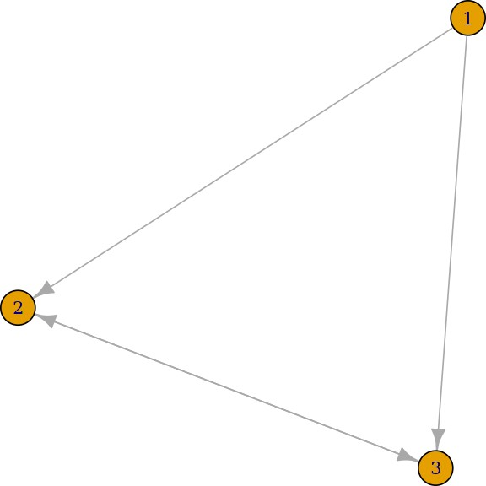

[9]:

[10]:

### Formula

dyad.census(dg)

**$mut** 1

### $asym 2

**$null** 0

2*dyad.census(dg)$mut/ecount(dg)

0.5

### 4)Transitivity

[11]:

kite <- graph.famous("Krackhardt_Kite") atri <- adjacent.triangles(kite) plot(kite, vertex.label=atri)

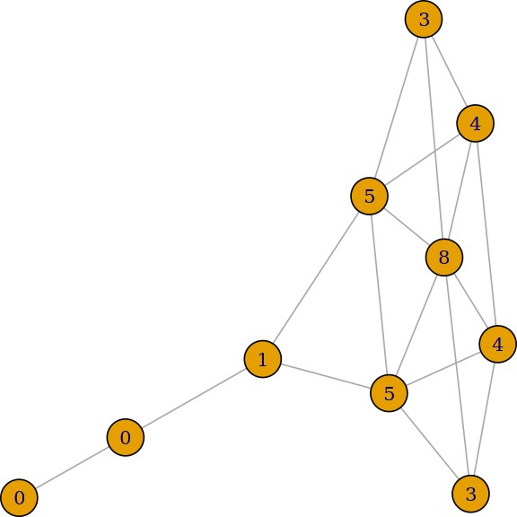

[12]:

[13]:

transitivity(kite, type="local")

1. 0.666666666666667 2. 0.666666666666667 3. 1 4. 0.533333333333333 5. 1 6. 0.5 7. 0.5

8. 0.333333333333333 9. 0 10. NaN

### Formula

adjacent.triangles(kite) / (degree(kite) * (degree(kite)-1)/2)

1. 0.666666666666667 2. 0.666666666666667 3. 1 4. 0.533333333333333 5. 1 6. 0.5 7. 0.5

8. 0.333333333333333 9. 0 10. NaN

[14]:

[15]:

### 5)Centralization

Degree of centrality

centralization.degree(net, mode="in", normalized=T)

**$res** 1. 5 2. 3 3. 6 4. 4 5. 1 6. 4 7. 1 8. 2 9. 4 10. 4 11. 3 12. 3 13. 2 14. 2 15. 2 16. 1 17. 4

**$centralization** 0.1875

**$theoretical_max** 272 Closeness Centralization

closeness(net, mode="all", weights=NA) centralization.closeness(net, mode="all", normalized=T)

[16]:

**s01** 0.0333333333333333 **s02** 0.0303030303030303 **s03** 0.0416666666666667 **s04**

0.0384615384615385 **s05** 0.032258064516129 **s06** 0.03125 **s07** 0.0303030303030303 **s08**

0.0285714285714286 **s09** 0.0256410256410256 **s10** 0.0294117647058824 **s11** 0.032258064516129

**s12** 0.0357142857142857 **s13** 0.027027027027027 **s14** 0.0294117647058824 **s15**

0.0303030303030303 **s16** 0.0222222222222222 **s17** 0.0285714285714286

**$res** 1. 0.533333333333333 2. 0.484848484848485 3. 0.666666666666667 4. 0.615384615384615

5. 0.516129032258065 6. 0.5 7. 0.484848484848485 8. 0.457142857142857 9. 0.41025641025641

10. 0.470588235294118 11. 0.516129032258065 12. 0.571428571428571 13. 0.432432432432432

14. 0.470588235294118 15. 0.484848484848485 16. 0.355555555555556 17. 0.457142857142857

**$centralization** 0.375359630727278

**$theoretical_max** 7.74193548387097 Betweeness Centrality

betweenness(net, directed=T, weights=NA) edge.betweenness(net, directed=T, weights=NA) centralization.betweenness(net, directed=T, normalized=T)

**s01** 26.8571428571429 **s02** 6.23809523809524 **s03** 126.511904761905 **s04** 92.6428571428571 **s05** 13

**s06** 20.3333333333333 **s07** 1.75 **s08** 21 **s09** 1 **s10** 15 **s11** 0 **s12** 33.5 **s13** 20 **s14** 4 **s15**

5.66666666666667 **s16** 0 **s17** 58.5

1. 6.61904761904762 2. 6.61904761904762 3. 11.7857142857143 4. 8.33333333333333 5. 6.5

6. 11.1666666666667 7. 21.3333333333333 8. 4.25 9. 4.25 10. 16 11. 64.4761904761905 12. 9.5

13. 3.26190476190476 14. 3.26190476190476 15. 15 16. 1 17. 15 18. 17 19. 16.75 20. 2 21. 1.25

22. 8 23. 12.5 24. 4 25. 26 26. 18 27. 14.5 28. 17 29. 7.5 30. 4.5 31. 2.73809523809524 32. 23 33. 11

34. 31 35. 9.01190476190476 36. 18 37. 28.5 38. 3 39. 6.5 40. 17 41. 8.66666666666667 42. 74.5

43. 11.75 44. 34 45. 4.5 46. 6.33333333333333 47. 8.80952380952381 48. 5.33333333333333 49. 3

50. 28 51. 10

[17]:

**$res** 1. 26.8571428571429 2. 6.23809523809524 3. 126.511904761905 4. 92.6428571428571 5. 13

6. 20.3333333333333 7. 1.75 8. 21 9. 1 10. 15 11. 0 12. 33.5 13. 20 14. 4 15. 5.66666666666667

16. 0 17. 58.5

**$centralization** 0.443932911706349

**$theoretical_max** 3840 Eigenvector centrality

centralization.evcent(net, directed=T, normalized=T)

**$vector** 1. 0.777185829200523 2. 0.569523129226997 3. 1 4. 0.821414404772152

5. 0.306115118060718 6. 0.605185074708371 7. 0.103395270890436 8. 0.337765973616263

9. 0.47483664722783 10. 0.657460289883597 11. 0.627101587234399 12. 0.638699752169925

13. 0.265054751720928 14. 0.227166505596393 15. 0.331614797366162 16. 0.185256300592937

17. 0.574550689029643

**$value** 3.26674489758997

### $options $bmat ’I’

**$n** 17

**$which** ’LR’

### $nev 1

**$tol** 0

### $ncv 0

**$ldv** 0

### $ishift 1

**$maxiter** 3000

### $nb 1

**$mode** 1

### $start 1

**$sigma** 0

### $sigmai 0

**$info** 0

### $iter 7

**$nconv** 1

**$numop** 30

### $numopb 0

**$numreo** 20

**$centralization** 0.53110461741892

[18]:

*# let's generate two networks and merge them into one graph.*

g2 <- barabasi.game(50, p=2, directed=F)

g1 <- watts.strogatz.game(1, size=100, nei=5, p=0.05) g <- graph.union(g1,g2)

*#Let's remove multi-edges and loops*

g <- simplify(g) plot(g)

**$theoretical_max** 16

## 6) Clustering

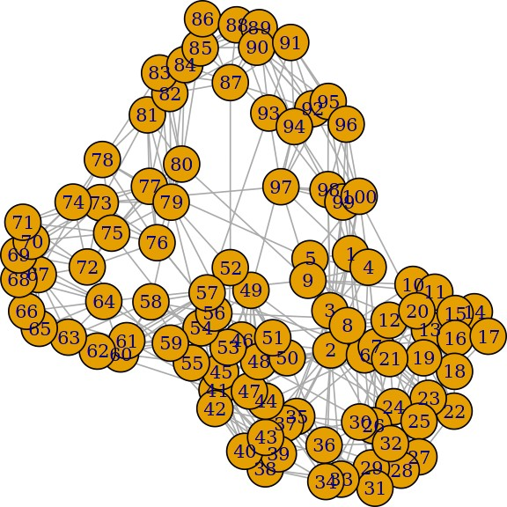

# Practical 04

## Aim:

For a given network find the following: (i) Length of the shortest path from a given node to ano

[1]:

library(igraph)

Attaching package: ‘igraph’

The following objects are masked from ‘package:stats’: decompose, spectrum

The following object is masked from ‘package:base’: union

### (i) Length of the shortest path from a given node to another node;

[2]:

matt <- as.matrix(read.table(text= "node R S T U

R 7 5 0 0

S 7 0 0 2

T 0 6 0 0

U 4 0 1 0", header=T))

[3]:

nms <- matt[,1 ]

matt <- matt[, -1]

colnames(matt) <- rownames(matt) <- nms matt[is.na(matt)] <- 0

g <- graph.adjacency(matt, weighted=TRUE) plot(g)

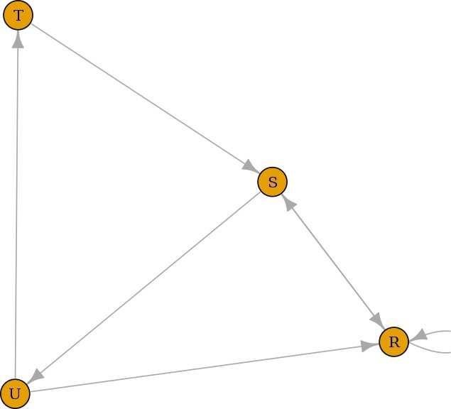

[4]:

s.paths <- shortest.paths(g, algorithm = "dijkstra") print(s.paths)

|  |  |  |  |
| --- | --- | --- | --- |
| R | S | T | U |
| R 0 | 5 | 5 | 4 |
| S 5 | 0 | 3 | 2 |
| T 5 | 3 | 0 | 1 |
| U 4 | 2 | 1 | 0 |

[5]:

shortest.paths(g, v="R", to="S")

A matrix: 1 × 1 of type dbl

S

R 5

[6]:

plot(g, edge.label=E(g)$weight)

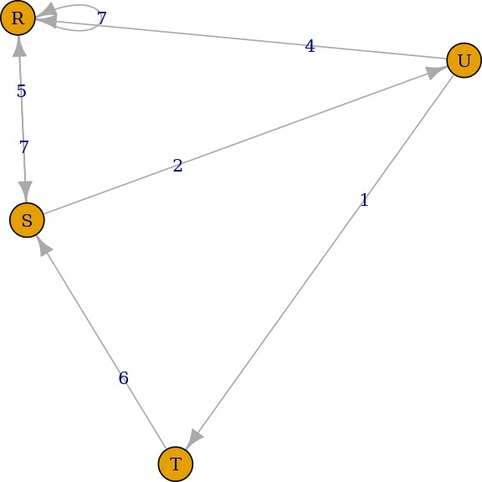

### (ii) the density of the graph

[7]:

dg <- graph.formula(1-+2, 1-+3, 2++3) plot(dg)

graph.density(dg, loops=TRUE)

0.444444444444444

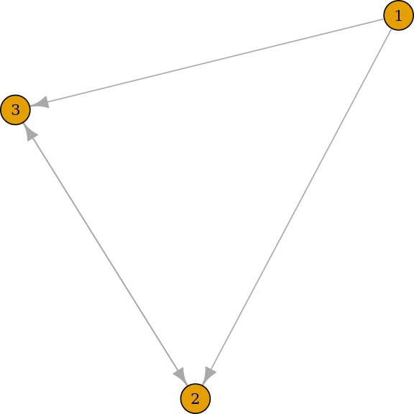

[8]:

[1]:

graph.density(simplify(dg), loops=FALSE)

0.666666666666667

# Practical 05

## Aim:

Write a program to distinguish between a network as a matrix, a network as an edge list, and a 1)a network as a sociogram (or “network graph”)

library(igraph)

Attaching package: ‘igraph’

The following objects are masked from ‘package:stats’: decompose, spectrum

The following object is masked from ‘package:base’: union

### (i) Length of the shortest path from a given node to another node;

[2]: ng<-graph.

*‹→*formula(Andy++Garth,Garth-+Bill,Bill-+Elena,Elena++Frank,Carol-+Andy,Carol-+Elena,Carol++Dan,

[3]:

plot(ng)

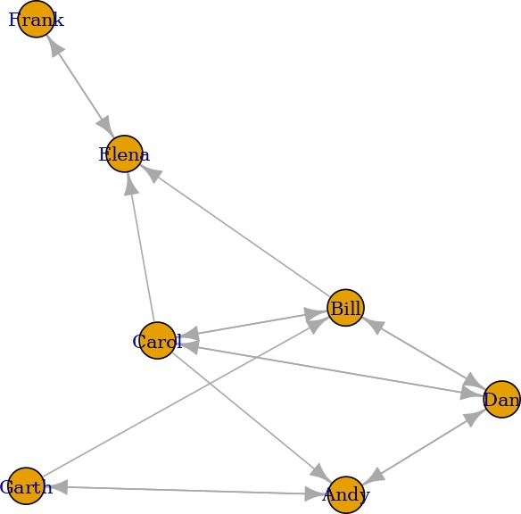

[4]:

2) a network as a matrix,

get.adjacency(ng)

7 x 7 sparse Matrix of class "dgCMatrix" Andy Garth Bill Elena Frank Carol Dan

Andy . 1 1

Garth 1 . 1 . . . .

Bill . . . 1 . 1 1

|  |  |  |  |  |  |
| --- | --- | --- | --- | --- | --- |
| Elena . . . | | . | 1 | . . | |
| Frank . . . | | 1 | . | . . | |
| Carol | 1 . 1 | 1 . . | | | 1 |
| Dan | 1 . 1 | . . 1 | | | . |

[5]:

[6]:

iii) a network as an edge list.

E(ng)

+ 16/16 edges from 9022c9b (vertex names):

[1] Andy ->Garth Andy ->Dan Garth->Andy Garth->Bill Bill ->Elena

[6] Bill ->Carol Bill ->Dan Elena->Frank Frank->Elena Carol->Andy

[11] Carol->Bill Carol->Elena Carol->Dan Dan ->Andy Dan ->Bill

[16] Dan ->Carol

get.adjedgelist(ng,mode="in")

$Andy

+ 3/16 edges from 9022c9b (vertex names):

[1] Garth->Andy Carol->Andy Dan ->Andy

$Garth

+ 1/16 edge from 9022c9b (vertex names):

[1] Andy->Garth

$Bill

+ 3/16 edges from 9022c9b (vertex names):

[1] Garth->Bill Carol->Bill Dan ->Bill

$Elena

+ 3/16 edges from 9022c9b (vertex names):

[1] Bill ->Elena Frank->Elena Carol->Elena

$Frank

+ 1/16 edge from 9022c9b (vertex names):

[1] Elena->Frank

$Carol

+ 2/16 edges from 9022c9b (vertex names):

[1] Bill->Carol Dan ->Carol

$Dan

+ 3/16 edges from 9022c9b (vertex names):

[1] Andy ->Dan Bill ->Dan Carol->Dan

# Practical 05

## Aim:

Write a program to distinguish between a network as a matrix, a network as an edge list, and a 1)a network as a sociogram (or “network graph”)

[1]:

install.packages("sna") install.packages("network")

Installing package into ‘/usr/local/lib/R/site-library’ (as ‘lib’ is unspecified)

Installing package into ‘/usr/local/lib/R/site-library’ (as ‘lib’ is unspecified)

[4]:

library(sna) library(igraph)

### (i) i) structural equivalence

[6]:

links2 <- read.csv("/kaggle/input/sna-edges/edges1.csv", header=T, row.names=1) eq<-equiv.clust(links2)

plot(eq)

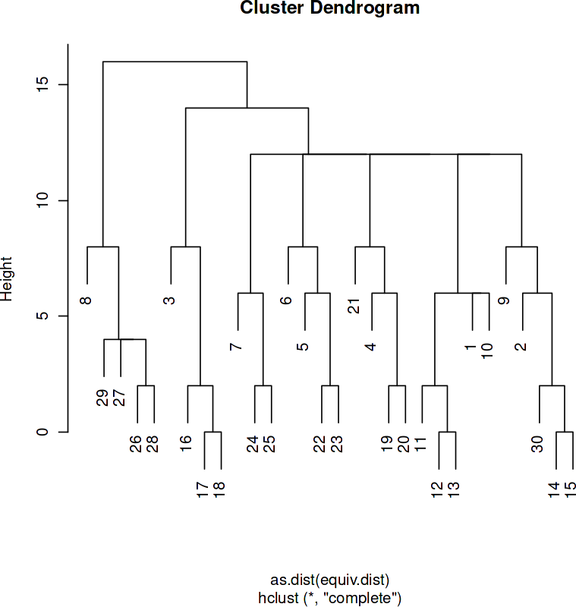

[7]:

g.se<-sedist(links2)

*#Plot a metric MDS of vertex positions in two dimensions*

plot(cmdscale(as.dist(g.se)))

## ii) automorphic equivalence,

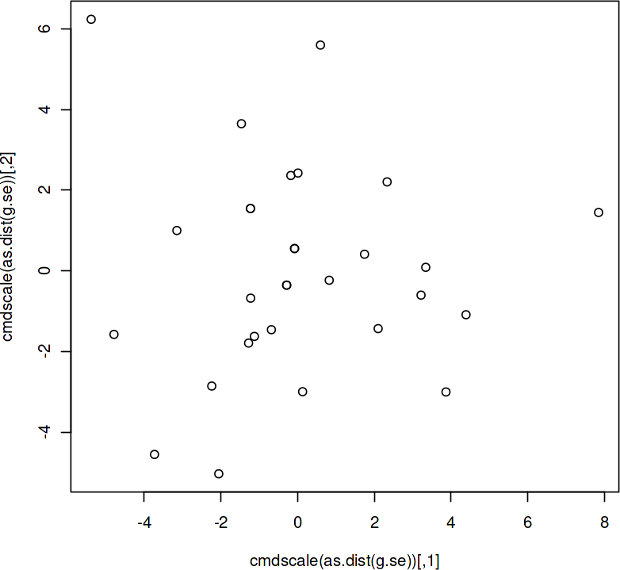

[8]:

## 3) regular equivalence from a network.

Blockmodeling

b<-blockmodel(links2,eq,h=10) plot(b)

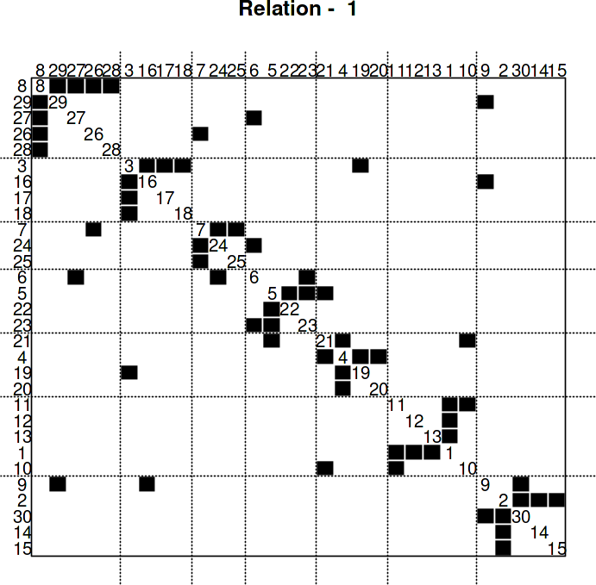

# Practical 07

## Aim:

Create sociograms for the persons-by-persons network and the committee-bycommittee network for a

[1]:

library(igraph)

Attaching package: ‘igraph’

The following objects are masked from ‘package:stats’:

decompose, spectrum

The following object is masked from ‘package:base’: union

[2]:

*# Create sample data for data_Network_1*

data_Network_1 <- data.frame(

Source = c(1, 1, 2, 2, 2, 2, 2, 3, 3, 3),

Target = c(2, 3, 1, 3, 4, 5, 6, 2, 4, 5)

)

*# Create graph object*

g <- graph_from_data_frame(data_Network_1, directed = TRUE)

[3]:

*# Set binary code for edges to be displayed*

bytes <- "00111111111000000000"

*# Extract edges based on binary code*

edges <- which(strsplit(bytes, "")[[1]] == "1")

*# Get layout for visualization*

layout <- layout_with_kk(g)

[4]:

library(dplyr)

*# Plot sociogram*

plot(g, layout = layout, edge.color = if_else(E(g)$id %in% edges, "red", "gray"))

Attaching package: ‘dplyr’

The following objects are masked from ‘package:igraph’: as_data_frame, groups, union

The following objects are masked from ‘package:stats’: filter, lag

The following objects are masked from ‘package:base’:

intersect, setdiff, setequal, union

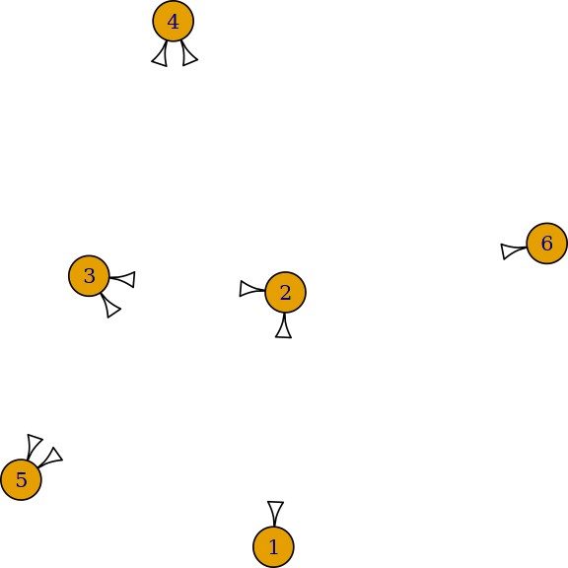

[ ]:

# Practical 08

## Aim:

Perform SVD analysis of a network.

[1]:

library(igraph)

Attaching package: ‘igraph’

The following objects are masked from ‘package:stats’: decompose, spectrum

The following object is masked from ‘package:base’: union

[2]:

a <- matrix(c(1, 1, 1, 1, 1, 1, 1, 1, 1, 1, 1, 1, 0, 0, 0, 0, 0,

0, 0, 0, 0, 1, 1, 1, 0, 0, 0, 0, 0, 0, 0, 0, 0, 1, 1, 1), 9, 4)

[3]:

print(a)

|  |  |  |  |  |
| --- | --- | --- | --- | --- |
|  | [,1] | [,2] | [,3] | [,4] |
| [1,] | 1 | 1 | 0 | 0 |
| [2,] | 1 | 1 | 0 | 0 |
| [3,] | 1 | 1 | 0 | 0 |
| [4,] | 1 | 0 | 1 | 0 |
| [5,] | 1 | 0 | 1 | 0 |
| [6,] | 1 | 0 | 1 | 0 |
| [7,] | 1 | 0 | 0 | 1 |
| [8,] | 1 | 0 | 0 | 1 |
| [9,] | 1 | 0 | 0 | 1 |

[4]:

svd(a)

**$d** 1. 3.46410161513775 2. 1.73205080756888 3. 1.73205080756888 4. 1.35973995551052e-16

-0.3333333 0.4714045 -3.202997e-16 3.693981e-01

-0.3333333 0.4714045 -3.415341e-16 4.459029e-01

-0.3333333 0.4714045 8.520300e-18 -8.153010e-01

-0.3333333 -0.2357023 -4.082483e-01 7.849070e-17

**$u** A matrix: 9 × 4 of type dbl

-0.3333333 -0.2357023 -4.082483e-01 1.340019e-16

-0.3333333 -0.2357023 -4.082483e-01 1.340019e-16

-0.3333333 -0.2357023 4.082483e-01 1.182076e-16

-0.3333333 -0.2357023 4.082483e-01 1.182076e-16

-0.3333333 -0.2357023 4.082483e-01 1.182076e-16

[ ]:

**$v** A matrix: 4 × 4 of type dbl

-0.8660254 0.0000000 -4.378026e-17 0.5

-0.2886751 0.8164966 -2.509507e-16 -0.5

-0.2886751 -0.4082483 -7.071068e-01 -0.5

-0.2886751 -0.4082483 7.071068e-01 -0.5