**PROJECT SYNOPSIS**

**of**

**SIGN LANGUAGE DETECTION AND RECOGNITION SYSTEM**

*Submitted in the partial fulfillment of Bachelor of Technology*

*in*

*Computer Science and Engineering*

Submitted by

**Yash Raj Suman 161/21**

Under the guidance

of

**Mr. Vishwa Mitter**

At

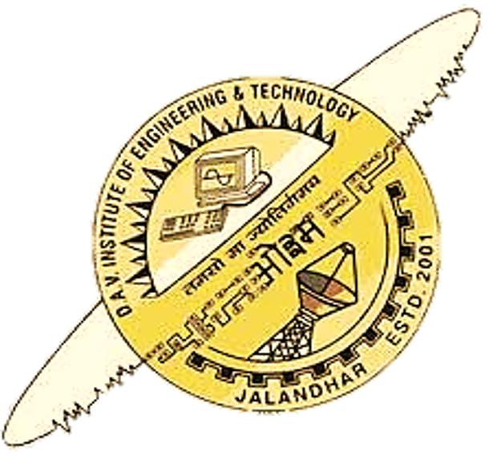

**DAV Institute of Engineering & Technology, Jalandhar**

(2021-2025)

**TIME FRAME REQUIRED FOR VARIOUS STAGES OF PROJECT IMPLEMENTATION**

|  |  |  |
| --- | --- | --- |
| **Sr. No.** | **PHASES** | **TIME DURATION** |
| 1. | Software Requirement Specification | 1 week |
| 2. | System Design | 2 weeks |
| 3. | Coding and Implementation | 4 weeks |
| 4. | Deployment and Testing | 2 weeks |

**INTRODUCTION**

The Sign Language Detection and Recognition project aims to develop a system that can accurately recognize and interpret sign language gestures. This system will have applications in improving communication accessibility for the hearing-impaired community and facilitating real-time translation of sign language into text or speech.

**Needs of Sign Language Detection and Recognition:**

**1. Accessibility for the Deaf and Hard of Hearing:** Sign language detection and recognition systems improve accessibility for individuals who rely on sign language as their primary mode of communication.

**2.** **Inclusive Communication Platforms:** By integrating sign language recognition into communication platforms, such as video conferencing tools and messaging apps, the project promotes inclusive communication for all users.

**3. Education and Learning Support:** Sign language detection and recognition tools enhance learning experiences for students with hearing impairments by providing real-time translation of sign language into text or speech.

**Block Diagram of Sign Language Detection and Recognition:**

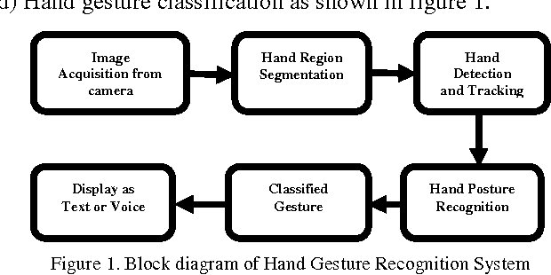

**OBJECTIVE OF PROJECT:**

1. **Develop a System:** Design and implement a robust system capable of detecting and recognizing sign language gestures accurately.
2. **Real-Time Translation:** Provide real-time translation of sign language gestures into text or speech, enabling seamless communication in various contexts.
3. **Improve Communication:** Enhance communication accessibility for individuals who use sign language as their primary mode of communication.
4. **User-Friendly Interface:** Create a user-friendly interface that allows users to input sign language gestures easily through webcam or image upload.

**SCOPE OF PROJECT:**

The sign language detection and recognition project aim to develop a comprehensive system that enhances communication accessibility for individuals using sign language. It involves collecting and preprocessing a diverse dataset of sign language gestures, training machine learning models for accurate gesture recognition, and implementing real-time translation capabilities. The project also focuses on user-friendly interface design, rigorous evaluation, and testing for usability and effectiveness. Deployment on suitable platforms and integration with communication tools are part of the scope, ensuring widespread accessibility and continuous improvement based on user feedback. Overall, the project seeks to empower individuals with hearing impairments, promote social inclusion, and facilitate seamless interaction in diverse environments.

**TOOLS AND TECHNOLOGIES:**

**1. Programming Languages:** Python is commonly used for its versatility and extensive libraries for machine learning and computer vision tasks.

**2. Libraries and Frameworks:**

* OpenCV for image and video processing, including gesture detection and tracking.
* Mediapipe for hand tracking and pose estimation, providing robust features for detecting hand gestures in sign language.
* TensorFlow for developing and training deep learning models for sign language recognition.
* Scikit-learn for traditional machine learning algorithms and model evaluation.
* NumPy and Pandas for data manipulation and analysis**.**

**3. Development Environment:** Integrated Development Environments (IDEs) such as PyCharm, Jupyter Notebook, or Visual Studio Code for code development, debugging, and experimentation.

**4.** **User Interface (UI) Design:** Frameworks like PyQt or streamlit for developing the user-friendly interface for gesture input and system interaction.

**5.** **Version Control:** Git and platform like GitHub for version control, collaboration, and code management.