GYM AND FITNESS MANAGMENT

**ABSTRACT**

Physical fitness is to the human body what fine tuning is to an engine. Regular exercise and physical activity promote strong muscles and bones. It improves respiratory, cardiovascular health, and overall health. Staying active can also help you maintain a healthy weight, reduce your risk for type 2 diabetes, heart disease, and reduce your risk for some cancers. Fitness can be described as a condition that helps us look, feel and do our best. Many people join gym to remain physically fit. This website will help people to get registered and choose the

trainer. In this system there are three entity namely Admin, Member and Trainer. Admin can login, Add new members. Admin can also delete the members who left the gym. Admin will add new trainer, Update the information of trainer and delete the trainer. Admin can also modify members data and trainers shift.Members can login using credentials and transfer money online. Trainer can login and mark the attendance of the members.

Modules:

The system comprises of 3 major modules with their sub-modules as follows:

1. Admin:

Login: Admin can login using credentials.

Add member: Admin can add new member.

Delete member: Admin can delete unwanted members.

Add Trainer: New trainer can be added.

Delete trainer: Unwanted trainers can be deleted.

Modify Member Data: Admin will modify data of members.

Modify Trainers Shift: Admin will modify trainers shift.

2. Member:

Login: Member can login using credentials.

Payment: Member can pay money by using electronic transfer.

3. Trainer:

Login: Trainer can login using credentials.

Attendance: Trainer can mark attendance of the members.

Hardware Requirement:

i3 Processor Based Computer or higher

Memory: 1 GB

Hard Drive: 50 GB

Monitor

Internet Connection

Software Requirement:

Windows 7 or higher

Visual Studio

SQL Server

Google Chrome Browser

**OBJECTIVE:**

The primary objective of gym and fitness management is to create a safe, motivating, and efficient environment that helps individuals achieve their health and wellness goals. This multifaceted management approach encompasses several key goals:

* Member Satisfaction: To provide a welcoming and member-centric experience, ensuring high levels of satisfaction among gym and fitness center clients.
* Health and Wellness Promotion: To promote and support the physical and mental well-being of members by offering a range of fitness programs and resources tailored to their needs and aspirations.
* Safety and Compliance: To maintain a safe and secure environment, adhering to health and safety regulations while mitigating potential risks associated with fitness activities and equipment.
* Business Viability: To ensure the financial sustainability of the fitness center through effective business strategies, marketing, and membership retention efforts.
* Staff Development: To invest in the training and professional development of fitness trainers, instructors, and other staff members to deliver high-quality services.
* Facility Maintenance: To keep the gym and fitness facility clean, well-maintained, and equipped with up-to-date, functional exercise machines and equipment.
* Customized Programming: To offer diverse fitness programs, classes, and training options tailored to different fitness levels, interests, and goals.
* Member Retention: To implement strategies that enhance member retention and loyalty through engagement, personalized support, and a sense of community.
* Technological Integration: To leverage technology for member management, data analytics, and marketing to enhance the overall member experience.

**ER DIAGRAM:**

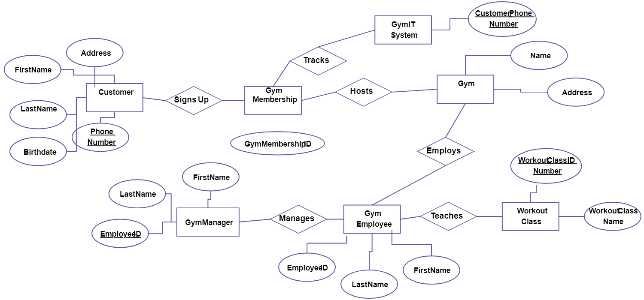

**USE CASE DIAGRAM:**

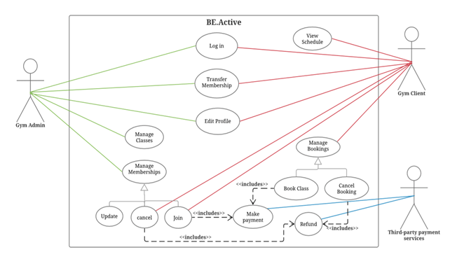

##### **Available Features:**

* Admin Panel
* Customer Panel
* Staff Panel
* Customer Management
* Staff Management
* Customer’s To-Do List
* Reminders
* Gym Announcement
* Gym Equipment Management
* Attendance Management
* Manage Customer’s Progress
* Member’s Account Status
* Notify Customers/Alert
* Payments and Plans
* Payment Receipts
* Download/Print Receipts
* Total Earnings
* Search Records
* Services Report
* Earnings and Expenses Report
* Member’s Report
* Customer’s Progress Report

**LAYOUT:**

