**Polymorphism**

The word polymorphism means having many forms. In simple words, we can define polymorphism as the ability of a message to be displayed in more than one form.

Real World Example:

* A person at the same time can have different characteristics. Like a man at the same time is a father, a husband, an employee. So, the same person possesses different behaviour in different situations. This is called polymorphism.

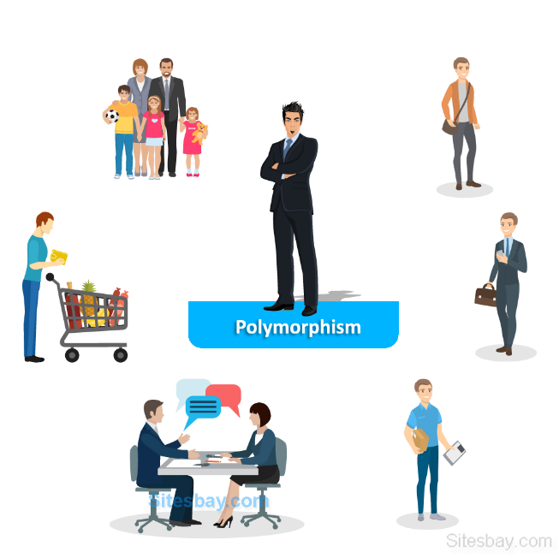Types of Polymorphism:

1. Compile-Time Polymorphism
2. Runtime Polymorphism

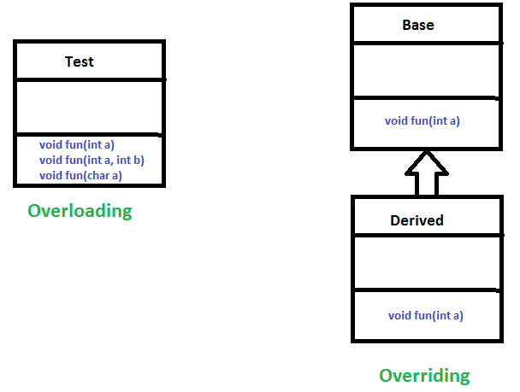

Compile-Time Polymorphism (**Overloading**):

* Static polymorphism
* Function **Overloading**
* When there are multiple functions with the same name but different parameters then these functions are said to be **overloaded**.