ASSIGNMENT – 2

1.Write a SQL query to find the salesperson and customer who reside in the same city. Return Salesman, cust_name and city

ANS: SELECT name,cust_name,salesman.city
FROM salesman
INNER JOIN customer ON salesman.city = customer.city;
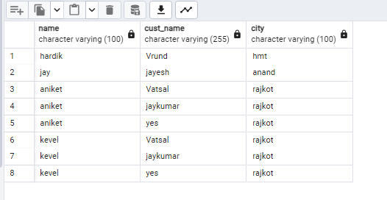

2.Write a SQL query to find those orders where the order amount exists between 500 and 2000. Return ord_no, purch_amt, cust_name, city

ANS: SELECT orders.id,purch_amt,cust_name,customer.city
FROM orders
INNER JOIN customer ON orders.id = customer.id where orders.purch_amt BETWEEN 5000 AND 20000;
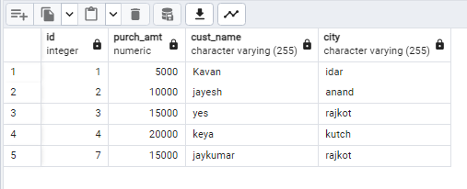

3.Write a SQL query to find the salesperson(s) and the customer(s) he represents. Return Customer Name, city, Salesman, commission

ANS: SELECT name, commission, customer.cust_name,customer.city
FROM salesman
INNER JOIN customer ON salesman.id = customer.id;
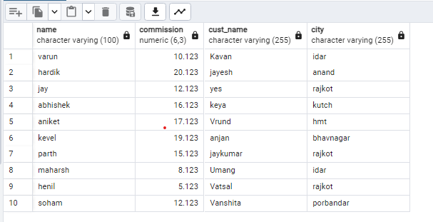
4.Write a SQL query to find salespeople who received commissions of more than 12 percent from the company. Return Customer Name, customer city, Salesman, commission.

ANS: SELECT customer.cust_name,customer.city,name,commission
FROM salesman
INNER JOIN customer ON salesman.id = customer.id WHERE commission>0.12;
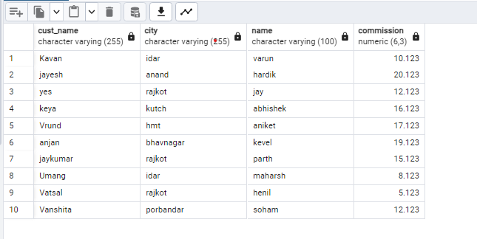
5.Write a SQL query to locate those salespeople who do not live in the same city where their customers live and have received a commission of more than 12% from the company. Return Customer Name, customer city, Salesman, salesman city, commission

ANS: SELECT customer.cust_name, customer.city, name, salesman.city ,commission
FROM salesman
INNER JOIN customer ON salesman.id = customer.id
WHERE (salesman.city <> customer.city) AND commission>0.12;
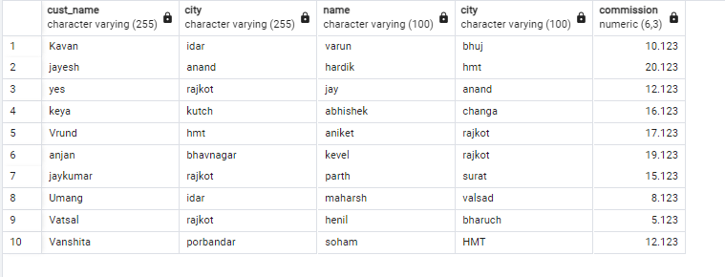
6.Write a SQL query to find the details of an order. Return ord_no, ord_date, purch_amt, Customer Name, grade, Salesman, commission

ANS: SELECT orders.id,ord_date,purch_amt,cust_name,grade,name,commission
FROM orders
INNER JOIN customer ON orders.id = customer.id
INNER JOIN salesman ON orders.id = salesman.id;
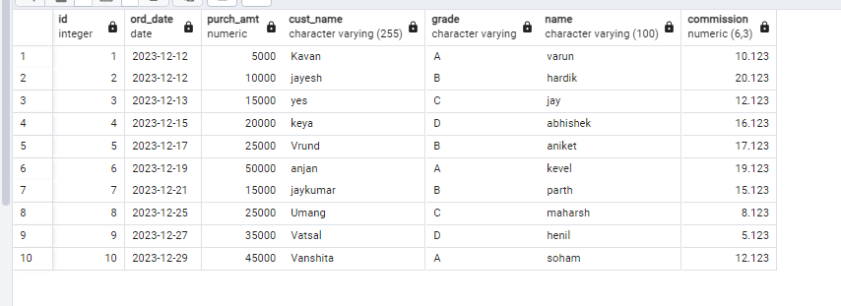

7. Write a SQL statement to join the tables salesman, customer and orders so that the same column of each table appears once and only the relational rows are returned.

ANS: SELECT * FROM orders
NATURAL JOIN (SELECT name,city,commission FROM salesman)
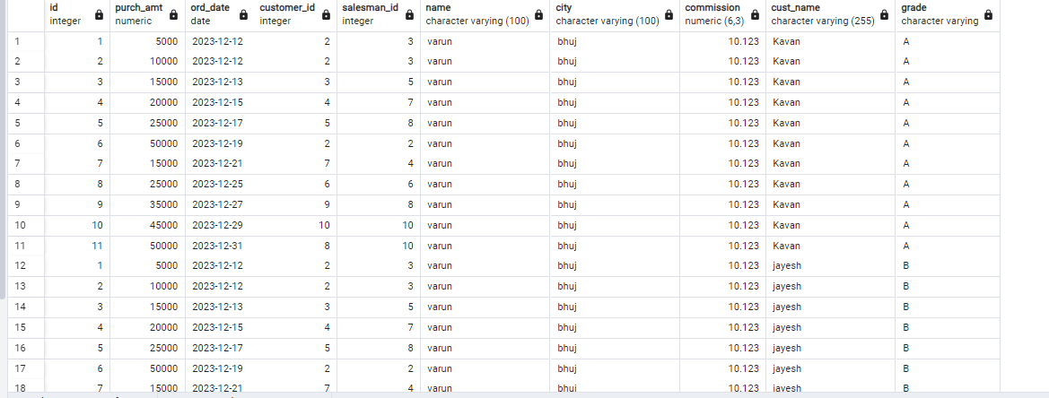
NATURAL JOIN (SELECT cust_name,grade FROM customer);

8.Write a SQL query to display the customer name, customer city, grade, salesman, salesman city. The results should be sorted by ascending customer_id.

ANS: SELECT cust_name,customer.city,grade,salesman.name,salesman.city
FROM customer
LEFT JOIN salesman ON customer.id = salesman.id
ORDER BY customer.id ASC;
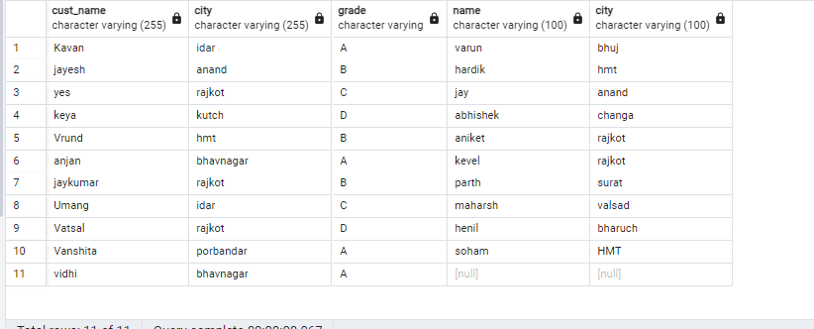
9.Wite a SQL query to find those customers with a grade less than 300. Return cust_name, customer city, grade, Salesman, salesmancity. The result should be ordered by ascending customer_id.

ANS: SELECT cust_name,customer.city,grade,salesman.name,salesman.city
FROM customer
LEFT OUTER JOIN salesman ON salesman.id = customer.id
ORDER BY customer.id;
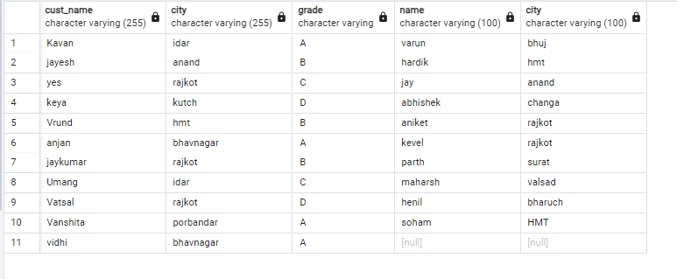

10.Write a SQL statement to make a report with customer name, city, order number, order date, and order amount in ascending order according to the order date to determine whether any of the existing customers have placed an order or not

ANS: SELECT cust_name,customer.city,orders.id,ord_date,purch_amt
FROM customer
LEFT OUTER JOIN orders ON customer.id = orders.id
ORDER BY ord_date;

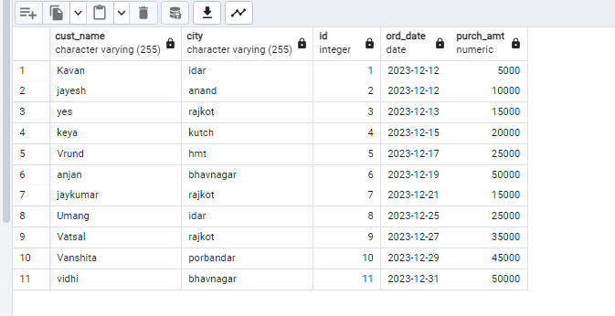

11. Write a SQL statement to generate a report with customer name, city, order number, order date, order amount, salesperson name, and commission to determine if any of the existing customers have not placed orders or if they have placed orders through their salesman or by themselves

ANS: SELECT cust_name,customer.city,orders.id,ord_date,purch_amt,salesman.name,commission
FROM customer
LEFT OUTER JOIN orders ON customer.id = orders.id
LEFT OUTER JOIN salesman ON customer.id = salesman.id;
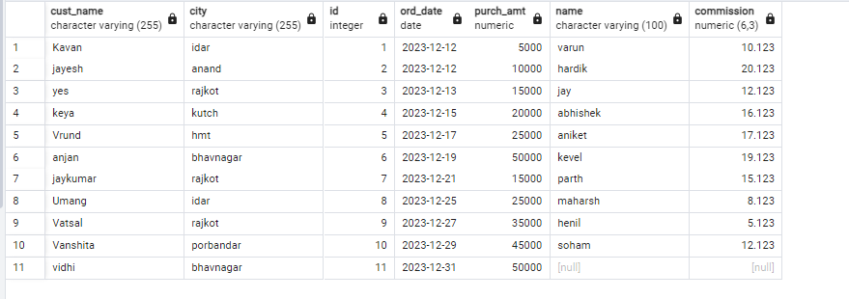

12.Write a SQL statement to generate a list in ascending order of salespersons who work either for one or more customers or have not yet joined any of the customers

ANS: SELECT cust_name,customer.city,grade,salesman.name,salesman.city
FROM customer
RIGHT OUTER JOIN salesman ON customer.id = salesman.id
ORDER BY salesman.id;

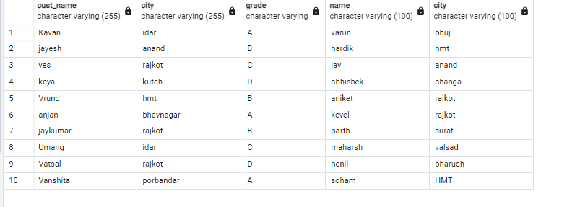
13. write a SQL query to list all salespersons along with customer name, city, grade, order number, date, and amount.

ANS: SELECT salesman.name,cust_name,customer.city,grade,orders.id,ord_date,purch_amt
FROM salesman
INNER JOIN customer ON customer.id=salesman.id
INNER JOIN orders ON salesman.id=orders.id;

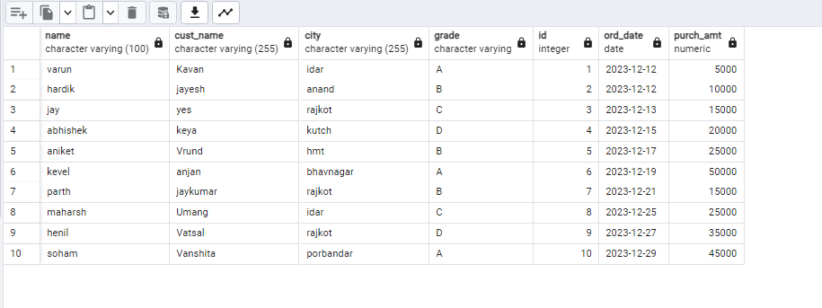

14. Write a SQL statement to make a list for the salesmen who either work for one or more customers or yet to join any of the customers. The customer may have placed, either one or more orders on or above order amount 2000 and must have a grade, or he may not have placed any order to the associated supplier.

ANS : SELECT salesman.name,customer.cust_name,customer.city,grade,orders.id,
ord_date,purch_amt
FROM customer
LEFT OUTER JOIN salesman ON customer.id = salesman.id
RIGHT OUTER JOIN orders ON customer.id = orders.id
WHERE purch_amt>2000 AND grade IS NOT NULL;

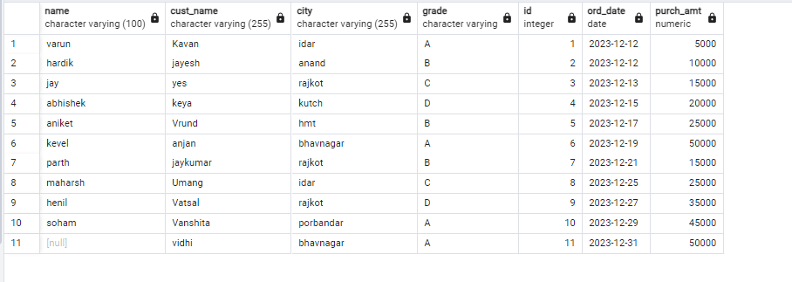

15. Write a SQL statement to generate a list of all the salesmen who either work for one or more customers or have yet to join any of them. The customer may have placed one or more orders at or above order amount 2000, and must have a grade, or he may not have placed any orders to the associated supplier.

ANS: SELECT salesman.name,customer.cust_name,customer.city,grade,
orders.id,ord_date,purch_amt
FROM customer
LEFT OUTER JOIN salesman ON customer.id = salesman.id
RIGHT OUTER JOIN orders ON customer.id = orders.id
WHERE purch_amt>2000 AND grade IS NOT NULL;

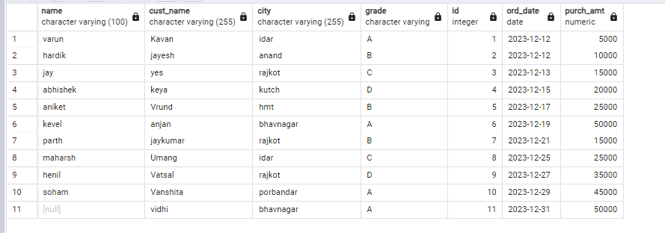

16. Write a SQL statement to generate a report with the customer name, city, order no. order date, purchase amount for only those customers on the list who must have a grade and placed one or more orders or which order(s) have been placed by the customer who neither is on the list nor has a grade.

ANS: SELECT cust_name,customer.city,orders.id,ord_date,purch_amt,grade
FROM customer
INNER JOIN orders ON customer.id = orders.id
WHERE grade IS NOT NULL;

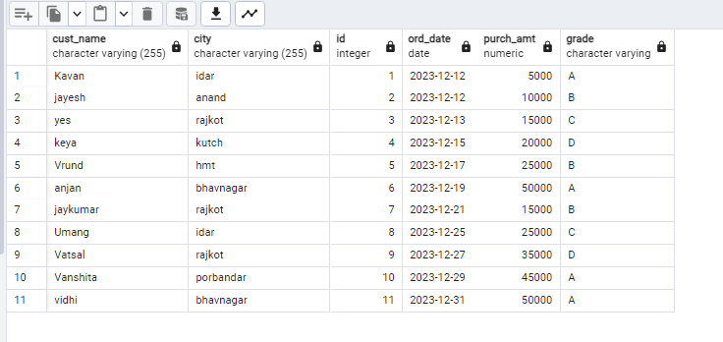
17. Write a SQL query to combine each row of the salesman table with each row of the customer table

ANS: SELECT * FROM salesman CROSS JOIN customer;

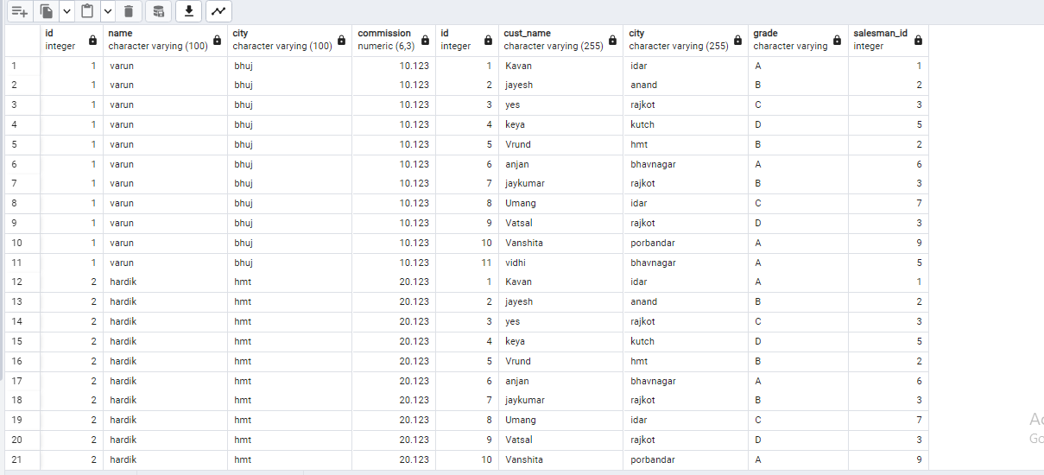

18. Write a SQL statement to create a Cartesian product between salesperson and customer, i.e. each salesperson will appear for all customers and vice versa for that salesperson who belongs to that city

ANS: SELECT * FROM salesman CROSS JOIN customer
WHERE salesman.city IS NOT NULL;

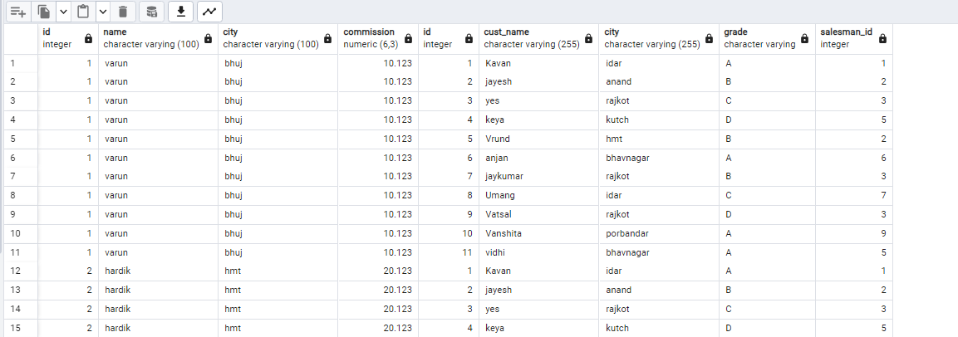

19. Write a SQL statement to create a Cartesian product between salesperson and customer, i.e. each salesperson will appear for every customer and vice versa for those salesmen who belong to a city and customers who require a grade

ANS: SELECT * FROM salesman CROSS JOIN customer
WHERE salesman.city IS NOT NULL AND grade IS NOT NULL;

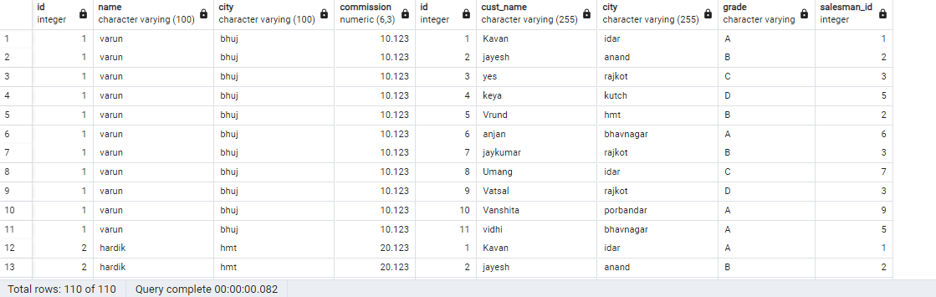

20. Write a SQL statement to make a Cartesian product between salesman and customer i.e. each salesman will appear for all customers and vice versa for those salesmen who must belong to a city which is not the same as his customer and the customers should have their own grade

ANS: SELECT * FROM salesman CROSS JOIN customer
WHERE salesman.city IS NOT NULL
AND grade IS NOT NULL
AND salesman.city <> customer.city;

