Assignment-3

1. write a SQL query to find Employees who have the biggest salary in their Department

ANS: SELECT emp_name,dept_id
FROM Employee
WHERE salary IN (SELECT max(salary) FROM Employee GROUP BY dept_id);
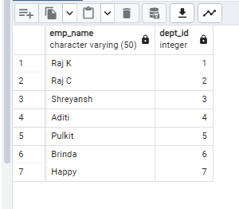

2. write a SQL query to find Departments that have less than 3 people in it

ANS: SELECT Department.id,dept_name
FROM Department
GROUP BY id HAVING COUNT (*) < 3;
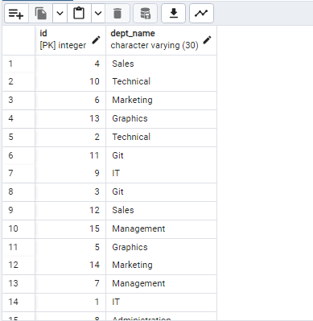

3. write a SQL query to find All Department along with the number of people there

ANS: SELECT id, COUNT(*) FROM Employee
GROUP BY id;

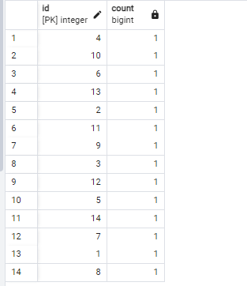

4. write a SQL query to find All Department along with the total salary there

ANS: SELECT dept_id,SUM(salary)
FROM Employee
GROUP BY dept_id;
