Assignment-4

2.write a SQL query to Create Stored procedure in the Northwind database to retrieve Employee Sales by Country

ANS: create or replace FUNCTION sales_by_country(cntry varchar)
returns table(
Country varchar,
last_name varchar,
first_name varchar,
shipped_date date,
order_id smallint
)
AS $$
begin
return query
SELECT
Employees1.Country,
Employees1.Last_Name,
Employees1.First_Name,
Orders1.Shipped_Date,
Orders1.Order_ID

FROM Employees1
INNER JOIN Orders1 ON Employees1.Employee_ID = Orders1.Employee_ID
WHERE employees1.country=cntry;

end;
$$ LANGUAGE plpgsql;

select * from sales_by_country('USA');

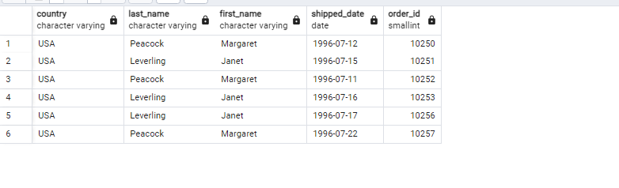
3.write a SQL query to Create Stored procedure in the Northwind database to retrieve Sales by Year

ANS: create or replace FUNCTION sales_by_year2(yr numeric)
returns table(
sale_year numeric,
ship_country varchar
)
AS $$

begin
return query
select
extract(year from shipped_date) as sale_year,
orders1.ship_country
from
orders1
where
extract(year from shipped_date) = yr
order by sale_year;

end;
$$ LANGUAGE plpgsql;

select * from sales_by_year2(1996);

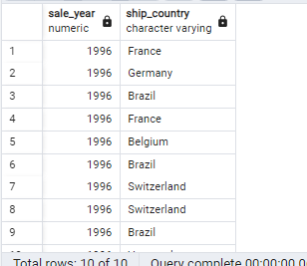

4.write a SQL query to Create Stored procedure in the Northwind database to retrieve Sales By Category

ANS: create or replace FUNCTION sales_by_category1(ctgr varchar)
returns table(
category_name varchar,
description text
)
AS $$
begin
return query
select
categories1.category_name, categories1.description
from
categories1
where
categories1.category_name =ctgr;

end;
$$ LANGUAGE plpgsql;

select * from sales_by_category1('Beverages');
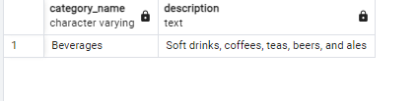

5.write a SQL query to Create Stored procedure in the Northwind database to retrieve Ten Most Expensive Products

ANS: create or replace function Top_Ten_Order1() returns setof products1 as
$BODY$
DECLARE
r products1%rowtype;
BEGIN
for r in
SELECT *FROM products1 ORDER BY unit_price DESC LIMIT 10
LOOP
-- can do some processing here
RETURN NEXT r; -- return current row of SELECT
END LOOP;
RETURN;
END;
$BODY$
LANGUAGE plpgsql;

SELECT * FROM Top_Ten_Order1();

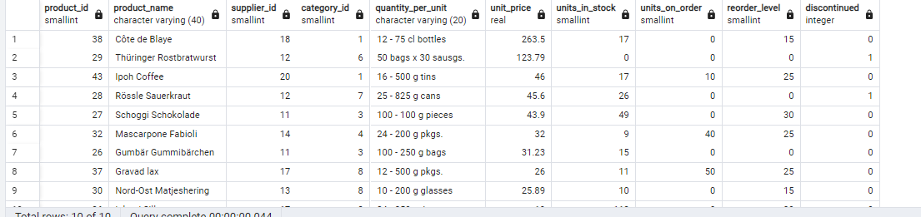
6.write a SQL query to Create Stored procedure in the Northwind database to insert Customer Order Details

ANS: CREATE PROCEDURE insert_order_details(a smallint,b smallint,c real,d smallint,e real )
LANGUAGE SQL
AS $$
INSERT INTO order_details1 VALUES (a,b,c,d,e);
$$;

call insert_order_details(1::smallint, 1::smallint, 1::real, 1::smallint, 0.05::real)
select *from order_details1;

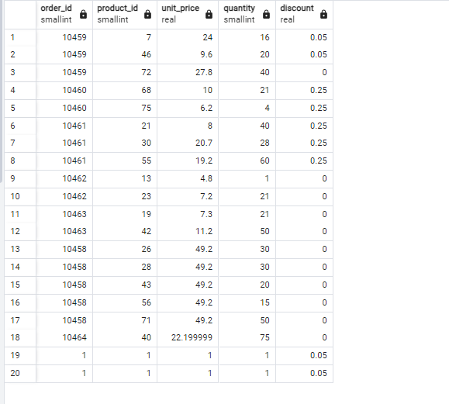

7.write a SQL query to Create Stored procedure in the Northwind database to update Customer Order Details

ANS: create or replace procedure UpdateOrder_details1(
a INT,
b decimal
)
language SQL
as $$
update order_details1
set unit_price = b
where order_id = a;
$$

call UpdateOrder(10458,49.2)
SELECT * FROM order_details1;

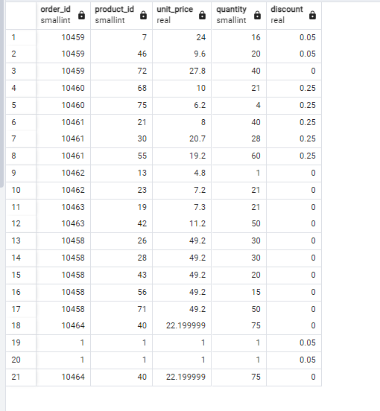
1. Create a stored procedure in the Northwind database that will calculate the average value of Freight for a specified customer.Then, a business rule will be added that will be triggered before every Update and Insert command in the Orders controller,and will use the stored procedure to verify that the Freight does not exceed the average freight. If it does, a message will be displayed and the command will be cancelled.

ANS: CREATE OR REPLACE PROCEDURE insert_orders_with_check(order_id_input int,
customer_id_input character varying,
employee_id_input int,
order_date_input date,
required_date_input date,
shipped_date_input date,
ship_via_input int,
freight_input numeric,
ship_name_input character varying,
ship_address_input character varying,
ship_city_input character varying,
ship_region_input character varying,
ship_postal_code_input int,
ship_country_input character varying)
LANGUAGE plpgsql
AS $$
DECLARE
avg_freight real;
BEGIN
SELECT AVG(orders1.freight) INTO avg_freight
FROM orders1
WHERE orders1.customer_id = insert_orders_with_check.customer_id_input;

IF freight_input > avg_freight THEN
RAISE EXCEPTION 'Freight exceeds average freight for the customer.';
ELSE
INSERT INTO orders1 (order_id,
customer_id,
employee_id,
order_date,
required_date,
shipped_date,
ship_via,
freight,
ship_name,
ship_address,
ship_city,
ship_region,
ship_postal_code,
ship_country)
VALUES (order_id_input,
customer_id_input,
employee_id_input,
order_date_input,
required_date_input,
shipped_date_input,
ship_via_input,
freight_input,
ship_name_input,
ship_address_input,
ship_city_input,
ship_region_input,
ship_postal_code_input,
ship_country_input);
END IF;
END;
$$;

CALL insert_orders_with_check(
10247,
'YASH',
5,
CAST ('2024-01-25' AS DATE),
CAST ('2024-02-05' AS DATE),
CAST ('2024-02-05' AS DATE),
1,
5.00,
'Hanari Carnes',
'Rua do Paço, 67',
'Rio de Janeiro',
'RJ',
05454-876,
'Surat'
);
select * from orders1;

