**Please follow the steps below to launch the course locally:**

1. Download and unzip the package on local drive
2. In the root folder of unzipped folder, locate the 2 files mentioned below:
   1. index_LOCAL_unlocked_Chrome.bat
   2. index_LOCAL_unlocked_Edge.bat

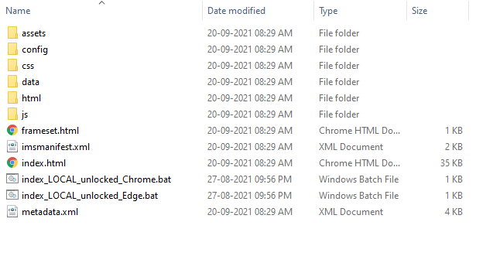

1. Assuming MS Edge and Chrome both are already installed, whichever browser with which you are planning to launch the course, please ensure that all other instances of that browser are closed before proceeding to the next step. This is a mandatory step.

E.g.: If you are going to launch course in MS Edge browser, ensure all other MS edge browser instances are closed. Chrome/IE11 can be open for MS Edge launch.

1. As per your preference, double click any of the .bat files available to launch the course in respective browser.
2. Course popup may get blocked by the popup blocker and you may need to enable the popups to view the course.