Assignment A59
Discrete-Time System Analysis via the Z-Transform
Signals and Systems Project Report

1. Objective
To solve the second-order difference equation y[n] − 0.8y[n−1] + 0.15y[n−2] = x[n] + 0.5x[n−1] for a unit-step input x[n] = u[n] using the Z-transform. The tasks are to find H(z), its partial-fraction expansion, the impulse response h[n] and the total response y[n], and then to split the response into its zero-state (ZSR) and zero-input (ZIR) parts for the initial conditions y[−1] = 1, y[−2] = 0. Finally, the identity total = ZSR + ZIR is verified numerically and plotted.

2. Transfer Function H(z)
With zero initial conditions, taking the Z-transform of both sides gives (1 − 0.8z⁻¹ + 0.15z⁻²)Y(z) = (1 + 0.5z⁻¹)X(z). Hence
H(z) = (1 + 0.5z⁻¹) / (1 − 0.8z⁻¹ + 0.15z⁻²) = z(z + 0.5) / [(z − 0.5)(z − 0.3)]
The denominator factors as z² − 0.8z + 0.15 = (z − 0.5)(z − 0.3), so the poles are at z = 0.5 and z = 0.3 and there is a zero at z = −0.5 (plus one at the origin). Both poles lie inside the unit circle, so the causal system is stable (ROC: |z| > 0.5).

3. Partial Fractions and Impulse Response h[n]
Expanding H(z)/z:
H(z)/z = (z + 0.5)/[(z − 0.5)(z − 0.3)] = A/(z − 0.5) + B/(z − 0.3)
A = (0.5 + 0.5)/(0.5 − 0.3) = 5 and B = (0.3 + 0.5)/(0.3 − 0.5) = −4. Therefore H(z) = 5z/(z − 0.5) − 4z/(z − 0.3), and the inverse transform gives
h[n] = [ 5(0.5)ⁿ − 4(0.3)ⁿ ] u[n]
Check: h[0] = 1 and h[1] = 2.5 − 1.2 = 1.3, which agree with the direct recursion h[1] = 0.8h[0] + 0.5 = 1.3.
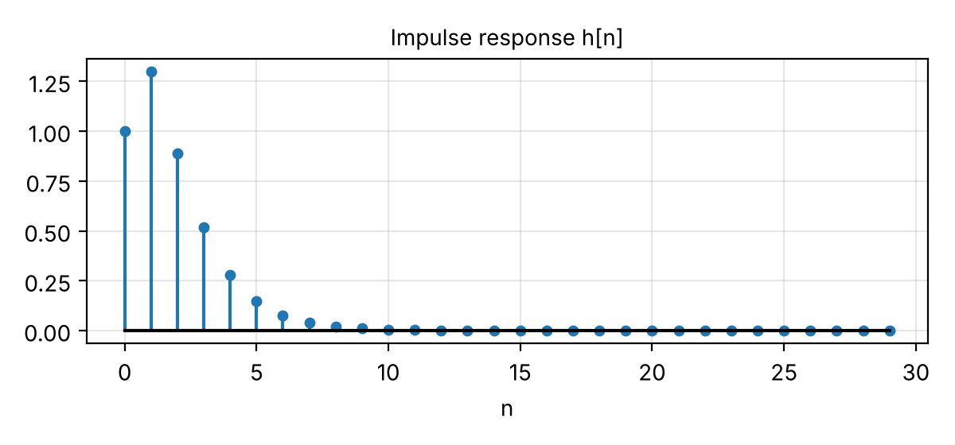
Fig. 1: Impulse response h[n]

4. Zero-State Response (ZSR) to the Unit Step
With all initial conditions zero, Y_zs(z) = H(z)·X(z) and X(z) = z/(z − 1), so
Y_zs(z) = z²(z + 0.5) / [(z − 1)(z − 0.5)(z − 0.3)]
Dividing by z and expanding, the residues are 30/7 at z = 1, −5 at z = 0.5 and 12/7 at z = 0.3. Thus
y_zs[n] = [ 30/7 − 5(0.5)ⁿ + (12/7)(0.3)ⁿ ] u[n]
The first term is the steady-state value H(1) = 1.5/0.35 = 30/7 ≈ 4.2857, and the other two are decaying transients. At n = 0 the value is 30/7 − 5 + 12/7 = 1, as expected.

5. Zero-Input Response (ZIR)
With x[n] = 0 and y[−1] = 1, y[−2] = 0, the unilateral Z-transform shifts are y[n−1] → z⁻¹Y(z) + y[−1] and y[n−2] → z⁻²Y(z) + z⁻¹y[−1] + y[−2]. Collecting the initial-condition terms gives
(1 − 0.8z⁻¹ + 0.15z⁻²) Y_zi(z) = 0.8y[−1] − 0.15z⁻¹y[−1] − 0.15y[−2] = 0.8 − 0.15z⁻¹
Y_zi(z) = z(0.8z − 0.15) / [(z − 0.5)(z − 0.3)]
Partial fractions of Y_zi(z)/z give residues 1.25 at z = 0.5 and −0.45 at z = 0.3, so
y_zi[n] = [ 1.25(0.5)ⁿ − 0.45(0.3)ⁿ ] u[n]
Here y_zi[0] = 0.8, which matches the recursion y_zi[0] = 0.8y[−1] − 0.15y[−2]. The ZIR decays to zero because the system is stable.

6. Total Response y[n] = ZSR + ZIR
Adding the two components,
y[n] = 30/7 − 3.75(0.5)ⁿ + (12/7 − 0.45)(0.3)ⁿ = 30/7 − 3.75(0.5)ⁿ + 1.2643(0.3)ⁿ, n ≥ 0
This is the same as solving the full equation in one step with the initial conditions included (y[0] = 1 + 0 + 0.8 = 1.8, y[1] = 2.79). The step response settles at 30/7 ≈ 4.2857; the initial condition only changes the transient.
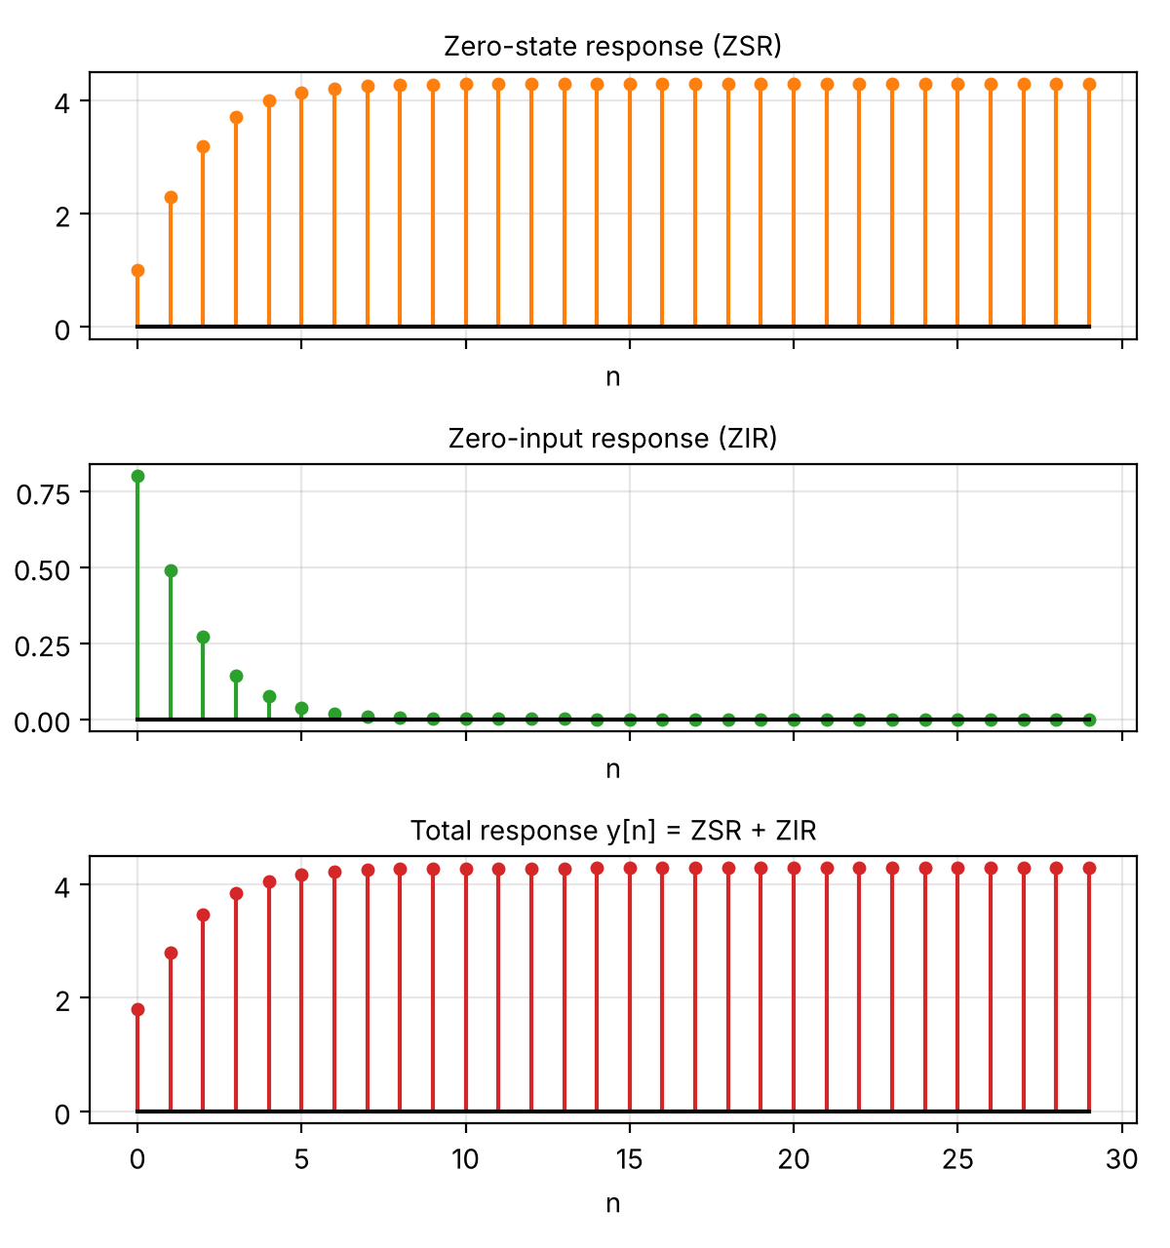
Fig. 2: Zero-state, zero-input and total responses (stem plots, n = 0 to 29)

7. Numerical Verification
The difference equation was iterated directly in Python (NumPy) starting from y[−1] = 1, y[−2] = 0, and the ZSR and ZIR were also computed independently by recursion with the appropriate initial conditions. All three were compared with the closed-form Z-transform results over 30 samples:
n | h[n] | ZSR | ZIR | ZSR+ZIR | Direct y[n]
0 | 1.0000 | 1.0000 | 0.8000 | 1.8000 | 1.8000
1 | 1.3000 | 2.3000 | 0.4900 | 2.7900 | 2.7900
2 | 0.8900 | 3.1900 | 0.2720 | 3.4620 | 3.4620
3 | 0.5170 | 3.7070 | 0.1441 | 3.8511 | 3.8511
4 | 0.2801 | 3.9871 | 0.0745 | 4.0616 | 4.0616
5 | 0.1465 | 4.1336 | 0.0380 | 4.1716 | 4.1716
10 | 0.0049 | 4.2808 | 0.0012 | 4.2821 | 4.2821
20 | 0.0000 | 4.2857 | 0.0000 | 4.2857 | 4.2857
29 | 0.0000 | 4.2857 | 0.0000 | 4.2857 | 4.2857
Table 1: Selected samples
The maximum absolute error between the direct recursion and the sum ZSR + ZIR is about 1.8 × 10⁻¹⁵ (floating-point round-off), and the recursively computed ZSR and ZIR match their analytic forms to the same precision. The total response therefore equals ZSR + ZIR.
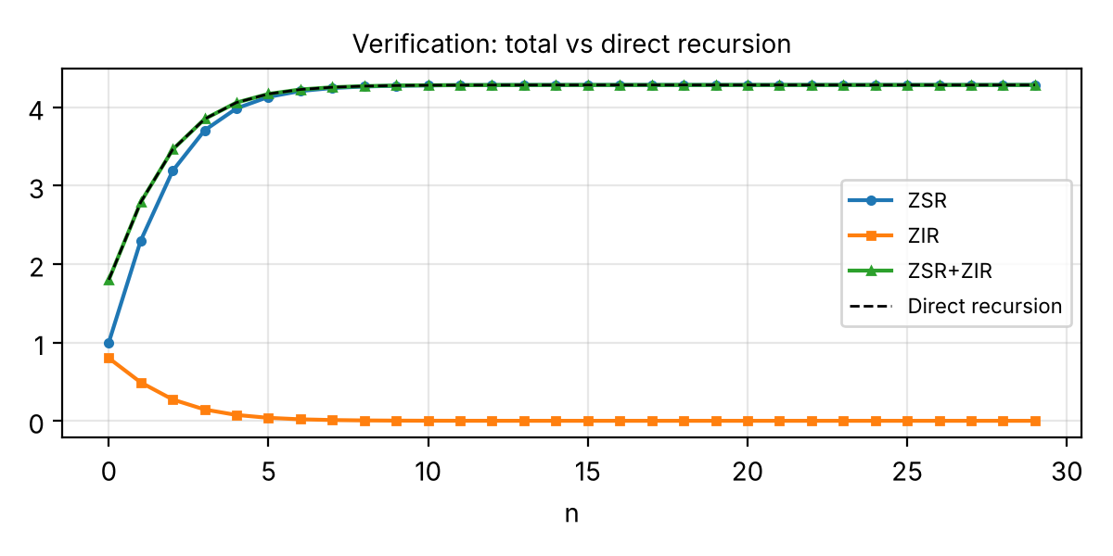
Fig. 3: Direct recursion overlaid on ZSR + ZIR (the curves coincide)

8. MATLAB Code
N = 40;
n = 0:N;

a = [1 -0.8 0.15];
b = [1 0.5];

% H(z) and partial fraction expansion
fprintf('H(z) = (1 + 0.5z^{-1})/(1 - 0.8z^{-1} + 0.15z^{-2})\n');
fprintf('H(z) = 5/(1 - 0.5z^{-1}) - 4/(1 - 0.3z^{-1})\n');
fprintf('h[n] = 5(0.5)^n - 4(0.3)^n, n >= 0\n');

% Zero-state response: x[n] = u[n], zero initial conditions
x = ones(size(n));
zsr = filter(b, a, x);

% Zero-input response with y[-1] = 1 and y[-2] = 0
zir = zeros(size(n));
ym1 = 1;
ym2 = 0;

for k = 1:numel(n)
zir(k) = 0.8 * ym1 - 0.15 * ym2;
ym2 = ym1;
ym1 = zir(k);
end

% Total response with input and specified initial conditions
total_response = zeros(size(n));
ym1 = 1;
ym2 = 0;
xm1 = 0;

for k = 1:numel(n)
total_response(k) = x(k) + 0.5 * xm1 + ...
0.8 * ym1 - 0.15 * ym2;
xm1 = x(k);
ym2 = ym1;
ym1 = total_response(k);
end

% Verification
error = max(abs(total_response - (zsr + zir)));
fprintf('Maximum numerical decomposition error: %.3e\n', error);

% Display initial values
disp(table(n(:), zsr(:), zir(:), total_response(:), ...
'VariableNames', {'n','ZSR','ZIR','TotalResponse'}));

% Plot responses
figure;
plot(n, zsr, 'b', 'LineWidth', 1.5);
hold on;
plot(n, zir, 'r--', 'LineWidth', 1.5);
plot(n, total_response, 'w', 'LineWidth', 1.5);
grid on;
xlabel('n');
ylabel('Amplitude');
legend('ZSR', 'ZIR', 'Total Response', 'Location', 'best');
title('DT System Response Decomposition');

9. Conclusion
The system has poles at 0.5 and 0.3, h[n] = 5(0.5)ⁿ − 4(0.3)ⁿ, and the step response tends to 30/7. The ZSR and ZIR were found separately with the Z-transform, and their sum agrees with the directly computed total response to machine precision.

