High Performance UHF RFID Fixed Reader

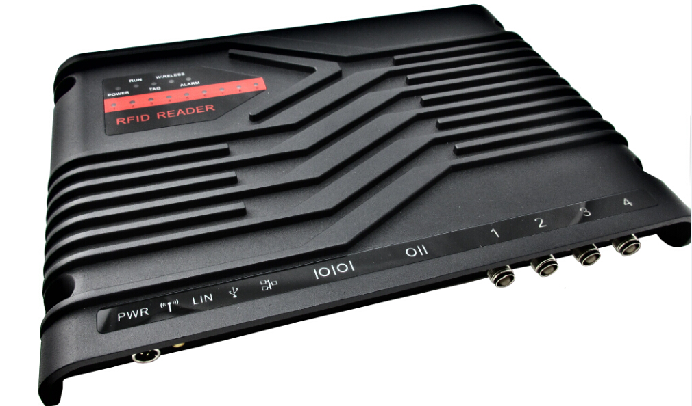

Model：UHFReader288A
Size：310mmx210mmx41mm
GENERAL DESCRIPTION
UHFREADER288A is a high performance UHF RFID fixed reader. It is designed upon fully self-intellectual property. Based on proprietory efficient digital signal processing algorithm, it supports fast tag read/write operation with high identification rate. It can be widely applied in many RFID application systems such as logistics, access control, anti-counterfeit and industrial production process control system.
FEATURES
- Self-intellectual property;
- Designed with Impinj R2000 RFID engine;
- Support ISO18000-6C(EPC C1G2) , ISO18000-6B protocol tag;
- 860~868MHz/902~928MHz frequency band(frequency customization optional);
- FHSS or Fix Frequency transmission;
- RF output power up to 30dbm(adjustable);
- 4 TNC antenna port with antenna auto-tuning and failure-detection;
- Support auto-running, answer, trigger and real-time-inventory work mode;
- Tag buffer size up to 800PCS (Max. 496bits EPC length);
- Support EPC and TID inventory;
- Low power dissipation with single +9 DC power supply;
- Support RS232, RS485, RJ45(TCPIP) with WiFi and POE optional;
- High reliability design;
- Support on-the-site firmware upgrading and optional Wince or Linux Operation System.
CHARACTERISTICS
- Absolute Maximum Rating
ITEM | SYMBOL | VALUE | UNIT
Power Supply | VCC | 16 | V
Operating Temp. | T_{OPR} | -10~+60 | ℃
Storage Temp. | T_{STR} | -20~+75 | ℃

- Electrical and Mechanical Specification
Under T_{A}＝25℃，VCC＝+9V unless specified
ITEM | SYMBOL | MIN | TYP | MAX | UNIT
Power Supply | VCC | 8 | 9 | 12 | V
Current Dissipation | IC |  | 800 | 1500 | mA
Frequency | F_{REQ} | 902 | 902~928 | 928 | MHz
Size | Size |  | 310×210×41 |  | mm

MECHANICAL DATA(UNIT mm)：

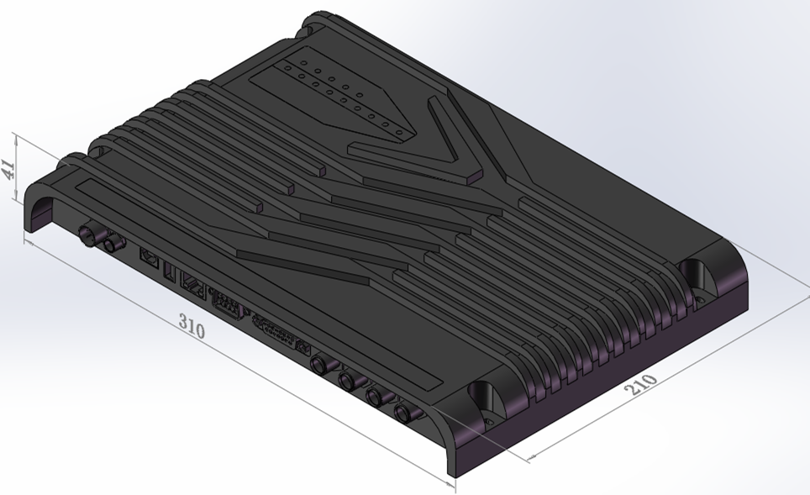

INTERFACE
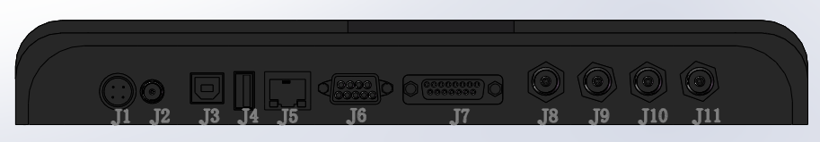

1．Power J1
No. | Symbol | Comment
2 | PWR | +9VDC
4 | GND | Ground
1,3 | NC | Reserved
2．WiFi Antenna J2 (SMA Female)
3. USB J3 (Slave)
4. USB J4 (Reserved)
5. TCPIP RJ45 Socket J5
6. UART J6 (RS232 DB9 Female)
No. | Symbol | Comment
1 | NC | Reserved
2 | TXD | Data output in RS232
3 | RXD | Data input in RS232
4 | NC | Reserved
5 | GND | Ground
6 | NC | Reserved
7 | NC | Reserved
8 | NC | Reserved
9 | NC | Reserved

7. GPIO J7 (DB15 Female)
No. | Symbol | Comment
1 | Output1 | General output1
2 | Output2 | General output2
3 | Output3 | General output3
4 | Output4 | General output4
5 | Input1 | General Intput1 with Internal 47k resistor pulled-down to ground
6 | Input2 | General Intput2 with Internal 47k resistor pulled-down to ground
7 | Input3 | General Intput3 with Internal 47k resistor pulled-down to ground
8 | Input4 | General Intput4 with Internal 47k resistor pulled-down to ground
9 | TGIN | Trigger input with internal 10k resistor pulled-up to +5V
10 | R+ | R+ in RS485
11 | R- | R- in RS485
12 | GND | Ground
13 | NC | Normal-Close terminal of internal relay
14 | NO | Normal-Open terminal of internal relay
15 | CM | Common terminal of internal relay

8．TNC Antenna Port1~Port4 J8~J11

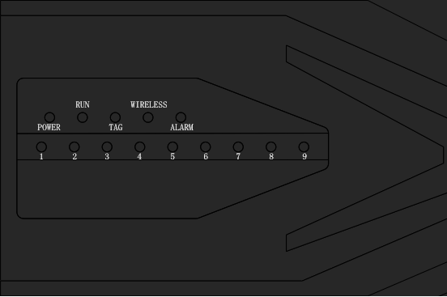
9．LED indicator
Symbol | Comment
POWER | Power on indicator
RUN | Command-executing indicator
TAG | Tag-detected indicator
WIRELESS | WiFi active indicator
ALARM | Alarm indicator
1~9 | RSSI indicator

