1. Medito Re-Designed
- Already Known: Name, Live URL (https://medito-re-designed.vercel.app/), scope, primary UX focus. https://medito-re-designed.vercel.app/
- Need from you:
  - GitHub Repository URL: https://github.com/yashtyagi9306/Medito-Re_Designed
  - Figma File / Prototype URL (if available):
  - Case Study Details (if available):
    - Main problem statement / motivation?
    - Key redesign changes (e.g., navigation, audio player, home screen)?
    - Do you have before vs. after screenshots?
  - Screenshot / Image assets: (Provide images or confirm if I should capture/extract them). 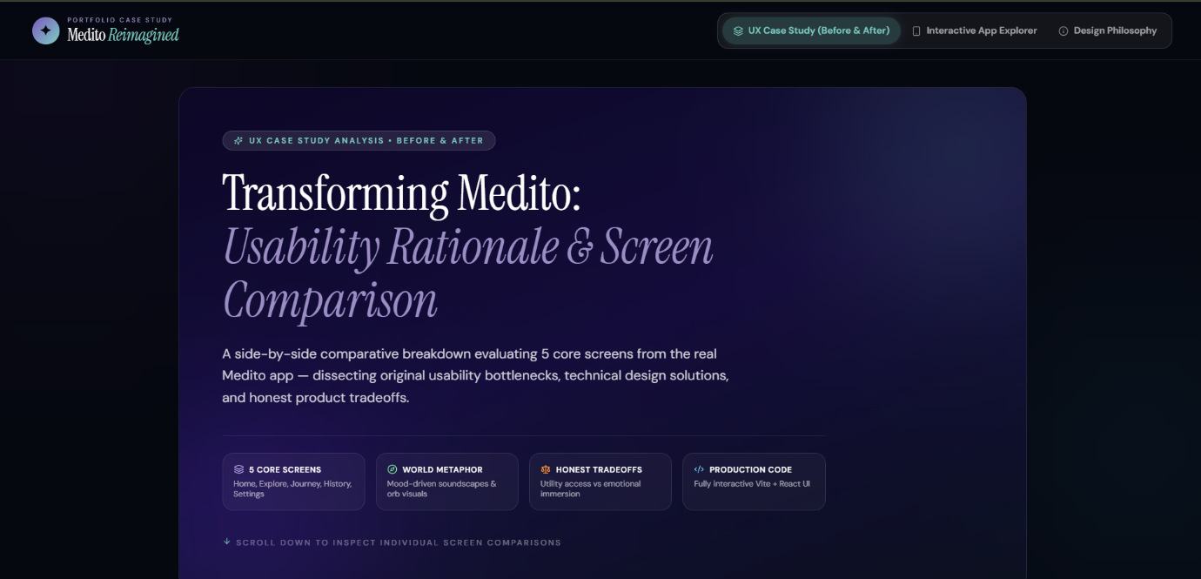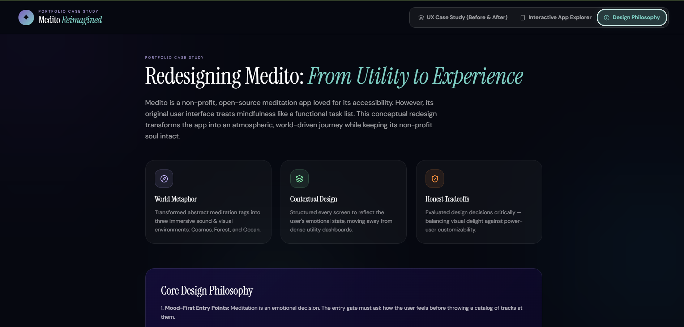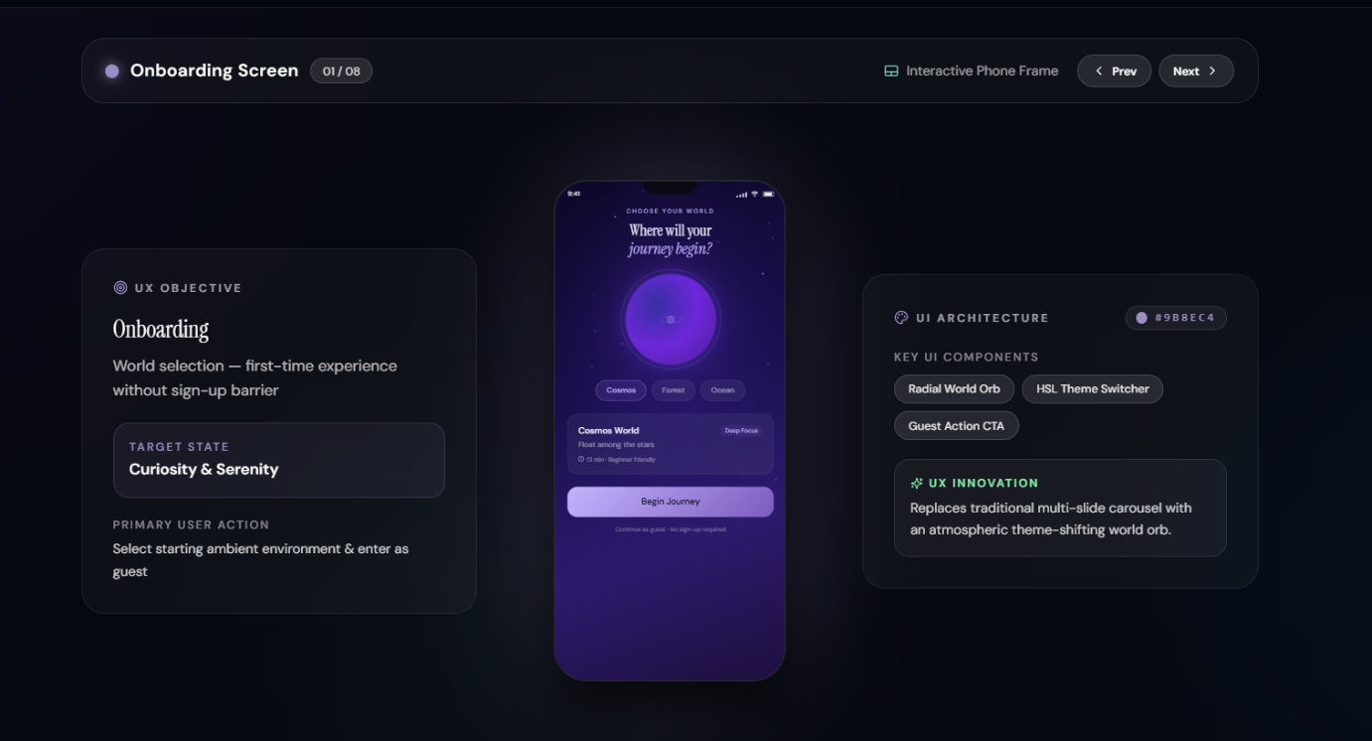

2. Laptop Website
- Already Known: Product showcase, built initially using Lovable AI, published.
- Need from you:
  - GitHub Repository URLhttps://github.com/yashtyagi9306/unveil-your-gear:
  - Production Live URL: https://unveil-your-gear.lovable.app/
  - Key design highlights / features you want emphasized:
  - Screenshot / Image assets: (Provide images or confirm if I should capture/extract them). 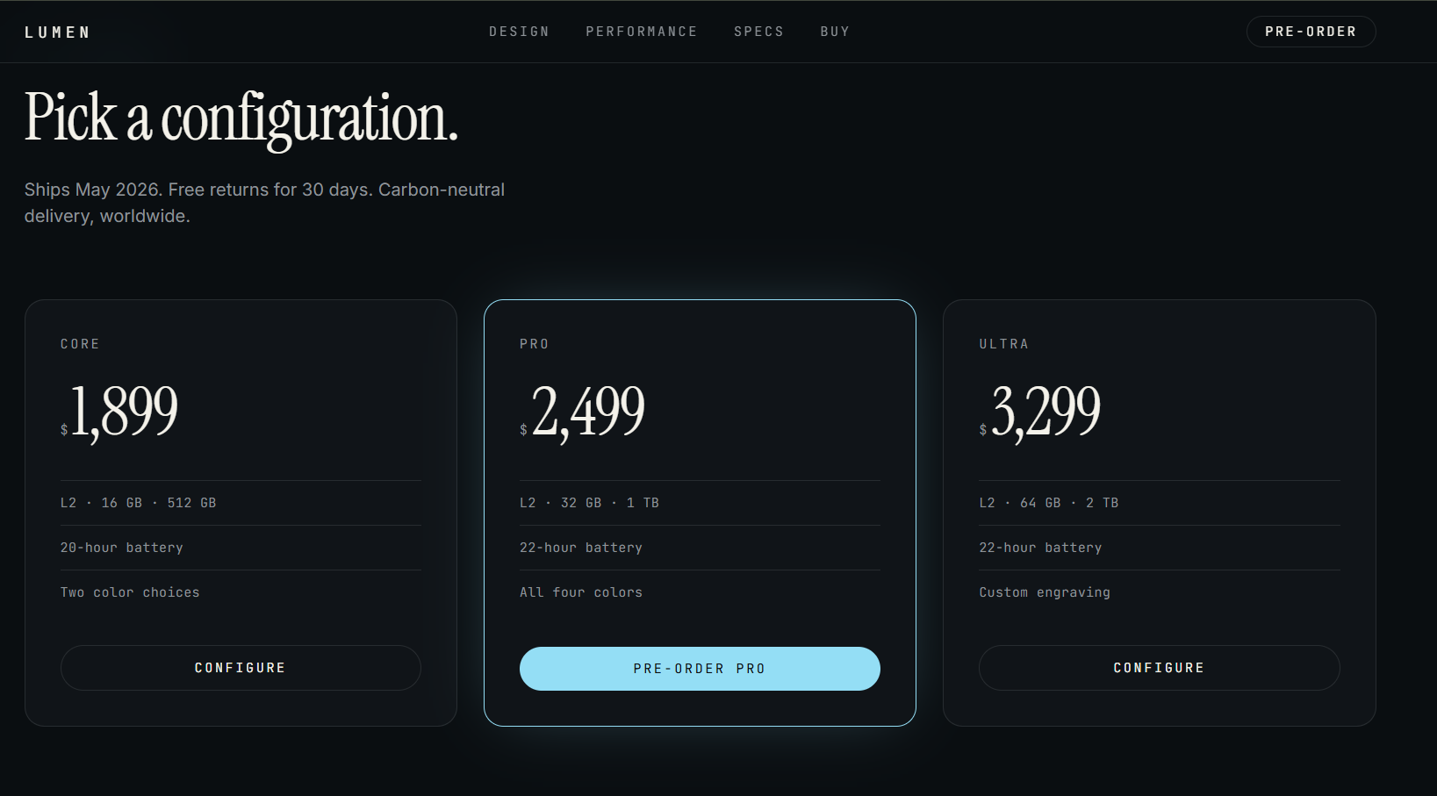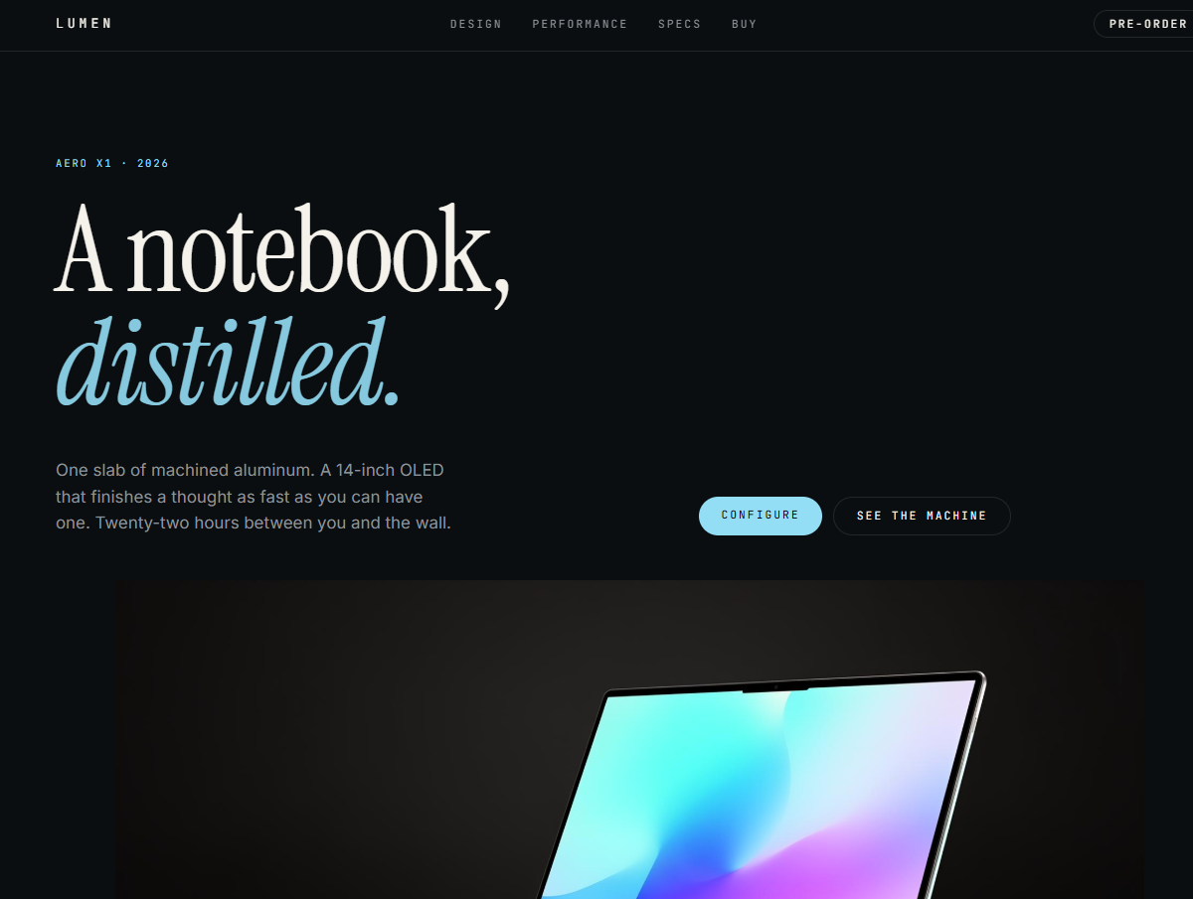

3. Pomodoro Timer
- Already Known: Productivity timer, simple interaction design.
- Need from you:
  - GitHub Repository URL: https://github.com/yashtyagi9306/Pomodoro_Timer
  - Production Live URL: (Which Vercel deployment is the correct production link?) https://pomodoro-timer-pc.vercel.app/
  - Technologies used (e.g., React, Tailwind, HTML5 Audio, LocalStorage)? Tech Stack
  - React 18
  - TypeScript
  - Vite
  - CSS
  - Local Storage

  - Screenshot / Image assets: (Provide images or confirm if I should capture/extract them). 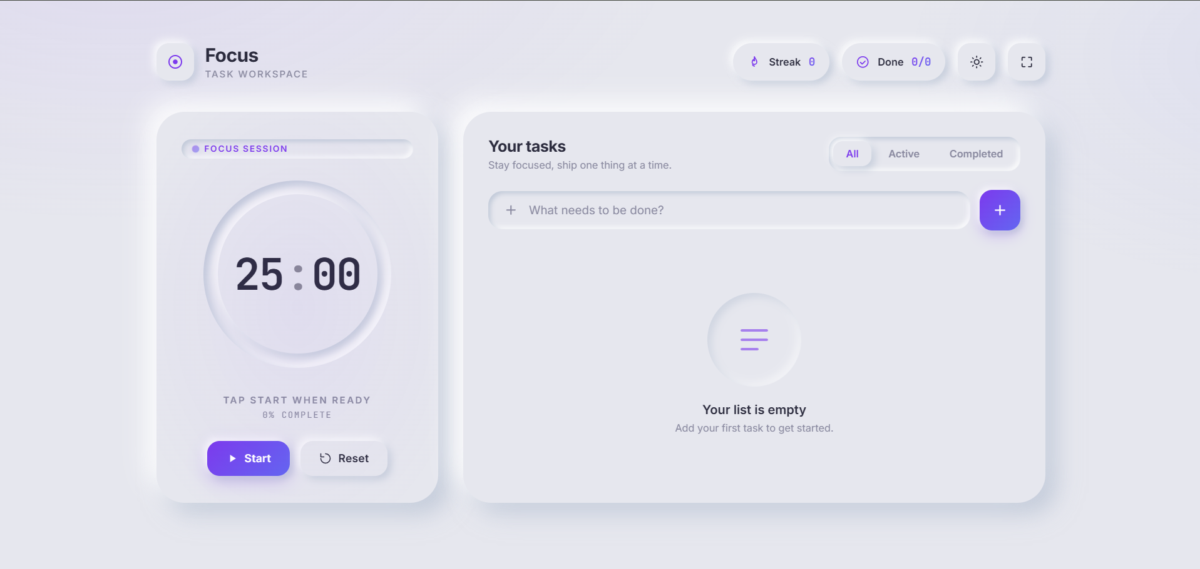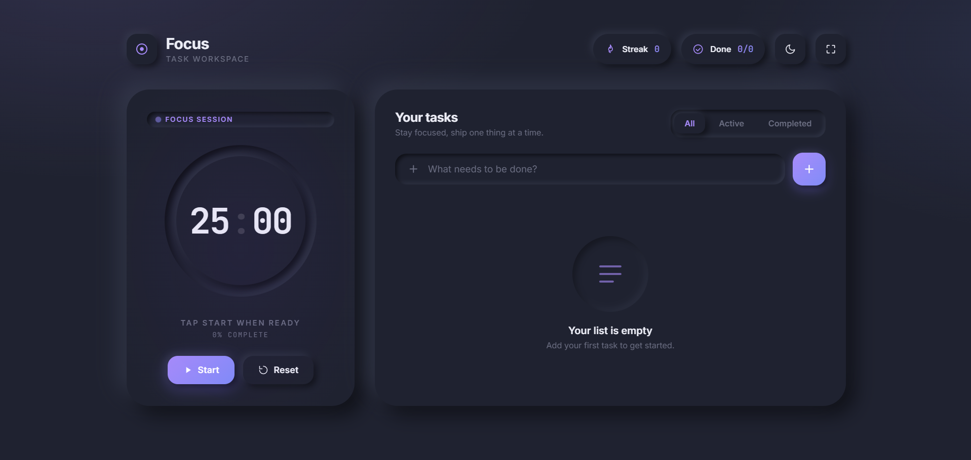

4. Duel
- Already Known: AI Debate platform, turn-based UX, AI feedback scoring.
- Need from you:
  - GitHub Repository URL: https://github.com/yashtyagi9306/Duel
  - Production Frontend Live URL: https://duel-drab.vercel.app/
  - Production Backend URL (if public/needed):
  - Screenshot / Image assets: (Provide images or confirm if I should capture/extract them). 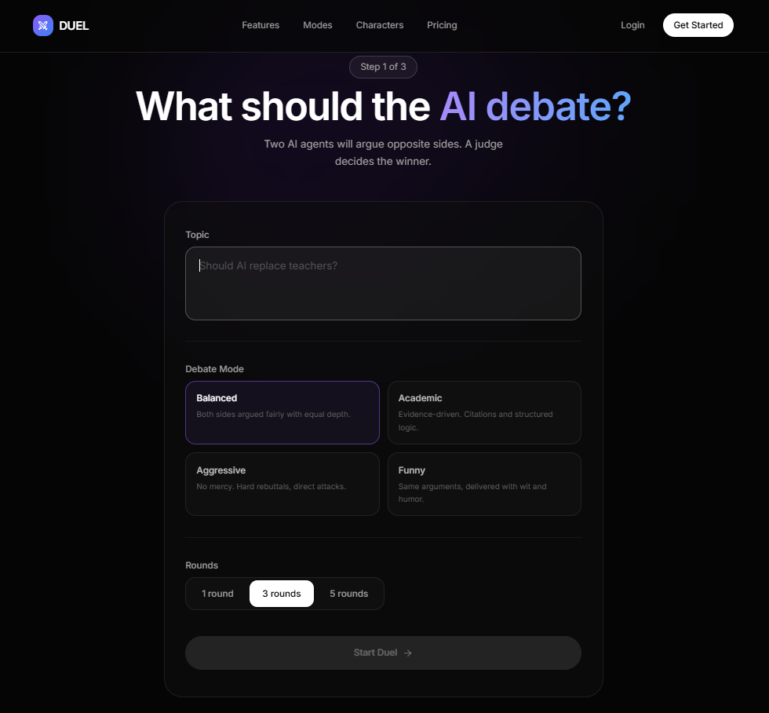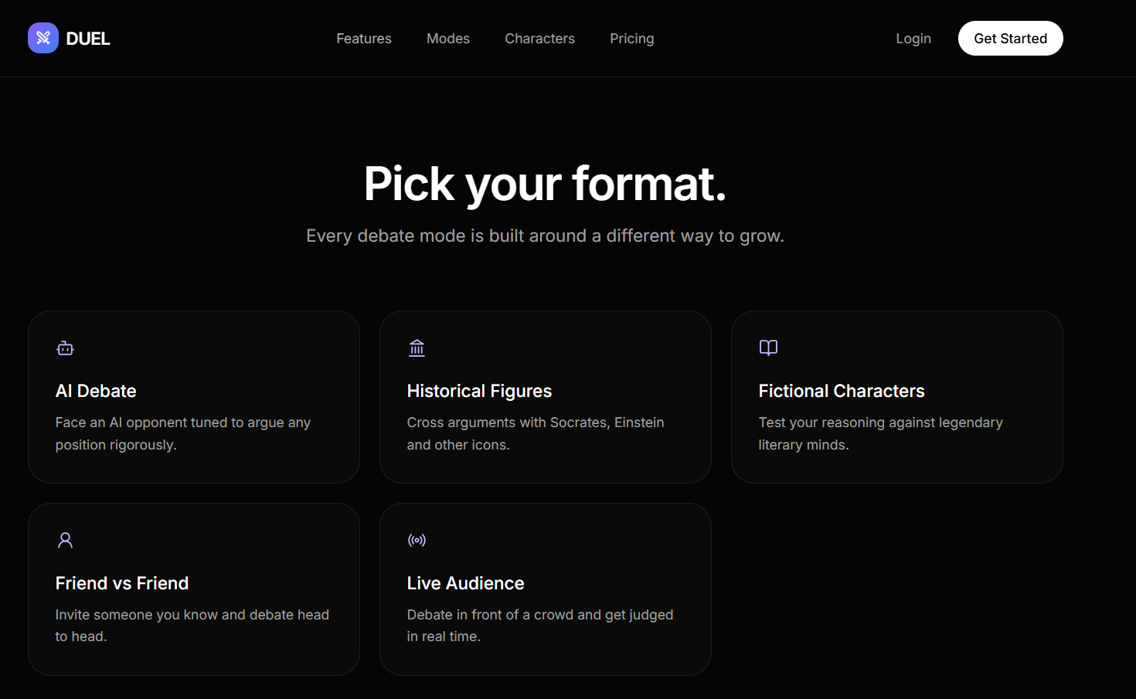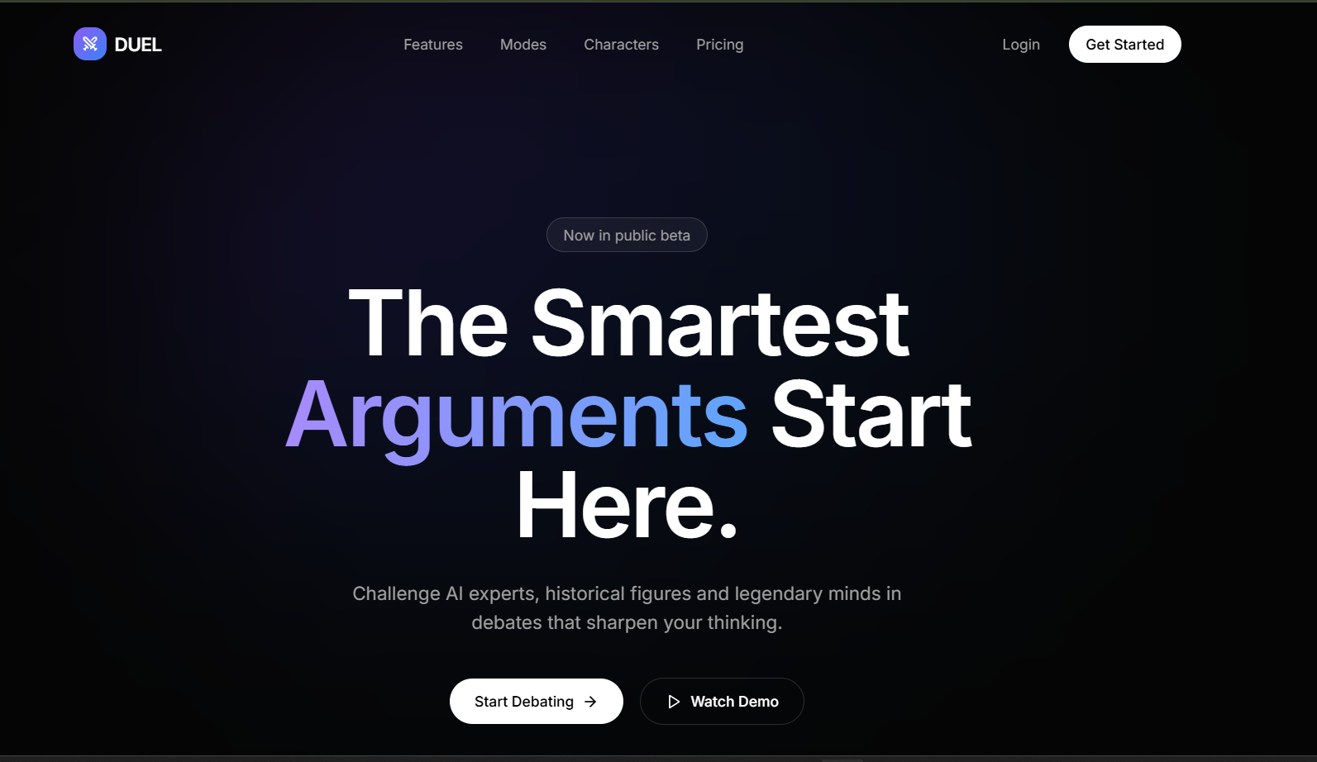

5. Bloom EMS
- Already Known: Employee Management System dashboard, role-based workflows.
- Need from you:
  - GitHub Repository URL: https://github.com/yashtyagi9306/Employee-Management-System
  - Production Live URL (if deployed): https://bloom-ems.vercel.app/
  - Core features (e.g., Admin dashboard, employee task management, role switching)?
  - Screenshot / Image assets: (Provide images or confirm if I should capture/extract them).
