Kennesaw State University

Department of Computer Science

Database Systems

Section CS:6070

Project: Hospital Management System

Full Name: Yasaswi Dendukuri

Email: [ydenduku@students.kennesaw.edu](mailto:ydenduku@students.kennesaw.edu)

KSU ID: 001088768

Table of Contents



Executive Overview *Page 3*

ER Diagram *Page 3*

Relational Schema *Page 3*

Data Dictionary *Page 3*

CRUD Matrix *Page 3*

Table Descriptions *Page 3*

Database Tables *Page 3*

Design Tables *Page 3*

Queries *Page 3*

Executive Overview

Primary Objective: To create a database for hospital management to store personal details about the patients, their contact information, appointment dates, doctor details, specializations and patients date of admission.

Client: Hospitals

Overview: The hospital management wants to have a database for storing information about patients and doctors. This database helps them to organize their schedule, when to give appointments to the patients. The database needs to have patient’s information like patient id, age, name, contact info, doctor’s information like doctor’s id, specialization, name. Lastly there also needs to be a record of the patient's date of admission.

This database is used to create appointments and to solve the inconsistencies in scheduling the appointments. I have created the databases for doctor details, patient details, appointment details. To retrieve the information from the tables different queries are created in which information like appointment date, admission date, specialization of doctors are the end results.

Entity-Relationship Diagram

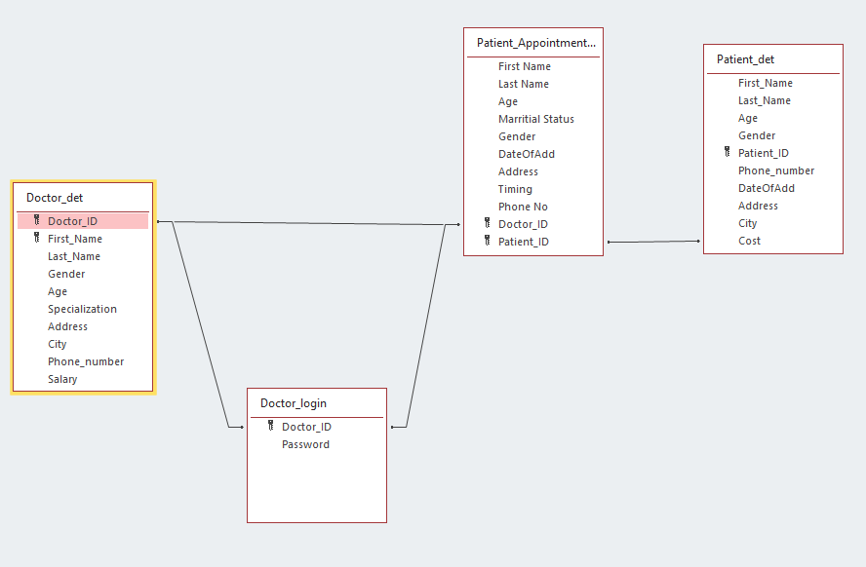

Relational Schema

Doctor_det(Doctor_id, First_Name, Last_Name, Gender, Age, Specialization, Address, City, Phone_number, Salary)

* Primary Key: Doctor_ID

Doctor_login(Doctor_id, Password)

* Foreign Key: Doctor_ID

Patient_Appointment(First_Name, Last_Name, Gender, Age, Address, Phone_number, DateOfAdd, Patient_ID, Marital Status, Timing)

* Foreign Key: Patient_ID
* Foreign Key: Doctor_ID

Patient_det(First_Name, Last_Name, Gender, Age, Address, Phone_number, DateOfAdd, Patient_ID, Cost, City)

* Primary Key: Patient_ID

Data Dictionary

| Attributes | Table | Null | Unique | Foreign  key | Primary  key | Ref  Table | Domain |
| --- | --- | --- | --- | --- | --- | --- | --- |
| Doctor_ID | Doctor_det | N | Y | N | Y | NA | Length 10 long int |
| Doctor_ID | Doctor_login | N | N | Y | N | Doctor_det | Length 10 long int |
| Doctor_ID | Patient_Appoint  ment_table | N | N | Y | N | Doctor_det | Length 10 long int |
| Patient_ID | Patient_det | N | Y | N | Y | NA | Length 10 long int |
| Patient_ID | Patient_Appoint  ment_table | N | N | Y | N | Patient_det | Length 10 long int |
| First_Name | Doctor_det | N | N | N | N | NA | Character string length 20 |
| First_Name | Patient_det | N | N | N | N | NA | Character string length 20 |
| First_Name | Patient_Appoint  ment_table | N | N | N | N | NA | Character string length 20 |
| Last_Name | Doctor_det | N | N | N | N | NA | Character string length 20 |
| Last_Name | Patient_det | N | N | N | N | NA | Character string length 20 |
| Last_Name | Patient_Appoint  ment_table | N | N | N | N | NA | Character string length 20 |
| Age | Doctor_det | Y | N | N | N | NA | Length 10 long int |
| Age | Patient_det | Y | N | N | N | NA | Length 10 long int |
| Age | Patient_Appoint  ment_table | Y | N | N | N | NA | Length 10 long int |
| Gender | Doctor_det | Y | N | N | N | NA | Character string length 20 |
| Gender | Patient_det | Y | N | N | N | NA | Character string length 20 |
| Gender | Patient_Appoint  ment_table | Y | N | N | N | NA | Character string length 10 |
| Specialisation | Doctor_det | N | N | N | N | NA | Character string length 10 |
| Address | Doctor_det | N | N | N | N | NA | Character string length 20 |
| Address | Patient_det | N | N | N | N | NA | Character string length 20 |
| Address | Patient_Appoint  ment_table | N | N | N | N | NA | Character string length 20 |
| City | Doctor_det | N | N | N | N | NA | Character string length 10 |
| City | Patient_det | N | N | N | N | NA | Character string length 10 |
| Phone_Number | Doctor_det | Y | N | N | N | NA | Length 10 long int |
| Phone_Number | Patient_det | Y | N | N | N | NA | Length 10 long int |
| Phone No | Patient_Appoint  ment_table | Y | N | N | N | NA | Length 10 long int |
| Salary | Doctor_det | N | N | N | N | NA | Length 10 long int |
| Password | Doctor_login | N | N | N | N | NA | Character string length 20 |
| Marital_Status | Patient_Appoint  ment_table | N | N | N | N | NA | Character string length 10 |
| Timing | Patient_Appoint  ment_table | N | Y | N | N | NA | Length 10 long int |
| Cost | Patient_det | Y | N | N | N | NA | Length 10 long int |
| DateOfAdd | Patient_det | N | N | N | N | NA | Date |

CRUD Matrix

|  | Create | Read | Update | Delete |
| --- | --- | --- | --- | --- |
| Doctor_det | C | R | U | D |
| Doctor_login | C | R | U | D |
| Patient_det | C | R | U | D |
| Patient_Appoint  ment_table | C | R | U | D |

Keys

C Create or insert a record

R Read/ Query or select a record

U Update or modify a record

D Delete a record

Table Descriptions

Doctor_det

Gives details like Doctor_id, First_Name, Last_Name, Gender, Age, Specialization, Address, City, Phone_number, Salary

Doctor_login

Gives details about Doctor_id, Password

Patient_Appointment

Gives personal information about First_Name, Last_Name, Gender, Age, Address, Phone_number, DateOfAdd, Patient_ID, Marital Status, Timing

Patient_det

Gives patient information likeFirst_Name, Last_Name, Gender, Age, Address, Phone_number, DateOfAdd, Patient_ID, Cost, City

Database Tables

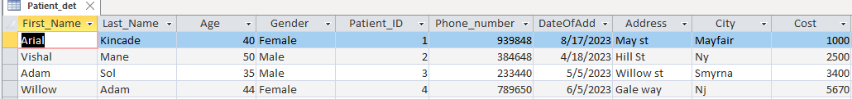

Patient details datasheet

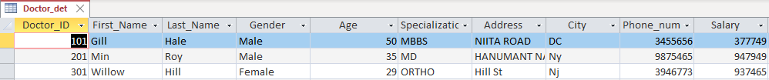

Doctor details datasheet

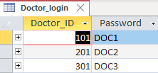

Doctor login Datasheet

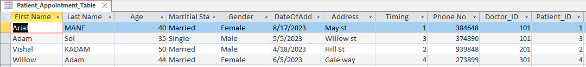

Patient Appointment Datasheet

Design Tables

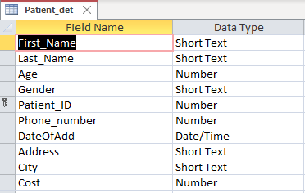

Patient_det design

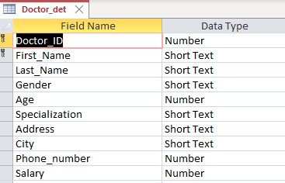

Doctor_det design

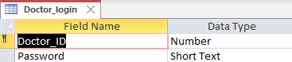

Doctor_login design

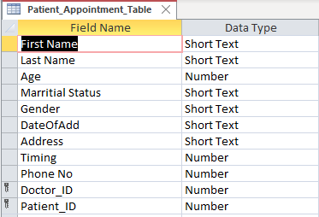

Patient_Appointment_Table design

Queries

Query for Patient age as the constraint.

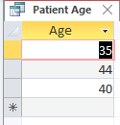

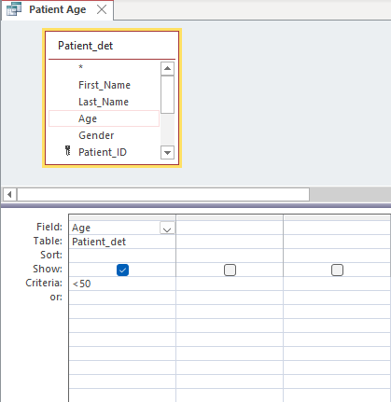

Date of Appointment query

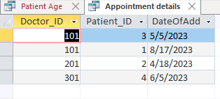

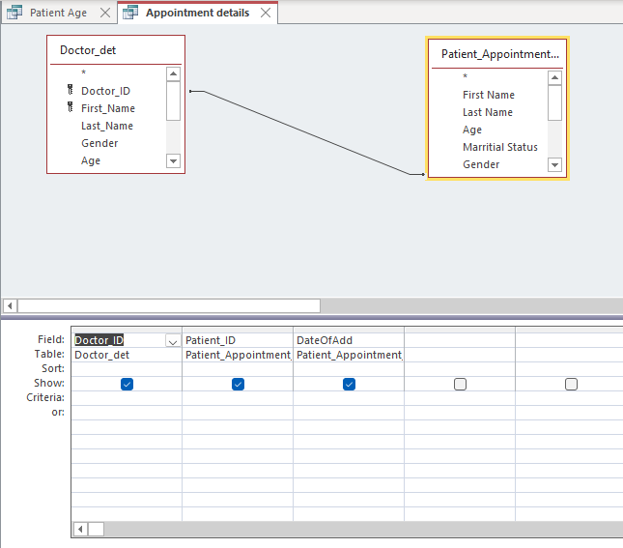

Specialization of the doctor query

