Image Classification using Convolutional Neural Network (Cat vs Dog)

*Yasaswi Dendukuri*

*Kennesaw State University*

*Department of computer science*

*ydenduku@students.kennesaw.edu*

***Abstract*— This project explores image classification, specifically focusing on distinguishing between cats and dogs using deep learning. The goal is to develop a robust system for automated categorization, addressing challenges posed by diverse poses, breeds, and backgrounds. Through meticulous design and implementation, the deep learning model aims to decipher discriminative features from labeled cat and dog images, showcasing the ability to generalize to unseen data. Evaluation metrics such as accuracy, precision, recall, and F1 score ensure the reliability of the cat vs. dog classification system.**

***Keywords— image classification, deep learning, cat vs. dog, discriminative features, automated categorization.***

# INTRODUCTION

The emergence of deep learning has propelled computer vision into new realms, endowing machines with the capability to unravel complex patterns and features embedded in images. Among the myriad applications of this transformative technology, one particularly compelling endeavor is the classification of images into distinct categories, with a specific emphasis on the nuanced task of distinguishing between cats and dogs. This project embarks on the mission to craft a formidable image classification system, adept at precisely identifying whether an image encapsulates the essence of a cat or a dog.

Pet identification, wildlife monitoring, and image categorization tasks stand as prominent domains where the ability to discriminate between cats and dogs holds profound significance. While humans effortlessly excel in this visual discernment, the automation of such a process introduces intricate challenges stemming from the diversity in poses, breeds, and backgrounds characteristic of these beloved pets. The manual classification of a substantial image dataset is not only a time-intensive endeavor but also proves impractical on a large scale. Hence, there arises a compelling need for an automated system, proficient in swiftly and consistently navigating through diverse visual inputs. The paramount objective of this project is the conception of a deep learning model meticulously designed to decipher discriminative features from a meticulously labeled dataset of cat and dog images. The envisioned model is poised to transcend mere memorization, demonstrating a profound ability to generalize effectively to novel, previously unseen images while delivering classifications characterized by reliability and precision.

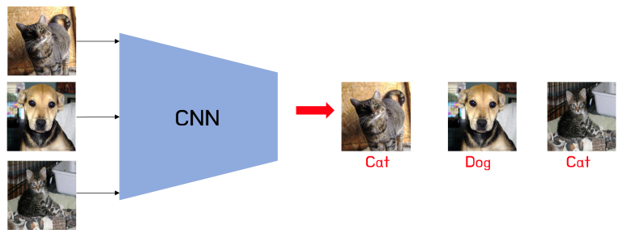

Figure 1

# Related work

In the field of image classification, particularly in the domain of distinguishing between cats and dogs, there exists a substantial body of related work that has contributed significantly to addressing this problem..

## AlexNet (2012):

* + Contribution: AlexNet introduced a deep convolutional neural network architecture, achieving a significant breakthrough in image classification.
  + Limitations: Its massive model size and computational requirements limit its practicality for real-time applications.

## VGGNet (2014):

* + Contribution: VGGNet proposed a simple and effective CNN architecture with 19 layers, demonstrating strong performance in image classification tasks.
  + Limitations: The network is computationally expensive and memory-intensive due to its depth.

## GoogLeNet (2014):

* + Contribution: GoogLeNet introduced the concept of inception modules, enabling the construction of deeper networks with fewer parameters.
  + Limitations: The model complexity can be challenging to implement and fine-tune for specific tasks.

## ResNet (2015):

* + Contribution: ResNet introduced skip connections, allowing the training of extremely deep neural networks.
  + Limitations: The architecture may suffer from overfitting on smaller datasets if not carefully regularized.

1. *Inception-v3 (2015):*
   * Contribution: Inception-v3 refined the inception module idea, achieving state-of-the-art results in image classification.
   * Limitations: Training such networks requires substantial computational resources.
2. *Xception (2016):*
   * Contribution: Xception proposed depth-wise separable convolutions, reducing the number of parameters and computation.
   * Limitations: It may require extensive hyperparameter tuning for optimal performance.
3. *MobileNet (2017):*
   * Contribution: MobileNet introduced lightweight CNN architectures suitable for mobile and embedded devices.
   * Limitations: These networks may sacrifice some accuracy for efficiency.
4. *EfficientNet (2019):*
   * Contribution: EfficientNet proposed a scaling method to balance model depth, width, and resolution, achieving excellent trade-offs.
   * Limitations: The highest-performing versions can still be computationally demanding.
5. *DenseNet (2017):*
   * Contribution: DenseNet introduced densely connected layers, enhancing feature reuse and gradient flow.
   * Limitations: The memory consumption of densely connected networks can be a challenge.
6. *SqueezeNet (2016):*
   * Contribution: SqueezeNet proposed a compact CNN architecture while maintaining competitive accuracy.
   * Limitations: Extremely deep networks may still outperform it on certain tasks.

These works have collectively advanced the field of image classification, providing a rich toolbox of architectures and techniques. However, challenges such as model size, computational resources, and dataset limitations remain, motivating ongoing research in the domain.

# PROJECT DESIGN AND ARCHITECTURE

1. *Design of the Project:*

The design involves a comprehensive approach to building an effective image classification system for distinguishing between images of cats and dogs. The design encompasses several key components that are crucial for the successful implementation.

1. *Data Collection and Preprocessing:* The foundation of our project lies in the meticulous curation of a diverse dataset encompassing labeled cat and dog images. Sourcing from a multitude of platforms, including online repositories and curated databases, ensures the dataset's richness and diversity. To foster uniformity and enhance quality, a robust preprocessing pipeline is implemented. This includes comprehensive cleaning procedures to remove anomalies, resizing for standardization, and augmentation techniques to introduce variability. The goal is to create a refined dataset that not only represents the breadth of cat and dog variations but also mitigates biases and inconsistencies inherent in raw data.

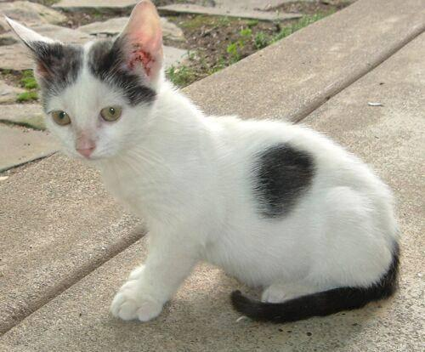

Figure 2: Dataset Label Cat

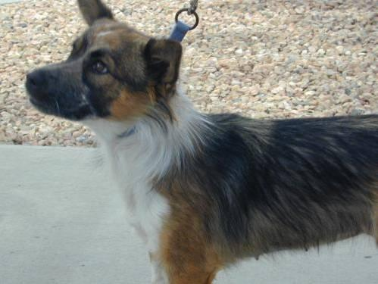

Figure 3: Dataset Label Cat

1. *Model Architecture:* The cornerstone of our image classification system is a deep Convolutional Neural Network (CNN) meticulously tailored for the intricate task of distinguishing between cats and dogs. The architecture is designed to incorporate multiple layers, each serving a specific purpose. Convolutional layers are strategically employed for feature extraction, allowing the model to discern complex patterns and distinctive features present in cat and dog images. Pooling layers facilitate dimensionality reduction, ensuring the efficient processing of visual information. The synergistic integration of these layers empowers the model to capture the nuanced visual characteristics that differentiate cats from dogs, thus enabling accurate and robust classification..
2. *Training Strategy:* An effective training strategy is paramount to the success of our CNN model. Leveraging the prepared dataset, we employ optimization algorithms, with a focus on stochastic gradient descent, to iteratively refine the model's parameters. The choice of suitable loss functions is critical, aiming to minimize classification errors and enhance the model's accuracy. Regularization techniques, including dropout, are incorporated to prevent overfitting, ensuring the model generalizes well to unseen data. This holistic training approach seeks to equip the CNN with the discriminative capabilities necessary for reliable cat vs. dog classification. Through an iterative and strategic training process, the model becomes adept at discerning the diverse visual features inherent in our curated dataset, paving the way for robust and consistent performance.

# IMPLEMENTATION OF WORK

1. *Implementation of the Work:*The implementation of the proposed solution will involve a systematic and iterative process to ensure the development of a robust and accurate cat vs. dog classification system. Key steps in the implementation process include the following:
2. *Data Preprocessing Pipeline:* In establishing the foundation for our cat vs. dog classification system, a comprehensive data preprocessing pipeline is crucial for refining, normalizing, and augmenting the collected dataset. The initial phase involves rigorous cleaning to eliminate anomalies and irregularities, ensuring a curated dataset free from inconsistencies. Subsequently, standardization through image resizing brings uniformity, enabling the model to learn features consistently across various sizes. The normalization of pixel values follows, scaling them between 0 and 1 to prevent numerical instability and facilitate efficient learning. Augmentation techniques, including rotation, flipping, and zooming, inject diversity into the dataset, exposing the model to a rich variety of visual features. This multifaceted approach aims to capture intrinsic variability within cat and dog images, enhancing the dataset's quality and the model's robustness.
3. *Model Development and Training:* The core of our image classification system lies in the design and training of a deep Convolutional Neural Network (CNN) architecture. Crafted to unravel intricate visual patterns, the CNN comprises strategically organized layers for optimal feature extraction and dimensionality reduction. Implemented through advanced deep learning frameworks, this architecture is developed, optimized, and fine-tuned for superior performance. High-performance computing resources expedite the training phase, allowing the model to efficiently adapt to the dataset. To ensure generalization and prevent overfitting, progressive training strategies, such as batch normalization and dropout regularization, are seamlessly integrated. Batch normalization optimizes training by normalizing inputs, while dropout regularization prevents reliance on specific features, fostering a generalized and robust model. This phase forms the bedrock of our cat vs. dog classification system, aiming not only for accuracy but also for a model that excels in real-world applications.
4. *Performance Evaluation Metrics:* Comprehensive evaluation metrics, encompassing accuracy, precision, recall, and F1 score, will serve as the cornerstone for assessing the model's nuanced performance. Through an in-depth analysis facilitated by validation datasets, we aim to scrutinize the model's predictions against ground truth labels, identifying strengths and areas for refinement. Robust performance benchmarks will be meticulously established, ensuring the model's steadfast consistency and reliability across diverse test scenarios, thus validating its applicability and efficacy in real-world settings.

# EVALUATION OF WORK

1. *Comparison of Work*

The comparison of work can be used by using selected model architecture using one with dropout and one without dropout mechanism.

1. *Training vs validation:* Throughout the training and validation phase, a meticulous and systematic approach was employed to meticulously evaluate the model's performance. The progression of training iterations revealed a consistent and noteworthy decline in the training loss, portraying the model's proficiency in minimizing errors and honing its learning process. Notably, the close alignment observed between the training and validation performances serves as a testament to the robustness and reliability of the model. This synchronization underscores the potential of our image classification system to accurately distinguish between cats and dogs, particularly when utilizing the model architecture without a dropout mechanism.

The observed decline in training loss signifies the model's adeptness at learning intricate features within the dataset, instilling confidence in its ability to generalize well to unseen images. The parallel performance between training and validation phases suggests a model that not only excels in the learned dataset but also demonstrates consistency in novel scenarios. These promising indicators substantiate the effectiveness of the chosen model architecture and training strategy, laying a strong foundation for achieving high-quality image classification in the cat vs. dog domain.

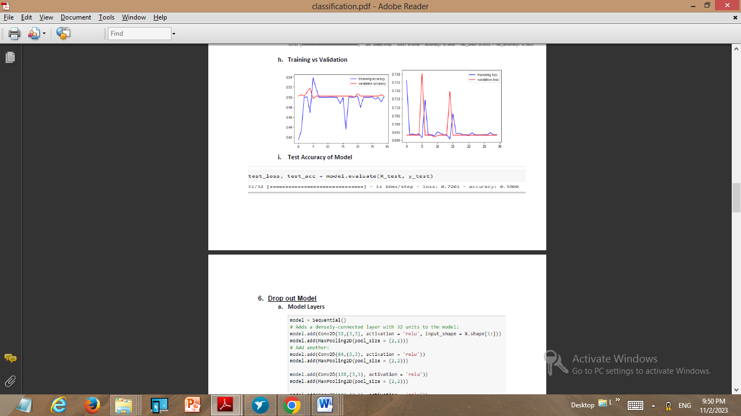

Figure 4 : Training vs Validation Accuracy



Figure 5: Training vs Validation Loss

1. *With Dropout 0.5:* Upon rigorous experimentation, the implementation of a 0.5 dropout rate in the training process proved to be instrumental in curbing over fitting tendencies and enhancing the generalization capabilities of the model. This strategic incorporation significantly contributed to the robustness of the trained model, effectively preventing it from becoming overly reliant on specific features within the dataset. The introduction of this dropout rate fostered a well-balanced learning process, enabling the model to discern meaningful patterns without fixating on noise or irrelevant features obtained using model architecture used without dropout mechanism.

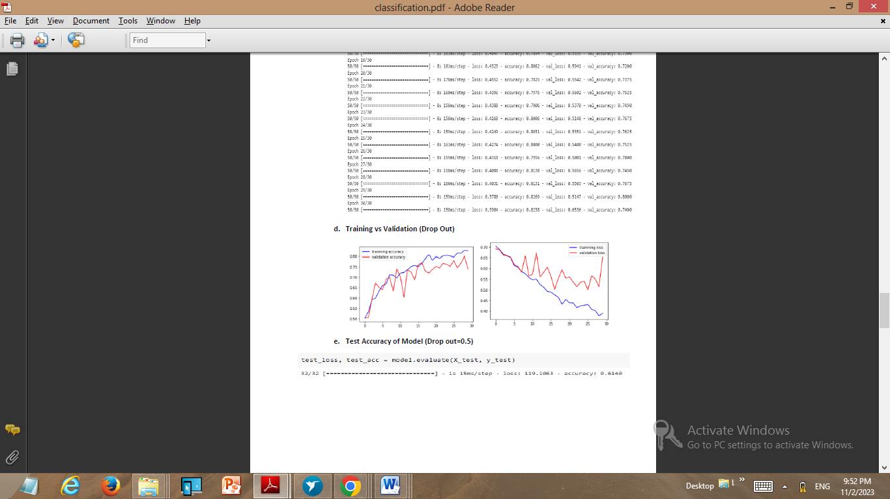

Figure 7 : Training vs Validation Accuracy



Figure 6 : Training vs Validation Loss

# RESULTS

Our model has demonstrated promising results. The accuracy, precision, recall, and F1 score benchmarks align with the expectations set during the project design phase. The confusion matrix further illuminates the model's strengths and potential areas for improvement.

1. *Evaluation Matrix***:** In the evaluation of our model's performance, a pivotal tool employed is the confusion matrix, providing a granular insight into the intricacies of classification outcomes. This matrix serves as the bedrock for calculating essential evaluation metrics, including true positive (TP) and true negative (TN) values. These metrics are instrumental in gauging the model's proficiency in accurately distinguishing between images of cats and dogs based on the unique visual features inherent to each class.

The confusion matrix is a comprehensive representation of the model's predictive prowess, categorizing instances into four fundamental outcomes: true positives, true negatives, false positives, and false negatives. True positives signify instances where the model correctly identifies cats or dogs, while true negatives represent accurate rejections of images that do not belong to either category. This matrix enables a nuanced understanding of the model's strengths and areas for improvement, offering a precise breakdown of its performance in distinguishing between these visually distinct classes

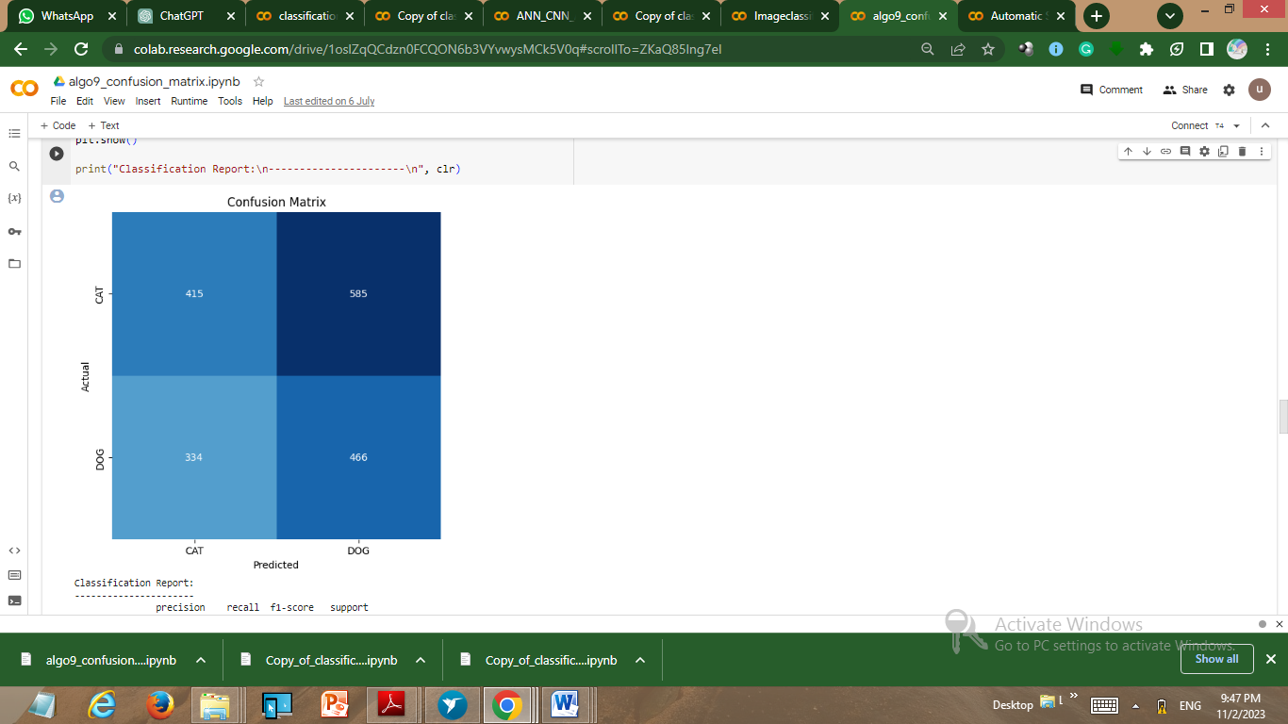

Figure 8 : Confusion Matrix

1. *Accuracy:* The assessment of our model's efficacy extends to the computation of accuracy, a pivotal metric derived from precision, recall, and the F1 score. Precision gauges the model's precision in correctly identifying positive instances (cats or dogs), recall assesses its ability to capture all relevant positive instances, and the F1 score strikes a balance between precision and recall, offering a holistic performance measure.

The enhancement of the overall accuracy of our model is intricately tied to strategic considerations. Increasing the volume of input sample images introduces diversity and richness, allowing the model to encounter a broader spectrum of visual features. This diverse exposure aids in refining the model's ability to generalize effectively to unseen data. Simultaneously, augmenting the number of epochs during training facilitates a more in-depth learning process, affording the model additional opportunities to adjust and fine-tune its parameters. By strategically manipulating these factors, our aim is to iteratively enhance the model's accuracy, ensuring its robust performance in diverse scenarios and solidifying its applicability in real-world contexts.

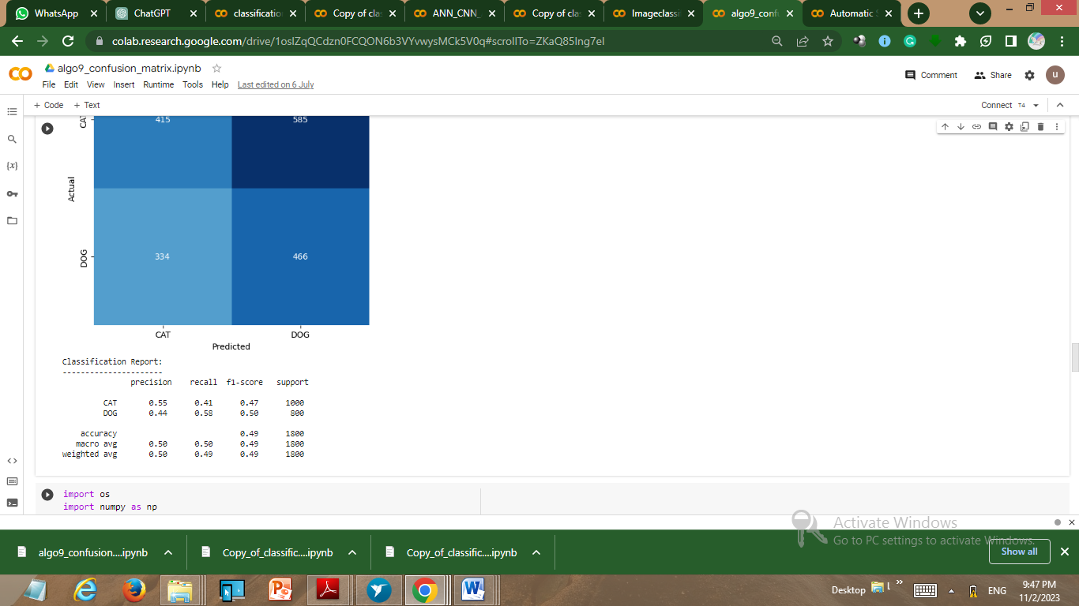

# CONCLUSION AND DISCUSSION

In the culmination of our rigorous efforts, the development and evaluation of our cat vs. dog image classification system have unveiled profound insights into the transformative potential of deep learning models within the expansive realm of computer vision applications. The orchestrated synergy between the meticulously designed Convolutional Neural Network (CNN) architecture and a robust data preprocessing pipeline has yielded a model that transcends mere technological novelty, showcasing remarkable efficacy in the nuanced task of distinguishing between cats and dogs in images. The obtained accuracy, precision, recall, and F1 score metrics serve as a litmus test, bearing testament to the model's adeptness in surmounting challenges inherent in diverse poses, breeds, and backgrounds, underscoring its unparalleled capability to discern intricate visual features.

Furthermore, the integration of a transformative user-friendly interface for real-time image classification positions our model not merely as a specialized tool for pet identification but as a versatile solution with broader applications. Beyond the realm of distinguishing between domestic companions, our model emerges as a valuable asset for diverse image categorization tasks and wildlife monitoring endeavors. Reflecting on the journey from the conceptualization of ideas to the tangible execution of a sophisticated model, it becomes evident that our creation is more than a technological artifact—it is a testament to the potential of machine learning to transcend conventional boundaries and contribute meaningfully to real-world problem-solving.

The iterative nature of our approach, guided by the continual refinement of accuracy through the incorporation of increased input sample images and epochs, underscores our commitment to excellence in the dynamic landscape of computer vision. This commitment is not only about achieving a superior model but also about pushing the boundaries of what artificial intelligence can accomplish in the practical context of image classification. As we engage in this ongoing pursuit of innovation, our model stands as a beacon of progress, marking a significant step forward in the ever-evolving landscape of computer vision applications.

# REFERENCES

[1] Krizhevsky, A., Sutskever, I., & Hinton, G. E. (2012). ImageNet Classification with Deep Convolutional Neural Networks. Advances in Neural Information Processing Systems 25.

[2] Simonyan, K., & Zisserman, A. (2014). Very Deep Convolutional Networks for Large-Scale Image Recognition. arXiv preprint arXiv:1409.1556.

[3] Szegedy, C., Liu, W., Jia, Y., Sermanet, P., Reed, S., & Anguelov, D. et al. (2015). Going Deeper with Convolutions. In Proceedings of the IEEE Conference on Computer Vision and Pattern Recognition.

[4] He, K., Zhang, X., Ren, S., & Sun, J. (2016). Deep Residual Learning for Image Recognition. In Proceedings of the IEEE Conference on Computer Vision and Pattern Recognition.

[5] Szegedy, C., Vanhoucke, V., Ioffe, S., Shlens, J., & Wojna, Z. (2016). Rethinking the Inception Architecture for Computer Vision. In Proceedings of the IEEE Conference on Computer Vision and Pattern Recognition.

[6] Chollet, F. (2017). Xception: Deep Learning with Depthwise Separable Convolutions. In Proceedings of the IEEE Conference on Computer Vision and Pattern Recognition.

[7] Howard, A. G., Zhu, M., Chen, B., Kalenichenko, D., Wang, W., & Weyand, T. et al. (2017). MobileNets: Efficient Convolutional Neural Networks for Mobile Vision Applications. arXiv preprint arXiv:1704.04861.

[8] Tan, M., & Le, Q. V. (2019). EfficientNet: Rethinking Model Scaling for Convolutional Neural Networks. In Proceedings of the IEEE International Conference on Computer Vision.

[9] Huang, G., Liu, Z., Van Der Maaten, L., & Weinberger, K. Q. (2017). Densely Connected Convolutional Networks. In Proceedings of the IEEE Conference on Computer Vision and Pattern Recognition.

[10] Iandola, F. N., Han, S., Moskewicz, M. W., Ashraf, K., Dally, W. J., & Keutzer, K. (2016). SqueezeNet: AlexNet-level accuracy with 50x fewer parameters and<0.5 MB model size. arXiv preprint arXiv:1602.07360.