TALENT-IQ CAREER COPILOT
UI Design Document · 3D Module Visual Guide

Wireframes · 3D Module Images · Component Specs · Design Tokens

Landing | Dashboard | Resume AI | Job Match | Mock Interview | Live Room

Next.js 15 · React Three Fiber · Drei · Rapier Physics · Framer Motion · TailwindCSS

1. Design System

1.1 Color Palette

Navy  #0F172A  Page Background | Dark Slate  #1E293B  Card Background | Mid Slate  #334155  Borders / Lines | Teal 600  #0D9488  Primary / CTA | Teal 300  #5EEAD4  Accent / Glow

Amber  #F59E0B  Bonus / Warning | Rose  #F43F5E  Missing / Error | Violet  #8B5CF6  AI Interviewer | Cyan  #06B6D4  Info / Highlights | Slate 100  #F1F5F9  Light Text

1.2 Typography Scale

Token | Font | Size / Weight | Usage
display-2xl | Syne | 72px / 800 | Hero headings, 3D scene labels
display-xl | Syne | 48px / 700 | Page titles
heading-lg | Syne | 32px / 700 | Section titles, card headers
body-lg | DM Sans | 18px / 400 | Primary body
body-md | DM Sans | 16px / 400 | Secondary body
mono | JetBrains Mono | 14px / 400 | Code, API responses
label | DM Sans | 12px / 600 | Badges, chips

1.3 Spacing & Radius Tokens

Token | Value | Usage
space-1 | 4px | Micro gaps, icon padding
space-4 | 16px | Card internal padding
space-8 | 32px | Card-to-card gap
space-16 | 64px | Section vertical rhythm
radius-sm | 6px | Buttons, badges
radius-md | 12px | Cards, inputs
radius-lg | 20px | Modals, panels
radius-3d | 16px | 3D canvas container

2. 3D Module Visual Reference

All 6 modules are built with React Three Fiber + @react-three/drei + @react-three/rapier. Each preview below shows the rendered visual alongside its technical specification.

2.1 HeroGlobe — Landing Page 3D Scene

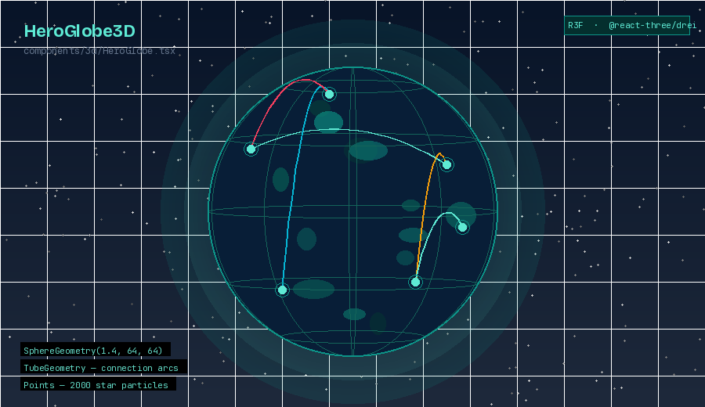
Fig 1 — HeroGlobe3D: rotating Earth with talent connection arcs and star particles

Component | components/3d/HeroGlobe.tsx
Geometry | SphereGeometry(1.4, 64, 64) with custom GLSL shader — dark ocean, teal continents
Arcs | TubeGeometry between random lat/lng pairs; dashOffset animation for flow effect
Particles | Points (BufferGeometry) — 2000 star particles on sphere surface
Lighting | AmbientLight(0.3) + PointLight teal front + PointLight navy rear
Camera | PerspectiveCamera, fov=60, position=[0, 0, 3.5]
Animation | useFrame: Y-axis rotation at 0.003 rad/frame; arcs fade in with lerp opacity
Interaction | Pointer events: hover slows rotation; scroll wheel adjusts camera Z depth
Performance | instancedMesh for arcs; DPR capped at 1.5; disposed on unmount
Fallback | CSS gradient sphere with CSS animation if WebGL unavailable

2.2 ResumeOrb — Resume Processing Visualization

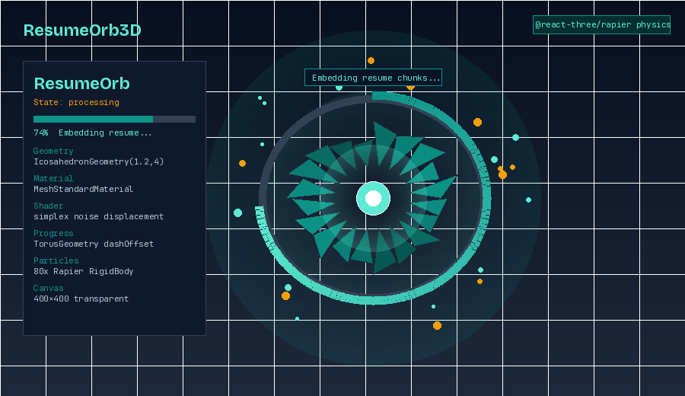
Fig 2 — ResumeOrb3D: state-reactive icosahedron with ring progress and physics particles

Component | components/3d/ResumeOrb.tsx
Geometry | IcosahedronGeometry(1.2, 4) — subdivided facets for organic look
Material | MeshStandardMaterial with emissive teal glow; roughness=0.3, metalness=0.7
States | idle: slow pulse | processing: noise displacement + fast spin | done: burst
Vertex Shader | simplex noise displacement; amplitude float tied to parse progress value
Progress Ring | TorusGeometry around orb; dashOffset animates from 2π → 0 as parsing completes
Particles | On done: 80 particles via Rapier RigidBody physics, gravity-fall off screen
Labels | @react-three/drei <Text> floating above: 'Extracting Skills…' / 'Done!'
Canvas | 400×400px, embedded in upload card, transparent background
Props | status: 'idle' | 'processing' | 'done' | 'error' + progress: 0–100

2.3 SkillGraph3D — Job Match Visualization

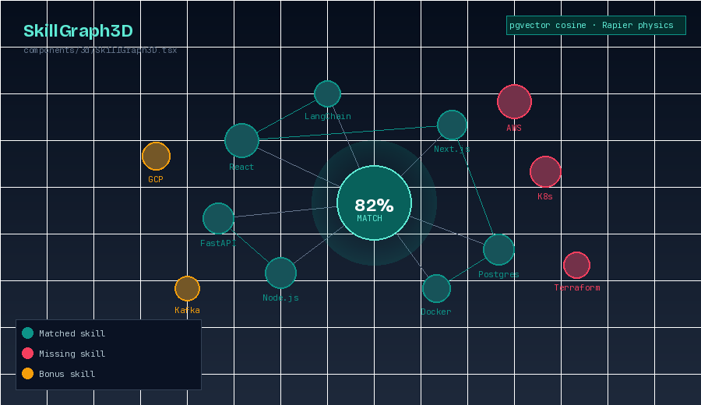
Fig 3 — SkillGraph3D: interactive physics node graph — matched (teal), missing (rose), bonus (amber)

Component | components/3d/SkillGraph3D.tsx
Node Types | Matched = teal sphere | Missing = rose sphere | Bonus = amber sphere
Node Size | Proportional to skill importance score; range 0.08–0.25 unit radius
Physics | @react-three/rapier RigidBody: nodes float with spring force, repel each other
Edges | Line geometry between related skills; opacity = relationship strength score
Labels | drei <Billboard> + <Text> — always face camera; fade when overlapping
Camera | OrbitControls; auto-rotate 0.5 rpm; damping=0.1
Interaction | Click node: tooltip with skill name + learning resource link
Center Orb | Large glowing sphere showing match % via radial GLSL gradient shader
Props | matchData: { matched[], missing[], bonus[], matchScore: number }

2.4 InterviewAvatar3D — AI Interviewer

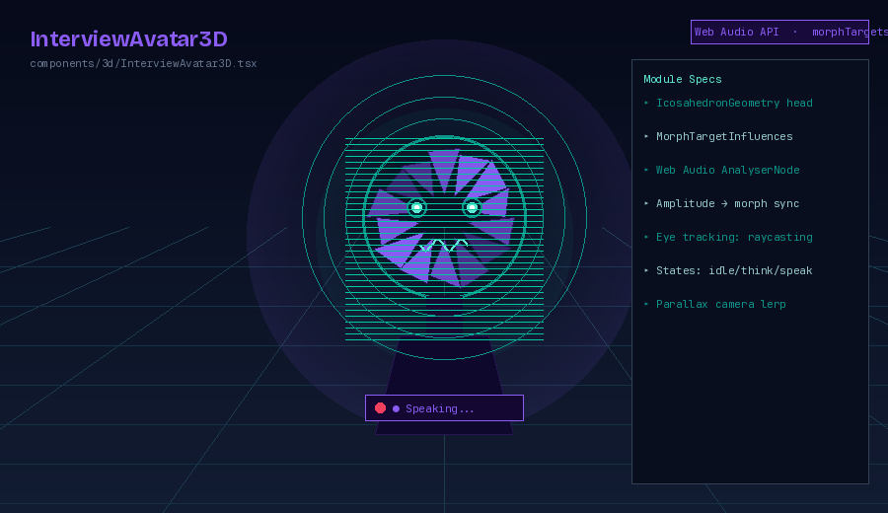
Fig 4 — InterviewAvatar3D: AI interviewer with morph-target mouth and eye tracking

Component | components/3d/InterviewAvatar3D.tsx
Head | IcosahedronGeometry with violet emissive material; subdivisions morph for 'thinking'
Eyes | SphereGeometry pupils; pupil raycasts toward mouse pointer each frame
Mouth | MorphTargetInfluences synced to TTS audio amplitude via Web Audio AnalyserNode
States | idle: head bob | thinking: slow rotation + glow | speaking: morph + burst
Audio Sync | useRef AudioContext analyser; useFrame reads frequency data → drives morph weight
Parallax | Camera lerp toward mouse position (±5°) gives depth illusion on mouse move
Scan Lines | Horizontal scan-line overlay texture for sci-fi AI aesthetic
Speaking Ring | Pulsing concentric ring animations around head when speaking state is active
Props | state: 'idle' | 'thinking' | 'speaking' + audioStream?: MediaStream

2.5 ScoreRing3D — Interview Score Display

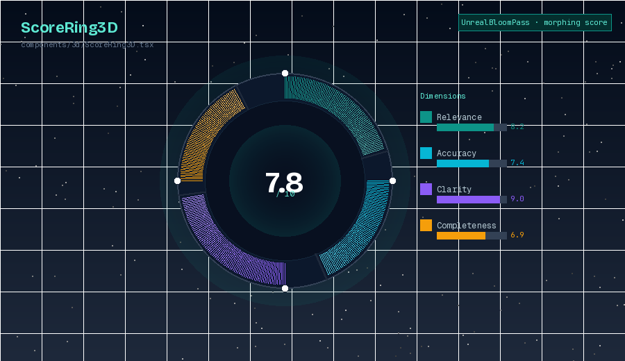
Fig 5 — ScoreRing3D: segmented score torus with UnrealBloom and per-dimension reveal animation

Component | components/3d/ScoreRing3D.tsx
Geometry | TorusGeometry(1, 0.12, 32, 200) — high segment count for smooth arc edges
Segments | 4 arcs: Relevance (teal) / Accuracy (cyan) / Clarity (violet) / Completeness (amber)
Animation | On mount: each arc draws itself via dashOffset 0→1 over 1.2s, staggered ease-out
Center Text | drei <Text3D> using Syne Bold; scales up with React Spring on load complete
Bloom | UnrealBloomPass postprocessing; bloom strength scales proportionally with score
Hover | Mouseover segment: segment scales to 1.1x, tooltip shows dimension label + score
Background | Starfield Points system with slow camera parallax on scroll
Dot Markers | White sphere placed at segment boundary joins for visual clarity
Props | scores: { relevance, accuracy, clarity, completeness } — all 0–10 range

2.6 RoomParticles — Live Interview Ambient Scene

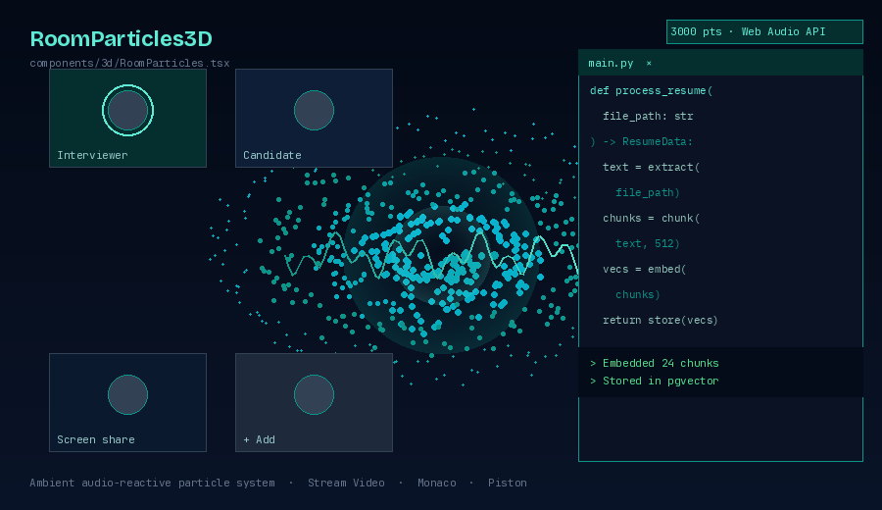
Fig 6 — RoomParticles3D: audio-reactive spiral particle system behind live interview room UI

Component | components/3d/RoomParticles.tsx
Geometry | Points (BufferGeometry) — 3000 particles in slow spiral formation
Motion | useFrame: particles orbit center; speed increases with audio amplitude
Color | Teal base with ±20° HSL hue variation per particle for organic variation
Audio React | Web Audio AnalyserNode connected to Stream video track; amplitude → speed
Canvas | Fixed full-screen, z-index -1, sits behind all UI elements
Performance | 800 particles on mobile; useMemo geometry; DPR=1.0 on low-end devices
PostProcess | Subtle chromatic aberration pass via @react-three/postprocessing
Live UI | Stream Video tiles, Monaco code editor, Piston output render above canvas
Integration | Canvas positioned as background; React UI layers sit in front via z-index

3. Page Wireframes

ASCII wireframes below show exact layout structure for each page. 3D canvas regions are labeled with their module name.

3.1 Landing Page
NAVBAR: [Logo] [Features] [Pricing] [Sign In] [Get Started]
---------------------------------------------------------------
HERO (100vh)
LEFT: Title: Your AI Career Copilot.
Body: Upload resume -> get matched -> get hired
CTAs: [Get Started Free] [Watch Demo]
RIGHT: +=====================+
| HeroGlobe3D | <- rotating globe + arcs
+=====================+
---------------------------------------------------------------
FEATURES (3-col): Resume AI | Job Match | Mock Interview
---------------------------------------------------------------
HOW IT WORKS: [1 Upload] --> [2 Analyze] --> [3 Practice] --> [4 Hired]
---------------------------------------------------------------
TESTIMONIALS auto-scroll carousel
FOOTER: Logo | Links | Social | (c) 2026

3.2 Candidate Dashboard
+--- SIDEBAR (240px) ----+ +---- MAIN CONTENT -------------------------+
| [Avatar] Yashpalsingh | | TOPBAR: Search | Notifications |
| ---------------------- | +-------------------------------------------+
| Dashboard | | STAT CARDS (4-col) |
| Resume | | [Resumes: 2] [Matches: 8] [Score: 82%] |
| Job Match | +-------------------------------------------+
| AI Copilot | | RECENT ACTIVITY feed |
| Mock Interview | | TOP SKILL GAPS bar chart |
| Tracker | | UPCOMING interview card |
| Live Rooms | | |
| Settings | | |
+-------------------------+ +-------------------------------------------+

3.3 Resume Analysis Page
[Back] Resume: YashpalsinghPawara.pdf ATS: 78/100 DONE
----------------------------------------------------------------------
LEFT: +===================+ RIGHT: [Skills] [Exp] [Edu] [Projects]
| ResumeOrb3D | SKILLS: React FastAPI Docker
| (done state) | EXPERIENCE: SoftEight Tech
| * teal glow | EDUCATION: IIITDM Jabalpur
+===================+
----------------------------------------------------------------------
AI SUGGESTIONS (streaming typewriter effect):
Tip: Quantify Weavy impact -- '20+ concurrent workflow runs'
Tip: Add Docker Compose explicitly to your skill list
[Improve with AI] [Match Against Job]

3.4 Job Match Page
JOB MATCH: Senior Backend Developer @ ZFunds
----------------------------------------------------------------------
+====================================================================+
| SkillGraph3D (full width, 520px height) |
| * React * FastAPI * PostgreSQL o K8s o AWS |
| \ | / | | |
| *---------O-----------* o--------o |
| 82% MATCH MISSING SKILLS |
+====================================================================+
LEFT: match_score: 82% | ats_score: 74% | skill_gap: 3
RIGHT: Recommendations:
1. Build a small AWS Lambda project
2. Add Kubernetes basics to resume
[Improve Resume] [Generate Cover Letter] [Save to Tracker]

3.5 Mock Interview Page
MOCK INTERVIEW -- Technical Mode -- Q3 of 8
----------------------------------------------------------------------
+======================+ +====================================+
| InterviewAvatar3D | | Describe the Celery + Redis |
| (400x400px canvas) | | architecture for resume jobs. |
| | | |
| /----------\ | | Timer: 01:32 remaining |
| | O O | spk | +====================================+
| | ~~~~ | |
| \----------/ |
+======================+
----------------------------------------------------------------------
YOUR ANSWER: [text area -- 5 lines tall]
[Record Voice] [Submit Answer] [Skip Question]

3.6 Interview Report Page
INTERVIEW REPORT -- Technical Mock -- Score: 7.8 / 10
----------------------------------------------------------------------
LEFT: +===================+ RIGHT: Dimension Scores
| ScoreRing3D | Relevance [########.] 8.2
| 7.8 / 10 | Accuracy [#######..] 7.4
| Teal / Cyan | Clarity [#########] 9.0
| Violet / Amber | Completeness [######...] 6.9
+===================+
----------------------------------------------------------------------
Q&A ACCORDION:
Q1 Describe Weavy architecture [8.5 / 10] done
Q2 Celery + Redis async jobs [7.0 / 10] done
Q3 pgvector cosine similarity [9.2 / 10] done
[Download PDF] [Share Results] [Start New Interview]

3.7 Live Interview Room
LIVE ROOM #A4F2 | LIVE (RoomParticles3D fills background z-index:-1)
-----------------------------------------------------------------------
+== VIDEO GRID ==============+ +== MONACO CODE EDITOR ===========+
| +-----------++---------+ | | Language: [Python] |
| | Recruiter || Yash | | | def process_resume(path): |
| | video || video | | | text = extract(path) |
| +-----------++---------+ | | vecs = embed(chunk(text)) |
| [mic] [cam] [mute] [end] | | [Run] stdout: Embedded 24 |
+============================+ +=================================+
+== STREAM CHAT ==============+
| Rec: can you explain ... | [Lock Room] [Interviewer Notes]
| [type message ...] [Send] |
+============================+

4. Component Library

4.1 Reusable UI Components

Component | Key Props | Description
<GlowButton> | variant, size, glow | Teal border + box-shadow glow on hover; Framer Motion press scale
<ScoreChip> | score, label, color | Animated number count-up on mount; color auto-maps to range
<SkillBadge> | skill, status, onClick | Pill: teal=matched, rose=missing, amber=bonus
<StatusDot> | status | Pulsing dot: green=active, amber=pending, red=error
<AITyping> | text, speed | Typewriter streaming text for copilot responses
<ProgressArc> | value, max, color | SVG arc ring; lightweight non-3D version for cards
<Canvas3D> | children, height, bg | R3F wrapper with Suspense, ErrorBoundary, DPR cap
<StaggerReveal> | children, delay | Framer Motion stagger; animates children on scroll enter
<GlassCard> | className, hover | Glassmorphism: backdrop-blur, semi-transparent, glow border
<CodeOutput> | stdout, stderr, runtime | Monaco read-only; green stdout, red stderr
<StreamAvatar> | userId, name | Stream video tile with name + audio ring

4.2 Canvas3D Wrapper Pattern
All 3D components use this standard wrapper ensuring safe SSR, loading states, and graceful WebGL degradation:

// components/3d/Canvas3D.tsx
export default function Canvas3D({ children, height = 400 }) {
return (
<ErrorBoundary fallback={<FallbackUI />}>
<Suspense fallback={<CanvasSkeleton height={height} />}>
<Canvas
dpr={[1, 1.5]} // DPR cap for performance
camera={{ fov:60, near:0.1, far:1000 }}
style={{ height, background:'transparent' }}
gl={{ antialias:true, alpha:true }}
>
<color attach='background' args={['transparent']} />
{children}
</Canvas>
</Suspense>
</ErrorBoundary>
)
}

4.3 Animation Standards

Type | Implementation | Used In
Page enter | Framer: opacity 0→1, y 20→0, 0.5s | Every route via layout.tsx
Card hover | CSS translateY(-4px) + box-shadow | GlassCard, SkillBadge, stat cards
Number count-up | requestAnimationFrame linear | ScoreChip, dashboard stats
Stagger reveal | Framer staggerChildren 0.08s | Feature grids, skill lists
Text streaming | setInterval + useState append | AI Copilot, interview feedback
3D idle rotation | useFrame: rotation.y += 0.003 | HeroGlobe, ResumeOrb idle
Spring physics | @react-three/rapier RigidBody | SkillGraph3D nodes
Morph targets | MorphTargetInfluences lerp | InterviewAvatar3D mouth

4.4 Responsive 3D Scaling

Breakpoint | Width | 3D Behavior
Mobile | < 640px | Canvas height 280px; particles reduced 50%; DPR=1.0; static fallback if GPU unavailable
Tablet | 640–1024px | Canvas height 360px; DPR=1.2; medium geometry subdivision
Desktop | 1024–1440px | Full heights; DPR=1.5; full geometry; all postprocessing enabled
Wide | > 1440px | 3D scenes scale proportionally with container; extra detail enabled

— End of UI Design Document —

