**DB HOMEWORK #2**

PROBLEM 1

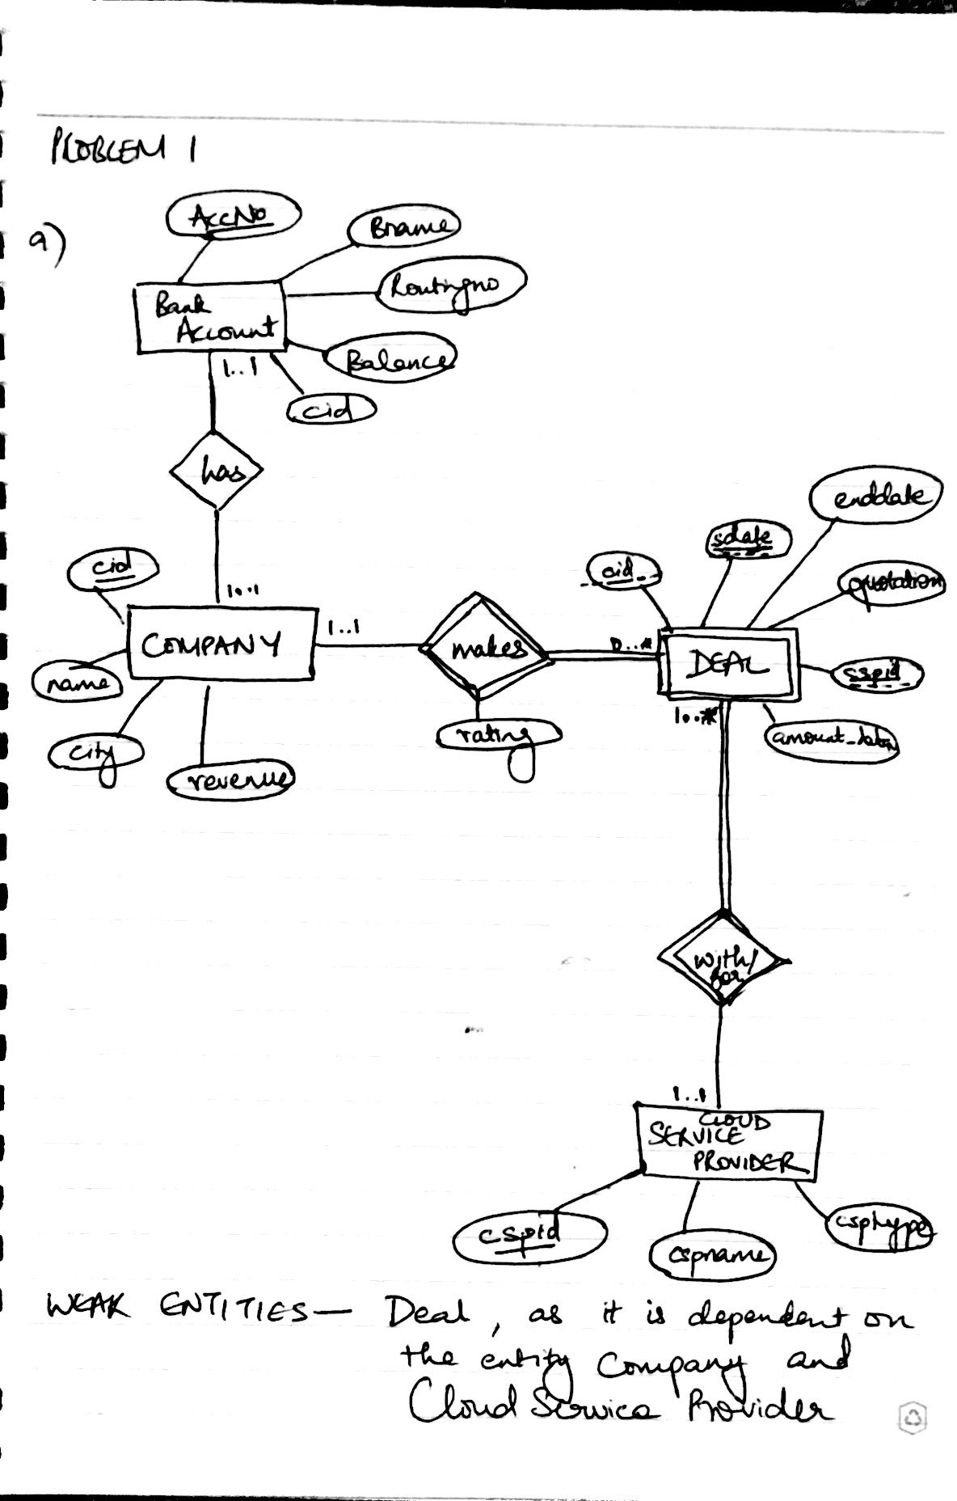

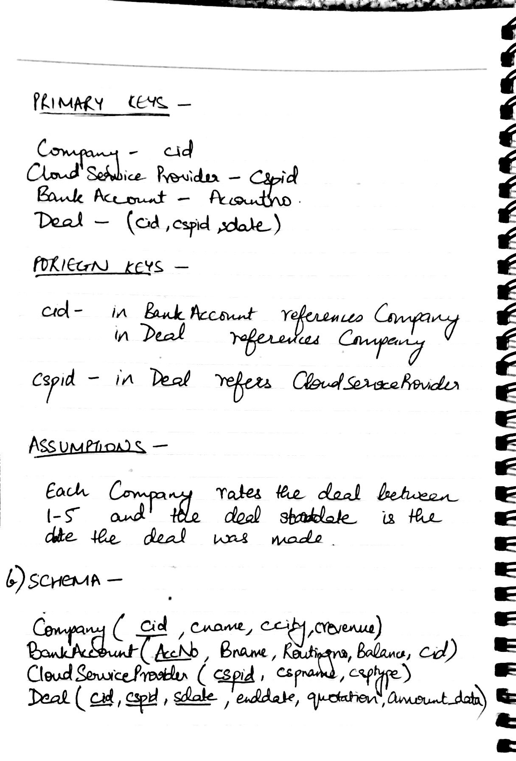

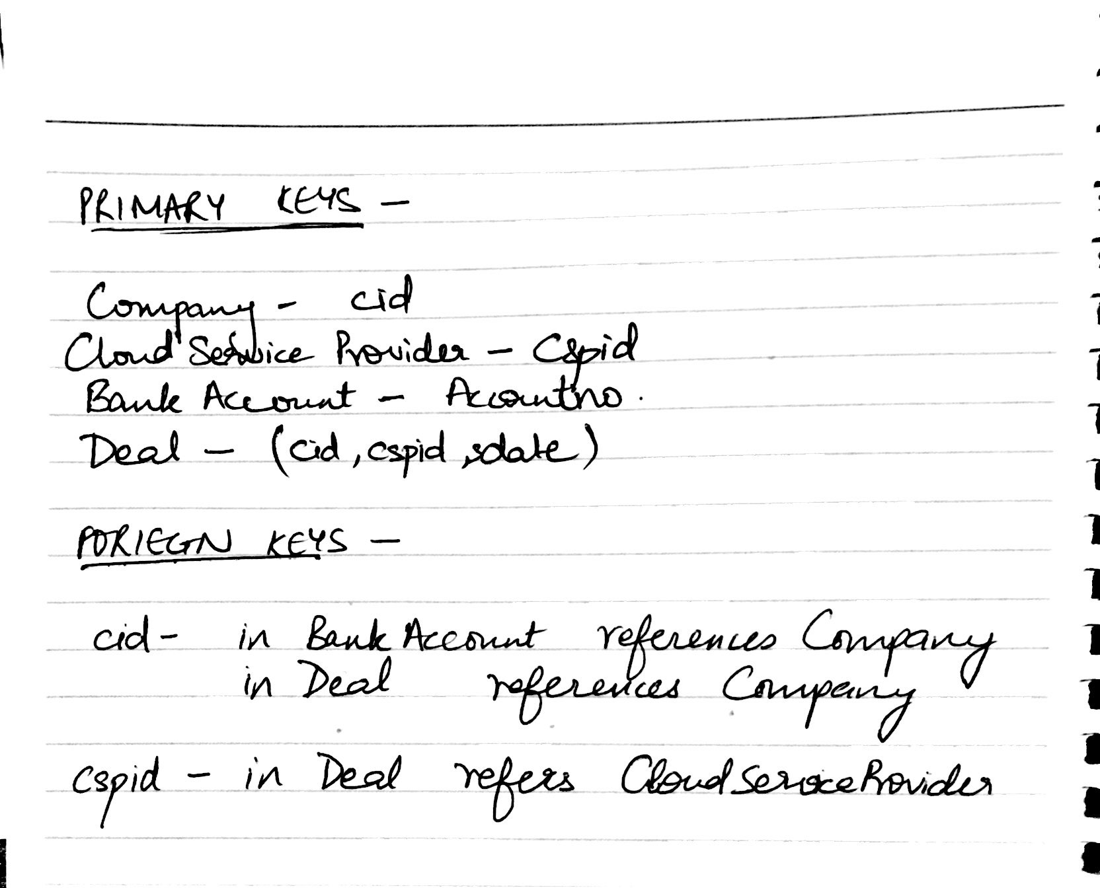

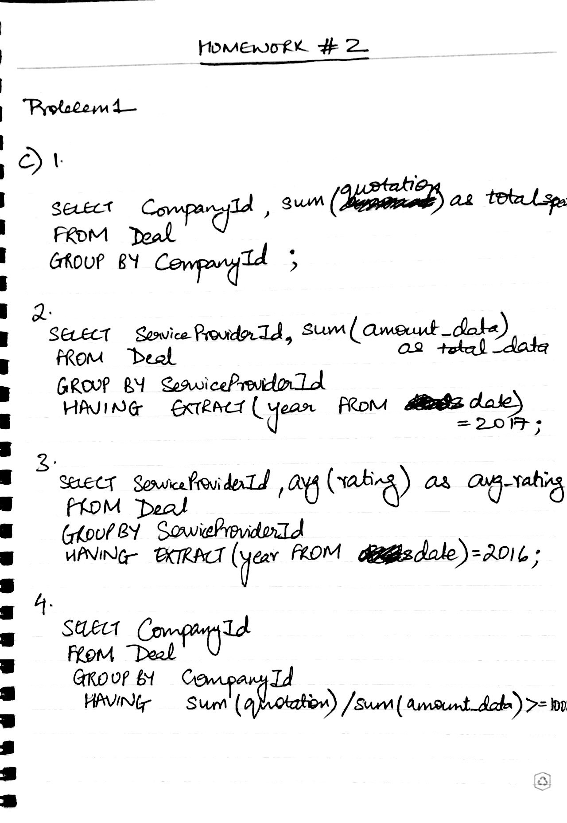

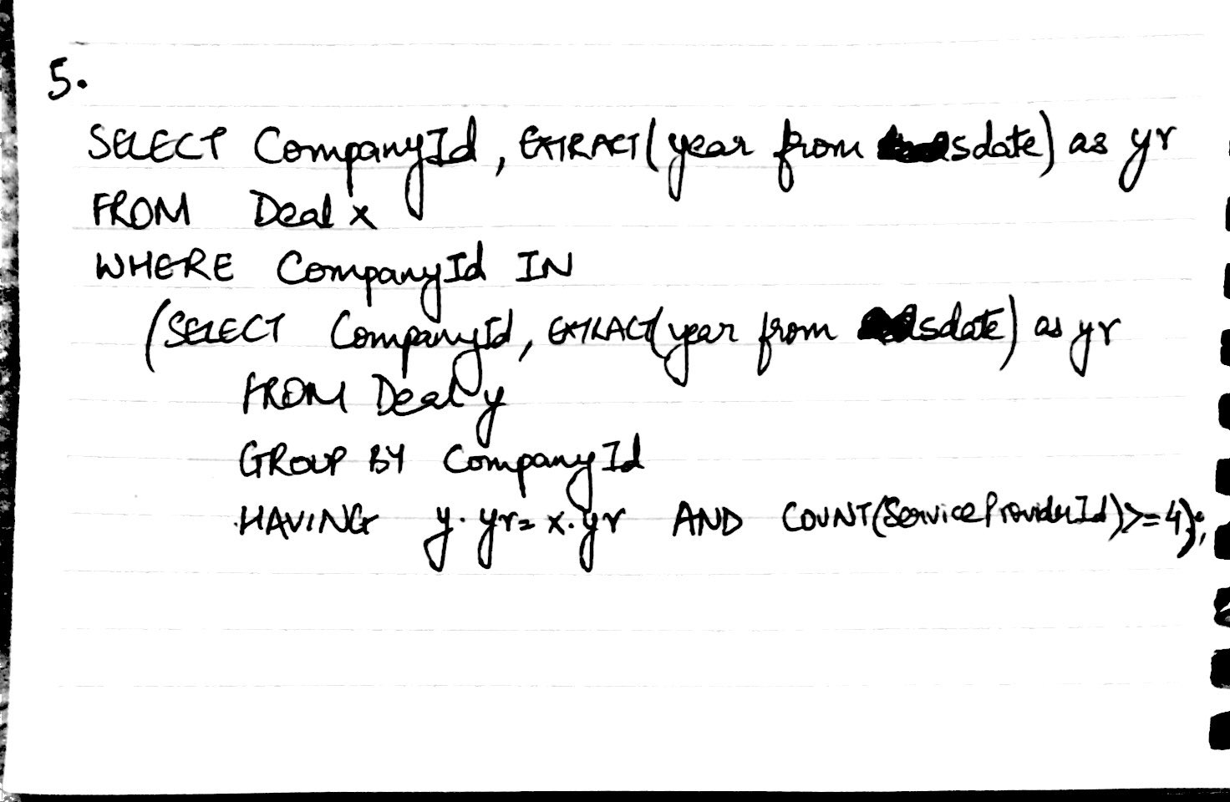

PROBLEM 2

a)

CREATE DATABASE leasing;

CREATE TABLE leasing.Customer (

cid int NOT NULL,

cname varchar(50) NOT NULL,

cphone DOUBLE NOT NULL,

ccity varchar(50) NOT NULL,

PRIMARY KEY (cid)

);

CREATE TABLE leasing.Landlord (

lid int NOT NULL,

lname varchar(50) NOT NULL,

lphone DOUBLE NOT NULL,

lcity varchar(50) NOT NULL,

PRIMARY KEY (lid)

);

CREATE TABLE leasing.Residence (

rid int NOT NULL,

rname varchar(50) NOT NULL,

rstate varchar(50) NOT NULL,

rcity varchar(50) NOT NULL,

raddr varchar(50) NOT NULL,

rtype varchar(50) NOT NULL,

rarea varchar(50) NOT NULL,

lid int NOT NULL,

PRIMARY KEY (rid),

FOREIGN KEY (lid) REFERENCES Landlord(lid)

);

CREATE TABLE leasing.Leases (

cid int NOT NULL,

rid int NOT NULL,

startdate datetime NOT NULL,

enddate datetime NOT NULL,

price DOUBLE NOT NULL,

PRIMARY KEY (cid, rid, startdate),

FOREIGN KEY (cid) REFERENCES Customer(cid),

FOREIGN KEY (rid) REFERENCES Residence(rid)

);

CREATE TABLE leasing.Rating (

cid int NOT NULL,

rid int NOT NULL,

rtime datetime NOT NULL,

score int NOT NULL CHECK (score>=1 AND score<=5),

PRIMARY KEY (cid, rid, rtime),

FOREIGN KEY (cid) REFERENCES Customer(cid),

FOREIGN KEY (rid) REFERENCES Residence(rid)

);

b)

1.

SELECT lid,rid

FROM leasing.Landlord natural join leasing.Residence

WHERE lcity='Brooklyn' AND rcity='Queens';

2.

SELECT count(r.rid),EXTRACT(Month from l.startdate) as month_in_date

FROM leasing.Residence r join leasing.Leases l on r.rid=l.rid

WHERE EXTRACT(Year from l.startdate)='2017' AND r.rcity='Chicago'

GROUP BY month_in_date;

3.

SELECT rtype, COUNT(DISTINCT (lid)) AS cnt

FROM leasing.Residence

GROUP BY rtype

HAVING cnt=max(cnt);

4.

SELECT c.*

FROM leasing.Customer c JOIN leasing.Leases l ON c.cid=l.cid

WHERE l.price = (Select max(price) from leasing.Leases);

5.

SELECT avg(price), lid, lname

FROM leasing.Leases natural join leasing.Residence natural join leasing.Landlord

GROUP BY lid;

c)

