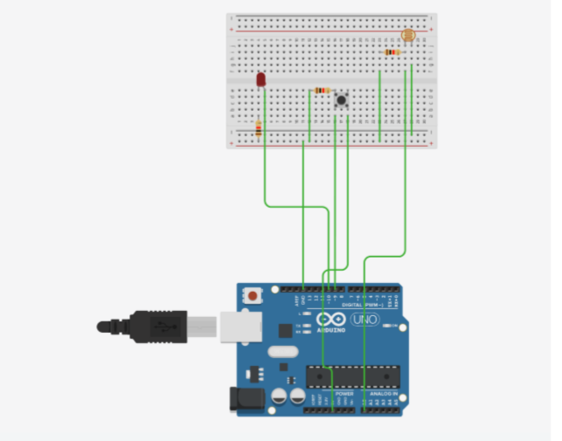

**Theory Concept Used:**

A system that automatically turns on the lights inside an almirah whenever it is opened (irrespective of day/night)

In this we will use Arduino to set up led in such a way that when ever push button is pressed led will be off and when it will be not pressed led will turn on automatically

**Learning and Observations**: Following observations were recorded during the experiment: 1. Arduino uses 5v supply 2. Turning off and on led

**Problems and Troubleshooting:** The experiment was performed successfully without any problem.

**Precautions:**

The following precautions need to be considered while performing this experiment: •  The connections of the USB in both the PC and the ARDUINO UNO board should be snug.

•  The USB ports of the PC and the ARDUINO UNO should be in a working condition.

•  The sketch should be logically and syntactically correct and germane to the experiment that needs to be performed.

• The correct serial port should be selected that is the one through which the ARDUINO UNO has been connected.

• Look for errors during compilation and upload of the executable to the ARDUINO UNO.

•  Do not open more than one instance of the ARDUINO IDE at a time.

**Learning outcomes:**

The various learnings as the outcome of performing the above-mentioned experiment are:

❖ Ability to identify and connect the push button with the ARDUINO through proper connections using a breadboard.