Kubernetes as a service in cloud

* Cloud providers like AWS, Azure , Google offering kubernetes as a service
* When we use these offerings
  + Google Kuberenetes Engine
  + Azure Kubernetes Services
  + Elastic Kubernetes Services
* The cloud provider will manage
  + the k8s master nodes
  + the networking configuration
  + Load balancing and ingress capabilities
  + Persistent Volume native support to the clouds block and file storage
  + Integrated logging and monitoring support

### Google Kubernetes Engine (GKE)

* GKE is fully managed k8s cluster offered by GCP

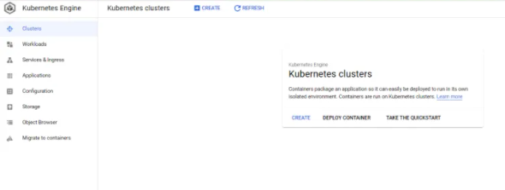

* Lets create a k8s cluster [Refer Here](https://cloud.google.com/sdk/gcloud/reference/container/clusters/create) and also navigate to the other sections
* Create a 3 node cluster

gcloud container clusters create gke-cluster --num-nodes=3 --region=us-central1

Now to configure the kubectl execute the get-credentials [Refer Here](https://cloud.google.com/sdk/gcloud/reference/container/clusters/get-credentials)