An IP (Internet Protocol) address is a unique address that different computers on a

computer network use to identify and communicate with one another. An IP

address is used as an identifier to find electronic devices connected to one another

on a network. Therefore, each device in the network must have its own unique

address. An IP address is like a mailing address that is used to deliver data (files)

to a computer.

Some IP addresses are meant to be unique within the scope of the Internet,

whereas others are meant to be unique within the scope of a specific network. The

Internet Assigned Numbers Authority (IANA) creates and manages IP addresses for

the public Internet. IANA allocates the superblocks of addresses to Regional

Internet Registries, which in turn allocate smaller blocks of addresses to Internet

service providers.

An IP address is 32 (thirty two) bits long, which can be divided into a network portion and a host portion with the help of a subnet mask. It is represented in the form of four octets, where 1 octet = 8 bits. Each octet is converted to a decimal format and is separated by a dot (.). For this reason, an IP

address is said to be expressed in a ‘dotted decimal format.’

Examples of IP addresses in decimal format:

10.1.1.1, 255.255.255.255, 220.3.1.5

The value in each octet ranges from 0 to 255 in decimal format. The ‘dotted

decimal format’ makes it easier for humans to read and remember the numbers,

but computers use IP addresses in a binary format only.

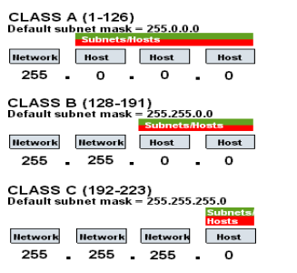

Example of an IP address in binary format:

10011101.11100010.10101110.11101000

Binary Octet to Decimal Format Conversion

There exists a well defined method for converting binary IP addresses into its

equivalent decimal format and vice versa. Humans prefer to operate on the dotted

decimal format, whereas behind the curtain, computers deal with IP addresses in

the binary form.

The right most bit or the least significant bit of an octet holds a value of 20. The bit

just to the left of it has a value of 21. This series continues until the left most 8th

bit gets a value of 27. Hence, if all the binary bits of an octet are 1, then the

decimal equivalent would be 255.

1 1 1 1 1 1 1 1

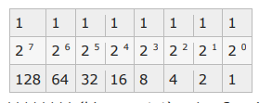

11111111 (binary octet) = 1 + 2 + 4 + 8 + 16 + 32 + 64 + 128 = 255 (decimal

format)

Below is an example where all octet bits are not 1.

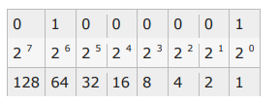

01000001 (binary octet) = 1+0+0+0+0+0+64+0 = 65 (decimal format)

**Subnet Masks**

Subnet masks represent what part of an IP address is used to determine network information versus host information. For a class B network, the subnet mask uses 16 bits, allowing the remaining 16 bits to be used for host information.

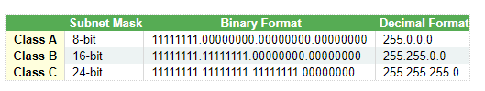

The total number of available hosts on a network can be determined from it's subnet mask. Since a class B network uses 16 bits for its subnet mask, it leaves 16 bits available for host information. 216 = 65,536. All hosts need a network address and a broadcast address. The network and broadcast addresses are indicated by either all 1s or all 0s in the host information part of an IP address. With those two addresses always reserved, the total number of assignable hosts for a class B network is 216 - 2 = 65,534.

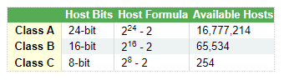

### CIDR Available Hosts

The formula to calculate the number of assignable IP address to CIDR networks is similar to classful networking. Subtract the number of network bits from 32. Raise 2 to that power and subtract 2 for the network and broadcast addresses. For example, a /24 network has 232-24 - 2 addresses available for host assignment.

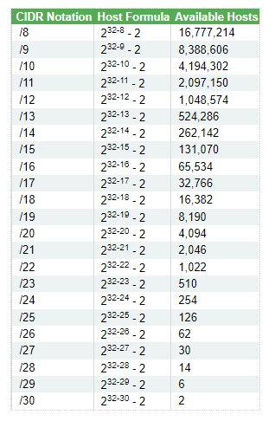

### CIDR Subnet Mask

The process to determine the subnet mask for a CIDR address is straight forward. The number of bits in the network portion of the address are converted to 1s and right padded with 0s until there are 32 numbers. The sequence of numbers is then divided into 4 octets. From then, it is a matter of converting the 4 octets from binary to decimal.

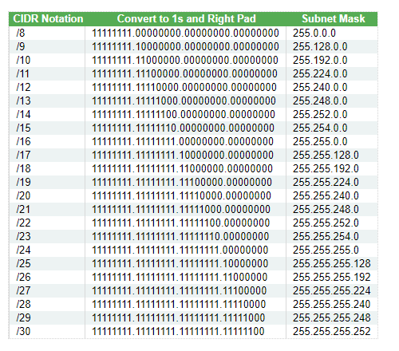

This table represents the most common reserved or special use address spaces for IPv4

