Kathmandu University Department of Computer Science and Engineering

Dhulikhel, Kavre

A Project Proposal on
PocketDev: Mobile Native Cloud Development Environment

COMP 207
(For partial fulfillment of the 2026 Year II/II in Computer Science)
Submitted by
Billjesh Man Baidya (Roll No. 06) Sujan Bhatta (Roll No. 14) Yashwant Raj Dhakal (Roll No. 20) Shaikh Abdullah Nepal (Roll No. 46)

Submitted to Mr. Suman Shrestha
Department of Computer Science and Engineering

Submission Date: 4/27/2026

Abstract
PocketDev is a mobile-native cloud development environment that enables developers to access, edit, execute, and manage their local codebases entirely from a smartphone - without requiring their personal computer to be powered on. Unlike existing browser-based solutions such as GitHub Codespaces or Gitpod, PocketDev is designed from the ground up for touch-first mobile interaction, eliminating the compromise of porting desktop tools to smaller screens.

The system operates through a lightweight CLI agent installed once on the developer's PC, which syncs the local codebase to secure per-user storage on a cloud VM using delta-based file transfer. Once synced, the PC is no longer required. From the mobile application, users can browse and edit files, execute commands, monitor live terminal output, and perform Git operations including commit, push, pull, and diff - all through a React Native interface backed by a real pseudo-terminal (PTY) session. Execution runs inside an isolated, hardened Docker container on the cloud VM; alternatively, when the developer's own desktop is online, the session is transparently routed back to that machine through a secure outbound tunnel, falling back to the cloud automatically when it is offline.

To share a single free-tier VM efficiently among multiple users, PocketDev implements a queue-based execution model using Redis and BullMQ. Free-tier users share a worker pool and are assigned a queue position when a resource-intensive command is triggered, while paid-tier users receive dedicated containers with instant execution. An on-device lightweight language model provides inline error explanation, reducing context-switching between the terminal and external documentation tools.

Keywords: Mobile Development Environment, Cloud Code Execution, PTY Streaming, Docker Containerization, gVisor Isolation, Queue-Based Scheduling, Local-Desktop Runtime, On-Device AI, React Native.

Table of Contents
Abstract 2
Table of Contents 3
List of Figures 4
List of Tables 4
Chapter 1: Introduction 5
  - Background 5
  - Objectives 5
  - Motivation and Significance 5
  - Expected Outcomes 6
Chapter 2: Related Works / Existing Works 8
Chapter 3: Procedure and Methods 9
  - Core Development Phases 9
Chapter 4: System Requirement Specifications 11
  - Software Specifications 11
  - Hardware Specifications 12
Chapter 5: Project Planning and Scheduling 13
Appendix 14
References 15

List of Figures
- Figure 1 PocketDev: System Architecture Overview
- Figure 2 PocketDev: User Flow and Execution Pipeline
- Figure 3 Estimated Gantt Chart for Software Development

List of Tables
- Table 1 Hardware Specifications
- Table 2 Project Planning and Scheduling

Chapter 1: Introduction

Background
Modern software development remains fundamentally tethered to desktop and laptop computers. While smartphones have surpassed personal computers in raw adoption and computational capability, no production-grade development environment exists that treats mobile as a first-class platform. Existing solutions such as GitHub Codespaces, Gitpod, and CodeSandbox require a browser and were architected for desktop use, resulting in degraded experiences on mobile screens. Alternatives like Termius provide only SSH access, and Working Copy covers only Git operations, leaving no unified tool that combines file management, real terminal execution, and Git workflows in a single native mobile application.

Additionally, all existing cloud-based solutions impose ongoing infrastructure costs that are passed to the user, limiting accessibility for student developers and independent contributors in regions where subscription pricing is prohibitive.

Objectives
    - Design and implement a lightweight CLI agent for one-time codebase synchronization from a local PC to cloud storage using delta-based file transfer.
    - Build a React Native mobile application providing a file browser, touch-optimized code editor, real-time terminal emulator, and Git operations panel.
    - Implement a PTY-based execution engine that streams real terminal output - including progress bars, interactive prompts, and long-running processes - over WebSocket to the mobile client.
    - Implement execution routing that runs commands on the developer's own desktop when it is online - reached through a secure outbound tunnel requiring no port forwarding - and transparently falls back to the cloud VM when the desktop is offline.
    - Develop a queue-based job scheduling system using Redis and BullMQ that lets multiple free-tier users share a single Oracle Free Tier VM, with an architecture designed to scale to many concurrent users.
    - Integrate an on-device quantized language model for inline error explanation without internet dependency.
    - Implement a freemium tier model differentiating shared queue access from dedicated container execution.

Motivation and Significance
The motivation for PocketDev originates from a direct and recurring developer pain point: the inability to perform meaningful development work from a mobile device when away from a workstation. Existing workarounds remote desktop applications, SSH clients, or browser-based IDEs - each address only part of the problem and none were designed for touch interaction.

From an infrastructure perspective, the project demonstrates that a multi-tenant cloud execution platform can be operated at zero recurring cost using Oracle Cloud's permanent free tier, which currently provides 2 ARM OCPUs and 12GB RAM per Always Free tenancy (reduced from 4 OCPUs and 24GB in June 2026). This positions PocketDev as both an engineering achievement and a viable product whose architecture is designed to scale to many users without requiring paid servers.

The project also consolidates skills developed across prior semesters - C/C++ systems thinking from the 2nd semester desktop application, IoT and React Native mobile development from the 3rd semester into a cohesive full-stack cloud and mobile engineering project.

Expected Outcomes
    - A fully functional React Native mobile application for iOS and Android supporting file editing, terminal execution, and Git operations.
    - A CLI agent capable of initial codebase sync and incremental delta updates to the cloud backend.
    - A hardened, Docker-based multi-tenant execution engine - isolated with gVisor - demonstrated on the Oracle Free Tier VM, with a queue architecture designed to scale to many concurrent users.
    - A working local-desktop execution mode that routes a session to the developer's own machine when it is online and falls back to the cloud VM otherwise.
    - A queue system that communicates real-time position and estimated wait time to mobile users.
    - On-device AI error explanation with no network dependency.
    - A working freemium model with demonstrable free and paid tier differentiation.

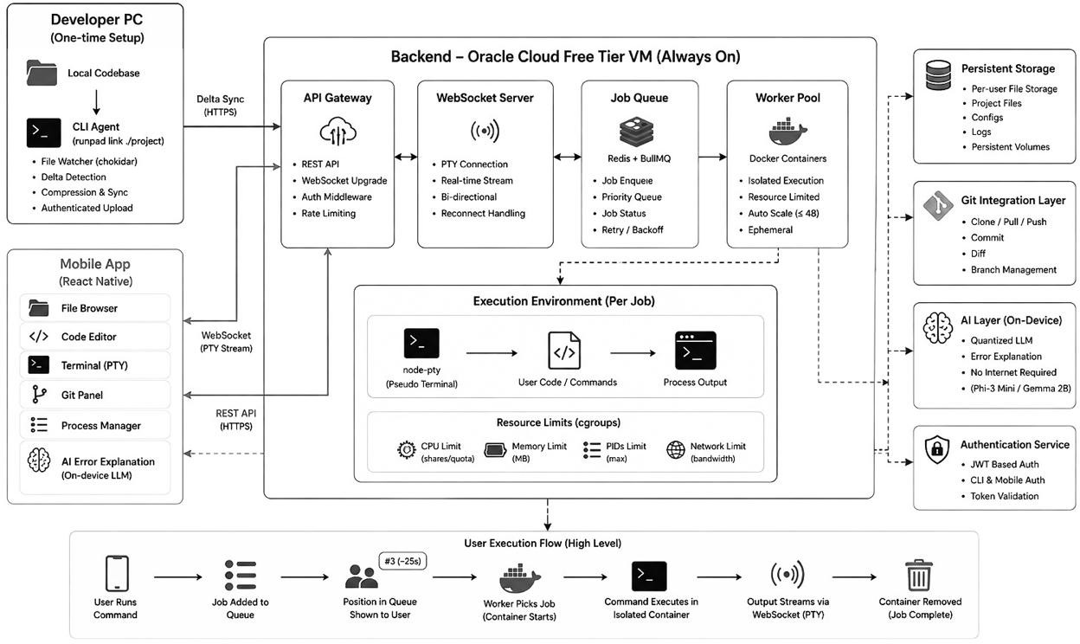
- Figure 1 PocketDev: System Architecture Overview

Chapter 2: Related Works / Existing Works
  - GitHub Codespaces (GitHub, 2022): Provides cloud-based development environments accessible via browser. Lacks a native mobile client and incurs per-hour compute costs making it inaccessible for casual or student use.
  - Gitpod (Gitpod GmbH, 2021): Browser-first cloud IDE with strong Git integration. No mobile-native application exists and pricing starts at $9/month for meaningful usage.
  - Termius (Termius, 2023): A polished SSH client for mobile. Provides terminal access to remote servers but requires the user to manage their own server infrastructure and offers no file editing, Git panel, or AI assistance.
  - Working Copy (Anders Borum, 2023): A native iOS Git client with file browsing and editing. Does not provide code execution, terminal access, or cloud syncing from a local PC.
  - Judge0 (Herman Zvonimir Dosilovic, 2019): An open-source code execution engine used by LeetCode and HackerRank. Handles isolated snippet execution but is not designed for full project environments, persistent file systems, or Git integration.
  - Replit (Replit Inc., 2022): The closest conceptual competitor. Browser-based, subscription-dependent, and not optimized for mobile. Does not support syncing from a local existing codebase.
  - Zhang et al. (2022): Demonstrated PTY-over-WebSocket architectures for browser-based terminals, validating the technical feasibility of streaming real terminal sessions to thin clients.
  - Kambatla et al. (2021): Explored queue-based resource scheduling for shared cloud compute environments, informing the BullMQ-based job lifecycle design in PocketDev.

Chapter 3: Procedure and Methods

Core Development Phases

Phase 1: Requirements Gathering and Architecture Design
The team will finalize system architecture, define API contracts between the CLI agent, backend, and mobile client, and establish Docker container resource limits. Queue behavior, tier differentiation logic, and WebSocket session management will be specified before any implementation begins.

Phase 2: CLI Agent and Backend Infrastructure
The lightweight PC-side CLI agent will be developed in Node.js, implementing folder watching, initial full sync, and subsequent delta transfers to the backend. The backend will be built as a NestJS modular monolith backed by PostgreSQL (via Prisma) for users, projects, jobs, and sessions, with a single execution worker split out as a separate process for untrusted-code isolation. The Oracle Free Tier VM will be provisioned with Docker Engine, Redis, and the BullMQ worker pool, fronted by a Caddy reverse proxy for automatic TLS. Per-user persistent storage volumes and the WebSocket PTY server will be established in this phase.

Phase 3: Execution Engine and Queue System
The Docker-based execution engine will be implemented with per-container resource limits enforced via cgroups and hardened with gVisor (runsc) so that no single user's workload can affect others or the host. The Redis and BullMQ queue system will be integrated, with real-time queue position broadcasting over WebSocket. Container lifecycle management - spin-up, execution, output streaming, and teardown - will be completed and stress tested. In addition, a desktop-agent runtime will run the same PTY-over-WebSocket server on the developer's own machine, exposed through an outbound Cloudflare Tunnel; the backend tracks desktop presence and routes each session to the desktop when it is online, falling back to the cloud container otherwise.

Phase 4: React Native Mobile Application
The mobile client will be built in React Native, implementing the file browser, touch-optimized code editor using CodeMirror mobile, the terminal UI rendering raw PTY output, the Git operations panel, and the process manager. WebSocket reconnection logic for unstable mobile networks will be implemented. UI will be designed specifically for touch interaction, not ported from desktop conventions.

Phase 5: On-Device AI Layer and Freemium Integration
A quantized language model (e.g. Phi-3 Mini or Gemma 2B, in GGUF Q4_K_M format) will be integrated into the mobile client via the llama.rn (llama.cpp) React Native binding for on-device error explanation, triggered automatically on non-zero exit codes. Paid-tier logic - dedicated container assignment and instant execution, with shareable preview URLs as a stretch goal - will be implemented and verified against free-tier queue behavior.

Phase 6: Integration, Testing, and Documentation
All components will be integrated end-to-end. Load testing will verify the queue system handles concurrent users without resource contention. Mobile UI will be tested across Android and iOS devices. Full system documentation and user guide will be completed.

Chapter 4: System Requirement Specifications

Software Specifications

User Interface (UI):
    - React Native + Expo (expo-router, NativeWind) for the cross-platform iOS and Android mobile application
    - Native touch-optimized code editor built in React Native with syntax highlighting - designed for touch, not ported from desktop conventions
    - Custom terminal renderer for PTY byte stream display on mobile
    - React Query and axios for API data fetching and caching; expo-secure-store for on-device token storage

Core Application Logic:
    - NestJS (modular monolith) backend for the REST API, authentication, WebSocket / PTY session management, and BullMQ job production, with one execution worker split out as a separate process for untrusted-code isolation
    - node-pty for pseudo-terminal session creation and piping, shared by the cloud worker (inside Docker) and the desktop agent (on the host) via a common pty-core module
    - Docker Engine for isolated per-user execution environments with cgroup resource limits, hardened with the gVisor (runsc) runtime
    - simple-git for Git operations - status, commit, push, pull, diff, and branch - invoked from the backend

Database and Persistence:
    - PostgreSQL (via Prisma ORM) as the relational store for users, projects, jobs, sessions, and subscriptions
    - JSONB columns for per-project file manifests within the relational schema

Queue and Job Scheduling:
    - Redis as the in-memory data store for job state management
    - BullMQ as the job queue library handling lifecycle, retries, and worker assignment

CLI Agent:
    - Node.js lightweight file watcher using chokidar for local codebase monitoring
    - Delta sync algorithm to push only changed files to backend storage on subsequent syncs

Local Desktop Runtime:
    - Desktop agent (Node.js) running the same PTY-over-WebSocket server on the developer's own machine
    - Cloudflare Tunnel (demo) / Tailscale (production) for outbound-only connectivity - no port forwarding or inbound ports
    - Presence-based routing in the backend - sessions run on the desktop when it is online, otherwise on the cloud VM

On-Device AI:
    - Quantized LLM (e.g. Phi-3 Mini 4K Instruct or Gemma 2B) in GGUF Q4_K_M format, run on-device via the llama.rn (llama.cpp) React Native binding
    - Triggered locally on execution error - no network call required

Authentication and Storage:
    - JWT-based authentication for mobile client and CLI agent
    - Per-user persistent volume storage on VM for codebase files

Infrastructure and Tooling:
    - Caddy reverse proxy - automatic Let's Encrypt TLS and WebSocket pass-through
    - gVisor (runsc) container runtime for the demo; Firecracker / Kata microVMs documented as the production isolation path
    - pnpm workspaces + Turborepo for monorepo build orchestration and caching
    - PM2 or systemd for keeping the API and execution worker alive on the VM

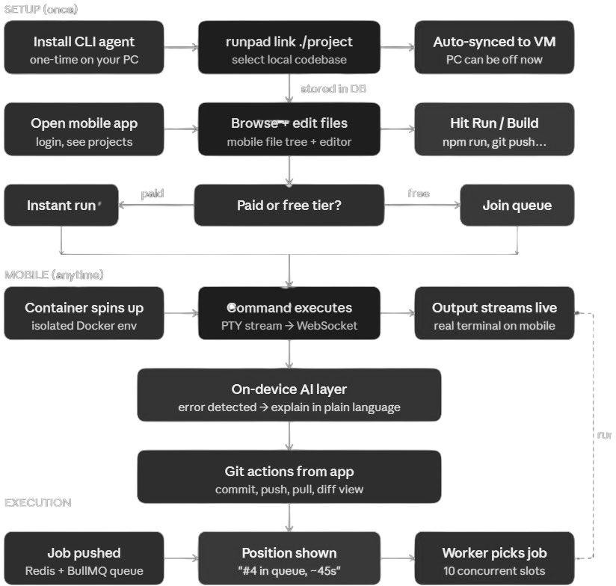

Figure 2 PocketDev: User Flow and Execution Pipeline

Hardware Specifications
Table 1: Hardware Specifications

Component | Requirements
Server | Oracle Cloud Always Free ARM VM (2 OCPU, 12GB RAM, up to 200GB block storage; reduced from 4 OCPU / 24GB in June 2026)
Mobile Device | Android 10+ or iOS 15+ with minimum 3GB RAM
Developer PC (setup only) | Any OS - Windows, macOS, or Linux - with Node.js installed
Network | Stable mobile data or WiFi for WebSocket streaming; offline file browsing supported

Chapter 5: Project Planning and Scheduling
Table 2: Project Planning and Scheduling

Week(s) | Activities
1–2 | System architecture finalization, API contract definition, Oracle VM provisioning; NestJS + PostgreSQL/Prisma backend scaffolding; Docker, Redis, and Caddy environment setup
3–4 | CLI agent development - folder watching, initial full sync, delta transfer algorithm, authentication
5–6 | Backend execution engine - PTY session management, WebSocket server, Docker container lifecycle, cgroup limits, gVisor hardening; local-desktop runtime agent and presence-based execution routing (Cloudflare Tunnel)
7–8 | Queue system implementation - Redis + BullMQ job lifecycle, real-time position broadcasting, worker pool tuning
9–10 | React Native mobile application - file browser, code editor, terminal UI, Git panel, WebSocket reconnection logic
11–12 | On-device AI integration (llama.rn), freemium tier logic, paid-tier dedicated container assignment; shareable preview URLs (stretch goal)
13–14 | End-to-end integration, load testing, cross-device UI testing, bug fixes, documentation and final report
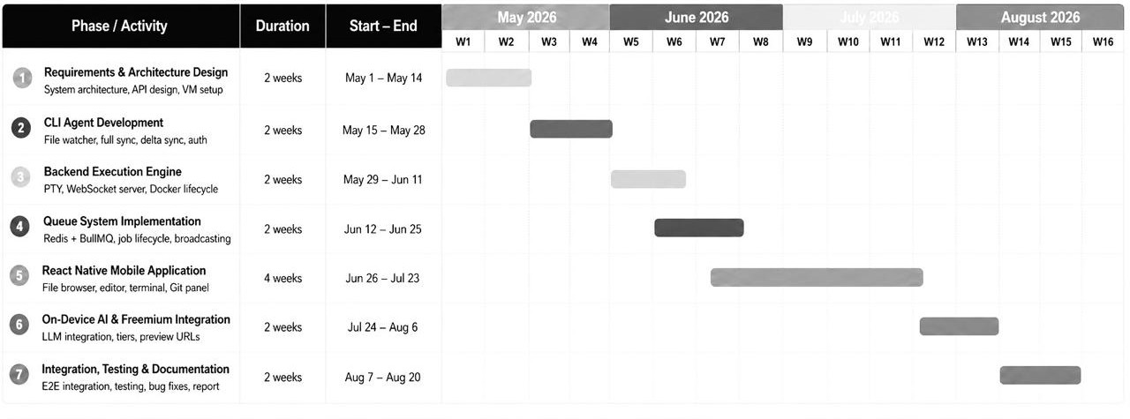
Figure 3 Estimated Gantt Chart for Software Development

Appendix

- Queue scheduling algorithm pseudocode and worker pool configuration

- CLI agent delta sync logic and file watch event handling

- Docker container resource limit configuration and cgroup settings

- On-device LLM integration architecture and model quantization details

References
  - GitHub. (2022). GitHub Codespaces: Cloud Development Environments.
  - Gitpod GmbH. (2021). Gitpod: Always Ready to Code.
  - Termius. (2023). Termius: SSH Platform for Mobile and Desktop.
  - Anders Borum. (2023). Working Copy: Git Client for iOS.
  - Dosilovic, H. Z. (2019). Judge0: Open Source Code Execution System.
  - Replit Inc. (2022). Replit: The Collaborative Browser Based IDE.
  - Zhang, L. et al. (2022). PTY-over-WebSocket Architectures for Browser-Based Terminal Emulation. IEEE Transactions on Software Engineering.
  - Kambatla, K. et al. (2021). Resource Scheduling in Shared Cloud Compute Environments. Journal of Systems Architecture.
  - Oracle Corporation. (2023). Oracle Cloud Free Tier: Always Free Cloud Services.
  - Marpe, D. et al. (2020). Delta Synchronization Algorithms for Distributed File Systems. ACM Computing Surv

