HCLTech Career Shaper Programme
IV Year Industry Project | Academic Year 2026-27
PROJECT REPORT
COVID-19 Data Analysis
and Visualisation
Project No. 48 | Domain: Data Analytics / Python
Learner Name | Yash Verma
Roll Number | 2300320130290
College / Campus | ABES EC
Mentor Name | Dipali Kedar Patki
Difficulty / Duration | Beginner | 4 Weeks | Individual Project
Submission Date | October 31, 2026

GitHub Repository: https://github.com/yashv5461/COVID19-Data-Analysis

Contents
1. Introduction
2. Objectives and Scope
3. Tools and Technology Stack
4. Dataset Description
5. System Architecture
6. Data Preparation and Cleaning
7. Exploratory Data Analysis
8. Interactive Dashboard
9. Results and Key Metrics
10. Challenges and Resolutions
11. Ethical Considerations
12. Conclusion and Future Scope
13. References
Appendix A: Analysis Code
Appendix B: Data Dictionary
Appendix C: AI Tool Disclosure

1. Introduction

1.1 Background
COVID-19 was first reported in late 2019 and was declared a pandemic by the World Health Organization (WHO) in March 2020. Over the following four years, countries published daily and weekly counts of cases, deaths and vaccinations. These figures are large, uneven and hard to compare: countries differ in population, testing, reporting schedules and data quality. Raw totals alone can mislead, for example by making large countries look worse simply because they have more people.
This project uses Python to clean, analyse and visualise the public Our World in Data (OWID) COVID-19 dataset, which compiles official WHO figures for every country. The result is a cleaned dataset in the 8-column format given in the project brief, a reproducible analysis notebook with 11 charts, and an interactive Plotly dashboard.

1.2 Problem Statement (5W1H)
- Who: students, analysts, public-health readers and decision-makers who need a clear, fair picture of how COVID-19 spread, how deadly it was and how vaccination progressed across countries.
- What: the official data is spread over hundreds of thousands of rows with gaps, revisions, reporting backlogs and no common scale, so it is difficult to compare countries or see the overall trend.
- When / where: worldwide, from January 2020 to August 2024, across 234 countries and territories.
- Why: misreading pandemic data leads to wrong conclusions about risk, policy and vaccine impact; clear and honest visualisation supports better public understanding.
- How: clean the data with pandas, flag quality problems, compute fair comparison measures (per million, case fatality rate, vaccination coverage), and present them in charts and an interactive dashboard.

1.3 Project Repository
All project artefacts (data preparation script, cleaned dataset, data dictionary, analysis notebook, charts, dashboard, report and synopsis) are kept in the project repository: https://github.com/yashv5461/COVID19-Data-Analysis.

2. Objectives and Scope
The objective is to turn the raw COVID-19 records into a clean, documented dataset and a set of clear, objective visualisations that answer basic questions about the pandemic. The specific objectives are:
- Audit the dataset supplied with the brief and document its quality problems.
- Build a cleaned dataset of 200,000+ rows across 200+ countries from the OWID source, in the brief's 8-column format.
- Flag data-quality problems (revisions, backlogs, impossible values) instead of silently deleting rows.
- Measure the spread, mortality and vaccination progress of COVID-19 globally, by continent and by country.
- Produce at least 3 visualisations (11 were produced) and an interactive Plotly dashboard.
- Report findings objectively, with sources cited and limitations stated.
Scope: descriptive and exploratory analysis of reported figures. Forecasting, causal analysis of policies, and sub-national (state-level) data are outside the scope.

2.1 Work Plan
Table 1: Work plan mapped to the four project weeks
Week | Focus | Output
1 | Problem understanding, tool setup, audit of dataset.csv, EDA plan | Problem statement, audit results
2 | Architecture design; data preparation script on the OWID dataset | dataset.csv, anomalies.csv, data dictionary
3 | EDA notebook, charts and the interactive Plotly dashboard; checks of every figure | Notebook, 11 charts, dashboard
4 | Report, synopsis, GitHub repository, demo preparation | Report, synopsis, repository, demo

2.2 Analysis Questions and Metrics
Table 2: Analysis questions and metric definitions
Item | Definition
Q1: How did the pandemic evolve over time? | Weekly new cases and deaths, world total
Q2: Which countries and continents were hit hardest? | Total cases; deaths per million people
Q3: How deadly was a reported case, and did that change? | Case fatality rate (CFR) = deaths / confirmed cases
Q4: How fast and how evenly did vaccination progress? | Share of population with at least one dose
Q5: How are the country-level measures related? | Spearman rank correlation
Fair-comparison rule | Per-million rankings use countries with population of 1 million or more

3. Tools and Technology Stack
Table 3: Tools used and their role
Layer | Tool | Purpose
Language | Python 3 | Data preparation, analysis and dashboard generation
Data handling | pandas, NumPy | Loading, cleaning, reshaping, grouping
Statistics | SciPy (stats) | Spearman correlation and p-values
Static visualisation | Matplotlib, Seaborn | 11 charts in the notebook and report
Interactive visualisation | Plotly (plotly.js) | Dashboard: country selector, world map, top-15 ranking
Environment | Jupyter Notebook / Google Colab | One reproducible analysis notebook
Storage | CSV files | Cleaned dataset, anomalies, data dictionary
Version control | Git and GitHub | Project repository
Diagrams | Mermaid | Data flow and block diagrams

4. Dataset Description

4.1 Source
The analysis uses the Our World in Data COVID-19 dataset (owid-covid-data.csv, GitHub repository owid/covid-19-data, licence CC BY 4.0). OWID compiles case and death counts reported to the WHO, and vaccination counts from national governments. The raw file has 429,435 rows and 67 columns covering 255 locations (including regional aggregates) from 1 January 2020 to 14 August 2024.
The WHO publishes country totals once a week, so in this data the cumulative figures change on one day each week. All trends in this report are therefore shown as weekly totals or 7-day averages.

4.2 Audit of the Supplied dataset.csv
The brief supplied a 500-row dataset.csv (10 countries over 50 days, January to February 2024). It has no missing values or duplicates, but its values are not internally consistent:
Table 4: Quality audit of the supplied dataset.csv
Check | Result | Reading
Countries with more than one population value | 10 of 10 | Population should be fixed per country
Countries assigned to more than one continent | 10 of 10 | e.g. India appears as Oceania, Africa and Americas
Rows where vaccinated > population | 342 of 500 (68%) | Impossible values
Rows where deaths > confirmed | 9 of 500 | Impossible values
Rows where recovered > confirmed | 228 of 500 (46%) | Impossible values
Countries whose cumulative 'confirmed' falls | 10 of 10 | Values rise and fall at random

Charts built on this file would show noise rather than the pandemic. Following the brief's dataset prompt ("Use Our World in Data COVID-19 dataset ... Clean and analyse 200,000+ rows across 200 countries"), the analysis uses the real OWID data reshaped into exactly the same 8 columns. The supplied file is kept unchanged in the repository as data/dataset_original.csv.

4.3 Cleaned Dataset at a Glance
Table 5: Cleaned dataset at a glance
Property | Value
File | data/dataset.csv
Rows x columns | 391,716 x 8
Countries / territories | 234 (6 continents)
Date range | 5 January 2020 to 4 August 2024 (1,674 days per country)
Missing values | Only in vaccinated: 35,154 rows (9%), for 21 territories that never reported
Duplicate country-date rows | 0
Rows flagged by quality rules | 5,509 (1.41%), listed in data/anomalies.csv

4.4 Column Overview
Table 6: Columns in dataset.csv (full dictionary in Appendix B)
Column | Type | Meaning
date | date | Reporting date (YYYY-MM-DD)
country | text | Country or territory name
confirmed | integer | Cumulative reported cases
deaths | integer | Cumulative reported deaths
recovered | integer (estimated) | Confirmed 14 days earlier minus deaths; not an official figure
vaccinated | integer, nullable | Cumulative people with at least one vaccine dose
population | integer | Country population (UN 2022 estimate)
continent | text | Continent of the country

5. System Architecture
Figure 1 shows the Level 0 data flow diagram: the system takes raw records from the external OWID/WHO source and user selections, and returns charts, key figures and an interactive dashboard. Figure 2 shows the internal blocks: a data preparation script writes the clean data store, which feeds both the analysis notebook and the dashboard builder.
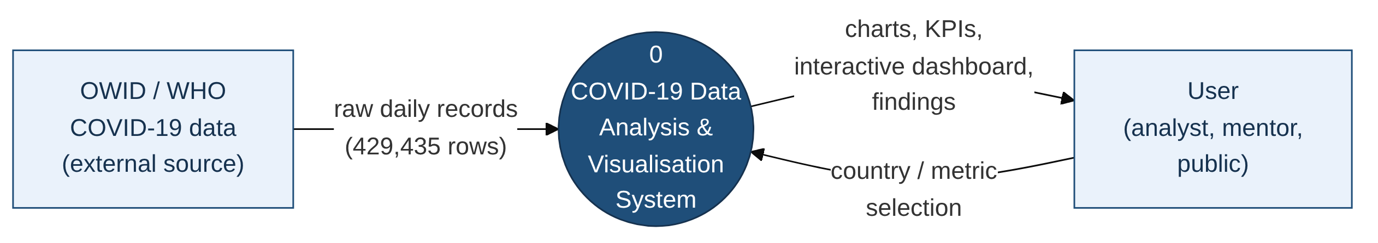
Figure 1: Data flow diagram, Level 0
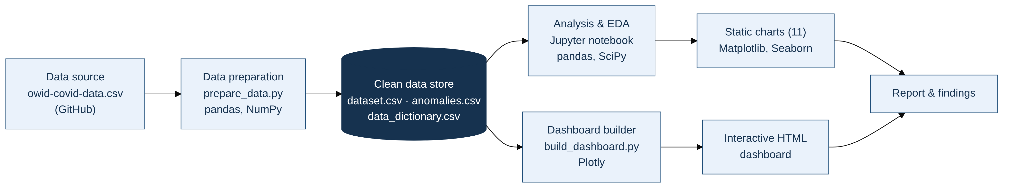
Figure 2: System block diagram
Table 7: Main program blocks
Block | File | Role
Data preparation | src/prepare_data.py | Downloads the OWID file if needed, cleans it, writes dataset.csv, anomalies.csv and cleaning_log.csv
Analysis | notebooks/COVID19_Data_Analysis.ipynb | Audit, feature engineering, EDA, correlation, 11 charts saved to images/
Dashboard | src/build_dashboard.py | Builds dashboard/covid_dashboard.html (works offline)

6. Data Preparation and Cleaning
The cleaning steps are written in src/prepare_data.py, so the dataset can be rebuilt with one command. The table below shows the row count after each step.
Table 8: Cleaning steps and row counts
Step | Action | Rows | Countries
1 | Load raw OWID file (8 needed columns of 67) | 429,435 | 255
2 | Remove aggregates (World, continents, income groups, EU, UK nations); keep Kosovo | 396,985 | 238
3 | Remove rows before a country began reporting | 391,716 | 234
4 | Convert types, trim names, remove duplicate country-date rows (none found), sort | 391,716 | 234
5 | vaccinated: carry the last reported value forward; 0 before the first report | 391,716 | 234
6 | recovered: estimate as confirmed 14 days earlier minus deaths (minimum 0) | 391,716 | 234
7 | Rename to the brief's 8 columns and save dataset.csv | 391,716 | 234

6.1 Data-Quality Rules
Problem rows were flagged, not deleted, so the cleaned file stays faithful to the official source. 5,509 rows (1.41%) are flagged in data/anomalies.csv:
Table 9: Data-quality rules and results
Rule | Rows | Countries | Example and treatment
vaccinated > population | 4,861 | 6 | UAE, Qatar, Gibraltar vaccinated non-residents; coverage capped at 100% in charts
Weekly cases > 5x previous 4-week average (and > 1,000) | 403 | 162 | China's December 2022 backlog; start of new waves; labelled on charts
deaths > confirmed | 217 | 5 | Early-2020 reporting mismatches (France, Germany); kept
Cumulative cases decreased | 19 | 19 | Downward revisions; daily value set to 0
Cumulative deaths decreased | 12 | 12 | Downward revisions; daily value set to 0

6.2 Derived Measures
- Daily / weekly new cases and deaths: difference between consecutive cumulative values (negative values set to 0), summed by week.
- Cases and deaths per million: cumulative count divided by population, multiplied by 1,000,000.
- Case fatality rate (CFR): deaths divided by confirmed cases. It measures deaths among reported cases, not among all infections.
- Vaccination coverage: people with at least one dose divided by population, capped at 100%.

7. Exploratory Data Analysis

7.1 Global Overview
Table 10: Global key figures
Measure (as of 4 August 2024) | Value
Total reported cases | 775,866,783
Total reported deaths | 7,057,132
Case fatality rate | 0.91%
People with at least one vaccine dose | 5,600,534,396 (70.5% of population)
Deaths per million people | 888

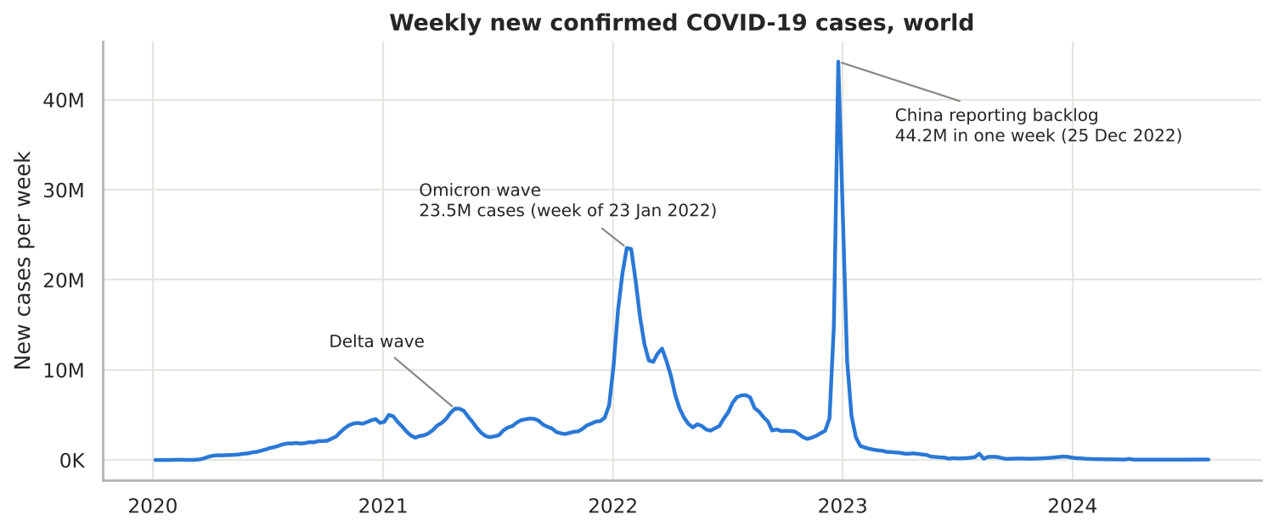
Figure 3: Weekly new confirmed cases, world
Figure 3 shows the main waves. The Delta wave peaked in spring 2021 and the Omicron wave in January 2022, when 23.5 million cases were reported in the week ending 23 January 2022. The single highest week (25 December 2022, 44.2 million) is a reporting artefact: China reported about 40.5 million cases at once after ending its zero-COVID policy. The quality rules flag this week.
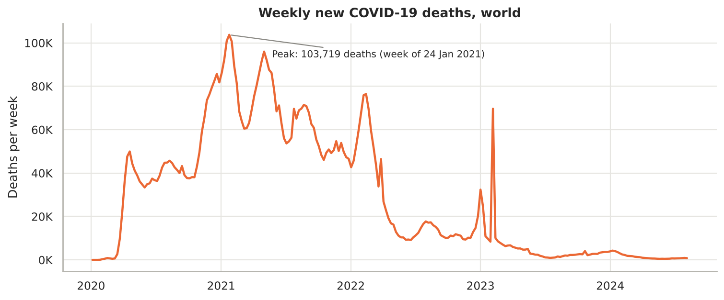
Figure 4: Weekly new deaths, world
Deaths followed a different pattern from cases. They peaked in the week ending 24 January 2021 (103,719 deaths), stayed high through the Delta period, and fell sharply after early 2022 even though Omicron produced far more cases. The short spike in early 2023 is again China's backlog.
Table 11: Cases, deaths and case fatality rate by year
Year | New cases | New deaths | CFR
2020 | 80,317,671 | 1,897,584 | 2.36%
2021 | 200,298,480 | 3,549,359 | 1.77%
2022 | 424,017,377 | 1,249,137 | 0.29%
2023 | 69,238,166 | 322,712 | 0.47%
2024 (to 4 Aug) | 2,063,363 | 42,302 | 2.05% (few tests, unreliable)

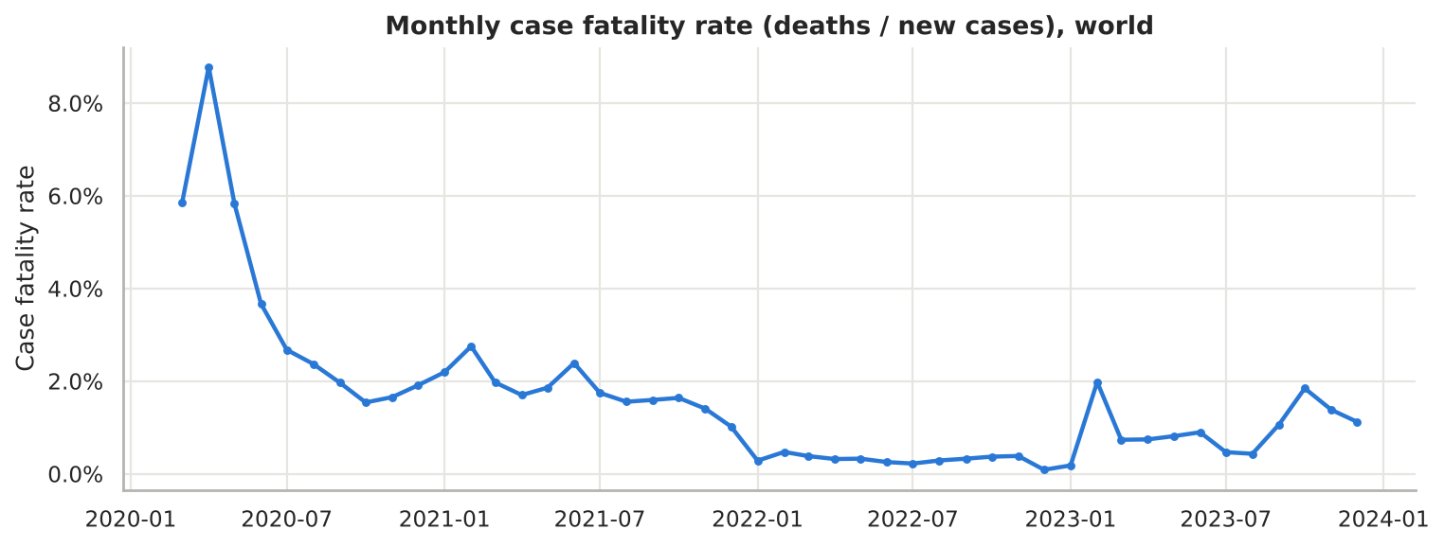
Figure 5: Monthly case fatality rate, world (March 2020 to December 2023)
The case fatality rate fell from 2.36% in 2020 to 0.29% in 2022. Three reasons explain this: wider testing found more mild cases, treatment improved, and vaccination reduced severe illness. The very high values in early 2020 reflect limited testing, when mainly severe cases were confirmed. In 2024 very few cases were still being tested, so the 2024 rate is not comparable.

7.2 Country Comparison
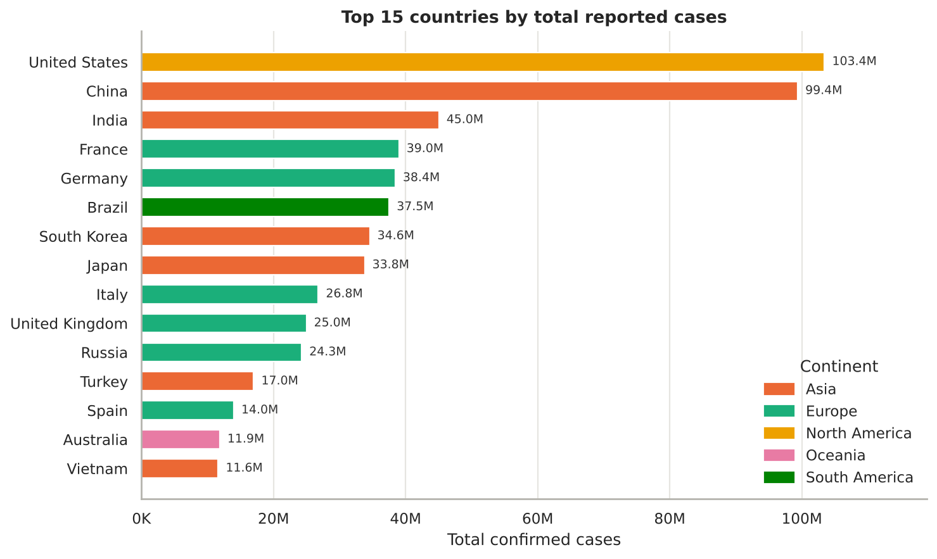
Figure 6: Top 15 countries by total reported cases
The United States (103.4 million), China (99.4 million) and India (45.0 million) reported the most cases. Totals mostly reflect population size and testing volume, so per-million figures are used for fair comparison.
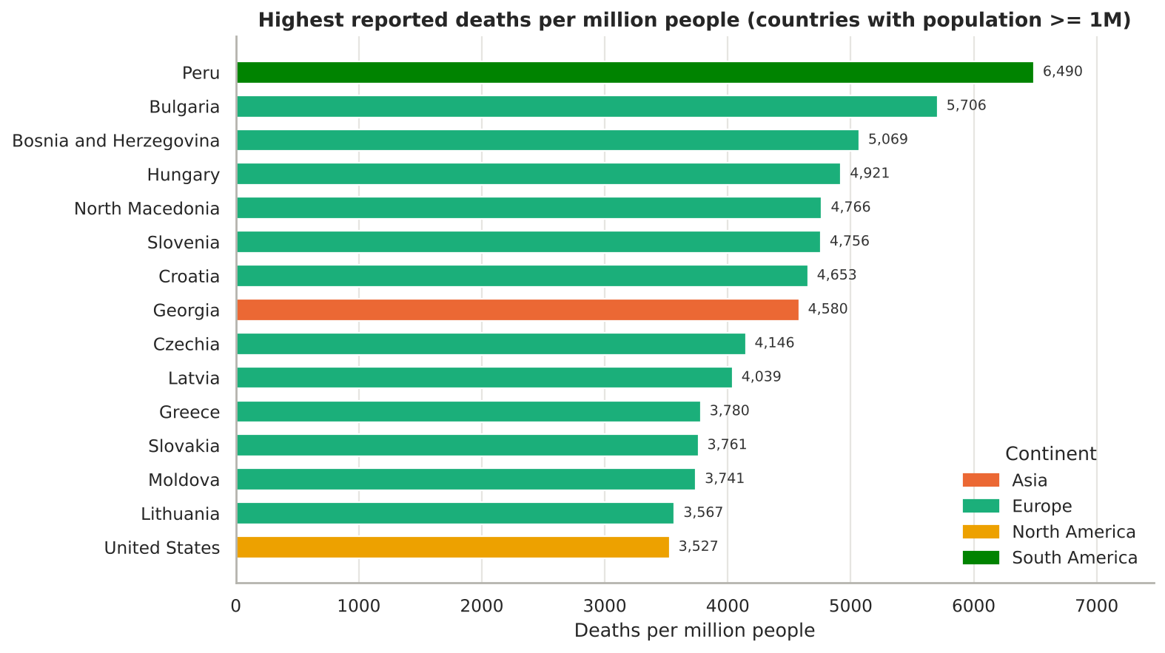
Figure 7: Highest reported deaths per million (population 1 million or more)
By deaths per million, Peru has the highest reported rate (6,490), followed by Bulgaria (5,706), Bosnia and Herzegovina (5,069) and Hungary (4,921). Twelve of the top fifteen are in Europe, mostly Eastern and Central Europe. The United States is fifteenth with 3,527 deaths per million.

7.3 Continent Comparison
Table 12: Key measures by continent (as of 4 August 2024)
Continent | Countries | Cases per million | Deaths per million | CFR | Vaccinated (1+ dose)
South America | 14 | 157,525 | 3,100 | 1.97% | 86.0%
Europe | 51 | 338,390 | 2,813 | 0.83% | 70.1%
North America | 41 | 207,376 | 2,784 | 1.34% | 76.4%
Oceania | 24 | 333,120 | 731 | 0.22% | 64.3%
Asia | 47 | 64,294 | 349 | 0.54% | 78.0%
Africa | 57 | 9,217 | 182 | 1.97% | 38.9%

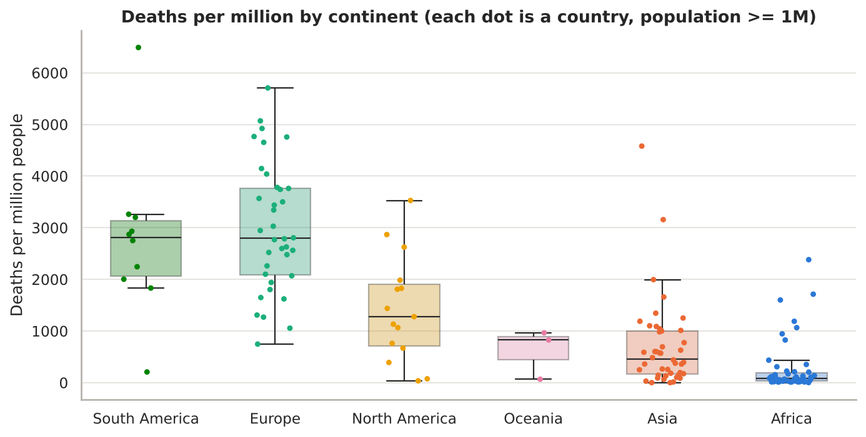
Figure 8: Deaths per million by continent; each dot is a country
South America and Europe have the highest median death rates. Africa's very low reported figures should be read with care: testing and death registration were limited in many African countries, so reported counts understate the true burden.
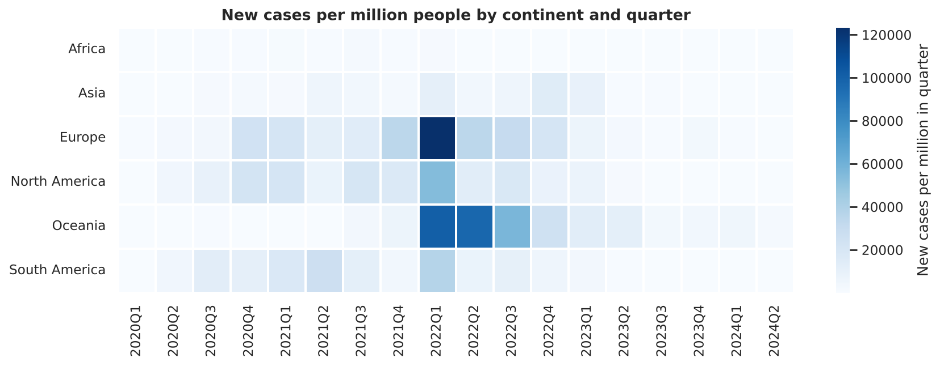
Figure 9: New cases per million people by continent and quarter
The heatmap shows when each continent was hit. Europe's heaviest quarter was the Omicron wave in early 2022. Oceania had almost no cases until 2022, then its heaviest quarters in the first half of 2022, after Australia and New Zealand reopened their borders.

7.4 Vaccination
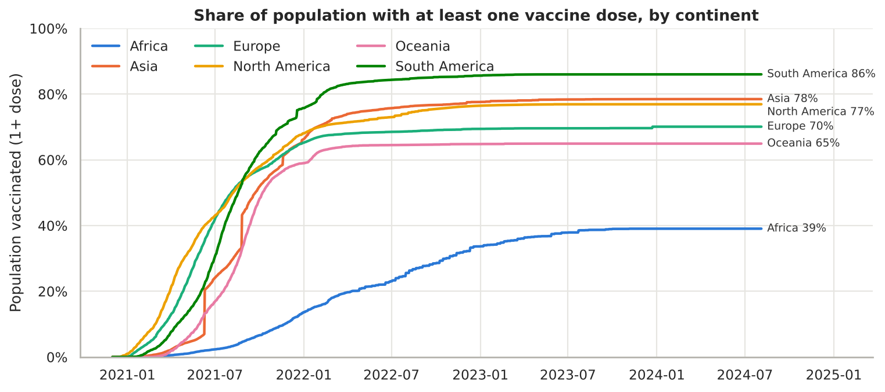
Figure 10: Share of population with at least one vaccine dose, by continent
Vaccination began in December 2020. North America and Europe moved first; South America reached the highest coverage (86%). Africa reached only 39%, showing the unequal global access to vaccines. The step in Asia's line in mid-2021 is when China began reporting people vaccinated.
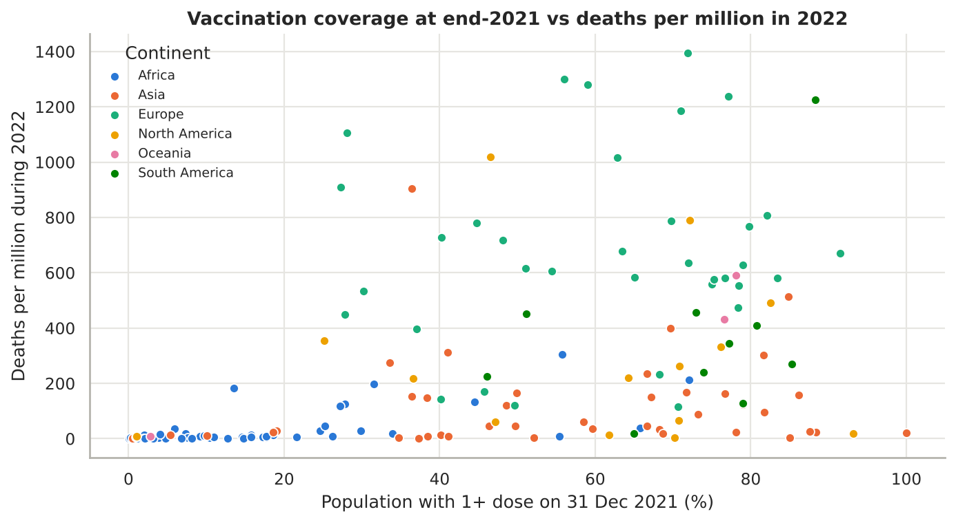
Figure 11: Vaccination coverage at end-2021 vs deaths per million in 2022
Across 154 countries (population 1 million or more), coverage at the end of 2021 and reported deaths per million in 2022 have a positive Spearman correlation (rho = 0.62, p < 0.001). This does not mean vaccines increased deaths. It is an example of confounding: the most vaccinated countries are mostly richer countries with older populations and more complete death reporting. Country-level data cannot measure vaccine effect; that needs clinical trials and individual-level studies. The result is reported as an association only.

7.5 Case Study: India
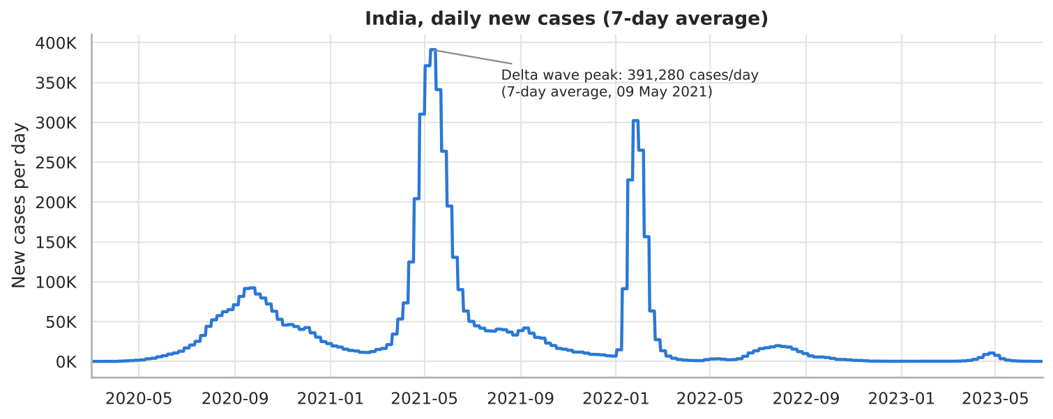
Figure 12: India, daily new cases (7-day average)
India reported 45,041,748 cases and 533,623 deaths (CFR 1.18%, 377 deaths per million), with 72.5% of the population vaccinated with at least one dose. The Delta wave in April and May 2021 was the most severe, averaging 391,280 new cases per day in the week ending 9 May 2021. A shorter Omicron wave followed in January 2022.

7.6 Correlation Analysis
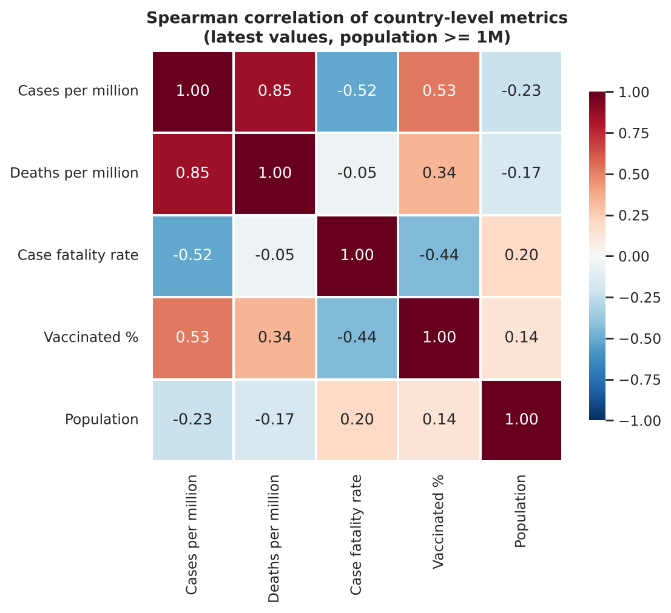
Figure 13: Spearman correlation of country-level measures (population 1 million or more)
Cases per million is strongly correlated with deaths per million (0.85) and moderately with vaccination coverage (0.53); all three tend to be higher where testing and reporting were stronger. The case fatality rate is negatively correlated with cases per million (-0.52): countries that tested widely found many mild cases, which lowers the rate. Population size has little relationship with any rate.

8. Interactive Dashboard
The dashboard (dashboard/covid_dashboard.html) is a single HTML file built with Plotly. Plotly.js and the map outlines are embedded in the file, so it opens in any browser without an internet connection, which suits a live demo.
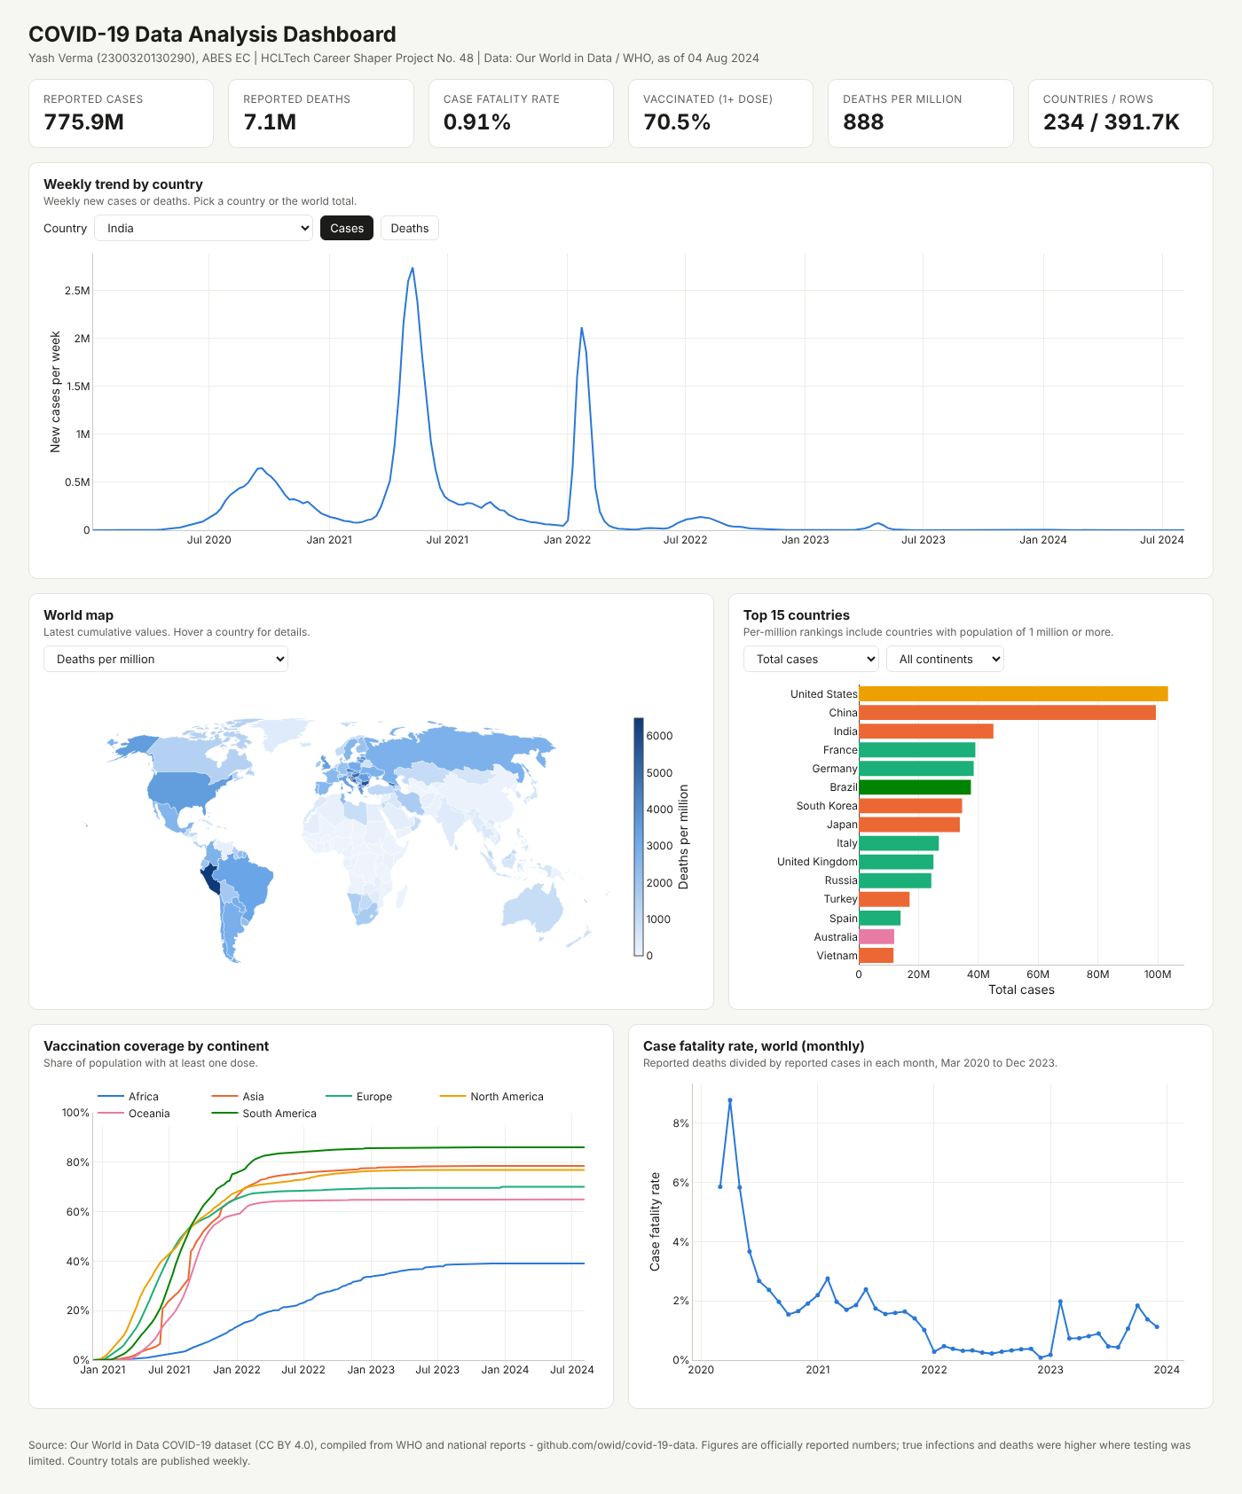
Figure 14: Interactive Plotly dashboard
Table 13: Dashboard panels
Panel | Interaction
Key figures | Total cases, deaths, CFR, vaccination share, deaths per million, row count
Weekly trend | Choose any of 234 countries or the world; switch between cases and deaths; hover for weekly values
World map | Choose deaths per million, cases per million or vaccination %; hover a country
Top 15 countries | Rank by total cases, deaths, or per-million rates; filter by continent
Vaccination by continent | Hover to compare all continents on one date
Case fatality rate | Monthly world CFR, March 2020 to December 2023

9. Results and Key Metrics
Table 14: Key results
Metric | Result
Data processed | 429,435 raw rows -> 391,716 clean rows, 234 countries, 8 columns
Data quality | 0 duplicates; 5,509 rows (1.41%) flagged by 5 rules; missing values only in vaccinated (9%)
Visualisations | 11 static charts + 1 interactive dashboard with 6 panels (brief requires 3+)
Global burden | 775.9 million reported cases, 7.06 million reported deaths, CFR 0.91%
Severity trend | CFR fell from 2.36% (2020) to 0.29% (2022)
Hardest-hit (per million) | Peru 6,490 deaths per million; Europe and South America highest by continent
Vaccination gap | South America 86% vs Africa 39% with at least one dose
Reproducibility | Full pipeline re-runs with 3 commands; notebook runs top to bottom without errors

Business value: the project turns a large, inconsistent public dataset into a documented, reproducible and interactive view that a non-technical reader can explore. The cleaning script, quality flags and data dictionary can be reused for any update of the OWID data.

10. Challenges and Resolutions
Table 15: Challenges and resolutions
Challenge | Resolution
The supplied dataset.csv had impossible values (populations and continents changing by row, vaccinated above population) | Audited and documented it; used the real OWID data in the same 8 columns, as the brief's dataset prompt recommends
OWID/WHO do not publish recoveries | Estimated recovered as confirmed 14 days earlier minus deaths, and labelled it as an estimate everywhere
Totals are published weekly, so daily differences are 0 on six days | Used weekly totals and 7-day averages for all trends
China's December 2022 backlog distorts the global peak | Flagged by a spike rule and labelled on the charts; Omicron peak reported separately
Population and reporting differences make totals unfair | Used per-million rates and a 1-million population threshold for rankings
Large file (98 MB raw) for GitHub | Raw file excluded from the repository and downloaded automatically by the script
Map needed an internet connection to load outlines | Embedded country outlines and Plotly in the dashboard file

10.1 Limitations
Table 16: Limitations
Limitation | Effect | Mitigation
Reported, not true, figures | Cases and deaths are undercounted, especially with low testing | Stated with every result; excess-mortality data suggested as future work
Recovered is estimated | Not an official figure | Not used for any conclusion
Different reporting quality by country | Comparisons can be biased | Per-million rates; findings framed as reported figures
Country-level correlation | Cannot show cause and effect | Associations reported only, with confounders named
Data ends August 2024 | Later changes not covered | Script can rebuild from a newer OWID file

11. Ethical Considerations
- Source and licence: the data comes from Our World in Data (CC BY 4.0) and the WHO, credited on every chart, the dashboard and the references.
- Privacy: the dataset contains country-level totals only. It has no names or personal information about any individual.
- Objectivity: COVID-19 data can be politically sensitive. Figures are presented as officially reported, without ranking governments or assigning blame, and the limits of reporting are stated.
- Transparency: problem rows are flagged and explained, not hidden or deleted; the estimated recovered column is labelled.
- Responsible interpretation: correlations are not presented as causes; the vaccination-deaths association is explained, not over-interpreted.
- AI disclosure: the use of AI tools is disclosed in Appendix C.
- Data protection: no personal data is processed, so the Digital Personal Data Protection Act, 2023 is complied with.

12. Conclusion and Future Scope
The project cleaned 429,435 raw records into a documented dataset of 391,716 rows across 234 countries, in the 8-column format of the brief, and analysed it with 11 charts and an interactive dashboard. The analysis shows that 775.9 million cases and 7.06 million deaths were reported worldwide; that deaths peaked in January 2021 while cases peaked with Omicron in January 2022; that the case fatality rate fell sharply after 2021; and that vaccination coverage was very unequal, with Africa far behind other continents. It also shows why careful cleaning and fair measures matter: reporting backlogs, revisions and differences in testing can easily mislead.
Future scope:
- Add excess-mortality data to estimate deaths missed by official reporting.
- Add testing, hospitalisation and policy-stringency data to explain differences between countries.
- Forecast cases with time-series models such as ARIMA or Prophet.
- Deploy the dashboard online (for example, with Streamlit or GitHub Pages) with scheduled data refresh.
- Add state-level analysis for India.

13. References
- Mathieu, E., Ritchie, H., Rodés-Guirao, L. et al. Coronavirus Pandemic (COVID-19). Our World in Data, 2020. https://ourworldindata.org/coronavirus
- Our World in Data. COVID-19 dataset (owid-covid-data.csv), CC BY 4.0. https://github.com/owid/covid-19-data
- World Health Organization. WHO COVID-19 dashboard. https://data.who.int/dashboards/covid19
- Mathieu, E. et al. A global database of COVID-19 vaccinations. Nature Human Behaviour 5, 947-953, 2021.
- McKinney, W. Python for Data Analysis, 3rd edition. O'Reilly Media, 2022.
- Plotly Technologies Inc. Plotly JavaScript and Python documentation. https://plotly.com/python/
- pandas development team. pandas documentation. https://pandas.pydata.org/docs/
- Government of India, Ministry of Electronics and Information Technology. The Digital Personal Data Protection Act, 2023.

Appendix A: Analysis Code
The full code is in the repository: src/prepare_data.py (cleaning), notebooks/COVID19_Data_Analysis.ipynb (analysis) and src/build_dashboard.py (dashboard). Key blocks are shown below in run order.
# --- block 1: keep countries only and drop rows before reporting began (prepare_data.py) ---
is_aggregate = df["iso_code"].str.startswith("OWID_") & (df["iso_code"] != "OWID_KOS")
df = df[~is_aggregate & df["continent"].notna()].copy()
df = df[df["total_cases"].notna() & df["total_deaths"].notna()].copy()
df = df.drop_duplicates(subset=["location", "date"]).sort_values(["location", "date"])

# --- block 2: vaccinated (carry forward) and estimated recovered ---
first_vax = df.loc[df["people_vaccinated"].notna()].groupby("location")["date"].min()
df["vaccinated"] = df.groupby("location")["people_vaccinated"].ffill()
df.loc[df["date"] < df["location"].map(first_vax), "vaccinated"] = 0
lagged = df.groupby("location")["total_cases"].shift(14).fillna(0)
df["recovered"] = (lagged - df["total_deaths"]).clip(lower=0)

# --- block 3: data-quality rules (rows are flagged, not deleted) ---
new_cases = df.groupby("country")["confirmed"].diff()
avg_week = new_cases.clip(lower=0).groupby(df["country"]).transform(
lambda s: s.rolling(28, min_periods=28).sum().shift(1) / 4)
rules = {"confirmed_decreased": new_cases < 0,
"deaths_exceed_confirmed": df["deaths"] > df["confirmed"],
"vaccinated_exceed_population": df["vaccinated"] > df["population"],
"case_spike_over_5x_4week_avg": (new_cases > 5 * avg_week) & (new_cases > 1000)}

# --- block 4: feature engineering (notebook) ---
g = df.groupby("country")
df["new_cases"] = g["confirmed"].diff().clip(lower=0).fillna(df["confirmed"])
df["new_deaths"] = g["deaths"].diff().clip(lower=0).fillna(df["deaths"])
df["deaths_per_million"] = df["deaths"] / df["population"] * 1e6
df["vax_coverage_pct"] = (df["vaccinated"] / df["population"] * 100).clip(upper=100)
latest = df[df["date"] == df["date"].max()].copy()
latest["cfr_pct"] = latest["deaths"] / latest["confirmed"] * 100

# --- block 5: weekly world trend chart ---
weekly = df.set_index("date").groupby(pd.Grouper(freq="W"))[["new_cases", "new_deaths"]].sum()
fig, ax = plt.subplots(figsize=(11, 4.2))
ax.plot(weekly.index, weekly["new_cases"], color="#2a78d6", lw=2)
ax.set_title("Weekly new confirmed COVID-19 cases, world")

# --- block 6: vaccination vs deaths (association only) ---
rho, p = stats.spearmanr(sc["vax_end_2021"], sc["deaths_pm_2022"])

Appendix B: Data Dictionary
The full data dictionary, with sample values, is provided as data/data_dictionary.csv.
Column | Type | Nullable | Description
date | date (YYYY-MM-DD) | No | Reporting date, 2020-01-05 to 2024-08-04; totals update once a week
country | string (categorical) | No | Country or territory name (234); aggregates removed
confirmed | integer | No | Cumulative reported cases (OWID total_cases)
deaths | integer | No | Cumulative reported deaths (OWID total_deaths)
recovered | integer (estimated) | No | Confirmed 14 days earlier minus deaths, minimum 0; not official
vaccinated | integer | Yes | People with 1+ dose (OWID people_vaccinated), carried forward; empty for 21 territories
population | integer | No | Population (UN WPP 2022), fixed per country
continent | string (categorical) | No | Africa, Asia, Europe, North America, Oceania or South America

Appendix C: AI Tool Disclosure
In line with the ethical compliance declaration, the following AI assistance is disclosed: an AI assistant (Claude, by Anthropic) was used to audit the supplied dataset, to write the data preparation, analysis and dashboard code, to check the calculations, and to help draft this report and the synopsis. No data was generated by AI: all figures come from the Our World in Data dataset. The learner reviewed the outputs and is responsible for the final submission.
Table 17: Learner details
Field | Details
Learner Name | Yash Verma
Roll Number | 2300320130290
College / Campus | ABES EC
Mentor Name | Dipali Kedar Patki
Submission Date | October 31, 2026

