Project Synopsis
HCLTech Career Shaper Programme | IV Year Industry Project | 2026-27

Field | Details (Learner to complete)
Project Title | COVID-19 Data Analysis and Visualisation
Project No. | 48
Domain | Data Analytics / Python
Difficulty | Beginner
Duration | 4 Weeks
Format | Individual Project
Learner Name | Yash Verma
Roll Number | 2300320130290
College / Campus | ABES EC
Mentor Name | Dipali Kedar Patki
Submission Date | October 31, 2026

1. Problem Statement
Students, analysts and decision-makers need a clear and fair picture of how COVID-19 spread, how deadly it was and how vaccination progressed across the world from 2020 to 2024. The official data is spread over hundreds of thousands of rows with gaps, revisions, reporting backlogs and no common scale, which makes countries hard to compare and easy to misread. This project cleans the public Our World in Data (WHO-sourced) dataset with Python and presents objective, per-capita comparisons in charts and an interactive dashboard.

2. Proposed Solution & Approach
A Python pipeline (pandas) builds a cleaned dataset of 391,716 rows across 234 countries in the brief's 8-column format (date, country, confirmed, deaths, recovered, vaccinated, population, continent), and flags problem rows with five data-quality rules instead of deleting them. A Jupyter notebook audits the supplied dataset.csv, derives weekly new cases and deaths, deaths per million, case fatality rate and vaccination coverage, and produces 11 charts with Matplotlib and Seaborn. An interactive Plotly dashboard lets users pick a country, a map metric and a ranking. Findings are reported as officially reported figures, with limitations stated.

3. System Architecture
Data flow: owid-covid-data.csv -> prepare_data.py (pandas cleaning and quality flags) -> dataset.csv, anomalies.csv and data_dictionary.csv -> analysis notebook (11 charts) and build_dashboard.py (interactive HTML dashboard) -> report and findings. The full description is in the project report (Section 5).
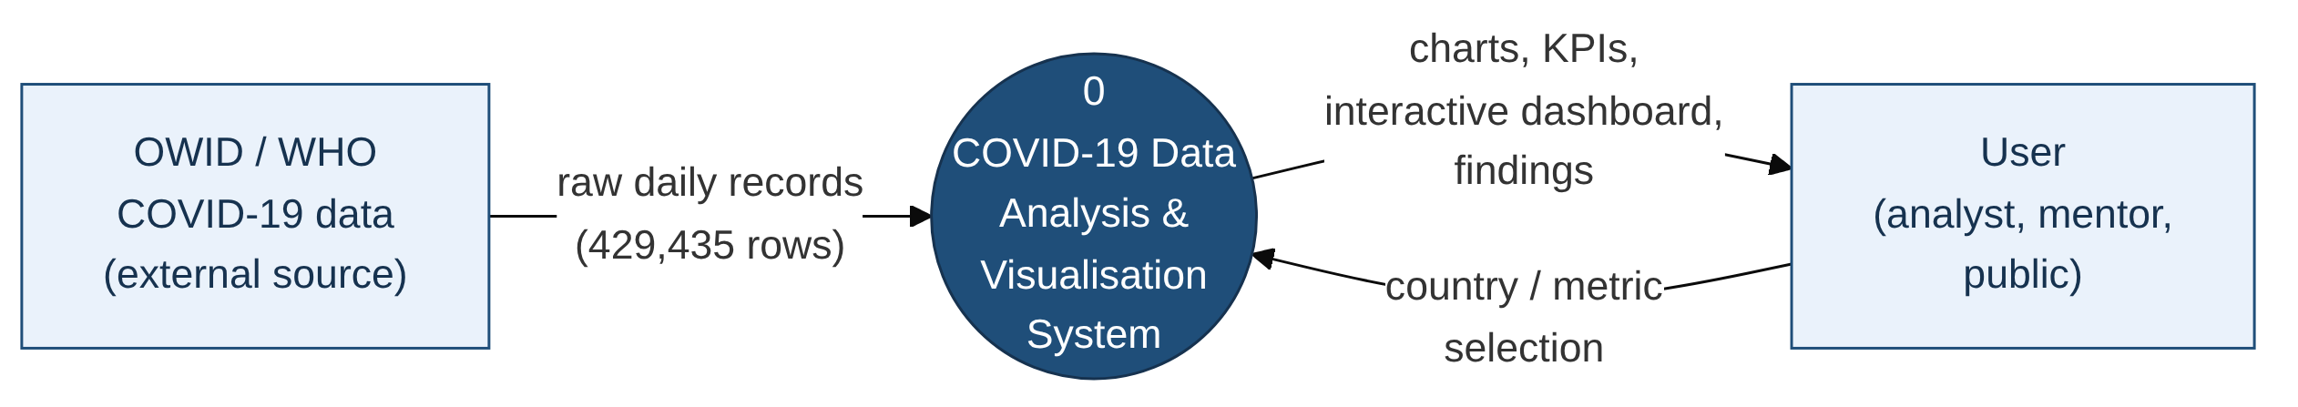
Figure 1: Data flow diagram, Level 0
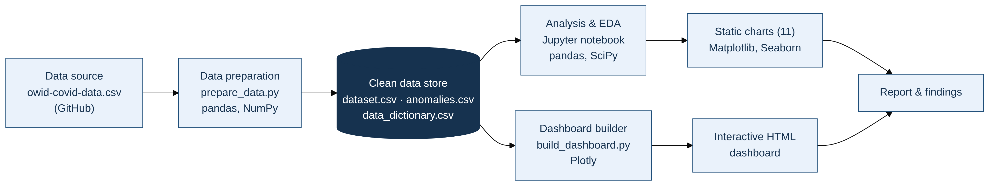
Figure 2: System block diagram

4. Technology Stack
Language: Python 3
Data handling: pandas, NumPy
Statistics: SciPy (Spearman correlation)
Visualisation: Matplotlib, Seaborn (static); Plotly (interactive dashboard)
Environment: Jupyter Notebook or Google Colab
Storage: CSV files (dataset.csv, anomalies.csv) with a data dictionary
AI/ML Framework: Not applicable (descriptive and exploratory analysis)
Hardware: Not applicable

5. Dataset Used
Dataset file name: dataset.csv, rebuilt from the Our World in Data COVID-19 dataset (CC BY 4.0, WHO-sourced) in the same 8 columns as the supplied file.
Number of rows: 391,716 (raw source: 429,435). Number of columns: 8. Countries: 234; dates 5 Jan 2020 to 4 Aug 2024.
Key columns: date, country, confirmed, deaths, vaccinated (also recovered, population, continent).
Any additional data collected: the supplied 500-row dataset.csv was audited and found inconsistent (each country had 5 different populations and continents; vaccinated exceeded population in 68% of rows), so the real OWID data was used as the brief's dataset prompt recommends. The supplied file is kept as dataset_original.csv. Recovered is estimated (confirmed 14 days earlier minus deaths), as OWID does not publish it.

6. Key Results & Metrics
Metric 1: Data quality: 0 duplicates; 5,509 rows (1.41%) flagged by 5 rules; missing values only in vaccinated (9%).
Metric 2: Global burden: 775.9 million reported cases and 7.06 million reported deaths (case fatality rate 0.91%).
Metric 3: Case fatality rate fell from 2.36% in 2020 to 0.29% in 2022; deaths peaked in January 2021 (103,719 in one week), cases peaked with Omicron in January 2022.
Metric 4: Highest reported deaths per million: Peru (6,490); vaccination (1+ dose) ranged from 86% in South America to 39% in Africa.
Business value achieved: a reproducible pipeline, a documented clean dataset, 11 charts and an offline interactive dashboard that let a non-technical reader explore the pandemic objectively.

7. Challenges Faced & How Resolved
Challenge 1: The supplied dataset.csv contained impossible values. Resolution: it was audited and documented, and the real OWID data was reshaped into the same 8 columns.
Challenge 2: Totals are published weekly and include backlogs (e.g. China reported 40.5 million cases in one week in December 2022). Resolution: weekly totals were used and a spike rule flags backlogs, which are labelled on the charts.
Challenge 3: Raw totals favour large countries and recoveries are not published. Resolution: per-million rates with a 1-million population threshold were used, and recovered was estimated and clearly labelled.

8. References
1. Mathieu, E., Ritchie, H., Rodés-Guirao, L. et al. Coronavirus Pandemic (COVID-19). Our World in Data, 2020. https://ourworldindata.org/coronavirus
2. Our World in Data. COVID-19 dataset, CC BY 4.0. https://github.com/owid/covid-19-data
3. World Health Organization. WHO COVID-19 dashboard. https://data.who.int/dashboards/covid19
4. McKinney, W. Python for Data Analysis, 3rd edition. O'Reilly Media, 2022.
5. Government of India, MeitY. Digital Personal Data Protection Act, 2023.

9. Ethical Compliance Declaration
I confirm that:
☑ All dataset usage complies with the source licence (Our World in Data, CC BY 4.0) and sources are cited.
☑ No personally identifiable information is stored; the data contains country-level totals only.
☑ COVID-19 data is presented objectively, as officially reported, with limitations stated.
☑ AI tools used for code and writing are disclosed in the project report (Appendix C).
☑ This project complies with the DPDP Act 2023 where applicable.

Learner Signature: Yash Verma Date: October 31, 2026
GitHub Repository: https://github.com/yashv5461/COVID19-Data-Analysis

