vOptions Trading & Black-Scholes: Complete Foundational Notes

1. Core Financial Concepts
What is a Stock?
A stock (or share) represents a fractional ownership interest in a corporation. Companies issue shares to raise equity capital. Share prices fluctuate continuously during market hours based on supply, demand, earnings performance, and macroeconomic factors.
What is a Derivative?
A derivative is a financial contract whose value is derived from the price performance of an underlying asset (such as a stock, index, commodity, or currency). Options are the most widely traded retail and institutional equity derivative.
What is an Option?
An option is a contract granting the buyer the right, but not the obligation, to buy or sell a specified quantity of an underlying asset at a fixed price (strike price) within a specified period (time to expiry).

2. Option Types & Mechanics
There are two fundamental types of option contracts:
- Call Option: Gives the holder the right to BUY the underlying stock at the strike price $K$.
- Put Option: Gives the holder the right to SELL the underlying stock at the strike price $K$.

Key Terminology
- Underlying Price ($S$): The current spot/market price of the asset.
- Strike Price ($K$): The locked-in transaction price specified in the contract.
- Time to Expiry ($T$): The remaining duration of the contract, measured in annualized years ($30\text{ days}=30/365=0.082\text{ years}$).
- Premium: The upfront cash market price paid by the buyer to the seller to acquire the contract.

The Four Option Positions
 | Call (Right to BUY stock) | Put (Right to SELL stock)
Buy (Long) | You have the RIGHT to BUY stock at $K. | You have the RIGHT to SELL stock at $K.
Sell (Short) | You have the obligation to SELL stock at $K if asked | You have to the obligation to BUY stock at $K if asked

3. Option Valuation: Intrinsic vs. Time Value
An option’s total market premium ($C$ or $P$) consists of two distinct components:
$$\text{Option Premium}=\text{Intrinsic Value}+\text{Time Value}$$
Intrinsic Value
The immediate monetary value if the contract were exercised today:
- Call Intrinsic Value: $\max\left(S-K,0\right)$
- Put Intrinsic Value: $\max\left(K-S,0\right)$
Moneyness Designations
- In-the-Money (ITM): Intrinsic value is greater than zero (e.g., Call with $S=\$310,K=\$300$).
- At-the-Money (ATM): Underlying spot price equals strike price ($S≈K$).
- Out-of-the-Money (OTM): Intrinsic value equals zero (e.g., Call with $S=\$300,K=\$315$).
Time Value
The extra premium buyers pay for the probability that the stock price moves favourably before expiration. As time to expiry ($T$) approaches zero, time value decays to zero.

4. Volatility ($σ$) & The Asymmetry Principle
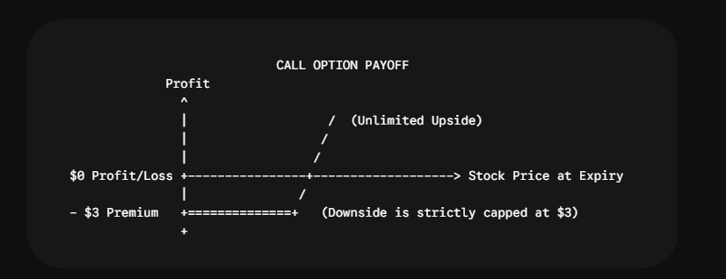
Option contracts exhibit payoff asymmetry:
$$\text{Call Payoff at Expiration}=\max\left(S_{T}-K,0\right)-\text{Premium Paid}$$
- Buyer Downside: Strictly capped at the initial premium paid.
- Buyer Upside: Theoretically unlimited (for Calls) or substantial (for Puts as $S→0$).
Because downside loss is capped while upside gain scales with price movement, higher volatility ($σ$) increases the value of both Call and Put options. Broader potential price swings increase the probability of deep in-the-money outcomes without increasing the maximum loss.
5. Market Dynamics & The Volatility Desk
Why Option Sellers Take the Trade
While unhedged option sellers face capped profits (the premium collected) and large potential liabilities, institutional sellers consistently write options due to four structural advantages:
- Probability Asymmetry: Out-of-the-money options have a high statistical probability of expiring worthless. Sellers act like the "casino," earning small, consistent gains.
- Time Decay (Theta): Time passing reduces option value daily, working continuously in favor of the short position.
- Volatility Risk Premium: Historical data demonstrates that Implied Volatility ($σ_{IV}$) consistently overestimates actual Realized Volatility ($σ_{RV}$).
- Dynamic Risk Control (Delta Hedging): Professional desks eliminate directional market risk using underlying shares.
6. Dynamic Delta Hedging
A Volatility Trading Desk does not speculate on market direction (whether a stock moves up or down). Instead, it isolates and trades volatility itself by maintaining a Delta-Neutral Portfolio.
Step-by-Step Delta Hedging Mechanism
- Option Sale: Desk sells a Call option on a $\$300$ stock with $\text{Delta}=0.50$, collecting a $\$10$ premium. The short option position creates a portfolio delta of $-0.50$.
- Initial Hedge: The desk immediately purchases 0.50 shares of stock ($+0.50\text{ Delta}$) at $\$300$.
$$\text{Net Portfolio Delta}=-0.50+0.50=0.00$$
- Directional Neutrality: If the stock rises by $+\$3.00$ to $\$303$:
  - Option Loss: $-\$3.00×0.50=-\$1.50$
  - Stock Gain: $+\$3.00×0.50=+\$1.50$
  - Net Portfolio P&L: $-\$1.50+\$1.50=\$0.00$
- Rehedging: As stock prices change, Delta updates. The desk continuously adjusts its underlying share count to maintain a net Delta of $0.00$.

7. The Black-Scholes Model
Derived by Fischer Black, Myron Scholes, and Robert Merton, the Black-Scholes model calculates the unique fair theoretical price for European options.
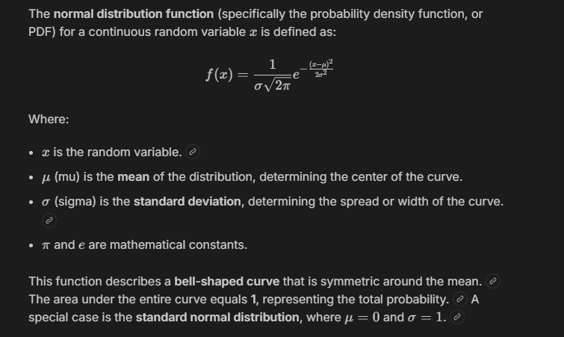
Governing Assumptions
- Stock log-returns are normally distributed (Geometric Brownian Motion).
- No transaction costs or taxes.
- Risk-free rate ($r$) and volatility ($σ$) remain constant over the period.
- No arbitrage opportunities exist.

Black-Scholes Pricing Equations
$$\text{Call Price }\left(C\right)=S⋅N\left(d_{1}\right)-Ke^{-rT}⋅N\left(d_{2}\right)$$
$$\text{Put Price }\left(P\right)=Ke^{-rT}⋅N\left(-d_{2}\right)-S⋅N\left(-d_{1}\right)$$
Where $N\left(x\right)$ is the cumulative standard normal distribution function, and:
$$d_{1}=\frac{\ln\left(\frac{S}{K}\right)+\left(r+\frac{σ^{2}}{2}\right)T}{σ\sqrt{T}}$$
$$d_{2}=d_{1}-σ\sqrt{T}=\frac{\ln\left(\frac{S}{K}\right)+\left(r-\frac{σ^{2}}{2}\right)T}{σ\sqrt{T}}$$
Mathematical Intuition of Terms
To understand these four terms intuitively, remember the core idea of a Call option at expiration:
$$\text{Call Payoff}=\left(\text{Receive Stock}\right)-\left(\text{Pay Strike Price }K\right)$$
The Black-Scholes formula simply probability-weights both pieces and discounts them back to today's dollars:
$$\text{Call Price}=S⋅N\left(d_{1}\right)-Ke^{-rT}⋅N\left(d_{2}\right)$$
Here is what each term means step-by-step:

1. $N\left(d_{2}\right)$: The Probability of Exercising
- What it means: $N\left(d_{2}\right)$ is literally a probability percentage (like $0.60$ or $60\%$).
- Intuition: It answers the question: "What are the odds that the stock price ends up above the strike price ($S_{T}>K$) at expiration?"
- Example: If $N\left(d_{2}\right)=0.60$, there is a 60% chance you will choose to exercise the option and buy the stock.

2. $Ke^{-rT}⋅N\left(d_{2}\right)$: What You Expect to PAY
This is the cost side of exercising the option.
- $K$: The strike price you must pay if you exercise.
- $e^{-rT}$: Discounts that future strike price $K$ back to today's dollars using the risk-free interest rate $r$.
- $N\left(d_{2}\right)$: Multiplies by the likelihood (probability) that you end up exercising.
- Intuition: It represents the expected present value of the cash you will hand over to buy the share. If there's a 60% chance of paying $100 (discounted to $98 today), the expected cost today is $0.60×\$98=\$58.80$.

3. $N\left(d_{1}\right)$: The Stock-Weighted Probability (Delta)
- What it means: $N\left(d_{1}\right)$ is also a probability-like percentage, but it is slightly higher than $N\left(d_{2}\right)$.
- Intuition: Why isn't $N\left(d_{2}\right)$ used for both terms? Because if the stock ends up above the strike price, it doesn't just stop at $K$—it could end up way above $K$. $N\left(d_{1}\right)$ adjusts $N\left(d_{2}\right)$ to account for how high the stock might go when you do exercise.
- Key Role: For a call option, $N\left(d_{1}\right)$ is also equal to the option's Delta ($Δ$).

4. $S⋅N\left(d_{1}\right)$: What You Expect to RECEIVE
This is the benefit side of exercising the option.
- $S$: The current stock price today.
- $N\left(d_{1}\right)$: Multiplies the stock's value by the probability factor of owning it at expiration.
- Intuition: It represents the expected present value of the stock share you will receive if the option finishes in the money.
The Big Picture Summary
Putting both halves together:
$$\text{Call Option Price}=\text{Expected Value of Stock Received }\left[S⋅N\left(d_{1}\right)\right]-\text{Expected Value of Cash Paid }\left[Ke^{-rT}⋅N\left(d_{2}\right)\right]$$
It is simply: (What you expect to get) − (What you expect to pay), both probability-weighted and discounted to today's money.
8. The Option Greeks
The Greeks represent partial derivatives of the Black-Scholes pricing formula, measuring sensitivity to individual input parameters.
Greek | Mathematical Definition | Definition & Concept | Practical Application
Delta ($Δ$) | $$\frac{∂C}{∂S}=N\left(d_{1}\right)$$ | Sensitivity of option price to a $\$1.00$ change in underlying spot price $S$. | Used to calculate share hedge ratios for risk-neutral positioning.
Gamma ($Γ$) | $$\frac{∂^{2}C}{∂S^{2}}=\frac{N'\left(d_{1}\right)}{Sσ\sqrt{T}}$$ | Rate of change of Delta per $\$1.00$ move in underlying spot price $S$. | Measures curvature risk and how frequently a delta hedge must be rebalanced.
Vega ($ν$) | $$\frac{∂C}{∂σ}=S\sqrt{T}N'\left(d_{1}\right)$$ | Sensitivity of option price to a $1\%$ ($0.01$) absolute change in volatility $σ$. | Core metric used by volatility desks to price and trade volatility mispricings.
Theta ($Θ$) | $$\frac{∂C}{∂T}$$ | Sensitivity of option price to time decay (expressed per day passing). | Quantifies daily loss in time value for long positions / daily gain for short positions.
Rho ($ρ$) | $$\frac{∂C}{∂r}=KTe^{-rT}N\left(d_{2}\right)$$ | Sensitivity of option price to a $1\%$ change in the risk-free rate $r$. | Evaluates exposure to baseline interest rate shifts.

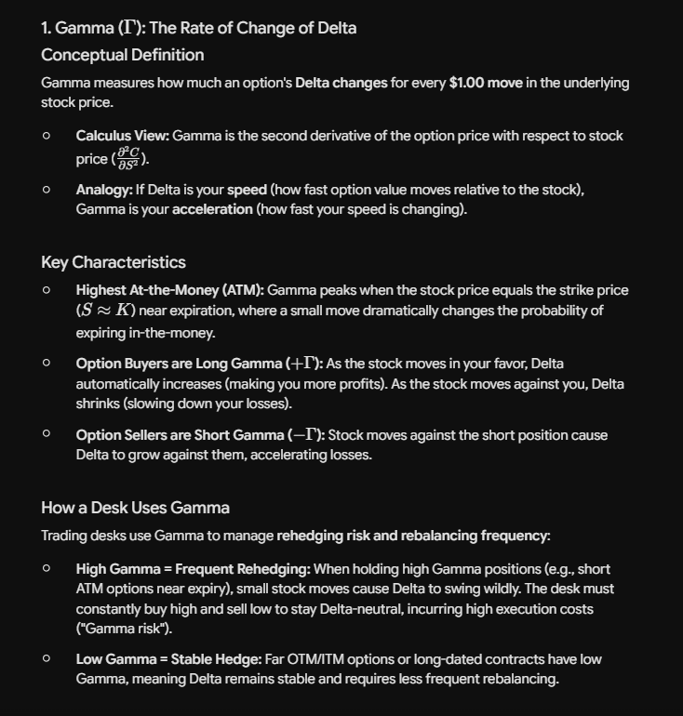
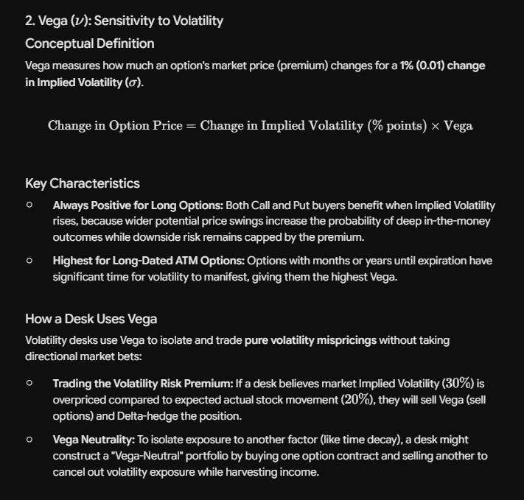
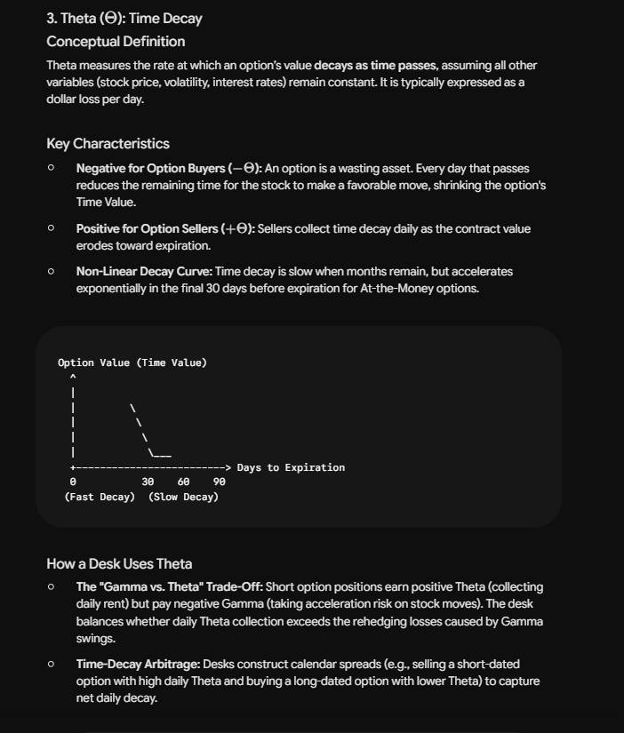
9. Implied Volatility & Root Finding
Historical vs. Implied Volatility
- Historical Volatility ($σ_{hist}$): Standard deviation of past logarithmic stock returns annualized over a sample period ($σ_{annual}=σ_{daily}×\sqrt{252}$).
- Implied Volatility ($σ_{IV}$): Forward-looking market consensus of expected volatility embedded directly within option market prices.
Back-Solving for Implied Volatility
Because the Black-Scholes formula cannot be inverted algebraically for $σ$, numerical root-finding algorithms—such as the Newton-Raphson method—are applied:
$$σ_{n+1}=σ_{n}-\frac{C_{BS}\left(σ_{n}\right)-C_{market}}{\text{Vega}\left(σ_{n}\right)}$$
Iterating this calculation back-solves the exact Implied Volatility implied by live option market prices.
---------------------------------------------------------------------------------------------
The Newton-Raphson method is an iterative root-finding algorithm used in calculus and numerical finance to solve equations of the form:
$$f\left(σ\right)=0$$
1. The Core Problem in Options Trading
When pricing an option, the Black-Scholes formula accepts five inputs:
- Underlying Stock Price ($S$)
- Strike Price ($K$)
- Time to Expiration ($T$)
- Risk-free Interest Rate ($r$)
- Volatility ($σ$)
In live markets, $S$, $K$, $T$, and $r$ are known parameters, and the option's trading price ($C_{\text{market}}$) is quoted on the exchange. However, Implied Volatility ($σ$) is not directly observable.
To extract $σ$, we must invert the Black-Scholes formula:
$$\text{BlackScholes}\left(σ\right)=C_{\text{market}}$$
Which rearranges to finding the root of:
$$f\left(σ\right)=\text{BlackScholes}\left(σ\right)-C_{\text{market}}=0$$
Because $σ$ appears inside non-linear cumulative normal distribution functions $N\left(d_{1}\right)$ and $N\left(d_{2}\right)$, this equation cannot be solved algebraically. We must approximate it using a numerical search algorithm.
2. Geometric Intuition of Newton-Raphson
Imagine plotting a curve where the horizontal axis represents volatility ($σ$) and the vertical axis represents the pricing error $f\left(σ\right)=\text{BlackScholes}\left(σ\right)-C_{\text{market}}$.
We want to find the exact point where this curve crosses zero ($f\left(σ\right)=0$).
- Initial Guess ($σ_{0}$): We start with an initial volatility estimate (e.g., $25\%$).
- Tangent Line (Derivative): We draw a tangent line to the curve at our current guess point $\left(σ_{0},f\left(σ_{0}\right)\right)$. The slope of this tangent line is the first derivative of the pricing function with respect to volatility, which is Vega ($\frac{∂C}{∂σ}$).
- Next Step ($σ_{1}$): Follow the tangent line down to where it intersects the horizontal axis. This intersection point becomes our refined estimate ($σ_{1}$).
- Iterate: Repeat this process until $f\left(σ_{n}\right)$ is effectively zero.
3. Deriving the Update Formula
Using the point-slope form of a linear equation:
$$\text{Slope}=\frac{Δy}{Δx}=\frac{f\left(σ_{n}\right)-0}{σ_{n}-σ_{n+1}}$$
Since the slope of the option price with respect to volatility is Vega ($f'\left(σ_{n}\right)=\text{Vega}$):
$$\text{Vega}=\frac{f\left(σ_{n}\right)}{σ_{n}-σ_{n+1}}$$
Rearranging for the next estimate $σ_{n+1}$:
$$σ_{n+1}=σ_{n}-\frac{f\left(σ_{n}\right)}{\text{Vega}\left(σ_{n}\right)}$$
Substituting $f\left(σ_{n}\right)$:
$$σ_{n+1}=σ_{n}-\frac{\text{BlackScholes}\left(σ_{n}\right)-C_{\text{market}}}{\text{Vega}\left(σ_{n}\right)}$$
4. Summary of the Algorithm Steps in Code
- Set Initial Guess: Start at $σ_{0}=0.25$ ($25\%$).
- Compute Option Price: Calculate $\text{BlackScholes}\left(σ_{0}\right)$.
- Compute Error: Find the discrepancy $\text{diff}=\text{BlackScholes}\left(σ_{0}\right)-C_{\text{market}}$.
- Check Tolerance: If $|\text{diff}|<{10}^{-6}$, stop and return $σ_{0}$.
- Compute Slope: Calculate unscaled $\text{Vega}\left(σ_{0}\right)$.
- Update Guess: Apply $σ_{\text{new}}=σ_{\text{old}}-\frac{\text{diff}}{\text{Vega}}$.
- Repeat: Continue until convergence or reaching the maximum iteration threshold.
DOUBTS:
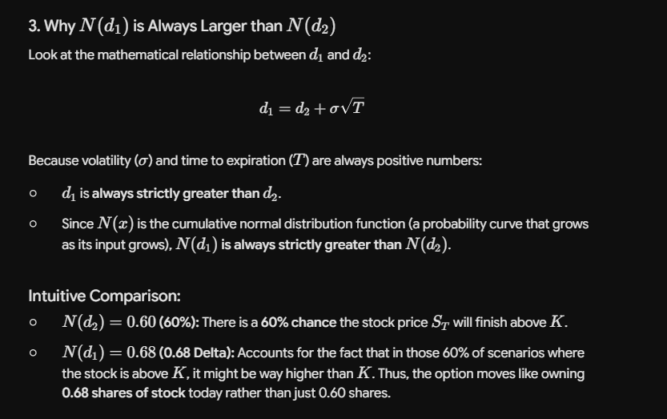
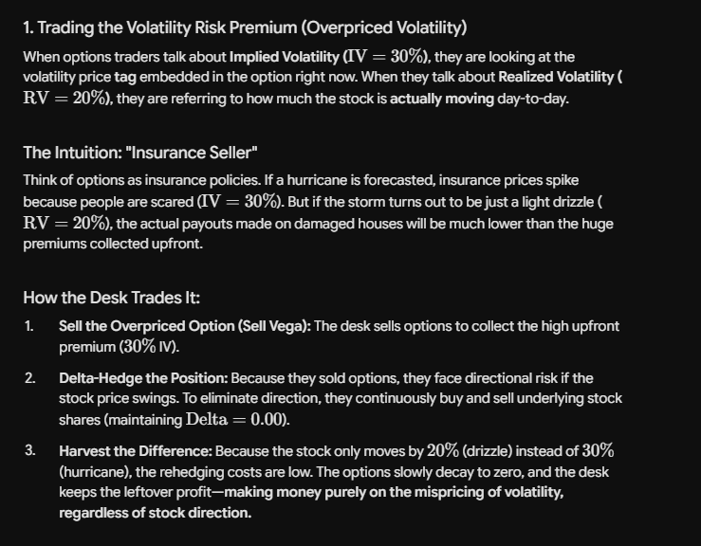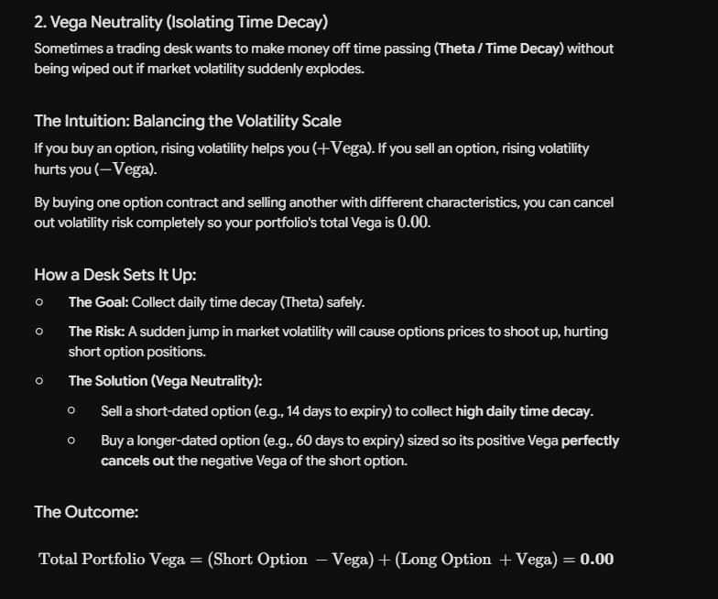

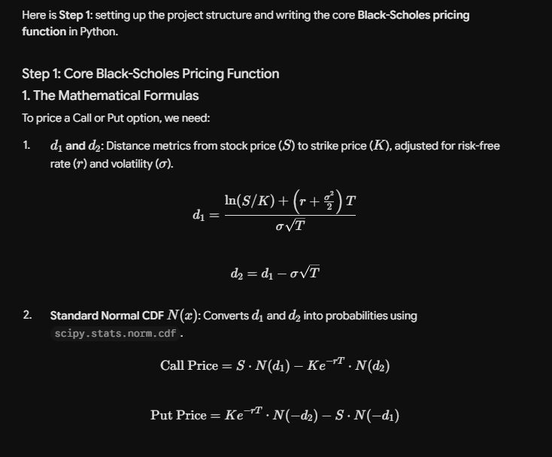
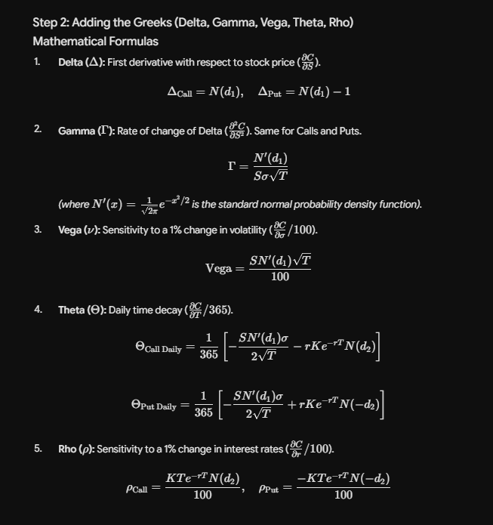

SANITY CHECKS
In the Put-Call Parity formula ($C-P=S-Ke^{-rT}$):
- $C$: The current price (premium) of a European Call option.
- $P$: The current price (premium) of a European Put option.
Both options must share the same underlying asset ($S$), strike price ($K$), time to expiration ($T$), and risk-free interest rate ($r$).
