The core idea: what is "historical volatility"?
Historical (realized) volatility measures how much an asset's price moved in the past. It's backward-looking — different from implied vol, which is the market's forward-looking guess baked into option prices. We use historical vol to sanity-check IV, spot mean-reversion opportunities, and build features for your other projects.
The basic building block is always the same: take a series of returns, compute their standard deviation, then annualize it (since vol is conventionally quoted per year).
$$σ_{annual}=σ_{daily}×\sqrt{252}$$
(252 ≈ trading days per year — this scaling comes from the fact that variance of independent returns adds up linearly with time, so standard deviation scales with √time.)
Where the three estimators differ is what data they use and how efficiently they extract information from it.
1. Close-to-Close (the classic one)
$$σ=\sqrt{\frac{1}{n-1}\sum_{i=1}^{n}{(}\left.r_{i}-\overline{r}{\left.)\right.}^{2}\right.}×\sqrt{252}$$
where $r_{i}=ln⁡\left(C_{i}/C_{i-1}\right)$ log return between consecutive closes.
- Uses: only closing prices.
- Pros: simple, robust, works with just daily close data.
- Cons: throws away all the intraday information. If a stock whipsaws +5%/-5% intraday but closes flat, close-to-close sees zero movement that day. It's statistically inefficient — you need a lot of data to get a stable estimate.

2. Parkinson (uses the day's range)
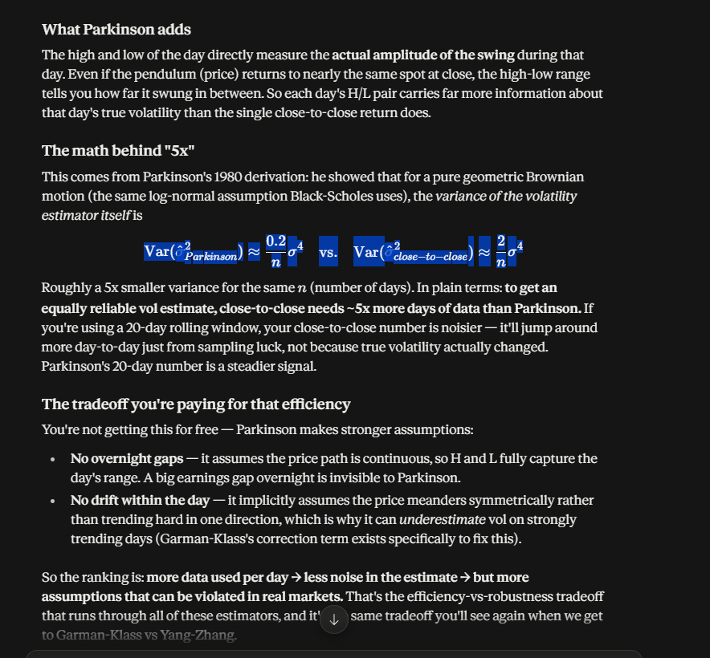
$$σ=\sqrt{\frac{1}{4n\ln{2}}\sum_{i=1}^{n}{{\left(\ln{\frac{H_{i}}{L_{i}}}\right)}^{2}}}×\sqrt{252}$$
- Uses: high and low of each day.
- Intuition: the high-low range of a day captures actual intraday movement, which close-to-close misses entirely. A wider range → more volatility, even if open ≈ close.
- Pros: ~5x more statistically efficient than close-to-close (needs far fewer observations for the same precision) — this is a known result from Parkinson's 1980 paper.
- Cons: assumes no overnight jumps (i.e., the stock doesn't gap between yesterday's close and today's open) and no drift within the day. It also only works for continuous trading — it underestimates vol when there's a trend within the day, because range-based measures miss directional drift.
3. Garman-Klass (uses the whole OHLC bar)
$$σ^{2}=\frac{1}{n}\sum_{i=1}^{n}{\left[\frac{1}{2}{\left(\ln{\frac{H_{i}}{L_{i}}}\right)}^{2}-\left(2\ln{2}-1\right){\left(\ln{\frac{C_{i}}{O_{i}}}\right)}^{2}\right]}σ=\sqrt{σ^{2}×252}$$
- Uses: open, high, low, and close.
- Intuition: it's Parkinson's range term, corrected by an open-to-close drift term (the second part) that removes bias from trending days.
- Pros: even more efficient than Parkinson (~7-8x more efficient than close-to-close under ideal conditions).
- Cons: still assumes no overnight jumps — a stock that gaps up 10% at the open (earnings, news) will make Garman-Klass understate true volatility, since it doesn't see what happened between yesterday's close and todays open.
4. Yang-Zhang: combining everything
The idea: don't pick between "captures overnight gaps" (close-to-close) and "efficiently captures intraday range" (Garman-Klass) — combine both, weighted so the result is unbiased even when the price drifts across days (has a trend), which the other estimators partially struggle with too.
It's built from three components, each measuring a different kind of variance:
1. Overnight variance — close-to-open jumps (this is the piece Parkinson/GK miss entirely):
$$σ_{overnight}^{2}=\frac{1}{n-1}\sum{{\left(\ln{\frac{O_{i}}{C_{i-1}}}-\overset{‾}{ln⁡\left(O_{i}/C_{i-1}\right)}\right)}^{2}}$$
2. Open-to-close variance — the day session itself:
$$σ_{open-close}^{2}=\frac{1}{n-1}\sum{{\left(\ln{\frac{C_{i}}{O_{i}}}-\overset{‾}{ln⁡\left(C_{i}/O_{i}\right)}\right)}^{2}}$$
3. Rogers-Satchell term — an intraday range-based estimator (like Garman-Klass's cousin) that's specifically drift-independent:
$$σ_{rs}^{2}=\frac{1}{n}\sum{\left[\ln{\frac{H_{i}}{C_{i}}}\ln{\frac{H_{i}}{O_{i}}}+\ln{\frac{L_{i}}{C_{i}}}\ln{\frac{L_{i}}{O_{i}}}\right]}$$
These are combined with a weighting constant $k$k (derived to minimize the estimator's variance):
$$σ_{YZ}^{2}=σ_{overnight}^{2}+k σ_{open-close}^{2}+\left(1-k\right) σ_{rs}^{2}k=\frac{0.34}{1.34+\frac{n+1}{n-1}}$$k=1.34+n−1n+1​0.34​
Then annualize as usual: $σ_{YZ}=\sqrt{σ_{YZ}^{2}×252}$
Why it's the "best" of the four
- Captures overnight gaps (unlike Parkinson/GK)
- Uses the full intraday range efficiently (unlike close-to-close)
- Is independent of drift — doesn't get thrown off by trending days (this is what the Rogers-Satchell piece buys you)
- Statistically, it's shown to be the minimum-variance unbiased estimator among these under general conditions — meaning same data, most reliable number.

"Bad" here means noisy, not biased
This is the key distinction. Close-to-close is an unbiased estimator — averaged over time, it converges to the true volatility just as correctly as Parkinson or Yang-Zhang. It's not systematically wrong. It's just noisier day-to-day — its estimate bounces around more for a given sample size.
So "bad" = "you need more data to get a stable number," not "gives you the wrong answer." If you use a 90-day window instead of 20-day, close-to-close's noise disadvantage mostly disappears. Industry risk systems typically do use longer windows (30/60/90/252-day), which is one reason the noise problem matters less in practice than it seems in theory.
Efficiency isn't the only thing that matters
Think about what a trading desk needs from a vol number:
- Reproducibility across every system, vendor, and counterparty. If your risk system, Bloomberg, your counterparty's risk system, and the exchange's margin calculator all need to agree on "what was 20-day realized vol," everyone needs to be computing the same well-defined thing from the same unambiguous data (close prices — no debate about which "high" print was real vs. a bad tick). A more "accurate" number that nobody can independently reproduce the same way is less useful than a slightly noisier number everyone agrees on.
- Data quality risk. Range-based estimators are more sensitive to bad prints. A single erroneous "high" tick (a stale quote, a fat-finger trade, a flash spike on a thin exchange) can meaningfully distort Parkinson/GK/YZ, because they weight that single extreme value heavily. Close-to-close only cares about the closing auction price, which is typically the most heavily scrutinized, most liquid, most "real" price of the day. So, it's more robust to bad data, even though it's less statistically efficient on clean data.
- Consistency with implied vol. Since options are priced/quoted against expectations of close-to-close moves (that's the convention the whole options market grew up around), comparing realized vol to IV works cleanest when both sides use the same definition of "a day's move."
The real-world analogy
It's a bit like why a thermostat uses a simple average temperature reading instead of a more "statistically optimal" sensor-fusion algorithm — the fancier method might technically extract more signal, but if it's fragile to sensor glitches and everyone else's thermostat uses the simple version, you'll disagree with the rest of the system in ways that cause bigger practical problems than the noise you were trying to reduce.
So, it's not "industry ignores better math." Its industry prioritizes robustness, standardization, and comparability over raw statistical efficiency — and reaches for the more efficient estimators specifically in contexts (short-window research, back testing) where that trade-off flips in their favour.

