EXP_5

**Image transform:**

1)Translation

import numpy as np

import cv2

img = cv2.imread('image.jpg')

if img is None:

print("Error: Unable to load the image.")

else:

cv2.imshow('img.jpg', img)

rows, cols, _ = img.shape

M = np.float32([[1, 0, 100], [0, 1, 50]])

dst = cv2.warpAffine(img, M, (cols, rows))

cv2.imshow('img', dst)

cv2.waitKey(0)

cv2.destroyAllWindows()

2) Reflection

import numpy as np

import cv2

img = cv2.imread('image.jpg',0)

cv2.imshow('image',img)

rows, cols = img.shape

M = np.float32([[1, 0, 0],[0, -1, rows],[0, 0, 1]])

reflected_img = cv2.warpPerspective(img, M,(int(cols),int(rows)))

cv2.imshow('img', reflected_img)

cv2.imwrite('reflection_out.jpg', reflected_img)

cv2.waitKey(0)

cv2.destroyAllWindows()

3)Rotation

import numpy as np

import cv2 as cv

img = cv.imread('image.jpg', 1)

cv.imshow('image', img)

rows, cols, _ = img.shape

M = cv.getRotationMatrix2D((cols/2, rows/2), 30, 0.6)

img_rotation = cv.warpAffine(img, M, (cols, rows))

cv.imshow('img', img_rotation)

cv.imwrite('rotation_out.jpg', img_rotation)

cv.waitKey(0)

cv.destroyAllWindows()

4)Scaling

import numpy as np

import cv2 as cv

img = cv.imread('image.jpg', 0)

rows, cols = img.shape

img_shrinked = cv.resize(img, (250, 200),interpolation=cv.INTER_AREA)

cv.imshow('img', img_shrinked)

img_enlarged = cv.resize(img_shrinked, None,fx=1.5, fy=1.5,interpolation=cv.INTER_CUBIC)

cv.imshow('img', img_enlarged)

cv.waitKey(0)

cv.destroyAllWindows()

5)Shearing_x

import numpy as np

import cv2 as cv

img = cv.imread('image.jpg', 1)

rows, cols,_ = img.shape

M = np.float32([[1, 0.5, 0], [0, 1, 0], [0, 0, 1]])

sheared_img = cv.warpPerspective(img, M, (int(cols*1.5), int(rows*1.5)))

cv.imshow('img', sheared_img)

cv.waitKey(0)

cv.destroyAllWindows()

6)Shearing_y

import numpy as np

import cv2 as cv

img = cv.imread('image.jpg', 1)

rows, cols,_ = img.shape

M = np.float32([[1, 0, 0], [0.5, 1, 0], [0, 0, 1]])

sheared_img = cv.warpPerspective(img, M, (int(cols*1.5), int(rows*1.5)))

cv.imshow('sheared_y-axis_out.jpg', sheared_img)

cv.waitKey(0)

cv.destroyAllWindows()

**Extract** **ORB** **Image** **features:**

import cv2

img = cv2.imread('image.jpg')

gray = cv2.cvtColor(img, cv2.COLOR_BGR2GRAY)

orb = cv2.ORB_create(nfeatures=2000)

kp = orb.detect(gray, None)

kp, des = orb.compute(gray, kp)

img1 = cv2.drawKeypoints(gray, kp, None, (0,0,255), flags=0)

cv2.imshow("ORB Keypoints", img1)

cv2.waitKey(0)

cv2.destroyAllWindows()

**FEATURE MATCHING:**

import cv2

image = cv2.imread('image.jpg')

gray_image = cv2.cvtColor(image, cv2.COLOR_BGR2GRAY)

fast = cv2.FastFeatureDetector_create()

fast.setNonmaxSuppression(False)

kp = fast.detect(gray_image, None)

kp_image = cv2.drawKeypoints(image, kp, None, color=(0, 255, 0))

cv2.imshow('FAST', kp_image)

cv2.waitKey()

**Cloning**

**Code will work if apt images is selected. Choose image such that the background of one image can merge with other**

import cv2

import numpy as np

src = cv2.imread("clone2.jpg")

dst = cv2.imread("clone1.jpg")

src_mask = np.zeros(src.shape, src.dtype)

poly = np.array([ [4,80], [30,54], [151,63], [254,37], [298,90], [272,134], [43,122] ],np.int32)

cv2.fillPoly(src_mask, [poly], (255, 255, 255))

center = (800,100)

output = cv2.seamlessClone(src, dst, src_mask, center, cv2.NORMAL_CLONE)

cv2.imwrite("images/opencv-seamless-cloning-example.jpg", output)

OUTPUT:

1)TRANSLATION

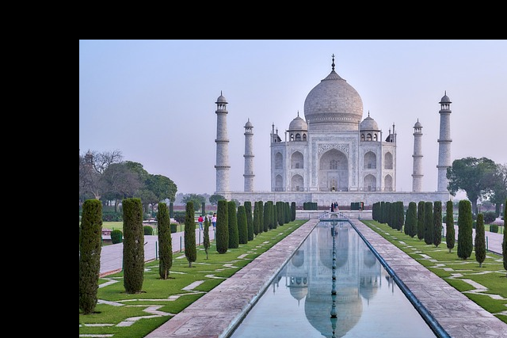

2)REFLECTION

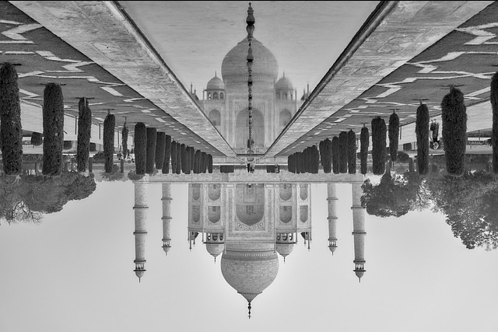

3)ROTATION

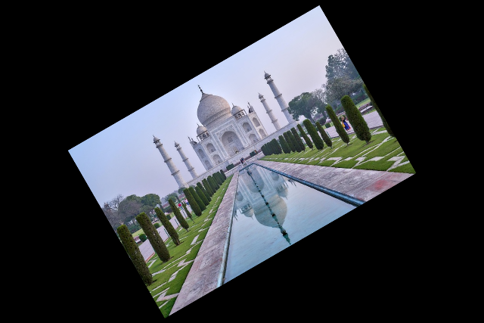

4)SCALING

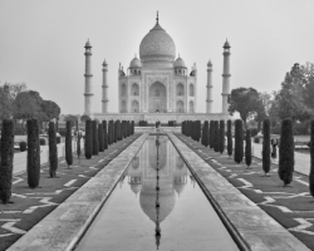

5)SHEARING_X

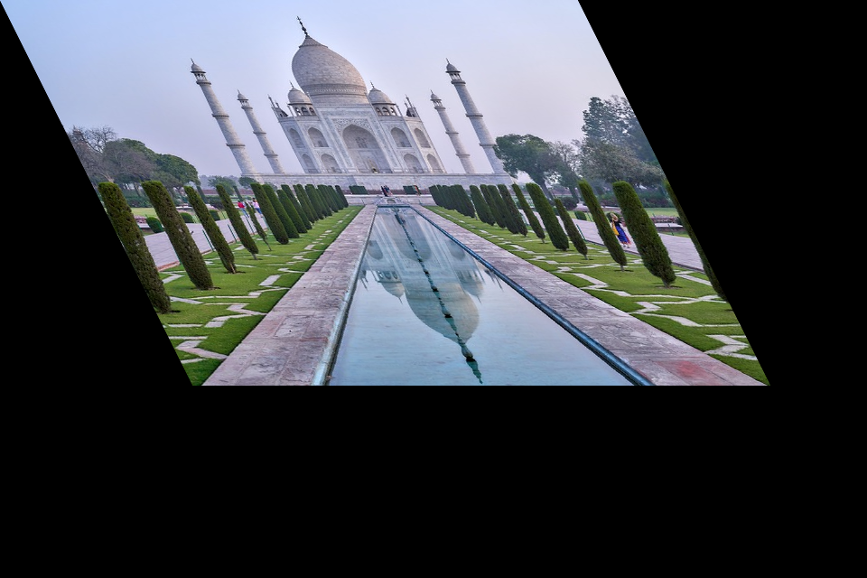

6)SHEARING_Y

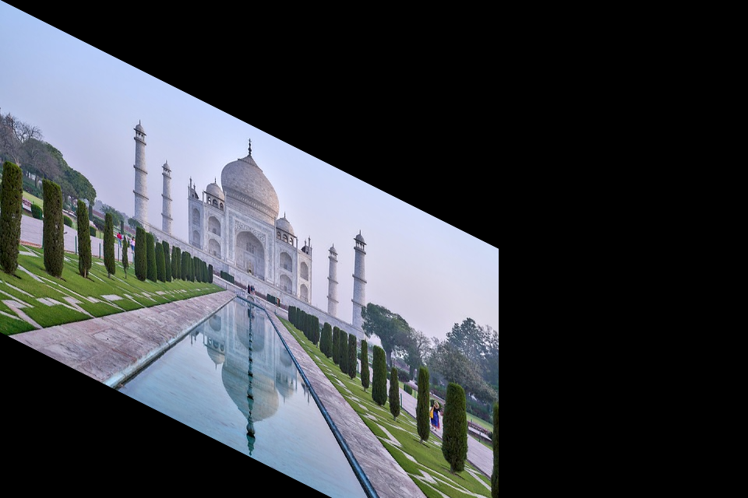

7)Extract ORB Image features

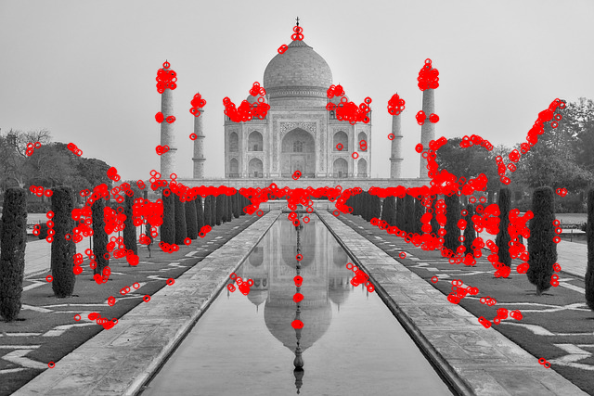

8)Feature Matching

