**Tic-Tac-Toe**

1. **Task Description**

Build a "Tic-Tac-Toe" game that allows two players to take turns and determine the winner.

1. **Task Output Screenshot**

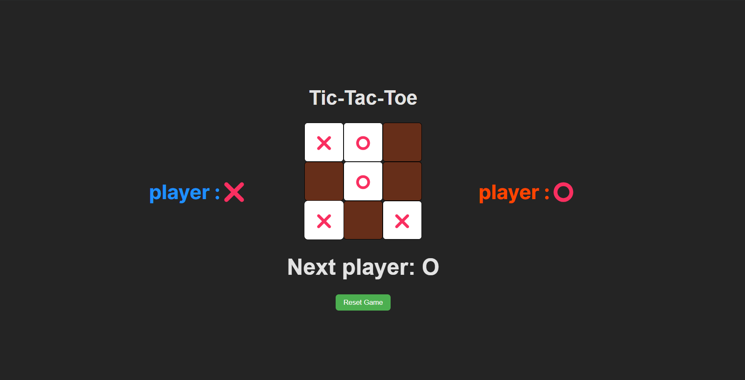

1. **Widget/Algorithm Used In Task**

* Game Board Component: This component holds the state of the game (e.g., the board, current player) and determines the game’s winner by checking all rows, columns, and diagonals after each move.
* Square Component: A reusable square component for rendering each cell on the game board. It accepts a prop for displaying the current player’s mark (X or O) and an onClick handler for triggering moves.
* Game Logic: The logic to check for the winner is implemented using an array that checks the possible win conditions after every move.