**Theme Changer**

1. **Task Description**

Implement a global app theme switcher using context and local storage.

1. **Task Output Screenshot**

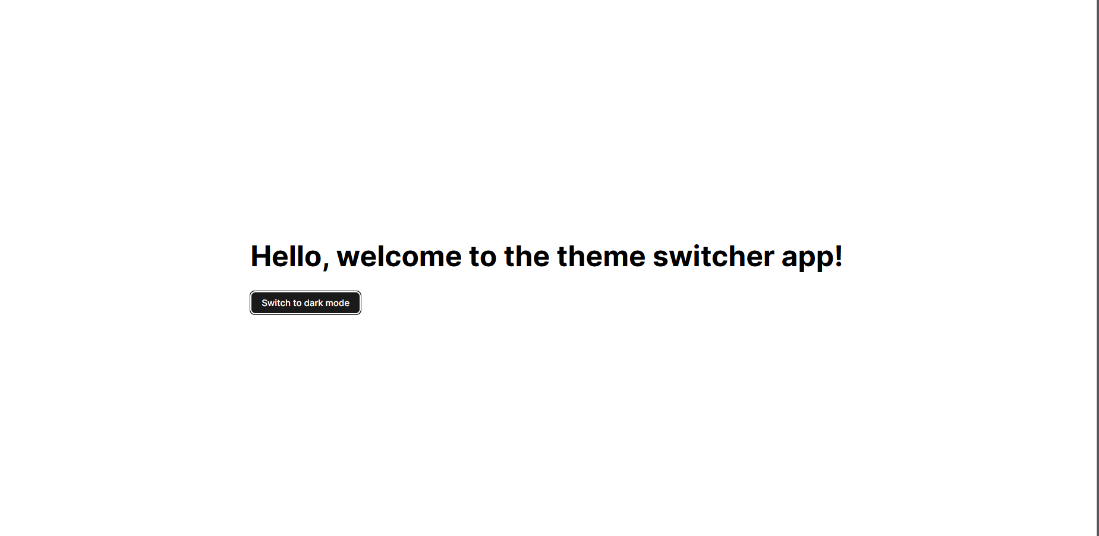

1. **Widget/Algorithm Used In Task**

* Theme Context:  
  The context API was used to create a global theme state, allowing for switching between light and dark modes throughout the application.
* Local Storage:  
  The selected theme is stored in local storage so that the user's preference persists across sessions.