**Portfolio Page**

1. **Task Description**

Create a personal portfolio page to showcase your projects and skills.

1. **Task Output Screenshot**

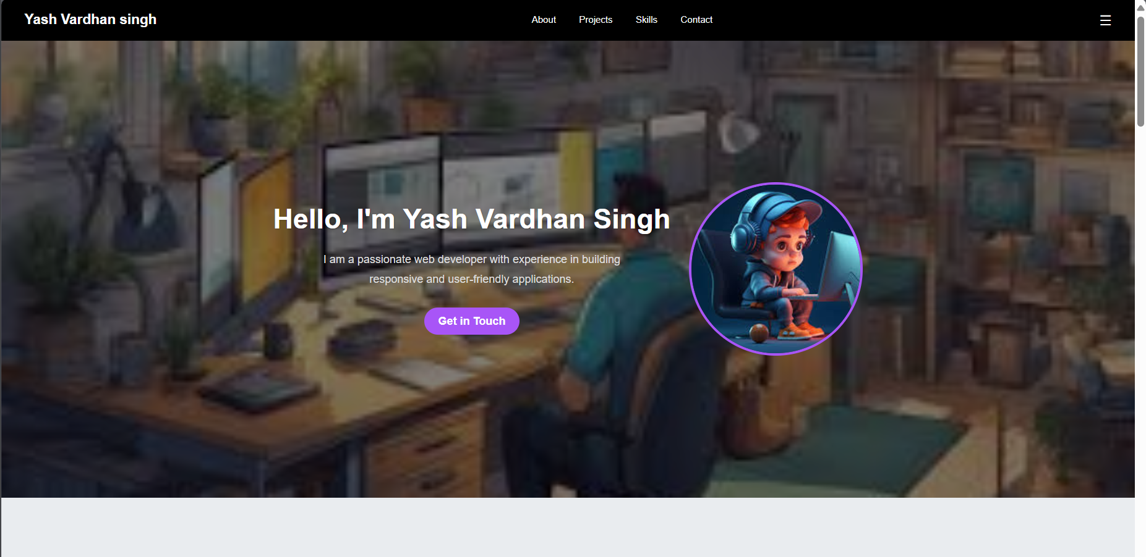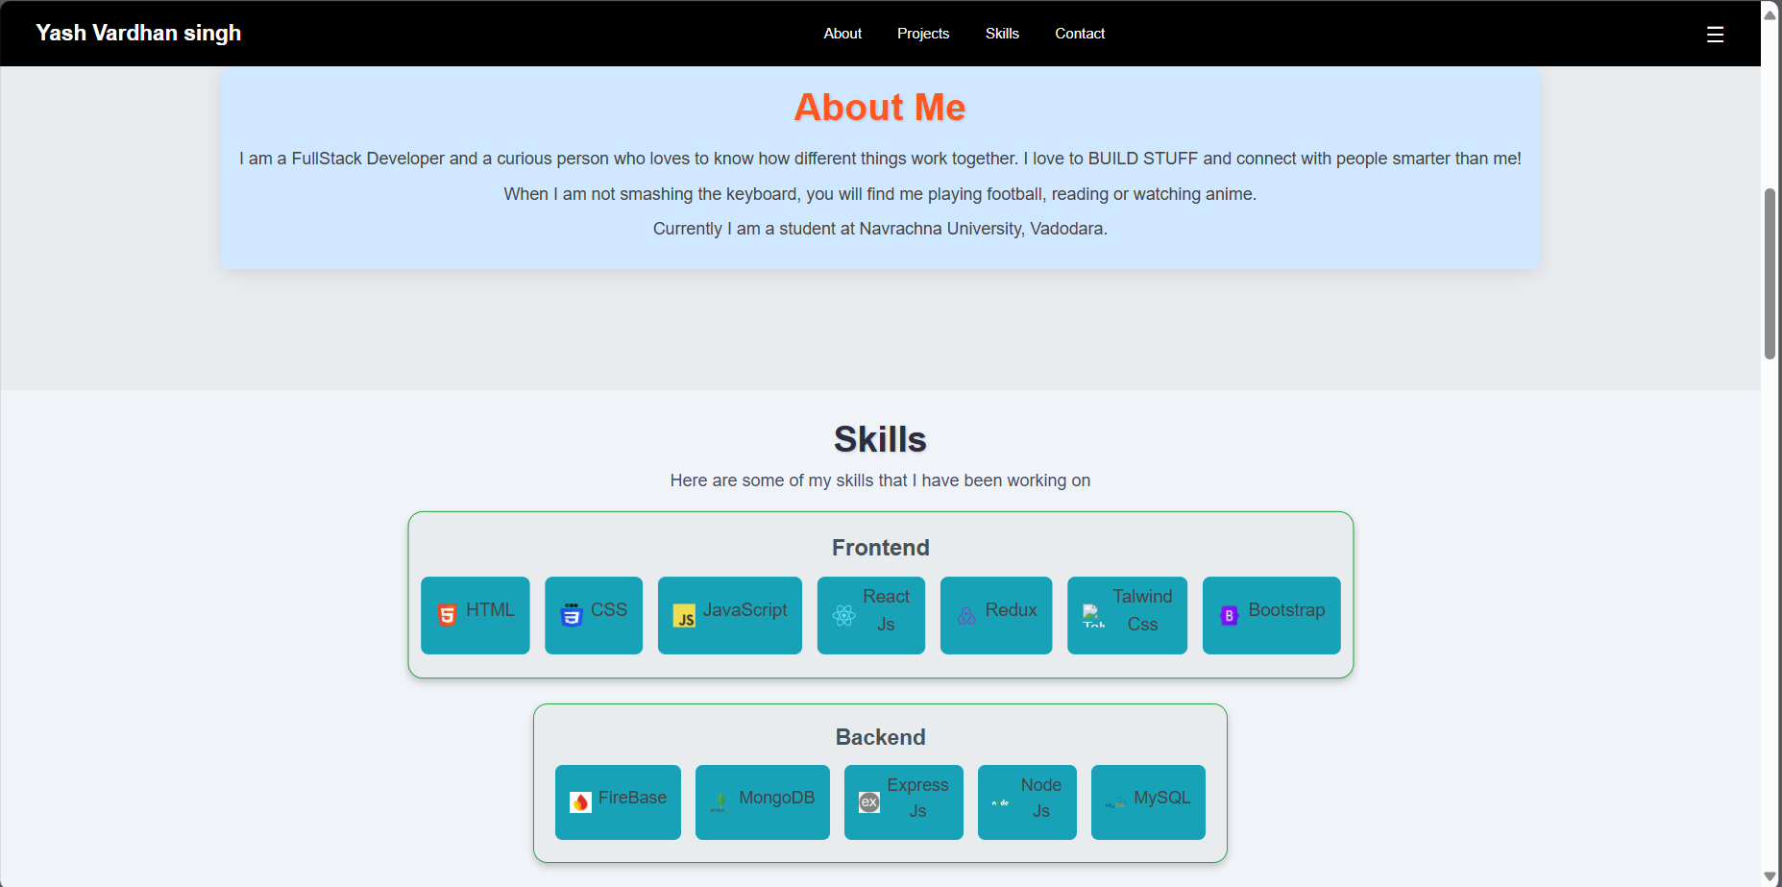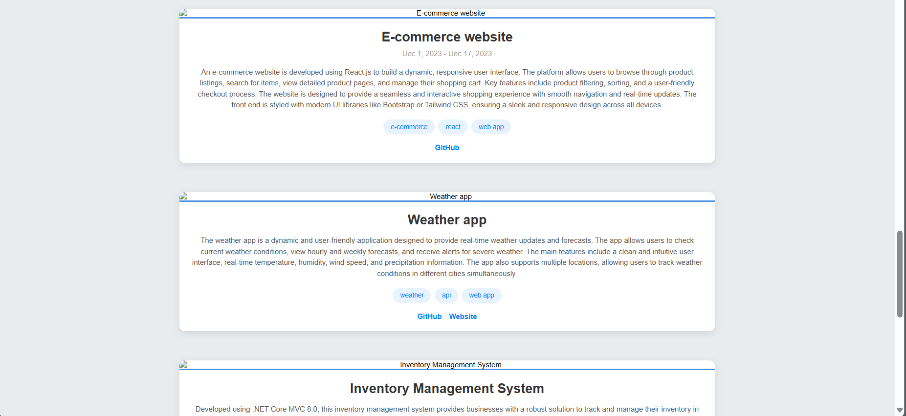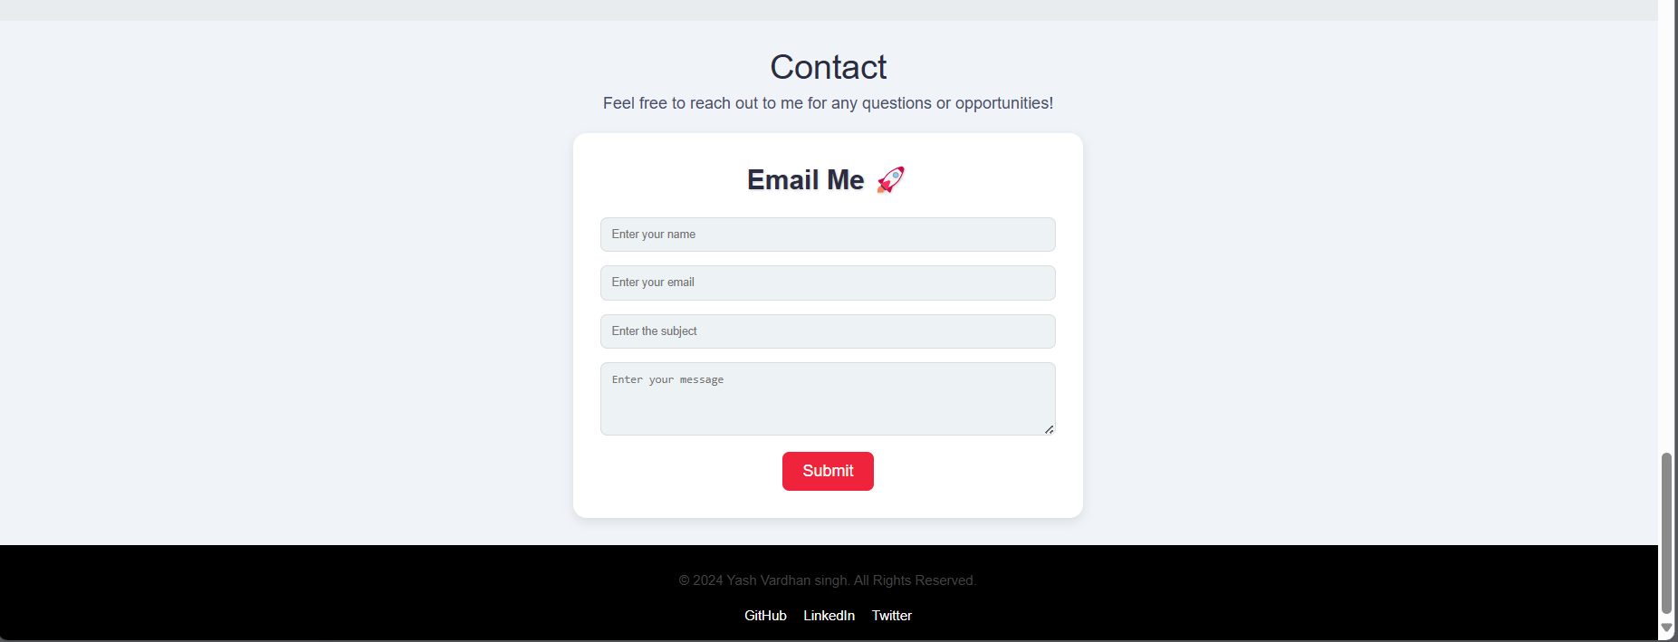

1. **Widget/Algorithm Used In Task**

* Portfolio Layout Component:  
  This component structures the layout, including sections for project showcases, skills, and contact information.
* Reusable Project Card Component:  
  A component to display individual projects, with props for the project title, description, and links to the project’s code or demo.