**Blog Posts**

1. **Task Description**

Create a blog post app with dynamic routing for individual posts.

1. **Task Output Screenshot**

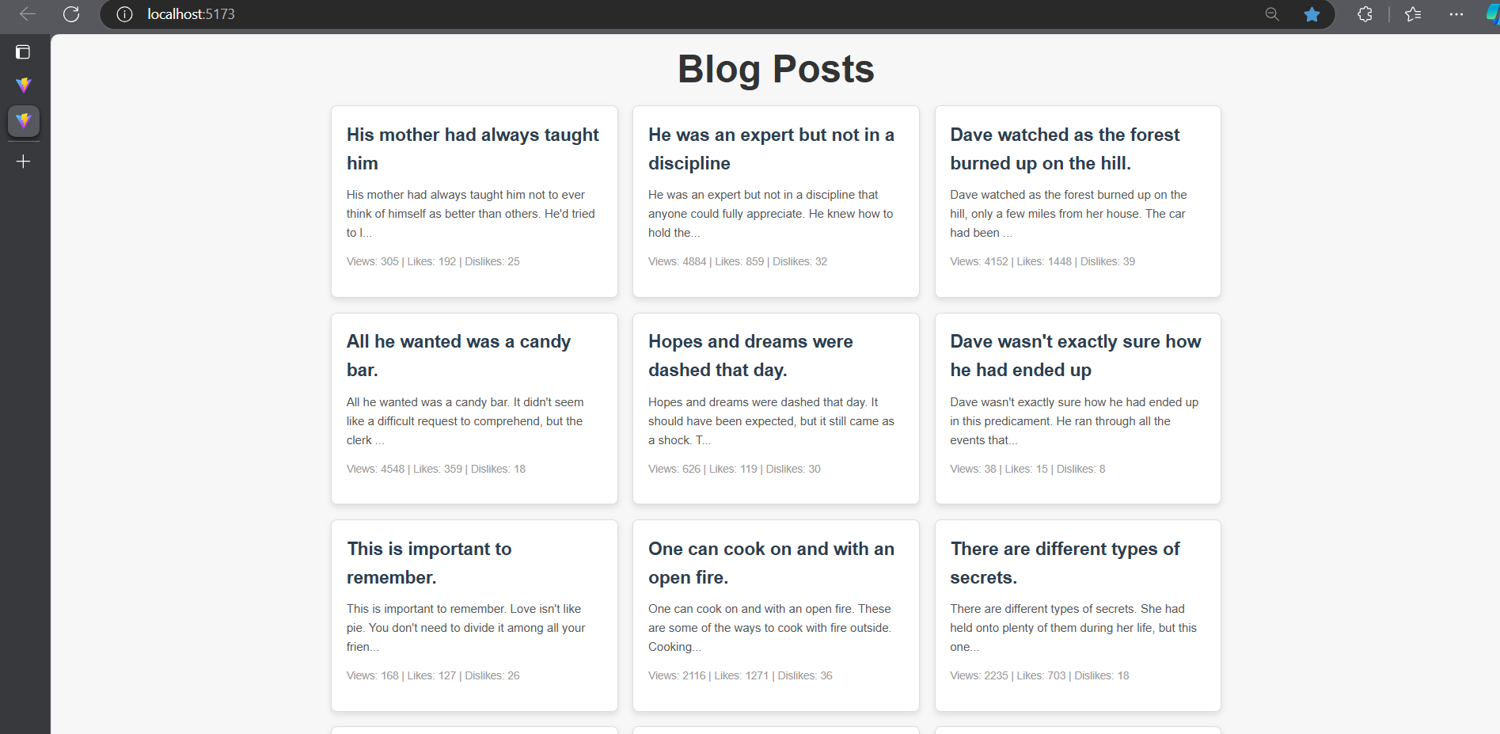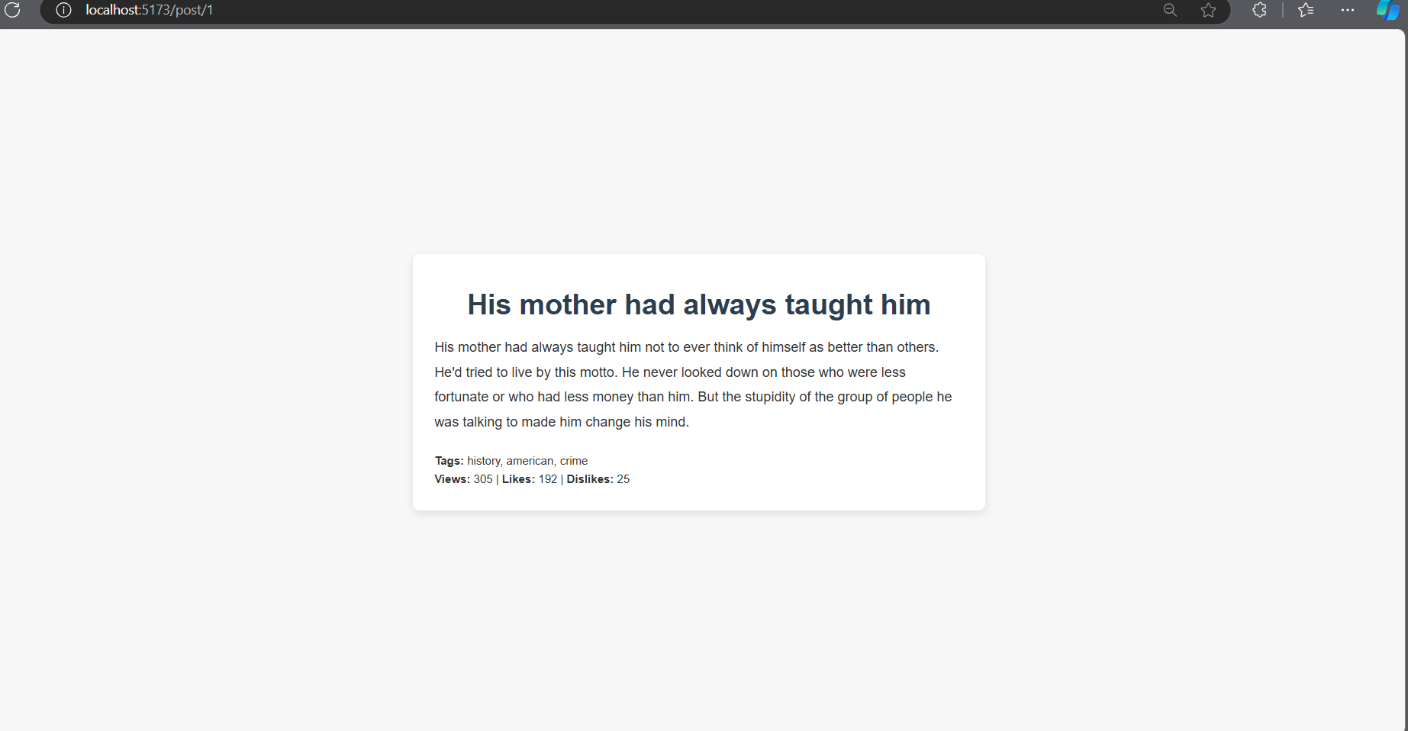

1. **Widget/Algorithm Used In Task**

* Post List Component:  
  Displays a list of blog post titles and descriptions, each linking to a dynamically generated route for the full post.
* Dynamic Routing:  
  React Router was used to implement dynamic routing. Each blog post has its own unique URL and page, which loads data based on the post ID from a dummy data source.