**Portfolio Page**

1. **Task Description**

Create pagination for the table of dummy data. It has previous and next buttons with three middle buttons representing pages, including ellipses.

1. **Task Output Screenshot**

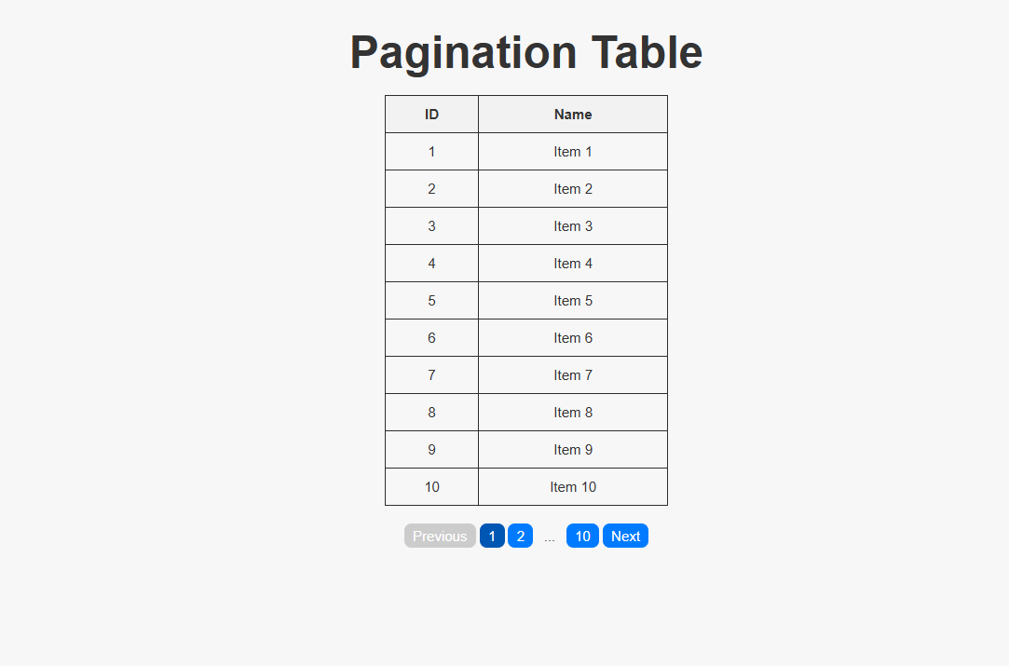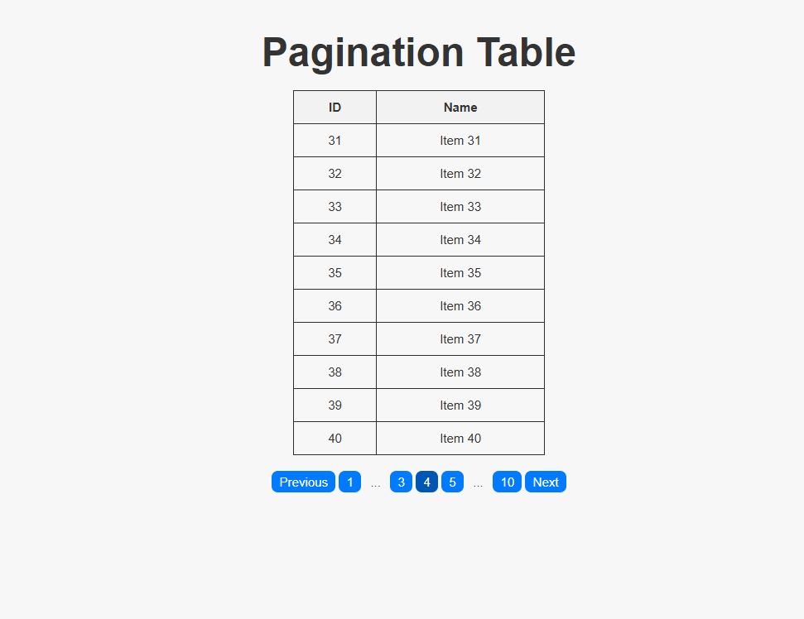

1. **Widget/Algorithm Used In Task**

* Pagination Component:  
  A reusable pagination component that controls the current page and displays buttons for navigating between pages.
* Ellipsis Logic:  
  Handles displaying the "three dots" for long pagination lists, ensuring that only relevant page numbers are displayed along with previous, next, and the first and last pages.