**project HR Management**

**Systems Migration Project, J.D. Monster Bank**

**Submitted by:**

**ISYS 630-601 Group 01**

**Organizational Chart:**

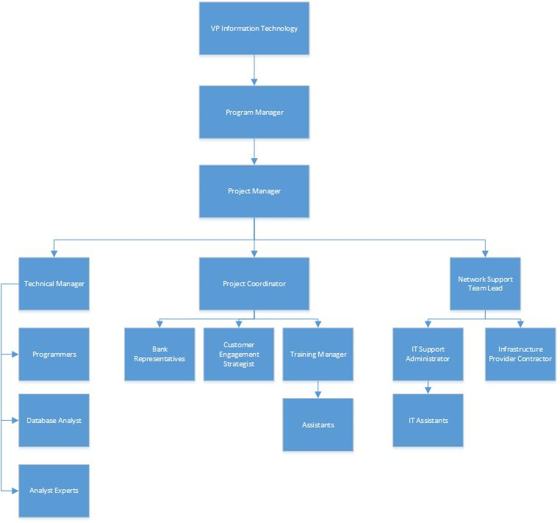

**Responsibility Assignment Matrix:**

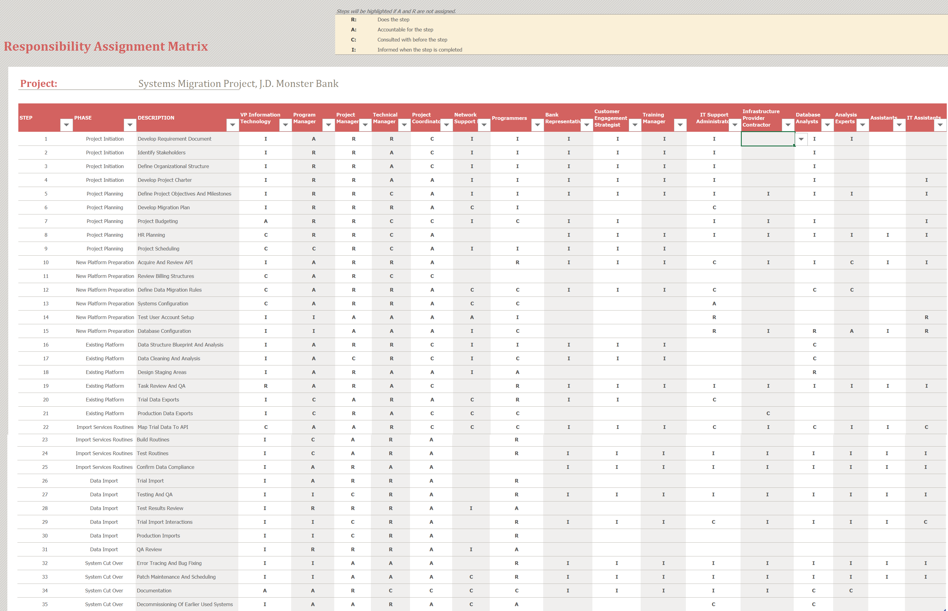

| **Code:** | **Stands For:** | **This Person Is:** |
| --- | --- | --- |
| R | Responsible | Responsible for performing the task or creating the document |
| A | Accountable | Accountable and has sign-off authority for the task, such as the project manager, sponsor, technical lead |
| C | Consult | Providing expertise, advice and support to the person responsible for the task or document and others |
| I | Inform | Informed of task progress or results, usually by the person responsible |