Project Charter

.
Project Title: | Systems Migration Project | Project ID: | JDMB630601
Sponsoring Organization: | J.D. Monster Bank | Sponsor Representative: | Yash Vardhan Sharma
Start Date: | 07/01/2017 | End Date: | 06/30/2018

- Project Stakeholders:

Position | Title/Name/Organization | Phone | E-mail
Sponsor  Representative | VP Information Technology  Yash Vardhan Sharma  J.D. Monster Bank | +1(979)985-8287 | yashvardhan@jdmb.com
Program Manager | Engagement Manager  Rituparna Das  J.D. Monster Bank | +1(979)985-8289 | rituparnadas@jdmb.com
Project Manager | VP Data Management  Jalaj Ranjan Pandey  J.D. Monster Bank | +1(312)477-9633 | jalajpandey@jdmb.com
Technical Manager | Senior Data Manager  Jacob Miller  J.D. Monster Bank | +1(352)456-9093 | jmiller@jdmb.com
Project Coordinator | Technology Associate  Katherine Scott  J.D. Monster Bank | +1(979)985-8289 | katscott@jdmb.com
IT Support Administrator | Technology Consultant  Samantha K.  J.D. Monster Bank | +1(979)985-8280 | ksamantha@jdmb.com
Network Support Team Lead | Network Administrator  Ajith Suman  J.D. Monster Bank | +1(352)456-9875 | ajihsuman@jdmb.com
Infrastructure Provider Contractor | TBD | -- | --
Training Manager | TBD | -- | --
Bank Representatives | TBD | -- | --
Customer Engagement Strategist | TBD | -- | --

- Executive Summary

- Develop a business process to enable secure and successful migration of banking data of all small banks acquired by J.D. Monster Bank.
- Devise virtual project teams leveraging state of the art, worldwide network to ensure the project operates 24x7.
- Ensure that the system migration of the banking systems do not affect the existing customer base during the project execution.

- Project Purpose
  - Business Need / Problem
- Lack of cohesion in technology implementations between J.D. Monster and other acquired banks.
- Banks acquired still use outdated mainframe systems for operations.
- A single global banking platform is in line with J.D. Monster’s objective of ensuring consistent implementation of policies and better revenue generation opportunities.

  - Business Objectives
Strategic Plan Element | Project Business Objectives
Determine migration strategy | Create a process to successfully migrate smaller bank information from host mainframe system to J.D. Monster Bank’s real time, cloud based banking networking system.
Design virtual team structures | Design a functional model to create virtual teams utilizing different time zones to ensure around the clock operations.
Determine project execution costs | Design a detailed project cost estimation including project planning, project execution, implementation and post implementation cost estimation and related details.
Develop risk mitigation strategy | Identify any possible risks for project planning and implementation and define clear mitigation strategies for each case.
Eliminate outdated technology | Eliminate usage of the mainframe system and other outdated technological implementations in the acquired banking systems by securely migrating onto the cloud-based system.

- Project Overview
  - Project Description
J.D. Monster Bank, based out of San Francisco, California aims to develop a business process to enable secure and successful migration of banking data of acquired banks. Leveraging state of the art, worldwide network, J.D. Monster targets to achieve the migration by creating virtual teams consisting of system analyst experts, programmers, database analysts and information technology assistants. To ensure the successful completion of the project, J.D. Monster CEO Mel Faesance has brought in a subject matter expert, I. Noitall to lend his expertise to the development group.

Project focusses on smooth transition of customer data from different technical implementations to a uniform cloud based infrastructure without affecting the existing user base for better operation and maintenance purpose as a unified system. Project aims to be completed within one fiscal year with a budget allocation of $350,000 per banking system migration.

  - Scope
The scope of the project would be to migrate data from all smaller banks acquired by J.D. Monster Bank into one system keeping in mind that the project targets to complete 10 migrations within the first fiscal year, i.e. from June 30 –July 31. The project is expected to start on July 1, 2016 and will be completed by June 30, 2016 and aims to successfully migrate information of ten banks into the J.D. Monster Bank system within the first fiscal year and financial estimate per migration is $350,000.

The project aims to identify and analyze requirements for devising a successful working model for virtual teams. Proposing shift to cloud based technology system, which shall minimize dependency on the existing mainframe system. Delivering a secure transition from old technology to the new one, and at the same time ensuring that this new technology is upholding integrity, security, and consistency. The project should contain properly structured project schedule and should be accompanied with documents once completed.
  - Assumptions
It is assumed that:

- Virtual team members have the required expertise to perform the tasks.
- Time estimated for one successful migration is enough.
- Costs estimation done are accurate.
- Individual departments will provide the required support.
- Technical failures have proper back up plans.
- Strategy for the virtual teams will work out with the team members.

  - Constraints
- Project should be worked out with financial constraint as not to exceed the estimated $350,000 per migration.
- A time constraint of completion of project within one fiscal year i.e., by June 30, 2016
- Common technical standards and performance constraint to be achieved for seamless execution of the project.

- Project Requirements / Deliverables

- Establishment of the virtual teams with system analysts, IT technicians and database administrators successfully functioning in each team.
- Migration of one bank at a time and validation of the process and strategy after each migration with suggested improvements on each iteration.
- Successful integration of ten systems by the end of the first fiscal year.
- Migration of customer bank accounts securely from the mainframe host system to the real-time cloud based system.
- Project migration costs per bank to be limited under $350,000.
- Secure integration of each migration with the existing banking system.

- Project Management Milestones and Deliverables

Milestone / Deliverable | Estimated Date | Responsible Individual
Devise plan with virtual teams | 07/15/2017 | Jalaj Ranjan Pandey, Yash Vardhan Sharma, Rituparna Das
Migration of the first bank | 09/30/2017 | Jalaj Ranjan Pandey, Yash Vardhan Sharma
Determine loopholes and problems | 01/10/2017 | Rituparna Das
Implement revised plan on the next bank | 12/31/2017 | Jalaj Ranjan Pandey, Yash Vardhan Sharma
Plan implementation on the remaining banks | 06/30/2018 | Rituparna Das, Jalaj Ranjan Pandey, Yash Vardhan Sharma

- Costs / Budget

Purpose | Amount | Source
Training of virtual team | $50,000 | First Estimation using the experiences of Mr. I Noitall.
Migration from main frame to cloud technology | $300,000 | Initial budget estimate (to be revised with detailed cost estimation in future)

- Personnel & Other Resources

Resources | Description
Project Team | - Yash Vardhan Sharma  - Rituparna Das  - Jalaj Ranjan Pandey
Support | J.D. Monster Bank technical support team; acquired bank’s technical support teams
Facilities | Datacenter, J.D. Monster Bank, NY; Stanford Labs; Acquired Bank’s facilities
Equipment | Database Servers, Cloud Services, Facilities, Information Technology systems (including computing centers, kiosks, networking hardware)
Software Tools | Cloud Data Services, Microsoft Servers, Windows Software

- Project Risks

- Technical problems leading to unsuccessful migration from mainframe to cloud based system.
- Lack of expertise and coordination in virtual teams.
- Lack of appropriate funding for the entire migration process.
- Breach of security during the integration and migration process.

- Project Organization
  - Project Organization Chart
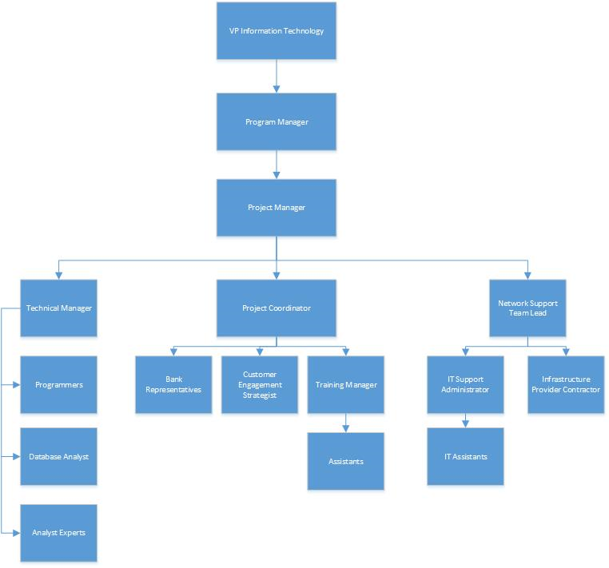
  - Roles & Responsibilities

Stakeholder Title | Name | Roles & Responsibilities
Sponsor  Representative | Yash Vardhan Sharma | Focuses on realization of benefits, champions the cause of the project, coordinates with other sponsors and provides feedback for the betterment of the project.
Program Manager | Rituparna Das | Engages in collaboration of the project team strategies with the teams from different banks undergoing the migration to carve out strategies for successful implementation and seamless transition.
Project Manager | Jalaj Ranjan Pandey | Defines and clarifies project scope, develops the project plan and schedule and devises policies and procedures to obtain the project objectives.
Technical Manager | Jacob Miller | Defines and sets working standards for individuals in the project team. Establishes technical standards and procedures for all the tasks defined in the project plan in detail.
Project Coordinator | Katherine Scott | Coordinates within and among different teams to ensure successful project plan implementation. Records grievances and complaints of project members, provides solutions to mitigate discrepancies in the team.
IT Support Administrator | Samantha K. | Provides on-demand Information technology before, during and after the migration process.
Network Support Team Lead | Ajith Suman | Ensures network related facilities for the complete process encompassing both software and hardware requirements in collaboration with IT Support team.
Infrastructure Provider Contractor | TBD | Delivers high quality infrastructure related supplies during the complete project execution.
Training Manager | TBD | Engages in designing a training plan for the bank representatives to make sure that they are aware of the migration process and a trained on the new system once the migration is completed.
Bank Representatives | TBD | Ensures that they are well informed of the migration project status and are well equipped with the new system once migration is completed.
Customer Engagement Strategist | TBD | Develops strategy for keeping customers informed about the ongoing migration and ensuring that the project results in minimum or no impact on the banking user base.

- Approval Signatures

Position/Title | Signature/Printed Name/Title | Date
Sponsor Representative | Yash Vardhan Sharma  VP Information Technology | 8th February, 2017
Program Manager | Rituparna Das  Engagement Manager | 8th February, 2017
Project Manager | Jalaj Ranjan Pandey  VP Data Management | 8th February, 2017

