CSE227 – Advanced Android Development
Name - Yash Vardhan Singh
Roll No. – 63
Section -
XML code screenshot –
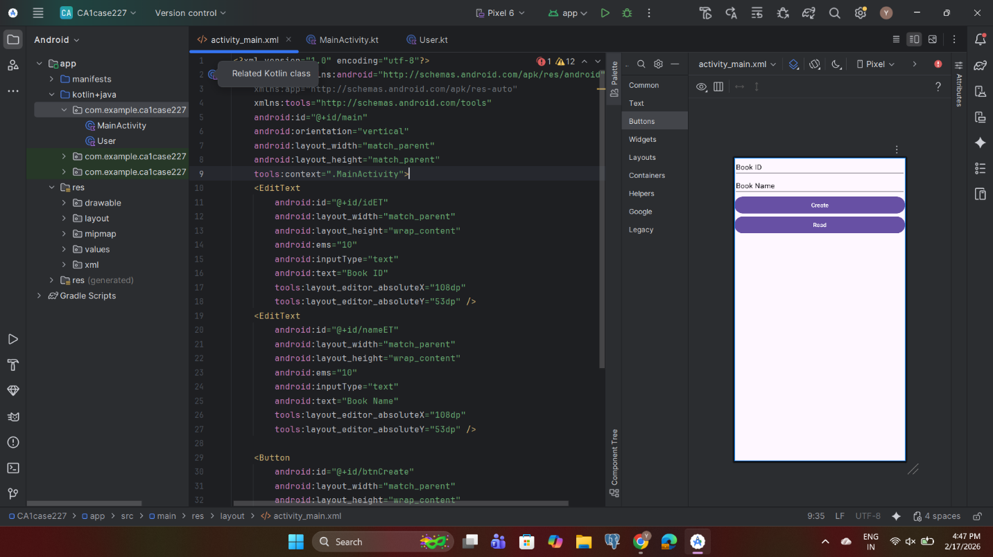
Kotline File Screenshot -
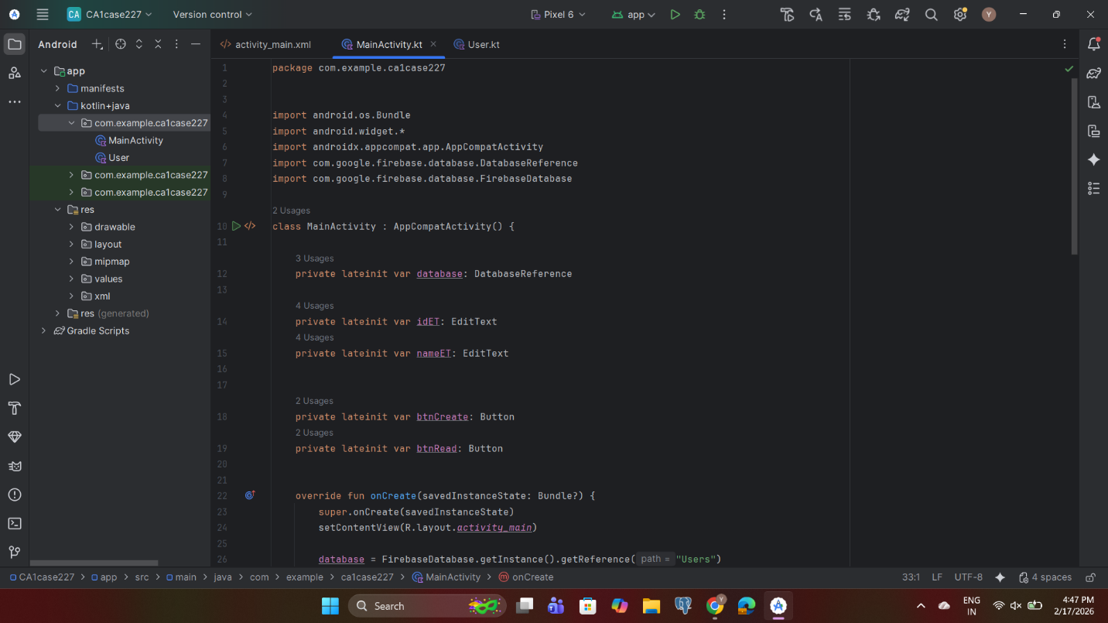
2nd screenshot –
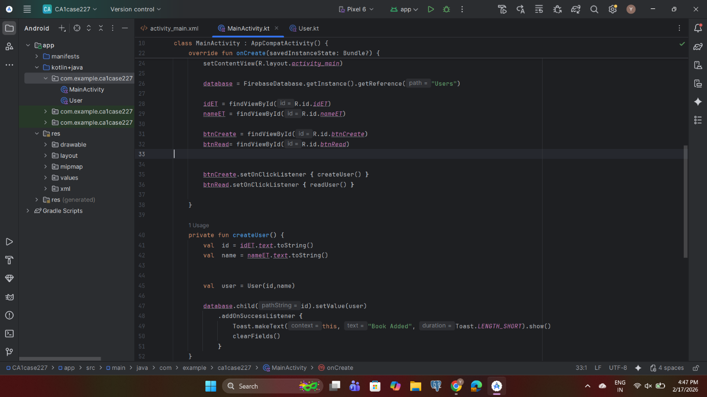
3rd screenshot –
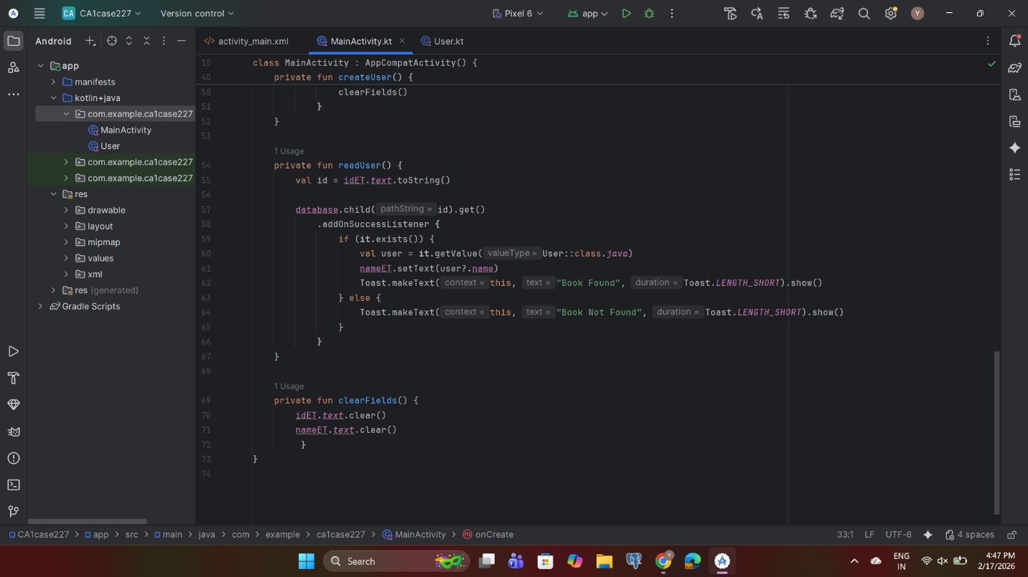

Text code of Kotlin -
package com.example.ca1case227
import android.os.Bundle
import android.widget.*
import androidx.appcompat.app.AppCompatActivity
import com.google.firebase.database.DatabaseReference
import com.google.firebase.database.FirebaseDatabase
class MainActivity : AppCompatActivity() {
private lateinit var database: DatabaseReference
private lateinit var idET: EditText
private lateinit var nameET: EditText
private lateinit var btnCreate: Button
private lateinit var btnRead: Button
override fun onCreate(savedInstanceState: Bundle?) {
super.onCreate(savedInstanceState)
setContentView(R.layout.activity_main)
database = FirebaseDatabase.getInstance().getReference("Users")
idET = findViewById(R.id.idET)
nameET = findViewById(R.id.nameET)
btnCreate = findViewById(R.id.btnCreate)
btnRead= findViewById(R.id.btnRead)
btnCreate.setOnClickListener { createUser() }
btnRead.setOnClickListener { readUser() }
}
private fun createUser() {
val id = idET.text.toString()
val name = nameET.text.toString()
val user = User(id,name)
database.child(id).setValue(user)
.addOnSuccessListener {
Toast.makeText(this, "Book Added", Toast.LENGTH_SHORT).show()
clearFields()
}
}
private fun readUser() {
val id = idET.text.toString()
database.child(id).get()
.addOnSuccessListener {
if (it.exists()) {
val user = it.getValue(User::class.java)
nameET.setText(user?.name)
Toast.makeText(this, "Book Found", Toast.LENGTH_SHORT).show()
} else {
Toast.makeText(this, "Book Not Found", Toast.LENGTH_SHORT).show()
}
}
}
private fun clearFields() {
idET.text.clear()
nameET.text.clear()
}
}
Data Class File Screenshot –

