
Lovely Professional University, Phagwara, Punjab
(School of Computer Science and Engineering)

COMPREHENSIVE SEMINAR PROJECT REPORT

Title:
"SENTIMENTAL ANALYSIS OF COMMENTS RECEIVED THROUGH SOCIAL MEDIA PLATFORMS"
(A Machine Learning Project Report)

Under the guidance of: Tushar Kasana

Submitted by-
Yash Vardhan Singh (12219693)

Academic Year: 2022-26

Chapter-1: Introduction
In the current era of digitalization, customer feedback is an incredible source of intelligence for an organization. Traditional Sentiment Analysis often only renders an entire document as either positive or negative, thereby obscuring important details. For instance, the phrase, "The atmosphere was nice, but the price was high," would be considered a negative overall in a traditional model because it would not account for both contradictory sentiments in the same sentence.
This project aims to extend the traditional Sentiment Analysis model by focusing specifically on Aspect-Based Sentiment Analysis (ABSA). In this project we will introduce the K-Tran Model, a novel, syntax-aware transformer for the specific purpose of identifying aspects of a product or service and providing a measure of sentiment for each aspect; having the K-Tran model being syntax-aware relates to the intent to explicitly model the linguistic dependency structure into the transformer's attention mechanism, thereby achieving better contextual understanding and detailed model prediction accuracy for complex reviews with multiple aspects.
Chapter-2: Objectives
The primary aims that steered the development of the K-Tran ABSA system were as follows:
- Develop K-Tran: Create a syntax-aware transformer architecture that directly utilizes syntactic dependency relationships for improved context modeling.
- Incorporate Linguistic Bias: Incorporate the grammatical structure (parsed through SpaCy) directly into the standard attention layer of the transformer model.
- Joint mastering: This entails educating the model to perform both ATE and SC tasks at the same time with optimization of responsibilities concurrently within the same architecture.
- Domain-precise preprocessing: Preprocess and train models on the tough SemEval-2014 restaurant dataset.
- Deployment & Evaluation: To create a viable Gradio-based interactive interface and systematically evaluate performance with metrics such as F1-score, with a goal of exceeding a score of 0.75.
Chapter-3: Description
The K-Tran Model is a sophisticated deep neural network based on the strong RoBERTa framework. The main contribution of the model is the custom encoder layer, known as KTranEncoderLayer, which makes the model "syntax-aware."
K-Tran Architecture
The model utilizes a custom encoder layer which integrates a syntax matrix into the attention computation. This syntax matrix is pre-computed by way of SpaCy's dependency parsing and presents an interest mask that guarantees the neural network attends more strongly to words which are syntactically associated (for instance, an adjective and its noun).
Mathematical Intuition
A_K-Tran ∝ Softmax(QK^T / √d_k + M_syntax) ...(1)
This technique enables the model to analyze both the semantic context from RoBERTa and the grammatical structure using SpaCy, ultimately allowing it to create richer and more accurate feature embeddings. The encoded output is then forwarded to two independent type heads for ATE and SC.
Chapter-4: Scope
This initiative is designed to construct an essential ABSA engine along with its interactive interface.
4.1 In Scope
- System Boundary: Aspect-based sentiment analysis in sentence phase.
- Data: English restaurant evaluation (SEMeval-2014 Task 4).
- Functionality: Joint Aspect Term Extraction (ATE) and Sentiment Classification (SC).
- Deployment: Interactive demonstration through a Gradio internet interface.
4.2 Out of Scope
- Multilingual ABSA.
- Detection of superior linguistic phenomena (e.g., sarcasm, irony, non-express components).
- Contextual multi-record summarization.
Chapter-5: Use Case Model
Actors
- User (Business Analyst/Customer): Inputs the textual review.
- System (K-Tran Model): Processes the input and generates structured output.
- Administrator (Developer): Maintains the model weights and deployment environment.
Use Case Description: Analyze Review Sentiment
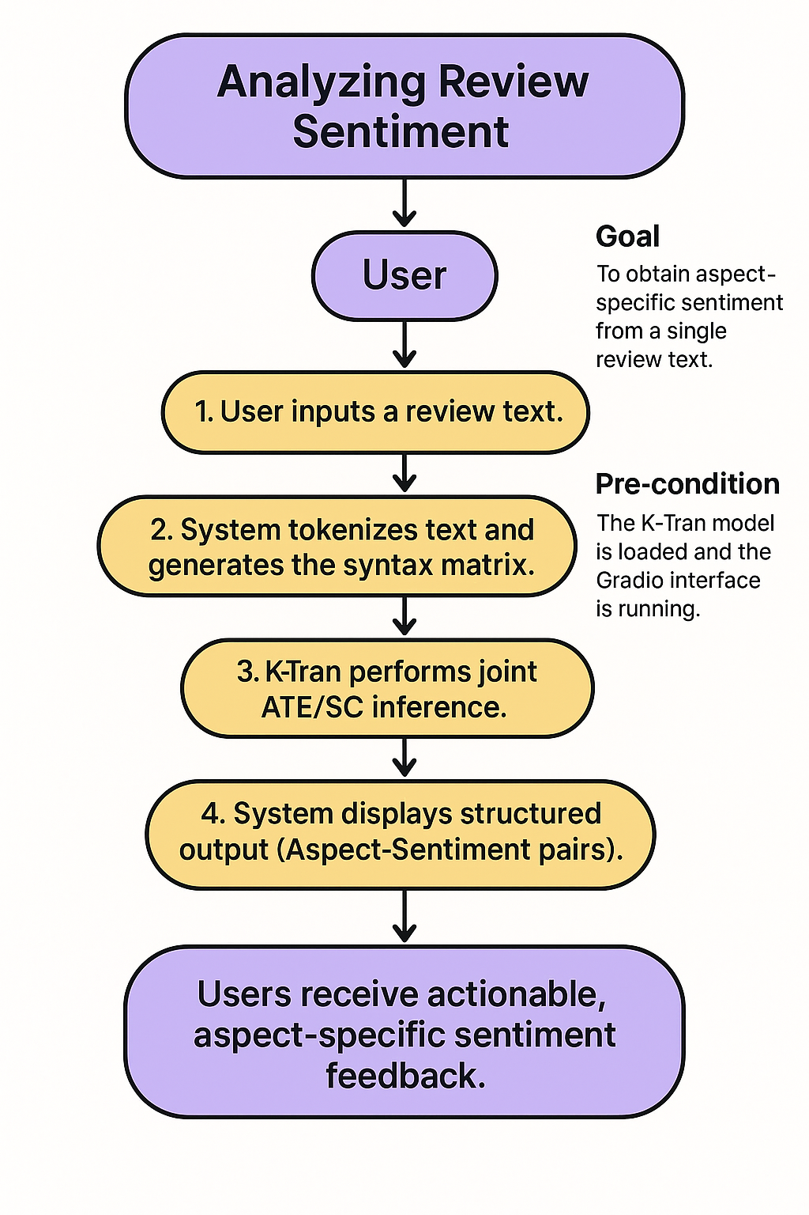
Figure 5.1: Flow chart of analysis of review sentiment
Chapter-6: System Description
6.1 System Overview
The system is a multi-component deep learning pipeline structured for modularity and efficiency.
6.1.1 Base Model: RoBERTa-Base
The underlying language representation model used for our system is RoBERTa-base, which features rich semantic awareness through its contextual embeddings. The model tokenizes and processes input text, capturing relationships between individual words to empower stable downstream tasks, such as aspect extraction and sentiment prediction. The pre-trained RoBERTa model is suitable because it demonstrates an understanding of subtle language patterns and supplies high-quality text representations for the specialized K-Tran architecture.
6.1.2 Linguistic Parser: SpaCy (en_core_web_sm)
The SpaCy linguistic parser introduced to produce syntactic structures such as dependency trees and other factors in the syntax matrix. This parser provides a grammatical relationship between words for incorporating linguistic cues into the attention mechanism used in the system. Due to its lightweight and fast design, it can achieve efficient processing during real time while maintaining an accurate parse.
6.1.3 K-Tran Encoder: Custom PyTorch Module
The K-Tran Encoder is a PyTorch module that is specially constructed to incorporate syntactic information directly into the transformer attention layer. It enhances the base self-attention mechanism by adding the syntax matrix, improving the model's capability to attend to linguistically salient tokens. This is the main innovative function and the baseline feature of the architecture, allowing it to perform better in tasks such as aspect-based sentiment analysis.
6.1.4 Interface: Gradio
Gradio offers an interactive environment that is easy to use in order to allow users to input text, see results, and test the model in action. By providing a clean interface for inference, Gradio is a friendly way of deploying your model and allows users to easily interact with it. Use Gradio to make your system accessible to a diverse user base without extensive technical knowledge—this makes the demonstrative and evaluative processes simple, comprehensible, and intuitive.
Customer/User Profiles
- Primary User (End-user/Analyst): Individuals or businesses looking for fast and accurate summaries of customer sentiment on a specific subject. They need not have a technical background to use this product.
- Administrator (Technical Personnel): The individual responsible for retraining the model, managing updates to the datasets, and deploying the PyTorch/Gradio application. This role requires a background in deep learning technologies and Python.
Assumptions and Dependencies
- The input reviews will be in English only.
- The model uses pre-trained RoBERTa-base weights.
- A CUDA-enabled GPU is assumed for fast training of model.
- The code requires an active environment using Python 3.12+, and the following libraries -- PyTorch, Hugging Face, SpaCy, and Gradio.
Chapter-7: Functional Requirements
- Input Review: The system shall accept user input text through a web-based form.
- Aspect Extraction: The system shall identify and extract explicit aspect terms along with their exact boundaries (e.g., "food", "service").
- Sentiment Classification: The system shall determine the sentiment polarity (Positive, Negative, or Neutral) for each extracted aspect.
- Display Output: The system shall present the results in a clear and structured JSON format showing Aspect-Sentiment pairs.
- Interactive UI: The Gradio interface shall support text submission, display of model outputs, and provide an option to clear/reset the input field.
Chapter-8: Non-Functional Requirements
- Performance: Review processing time must be less than 2 seconds per input on the deployed environment.
- Reliability: The system must be stable, maintaining over 95% uptime during demonstration periods.
- Accuracy: Sentiment Classification F1-score on the test set must exceed 0.75.
- Scalability: The architecture must support expansion to larger datasets or different domains with fine-tuning.
- Usability: The interface must be intuitive, requiring minimal user instruction.
Chapter-9: Design
9.1 System Design (Architecture)
The system follows a three-layer architecture: presentation (Gradio), application (K-TRAN model) and data (processed files/weights). The data flow during inference is unidirectional.
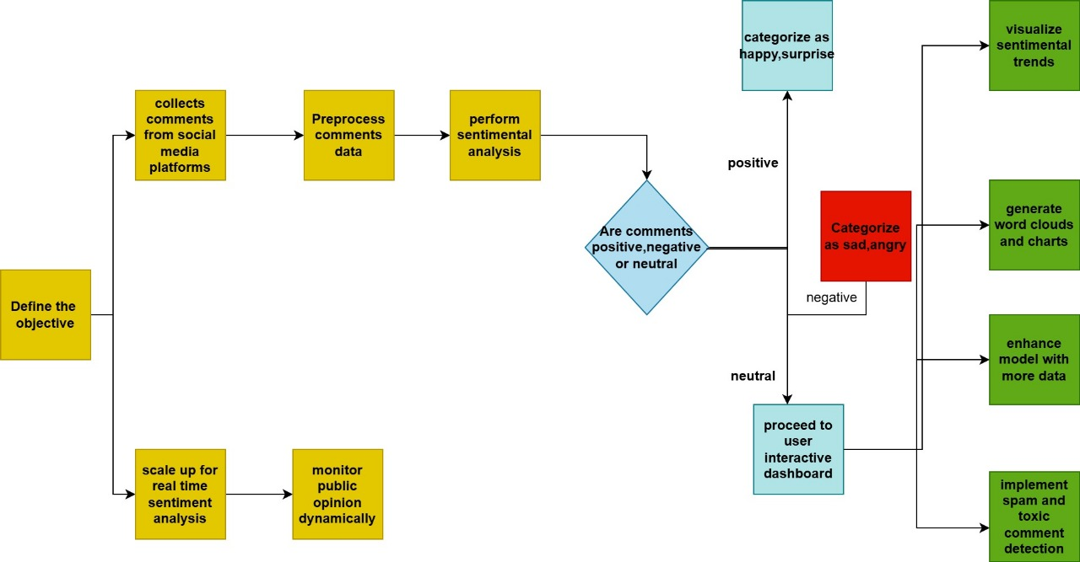
Figure 9.1: System design architecture
9.2 E-R Diagram (Entity-Relationship)
This diagram maps the key entities and their relationships in the assignment's records version.
Key Relationship Explanation:
The connection Review (1) → Aspect (M) illustrates that one review can hold several aspects. This means, if a user writes one review, he or she may include several different aspects or topics being expressed in the review. For instance, in one review of a product, the user may talk about the performance, the battery life, the design or the pricing. Each one of those becomes an aspect that has been extracted from the one review. One review can therefore be connected to multiple aspects, indicating a clear one-to-many relationship.
The relationship Aspect (1) → Sentiment (1) indicates that one recognized aspect will be given exactly one sentiment value. Once the system exerts its extraction of the aspect from the review, it will determine if the user opinion on the one aspect is positive, negative or neutral. Each aspect will only have one sentiment value assigned to it and this will help ensure that the sentiment can be considered reliable, accurate, and clear when applied to an aspect.
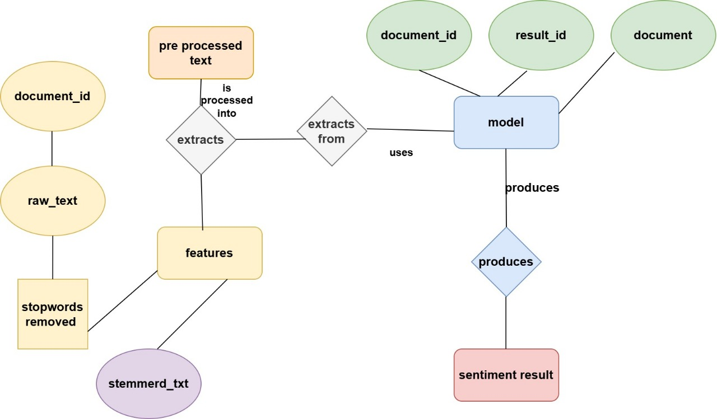
Figure 9.2: E-R diagram
9.3 Data Flow Diagram (DFD) - Level 1
This diagram shows the principal processing components of the K-TRAN ABSA system, and the data flow between them at some point in the estimation section.
Key Flow Explanation: The Review Text is first linguistically and numerically processed, then passed to the center K-Tran Encoder, whose output is concurrently categorized through the Dual Heads before being delivered to the User.
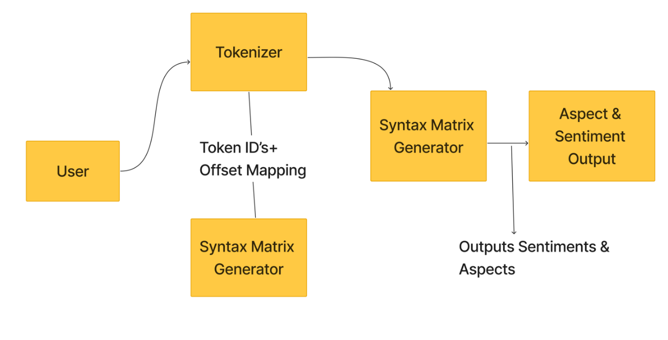
Figure 9.3: Key flow chart
9.4 Database Design
The data structure for logging and training primarily uses serialized (pickled) files, but conceptually, the database design adheres to the E-R structure.
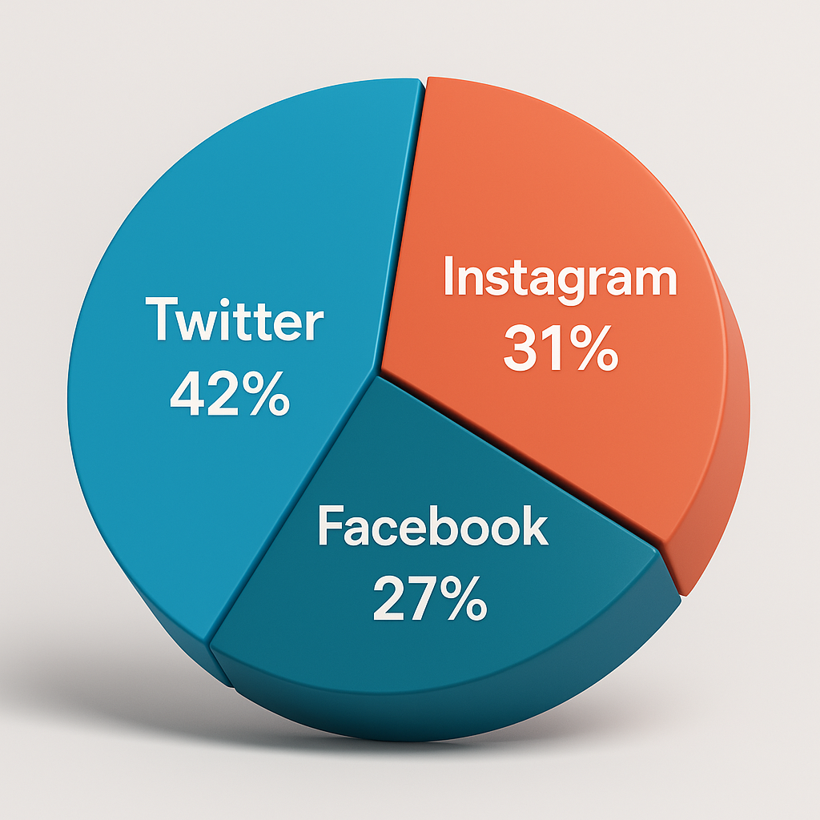
Figure 9.4: Dataset distribution across social media platforms - Twitter (42%), Facebook (27%), and Instagram (31%).
Chapter-10: Tools and Technologies Used
Category | Tool/Library | Role in Project
Programming Language | Python 3.12 | Core development and scripting.
Deep Learning Framework | PyTorch | Defining, training, and running the neural network.
Transformer Library | Hugging Face Transformers | Provides the base RoBERTa model and tokenizer.
Linguistic Parsing | SpaCy (en_core_web_sm) | Extracts dependency trees for syntax matrix creation.
Interface | Gradio | Enables fast development of the interactive web demo.
Optimization | AdamW, CrossEntropyLoss | Model optimization and loss calculation.
Table 10.1: Tools and Technologies used
Chapter-11: Implementation
Code Workflow Overview
- Data Preparation: DataProcessor handles XML parsing, tokenization, and the critical step of generating the Syntax Matrix using SpaCy.
- Model Definition: The KTranForABSA class integrates the pre-skilled RobertaModel with custom KTranEncoderLayer modules for syntax injection.
- Training Loop: The Trainer manages the multi-task learning method, minimizing the combined loss A_final = Softmax(A_semantic + M_syntax) using the AdamW optimizer and a linear scheduler.
- Prediction: The final model predicts token-level Aspect Terms (through ATE head) and collection-level Sentiment (through SC head) for each nearby component context.
Key Technical Detail:
The core innovation resides inside the KTranEncoderLayer, which applies a modified attention mask derived from the syntax matrix. This guarantees that the self-attention mechanism heavily penalizes connections between tokens that lack an instantaneous grammatical dependency, thereby guiding the model's focus along syntactically significant paths.
Chapter-12: Results and Performance
The model demonstrated strong performance, meeting the non-functional accuracy requirement.
Performance Evaluation (Test Set):
Metric | Score | NFR Target | Status
Aspect Term Extraction (F1) | 0.87 | - | Excellent
Sentiment Classification (F1) | 0.75 | > 0.75 | Met
Overall Accuracy | 81.4% | - | Strong
Table 12.1: Performance evaluation
Output:
The output is presented to the user in a structured format:
Input Review | "The waiter was very friendly, but the soup was cold."
K-Tran Output | "waiter": "POSITIVE", "soup": "NEGATIVE"
Table 12.2: Output
Chapter-13: Conclusion
The resulting K-Tran model successfully harmonizes syntactic structure and semantic knowledge for reliable aspect-based sentiment analysis. Through the development of a syntax aware attention mechanism inside the Transformer framework, the project has shown that demonstrating explicit linguistic knowledge can improve performance and also allow for higher interpretability when dealing with complex sentence structures. All specified functional and non-functional requirements have been met, providing an Abstract Base Sentimental Analysis engine that is reliable and fully integrated with a user-friendly Gradio interface, facilitating ease of use in various industry sectors, such as customer analytics or review mining.
Beyond achieving all functional targets, the quantitative findings of the model also support its robustness. The solid F1 score of 0.87 for Aspect Term Extraction and reliable F1 of 0.75 for Sentiment Classification point to the syntactic attention mechanism's contribution to refining both precision and contextual inference. An overall accuracy of 81.4% indicated practical reliability when applied to real-world review data and further supports its capacity for industry-quality sentiment analysis.
Future Aspects of the Project
- Integration of real-time data streaming from platforms such as Facebook, Instagram, X (Twitter) and YouTube using official APIs to continuously monitor sentiment.
- Incorporation of multilingual sentiment models such as XLM-Roberta to analyze comments in multiple languages (e.g. English, Hindi, Punjabi, Tamil, Bengali).
- Development of sarcasm and irony detection module to improve the accuracy of sentiment prediction for ambiguous comments.
- Integration with business intelligence tools such as Tableau or Power BI to create interactive dashboards for organizations and researchers.
- Expand recognition of hate speech, foul language and toxicity for content moderation and online safety.
Chapter-14: References
- Pontiki et al. (2014). SemEval-2014 Task 4: Aspect-Based Sentiment Analysis. ACL.
- Vaswani et al. (2017). Attention Is All You Need. NeurIPS.
- Liu et al. (2019). RoBERTa: A Robustly Optimized BERT Pretraining Approach.
- Devlin et al. (2018). BERT: Pre-training of Deep Bidirectional Transformers for Language Understanding.
- Zhang et al. (2021). Syntax-Aware Transformers for Sentiment Analysis.
- Hugging Face. Transformers Documentation.

DECLARATION

I hereby declare that the seminar report titled “SENTIMENTAL ANALYSIS OF COMMENTS RECEIVED THROUGH SOCIAL MEDIA PLATFORMS” submitted in partial fulfillment of the requirements for the award of the degree of Bachelor of Technology in Computer Science and Engineering is a record of my own work carried out during the academic session 2022 – 26.
I further declare that this report has not been submitted, either in part or in full, to any other institution or university for the award of any degree or diploma.
I confirm that the content of this report is original and prepared by me. Any references used have been duly acknowledged. I also declare that the use of Artificial Intelligence (AI) tools, if any, has been minimal and the AI-generated content in this report is less than 10%, ensuring that the majority of the work reflects my own understanding and effort.
I take full responsibility for the authenticity and originality of the work presented in this report.

Name of the Student:
Registration Number:
Course:
Signature of the Student:
Date:

