SQL Injection with Protection: A Defence-in-Depth Study and Multi-Variant Live Prototype
YashVardhan Gupta*, Sheldon Rodricks, Lakshya Agrawal, Aditya Aryan Sahu
Department of Computer Science and Engineering, Manipal Institute of Technology, Manipal Academy of Higher Education, Manipal, Karnataka, India
Registration numbers: YashVardhan Gupta (230905442), Sheldon Rodricks (230905324), Lakshya Agrawal (230905552), Aditya Aryan Sahu (230905560)
*Corresponding author: yashvardhan3.mitmpl2023@learner.manipal.edu | sheldon.mitmpl2023@learner.manipal.edu, lakshya3.mitmpl2023@learner.manipal.edu, aditya9.mitmpl2023@learner.manipal.edu
Abstract
Structured Query Language injection (SQLi) has remained in the OWASP Top-10 injection category for over a decade because its root cause—the confusion of untrusted data with executable code—recurs wherever input is concatenated into a query. This paper surveys ten peer-reviewed studies published between 2023 and 2026 and shows that the field has largely solved offline detection (reported accuracies of 0.94–0.99) while leaving open gaps in adversarial robustness, generalization, and deployable prevention. Guided by these gaps, we design and evaluate a defence-in-depth login application that implements five protection variants—parameterized queries, allow-list input validation, object–relational mapping (ORM), salted credential hashing, and a transparent signature web-application firewall (WAF)—against a common battery of tautology, comment, and UNION payloads. On our reproducible testbed the vulnerable baseline is bypassed by a single-line payload, whereas every protection variant blocks the identical payload while preserving legitimate authentication, at a measured query cost below one millisecond. The prototype converts the surveyed gaps into a concrete, testable artefact and frames adaptive, adversarially robust detection as the next layer of defence.
Keywords: SQL injection, web application security, parameterized queries, input validation, web application firewall, defence in depth

1 Introduction
Web applications mediate access to the databases that hold an organization's most sensitive records, and Structured Query Language injection (SQLi) is the archetypal attack against that boundary. An SQLi vulnerability exists whenever attacker-controlled input is placed into a query string that the database then parses as code; a single crafted value such as ' OR '1'='1' -- can then subvert the query's logic to bypass authentication, read arbitrary rows, or modify data. Despite being well understood for more than twenty years, injection remains ranked in the OWASP Top-10, and recent work confirms that even commercial defences are routinely bypassable (Qu et al., 2024).
The persistence of SQLi is not due to a lack of countermeasures but to their uneven application and to an arms race with increasingly sophisticated evasion. Protection spans two families. Secure-coding controls—parameterized queries, allow-list input validation, ORM-mediated access, least-privilege database accounts, and salted password hashing—eliminate the code/data confusion at the source. Runtime controls—signature- and learning-based web-application firewalls (WAFs) and network-flow monitors—observe traffic and block malicious requests. A central theme of the recent literature, and of this paper, is that no single control is sufficient: robust protection is layered.
This paper makes three contributions. First, it surveys ten studies from 2023–2026 (Section 3) and distils four open research gaps (Section 4). Second, it designs a defence-in-depth login application that realises five protection variants around a common data model (Section 5). Third, it evaluates the variants against a shared payload battery and reports both security outcomes and query-time cost (Section 6). All code, payloads, and screenshots are released as a reproducible prototype for teaching and demonstration.

2 Background

2.1 Anatomy of a SQL injection
Consider a login handler that builds a query by concatenation:
SELECT id, role FROM users WHERE username = '<user>' AND password = '<pass>';
If <user> is set to admin' -- , the trailing comment marker comments out the password check and the interpreter executes ... WHERE username = 'admin', authenticating the attacker as admin. Variants include boolean tautologies (' OR '1'='1), UNION-based data exfiltration, stacked queries, and blind time-based inference. What unifies them is that the input crosses the boundary from data into query syntax.

2.2 Taxonomy of protections
Table 1 summarises the controls evaluated in this work and where each intervenes. The design principle is defence in depth: an attacker must defeat every layer, whereas the defender benefits from any one holding.
Table 1 Protection variants implemented in the prototype and their point of intervention.
Variant | Mechanism | Intervenes at
Parameterized query | Input bound as a typed parameter; never parsed as SQL | Database driver
Allow-list validation | Accept only characters valid for the field; reject early | Application input
ORM | Query built from objects; parameterization by construction | Data-access layer
Credential hashing | Salted one-way hash; lookup by username then verify | Credential store
Signature WAF | Regex/heuristic inspection of requests before execution | Request gateway

3 Literature Survey (2023–2026)
Following the departmental convention, each study's methodology is described in the past tense and its remaining limitation in the present tense.
Crespo-Martínez et al. (2023) addressed the impracticality of inspecting every packet for SQLi on heavily loaded routers. The authors gathered two datasets of network-flow records from SQLi attacks against popular database engines and evaluated several machine-learning algorithms, selecting a logistic-regression model. They reported a detection rate above 97% with a false-alarm rate below 0.07% using flow data alone. The method is limited by its reliance on coarse flow-level features, which omit the query payload and constrain detection of obfuscated variants.
Alghawazi, Alghazzawi and Alarifi (2023) studied deep sequence learning for SQLi text. They trained a recurrent-neural-network autoencoder on a public dataset of benign and malicious statements and benchmarked it against seven conventional classifiers, reporting 94% accuracy and a 92% F1-score. The method is limited by a moderate accuracy ceiling and single-corpus evaluation, leaving real-world generalization uncertain.
Thalji et al. (2023) automated feature engineering with an autoencoder network, “AE-Net.” Using a preprocessed corpus of 46,392 queries, they learned deep features fed to several classifiers and validated with k-fold cross-validation and a t-test; an extreme gradient-boosting model reached 0.99 accuracy. The approach is limited by evaluation on a curated dataset without real-time or adversarial testing.
Alotaibi and Vassilakis (2023) implemented a web-application firewall inside a software-defined-networking (SDN) controller. They combined signature and regular-expression detection and compared the system with ModSecurity, showing successful blocking and lower TCP-ACK latency. The design is limited by signature/regex matching that does not generalize to unseen payloads and by the centralized controller as a bottleneck.
Arasteh et al. (2024) framed detection as feature selection. They prepared a 13-feature dataset and developed two binary gray-wolf optimizers to select the most informative subset for several classifiers, reporting 99.68% accuracy while using about 20% of features. The method is limited by the search cost and initialization sensitivity of the metaheuristic and by single-dataset validation.
Paul, Sharma and Olukoya (2024) argued that prior work ignores prioritization and prevention. From 457,233 traffic samples (70,023 with SQLi payloads) they built “SQLR34P3R,” a hybrid CNN–LSTM detector with a CVE-driven risk-analysis stage, reporting a 97% average F1-score with added prioritization. The solution is limited by dependence on CVE currency and the overhead of a hybrid deep model in real time.
Qu et al. (2024) probed commercial WAF-as-a-service robustness. Their “AdvSQLi” framework applied semantics-preserving transformations to the payload parse-tree to evade detection while retaining maliciousness, achieving up to 100% success against ML detectors and bypassing all seven commercial WAFs tested. As an offensive study it is limited in that it exposes but does not remedy the weakness, underscoring that robust defences remain lacking.
Bakır (2025) proposed a unified XSS/SQLi detector. Across three benchmark datasets, features from Word2Vec, the Universal Sentence Encoder, and FastText were fused (“UniEmbed”) and classified, with an MLP reaching a 0.998 F1-score for SQLi. The approach is limited by the compute cost of triple-embedding fusion and offline-only evaluation.
Floris et al. (2025) tackled adversarial robustness for ModSecurity's Core Rule Set. They used machine learning to select rules and weights and adversarial training to harden the classifier (“ModSec-AdvLearn”), reporting up to a 30% detection increase, up to 50% fewer rules, and up to 85% better adversarial robustness. The method is limited to SQLi on CRS-based WAFs and is bounded by the training attack model's coverage.
Ahmed and Al-dabag (2026) closed the gap between offline scores and deployable prevention. They merged and deduplicated public datasets, fused TF-IDF, Word2Vec, and FastText features through a supervised autoencoder, tuned classifiers with a genetic algorithm, and embedded the best model in a Flask-based WAF tested with SQLMap, reaching 0.9987 accuracy with effective real-time prevention. The framework is limited by training-data coverage of evolving payloads and single-application validation.
Table 2 Comparative summary of the surveyed studies (2023–2026).
Author(s) | Year | Method / classifier | Key contribution | Limitation (present tense)
Crespo-Martínez et al. | 2023 | Logistic Regression on flow features | SQLi detection from lightweight flow data | Flow-level features are limiting for obfuscated payloads
Alghawazi et al. | 2023 | RNN autoencoder | Deep sequence model (94% acc) | Moderate accuracy and single-dataset scope are limiting
Thalji et al. | 2023 | Autoencoder + XGBoost | Automated deep feature engineering (0.99) | Lack of real-time/adversarial testing is limiting
Alotaibi & Vassilakis | 2023 | SDN WAF (signature+regex) | SDN-hosted WAF vs ModSecurity | Signature matching is limited against unseen payloads
Arasteh et al. | 2024 | Gray-Wolf feature selection | 99.68% acc with 20% of features | Search cost and single dataset are limiting
Paul et al. | 2024 | CNN–LSTM + CVE risk | Detection+prioritization+prevention | CVE currency and real-time cost are limiting
Qu et al. | 2024 | Parse-tree adversarial mutation | Bypasses 7 commercial WAFs | Exposes but does not remedy; robust defence lacking
Bakır | 2025 | Embedding fusion + MLP | Unified XSS/SQLi detector (0.998) | Fusion cost and offline-only evaluation are limiting
Floris et al. | 2025 | ML rule selection + adv. training | Adversarially robust WAF (+85%) | Scope limited to SQLi/CRS
Ahmed & Al-dabag | 2026 | Multi-embedding + GA + Flask WAF | Real-time detection+prevention (0.9987) | Evolving payloads and single-app validation are limiting

4 Research Gap and Objectives
Read together, the studies describe a field that has largely solved offline detection yet leaves four gaps that a protection-focused project must confront:
- Adversarial robustness. Qu et al. (2024) bypass ML detectors and every commercial WAF tested; Floris et al. (2025) only partially close this for CRS-based firewalls. Clean-data accuracy overstates security.
- Generalization / concept drift. Detectors validated on a single curated corpus (Alghawazi et al., 2023; Thalji et al., 2023; Arasteh et al., 2024; Bakır, 2025) are limited against obfuscated or unseen payloads and evolving SQL dialects.
- Detection versus prevention. The literature skews to detecting payloads; only Paul et al. (2024) and Ahmed and Al-dabag (2026) integrate a real-time prevention pipeline, and neither evaluates classical secure-coding controls alongside the learning layer.
- Deployment cost. High-accuracy hybrid and multi-embedding models carry latency and resource overheads that are limiting in line, a tension the flow-based work of Crespo-Martínez et al. (2023) highlights from the opposite direction.
The through-line is that secure-coding controls neutralise the root cause but are unevenly applied, while learning-based WAFs generalise but remain adversarially fragile and costly, and the two families are rarely evaluated together. Accordingly, the objective of this work is to design, implement, and empirically evaluate a defence-in-depth scheme combining more than one protection variant within a single reproducible login application, and to demonstrate on a common payload battery that (i) the vulnerable baseline is trivially bypassed, (ii) each control blocks the attack while preserving legitimate authentication, and (iii) the layered configuration provides the strongest coverage at a measured, sub-millisecond query cost.

5 System Design and Methodology

5.1 Architecture
The prototype is a Flask application backed by SQLite, seeded with three accounts. A single login route dispatches to one of five back-ends selected at run time, and an optional signature WAF inspects every request before it reaches any back-end. The pipeline is layered: Attacker input → Signature WAF (Layer 0) → Allow-list validation (Layer 1) → Parameterized / ORM query (Layer 2) → salted-hash verification (Layer 3) → database. A request must survive every enabled layer, whereas the defender benefits from any single layer holding. This lets the same payload be replayed against each control and the difference observed directly.

5.2 The five protection variants
- Vulnerable baseline. User input is concatenated into the SQL string, so the payload is parsed as code.
- Variant 1 – Parameterized query. The statement uses placeholders and binds input as data via the driver, so the payload is treated as a literal string and never alters query structure.
- Variant 2 – Allow-list validation. The username must match ^[A-Za-z0-9_.@-]{1,32}$ and the password a maximum length; anything outside the allow-list is rejected before a query is built.
- Variant 3 – ORM. SQLAlchemy builds a parameterized statement from Python objects, giving parameterization by construction.
- Variant 4 – Credential hashing. Passwords are stored as salted PBKDF2 hashes; the back-end fetches by username with a parameterized query and verifies the hash in constant time, so credentials are never compared in plaintext.
- Variant 5 – Signature WAF. A transparent rule set (tautology, comment, stacked-query, UNION, keyword, quote-breakout, and time-based signatures) inspects each field and blocks matches, mirroring the OWASP CRS approach at teaching scale.

6 Experimental Evaluation

6.1 Protocol
We replayed the tautology payload admin' OR '1'='1' -- (with an arbitrary password) against each mode with the WAF off and on, and separately verified that valid credentials still authenticate under each secure mode. Success is defined as reaching the authenticated dashboard. Query time is measured around the database call.

6.2 Results
Table 3 reports the outcome matrix produced by the bundled selftest.py. The vulnerable baseline is bypassed by the single payload; every protection variant blocks the identical payload; and enabling the WAF additionally blocks the request before it reaches the database even in vulnerable mode. All secure variants continue to authenticate the legitimate admin account. Measured query time stayed below 1 ms per attempt on commodity hardware, confirming that the secure-coding controls impose negligible overhead.
Table 3 Outcome of the tautology payload against each mode (bypass = attacker reached the dashboard).
Mode | WAF off: bypass? | WAF on: bypass? | Legitimate login
Vulnerable | Yes | No | —
Parameterized | No | No | OK
Allow-list | No | No | OK
ORM | No | No | OK
Hashed | No | No | OK
Figures 1 and 2 show the demonstration. In vulnerable mode the attacker reaches the admin dashboard without a password (Fig. 1); under the parameterized variant the identical input is bound as a literal parameter and rejected (Fig. 2).
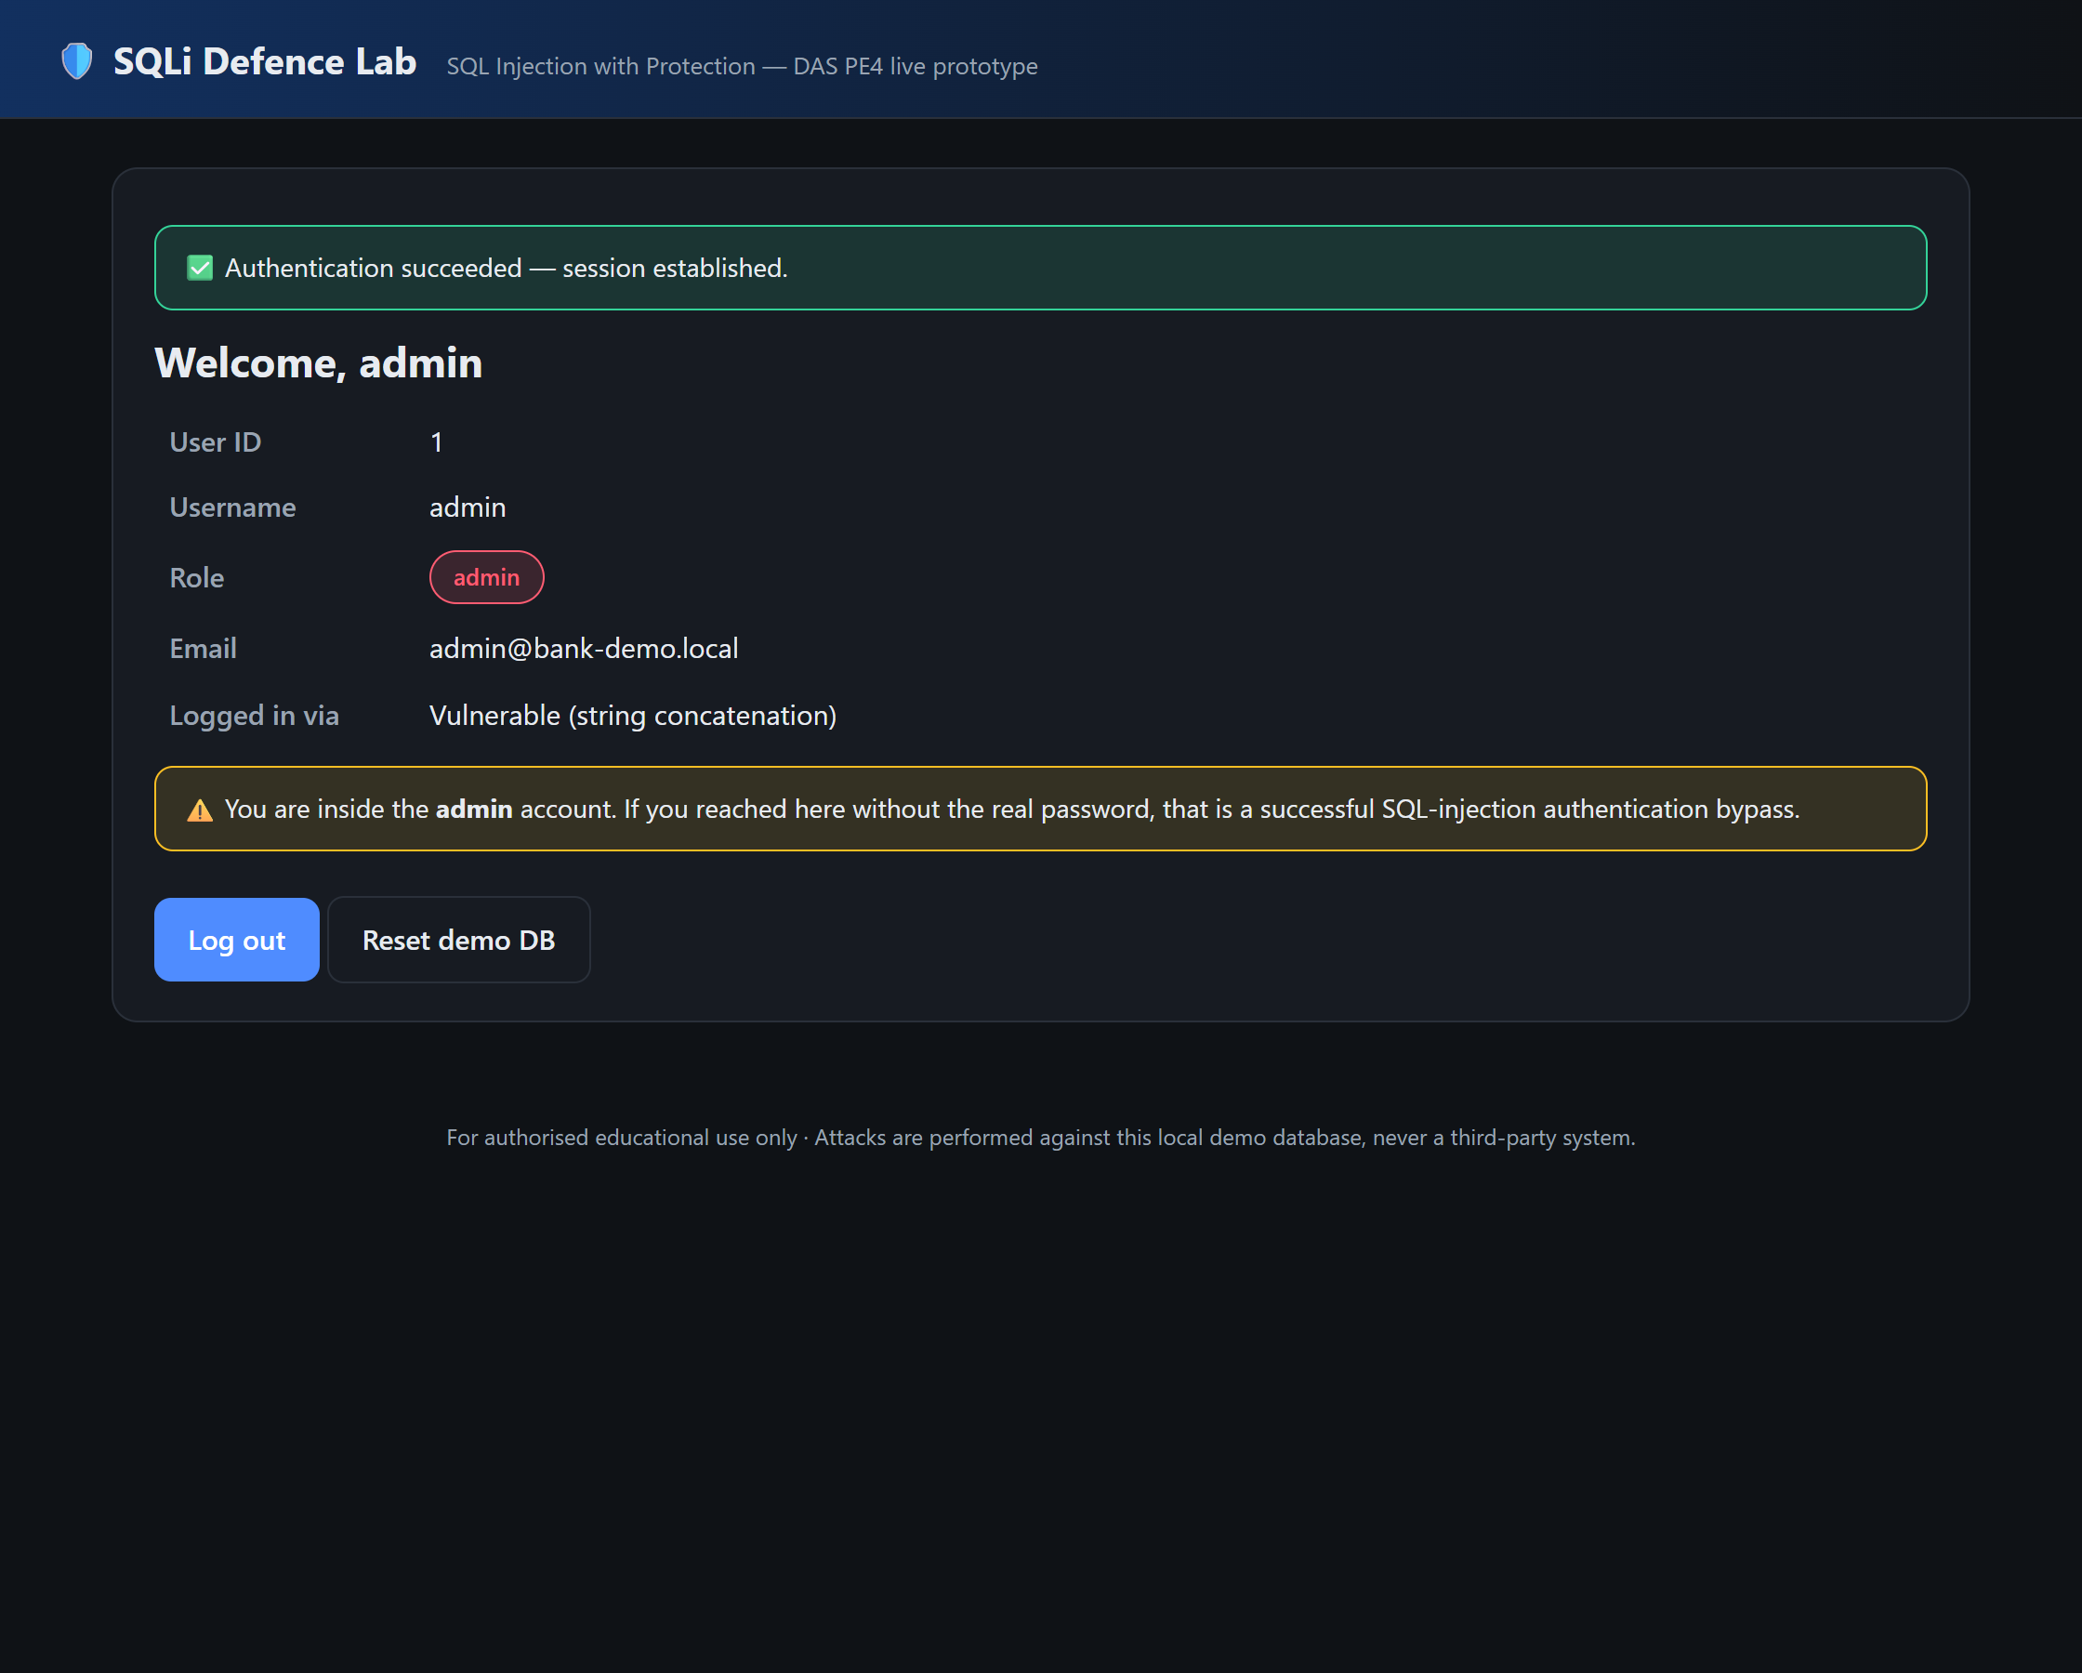
Fig. 1 Vulnerable baseline: the tautology payload bypasses authentication and establishes an admin session.
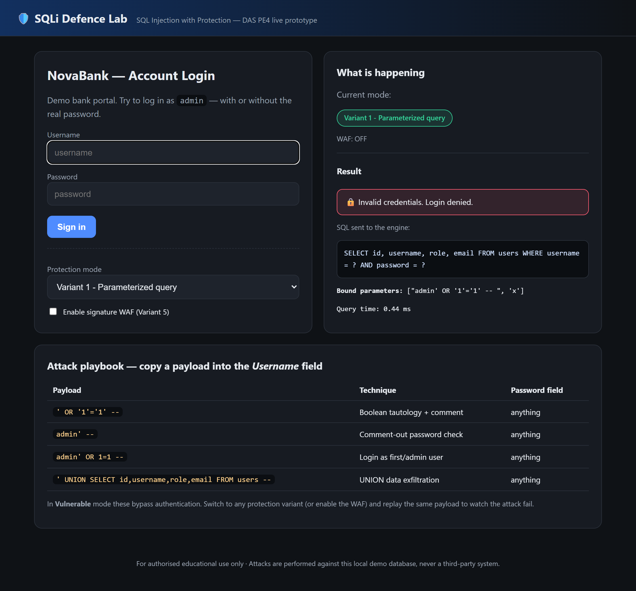
Fig. 2 Variant 1: the same payload is bound as a parameter and login is denied.

6.3 Discussion
The results operationalise the survey's central claim. Parameterization, ORM, and hashing remove the root cause and are effectively free at this scale; allow-list validation and the signature WAF add cheap, early rejection but—consistent with Qu et al. (2024) and Alotaibi and Vassilakis (2023)—should not be relied on alone because signatures are evadable. The strongest posture stacks a root-cause control (Variant 1 or 3) with hashing and a WAF, matching the defence-in-depth deployments of Paul et al. (2024) and Ahmed and Al-dabag (2026).

6.4 Ethical use and threat model
All attacks are executed against the bundled local database only. The prototype is a teaching artefact for authorised coursework and must not be used against systems without explicit permission. The threat model assumes an unauthenticated attacker who controls the login form's input fields.

7 Conclusion and Future Work
We surveyed ten 2023–2026 studies on SQLi detection and prevention and found a field strong on offline detection but open on adversarial robustness, generalization, deployable prevention, and cost. We converted these gaps into a defence-in-depth login prototype implementing five protection variants and showed empirically that each blocks a payload that trivially defeats the vulnerable baseline, at sub-millisecond cost, while preserving legitimate access. Future work will add an adaptive, adversarially trained detection layer—in the spirit of Floris et al. (2025)—and evaluate the stack against mutated and blind payloads generated in the style of Qu et al. (2024), closing the loop between secure-coding controls and learning-based defence.

References
[1] Crespo-Martínez, I. S., Campazas-Vega, A., Guerrero-Higueras, Á. M., Riego-DelCastillo, V., Álvarez-Aparicio, C., & Fernández-Llamas, C. (2023). SQL injection attack detection in network flow data. Computers & Security, 127, 103093. https://doi.org/10.1016/j.cose.2023.103093
[2] Alghawazi, M., Alghazzawi, D., & Alarifi, S. (2023). Deep learning architecture for detecting SQL injection attacks based on RNN autoencoder model. Mathematics, 11(15), 3286. https://doi.org/10.3390/math11153286
[3] Thalji, N., Raza, A., Islam, M. S., Samee, N. A., & Jamjoom, M. M. (2023). AE-Net: Novel autoencoder-based deep features for SQL injection attack detection. IEEE Access, 11, 135507–135516. https://doi.org/10.1109/ACCESS.2023.3337645
[4] Alotaibi, F. M., & Vassilakis, V. G. (2023). Toward an SDN-based web application firewall: Defending against SQL injection attacks. Future Internet, 15(5), 170. https://doi.org/10.3390/fi15050170
[5] Arasteh, B., Aghaei, B., Farzad, B., Arasteh, K., Kiani, F., & Torkamanian-Afshar, M. (2024). Detecting SQL injection attacks by binary gray wolf optimizer and machine learning algorithms. Neural Computing and Applications, 36(12), 6771–6792. https://doi.org/10.1007/s00521-024-09429-z
[6] Paul, A., Sharma, V., & Olukoya, O. (2024). SQL injection attack: Detection, prioritization & prevention. Journal of Information Security and Applications, 85, 103871. https://doi.org/10.1016/j.jisa.2024.103871
[7] Qu, Z., Ling, X., Wang, T., Chen, X., Ji, S., & Wu, C. (2024). AdvSQLi: Generating adversarial SQL injections against real-world WAF-as-a-service. IEEE Transactions on Information Forensics and Security, 19, 2623–2638. https://doi.org/10.1109/TIFS.2024.3350911
[8] Bakır, R. (2025). UniEmbed: A novel approach to detect XSS and SQL injection attacks leveraging multiple feature fusion with machine learning techniques. Arabian Journal for Science and Engineering, 50(19), 15591–15604. https://doi.org/10.1007/s13369-024-09916-4
[9] Floris, G., Scano, C., Montaruli, B., Demetrio, L., Valenza, A., Compagna, L., Ariu, D., Piras, L., Balzarotti, D., & Biggio, B. (2025). ModSec-AdvLearn: Countering adversarial SQL injections with robust machine learning. IEEE Transactions on Information Forensics and Security, 20, 6693–6705. https://doi.org/10.1109/TIFS.2025.3583234
[10] Ahmed, S. S., & Al-dabag, M. L. (2026). Deployment-oriented multi-embedding machine learning framework for SQL injection detection and prevention in a web application firewall. Computers, 15(6), 368. https://doi.org/10.3390/computers15060368
[11] OWASP Foundation. (2021). OWASP Top 10:2021 – A03 Injection. https://owasp.org/Top10/A03_2021-Injection/
[12] OWASP Foundation. (2024). SQL Injection Prevention Cheat Sheet. https://cheatsheetseries.owasp.org/cheatsheets/SQL_Injection_Prevention_Cheat_Sheet.html

