Healthcare Inventory Management System Report

This report documents the development, cleaning, analysis, and visualization of data from a healthcare inventory management system.  
The project includes MySQL-based operations on raw data, data cleaning stages, exploratory data analysis (EDA), and Microsoft Excel dashboard visualization.

# 1. Database Creation and Table Setup

The database was initialized and structured using the following SQL commands:  
- `CREATE DATABASE IF NOT EXISTS InventoryManagementSystem;`  
- `USE InventoryManagementSystem;`  
- The main source table `inventory_source` was created with fields including item_id, item_name, batch_no, dates, quantity, location, and transaction metrics.

# 2. Data Ingestion

Inventory data was loaded from a local CSV file into the database using:  
- `LOAD DATA LOCAL INFILE 'inventorySource.csv' INTO TABLE inventory_source ...`

# 3. Data Cleaning and Preparation

Cleaning operations included:  
- Handling NULLs and blank values for item_name and store_location.  
- Removing duplicates via `ROW_NUMBER()` and CTEs.  
- Standardizing inconsistent names and store locations.  
- Fixing negative or unrealistic values in quantity, sold_units, and returned_units.  
- Correcting date inconsistencies (e.g., purchase date after expiry).

# 4. Intermediate Tables

Two staging tables were created: `inventory_stageA` and `inventory_stageB`.  
These allowed iterative data transformation while maintaining data integrity from the original source.

# 5. Exploratory Data Analysis (EDA)

Key metrics and insights derived from `inventory_stageB` included:  
- Total items: COUNT(*)  
- Unique batches, store locations, and item names  
- Purchase and expiry date ranges  
- Items with highest return rate  
- Store-wise inventory and return rate  
- Out-of-stock items, expired items, and soon-to-expire inventory  
- Quantity distribution stats (min, max, average)  
- Monthly trends and most frequent items

# 6. Final Visualization Dashboard

The final dashboard was created using Microsoft Excel to visually represent:  
- Store-wise inventory vs. sales  
- Expiry status breakdown (Valid vs. Expired)  
- Forecast of expiring items by month  
- Item rejection rate by product  
- Inventory distribution by location  
- KPI metrics (Total Inventory, Units Sold, Items Returned, Mean Shelf Duration)

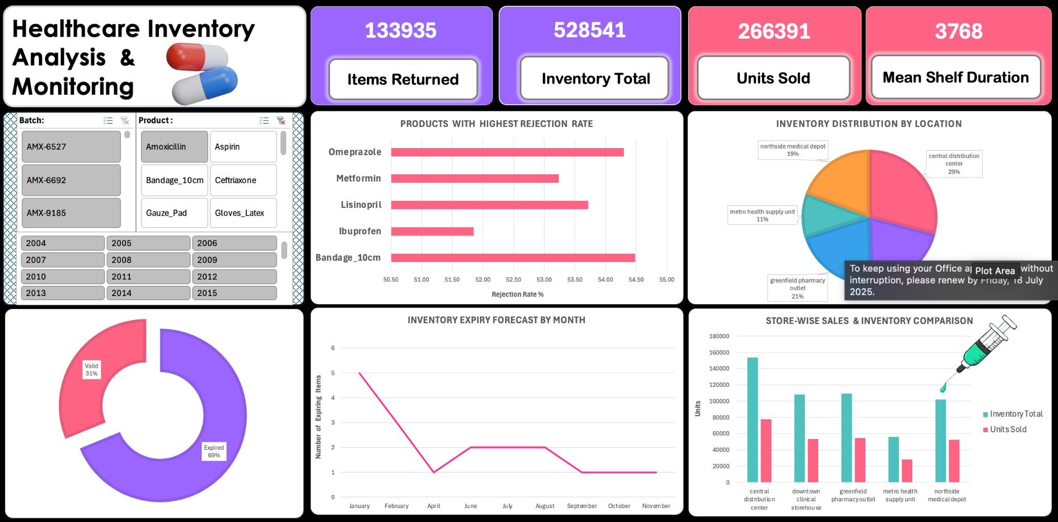

Figure: Healthcare Inventory Dashboard created in Microsoft Excel.