PROJECT DETAILS
SEARCH AND RESCUE DRONE

We have designed a more efficient system to assist humans in these extreme conditios.
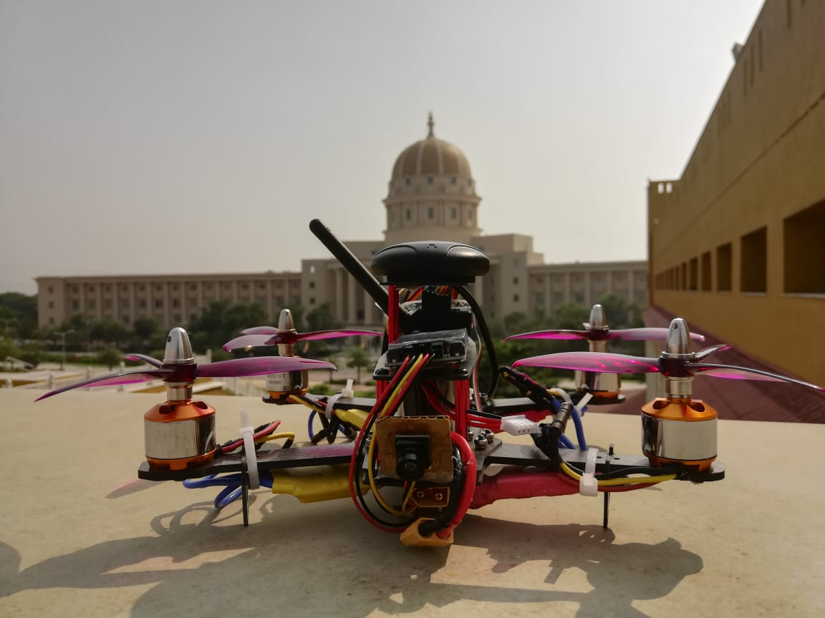

- Process Flow Chart

- Computer Vision Implementation Flow Chart
We use retina net model to detect the humans, through camera. So this model has is being trained on ten thousand images of humans in similar extreme conditions. In conclusion, the model has two stage detection. FPN and RCNN to localize the subject.
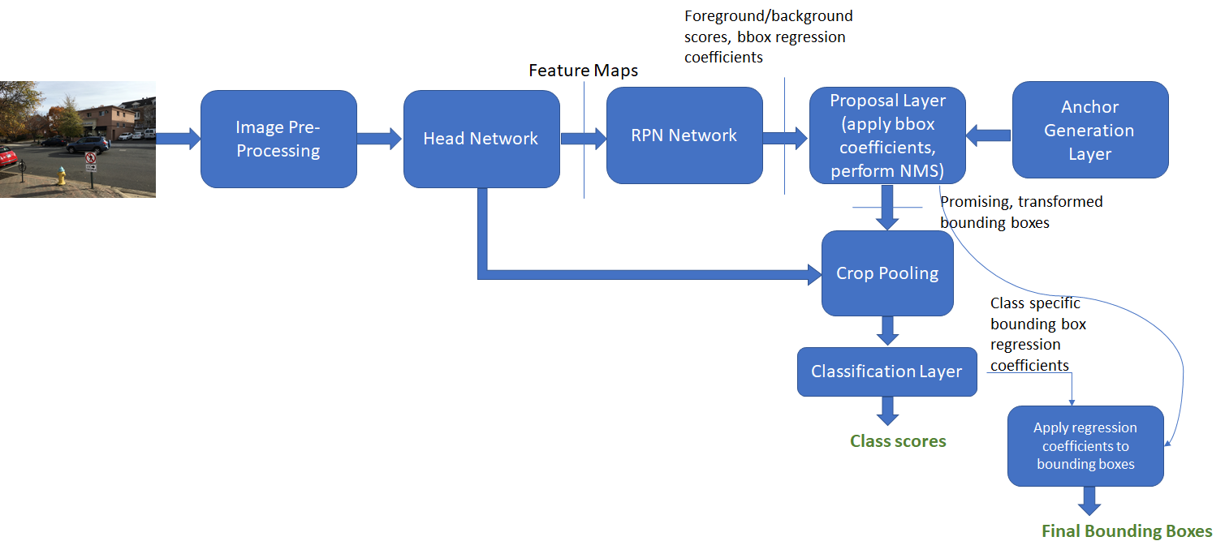
- Quadcopter Design Method
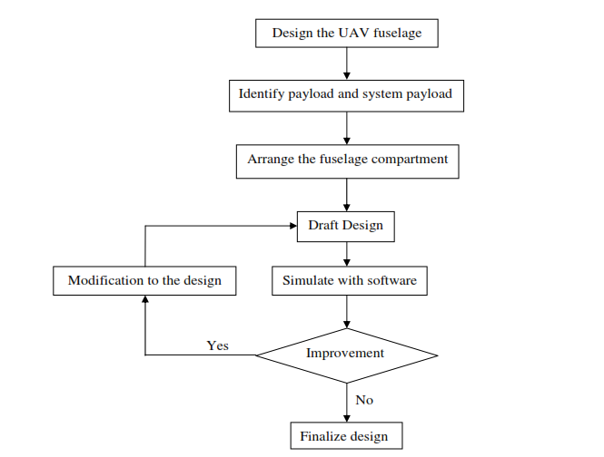
The model is designed and simulated in Solidworks and the shown process is followed.

- Technology Involved

- The algorithm used is Faster RCNN, it’s the Computer vision deep learning method which detects the human being and shows the position in the image by making a rectangular box around the detected human beings in the interface.

- Drone Hardware:

- KK2.1.5 Flight Controller is being used to stabilize and control the quadcopter system.
- BLDC motor of 1800kV is being used whilst considering torque and lift for the chosen frame size paired with 30A ESC.
- Carbon fiber frame of size 250mm is being used.
- The whole system is powered by LiPo battery, 3200mAh – 11.1V .
- FPV Camera of Resolution 700 TVL with Telemetry kit.
- Scope & Importance

This is an attempt to better understand control systems, deep learning via computer vision, microcontrollers and flight-oriented machines (Aeronautics).

Quadcopter is used to suspend the camera at a height to aerially scan the landscape and do the needful. The positions of the object, inclusive of GPS location will be sent back to the control user.

Future scope for the project involves automatized flight, automatic detection, load lifting capabilities (including human beings) and much more efficient aerial landscaping algorithm.

