Survey Analysis Insight Engine - PRD

Objective
- Automate analysis of large-scale Bain Growth Agenda survey data that is currently done manually in Excel
- Convert encoded raw survey data + data map into a fully decoded, analysis-ready dataset
- Automatically identify the key performance (growth) question to define winners and laggards (Revenue Growth %)
- Detect and recommend high-potential analysis questions that can generate meaningful business insights (Ex. What is the revenue growth rate that companies expect in 2024 compared to the actual rate in 2023? What is the difference in the revenue growth rate expectations of winner's vs laggards in 2024?)
- Enable user control to select, modify, and refine questions and filters before analysis
- Perform structured analysis (e.g., winner vs laggard, distributions, segment cuts) for each selected question
- Generate clean, question-wise analysis sheets instead of one aggregated output (Each question gets a different sheet)
- Use AI to create concise, business-ready 1–2 line insights based strictly on computed data (AI won’t be used in computing of data)
- Produce a well-structured Excel output ready for further analysis
- Lay the foundation for future automation of charts and PowerPoint slide generation based on the data set.

Expected Input
- Raw Data
- Data map

Output:

V1:
- Run_Summary – Overview of the entire analysis run (performance question, filters, sample size, counts)
- Question_Selection – List of selected analysis questions and rationale
- Question_Metadata – Parsed metadata of all survey questions (types, mappings, eligibility)
- Performance_Groups – Definition and breakdown of winners, laggards, and thresholds
- QXX_<Question_Name> (one per question) – Detailed analysis, insight, chart, and tables for each selected question

Sample Sheet: Q07_Challenges (Multi-select)
Insight: Laggards are 4.5x more likely to face technology adoption gaps (55% vs 12%) and are 18–43 pts higher across key challenges, indicating major execution and capability constraints on growth. (Generated by open ai based on the below table)

Challenge | Winner % | Laggard % | Gap | Lift
Technology adoption gap | 12% | 55% | -43 | 4.5x
Cost pressure | 40% | 52% | -12 | 0.77x
Data integration issues | 22% | 41% | -19 | 0.54x
Talent shortage | 48% | 66% | -18 | 0.73x

V2:
Version 2 Output (Charts + PowerPoint Integrated)
Outputs:
- Enhanced Excel
- Auto-generated PowerPoint deck
Excel (Enhanced):
- Same sheets as V1
- Each question sheet includes:
  - 💡 1–2 line insight
  - 📋 Clean Chart ready data table
  - 📊 Chart type recommendation based on the data table (by open ai)
PowerPoint (Core Value):
- Auto-created presentation with:
  - Title + methodology slides
  - Executive summary (AI-generated)
  - One slide per question
Each slide includes:
- Insight headline (title)
- 📊 Chart (auto-inserted)
- Short explanation
- Source / sample size at the bottom

Tech Stack / Tools Required
- Replit for deployment
- Claude Code / Antigravity
- Open AI API Key
- Python: pandas, numpy
scipy
statsmodels
openpyxl
xlsxwriter
streamlit
plotly

Process:
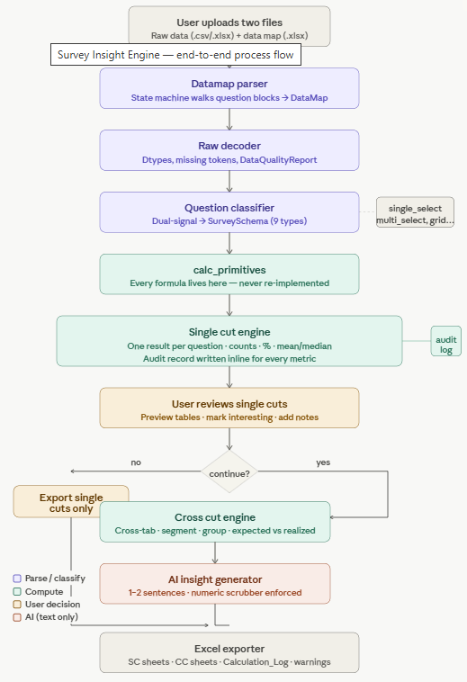
START
↓
1. INPUT FILES
├─ Raw survey data
│ ├─ Rows = companies/respondents
│ └─ Columns = encoded variables, e.g. Q1, Q2, Q33r1
│
└─ Data map
├─ Question text
├─ Answer labels
└─ Option mappings

↓
2. PARSE DATA MAP
├─ Identify question blocks
├─ Extract question IDs and text
├─ Extract answer codes and labels
├─ Map multi-select columns
└─ Build master metadata table

↓
3. CLASSIFY QUESTION TYPES
├─ Single-select
├─ Multi-select binary
├─ Numeric allocation
├─ Direct numeric
├─ Open text
├─ Demographic / segment
└─ Metadata / ID field

↓
4. IDENTIFY KEY QUESTIONS
├─ 4A. Revenue-based performance question
│ ├─ Search for revenue growth/change questions
│ ├─ Prioritize actual past revenue performance
│ ├─ Check for % range answer options
│ └─ Recommend candidates for defining winners/laggards
│
└─ 4B. High-potential analysis questions
├─ Meaning: questions likely to produce useful business insights
├─ Remove open text, IDs, low-sample, high-missing questions
├─ Score by variance, balance, sample size, and business relevance
├─ Shortlist top 40–60 questions
└─ OpenAI selects top N, default 20, with reasoning

↓
5. USER REVIEW
├─ Confirm revenue performance question
├─ Edit selected analysis questions
├─ Add or remove filters / segment cuts
└─ Preview run summary

↓
6. DECODE RAW DATA
├─ Map single-select codes to labels
├─ Map multi-select columns to option labels
├─ Map numeric allocation columns
├─ Apply filters
└─ Create analysis-ready dataset

↓
7. DEFINE WINNERS AND LAGGARDS
├─ Use selected revenue-based performance question
├─ Convert revenue ranges to numeric scores
│ ├─ grew 10–14% → 12
│ ├─ flat → 0
│ └─ decreased 3–5% → -4
├─ Apply user-confirmed thresholds
└─ Add performance_group column

↓
8. RUN QUESTION-LEVEL ANALYSIS
For each selected question:
├─ Determine analysis type
│ ├─ Winner vs laggard distribution
│ ├─ Winner vs laggard selection rate
│ ├─ Winner vs laggard average allocation
│ ├─ Segment profile
│ ├─ Overall distribution
│ └─ Cross-tab, if needed
│
├─ Calculate metrics
│ ├─ Winner %
│ ├─ Laggard %
│ ├─ Gap
│ ├─ Lift
│ ├─ Average value
│ ├─ Sample size
│ └─ Confidence / p-value
│
└─ Create one dedicated analysis sheet

↓
9. GENERATE INSIGHT TEXT
├─ Send only calculated tables to OpenAI
├─ Generate 1–2 line insight
├─ Do not change numbers
├─ Avoid unsupported causality
└─ Use fallback: “No major difference is visible”

↓
10. EXCEL EXPORT — VERSION 1
├─ Run Summary
├─ Question Selection
├─ Performance Groups
├─ Question Metadata
├─ One sheet per selected question
└─ Chart-ready data tables

↓
11. CHART GENERATION — VERSION 2
├─ Recommend chart type
├─ Generate chart from chart-ready table
└─ Insert chart into Excel or prepare for PPT

↓
12. POWERPOINT EXPORT — VERSION 2
├─ Executive summary
├─ Methodology
├─ Winner vs laggard overview
├─ One slide per question
└─ Appendix

END

