Yashvi Maheshbhai Patel
Sem: 7 Div: B
Roll No.:66 Full Stack Ass:3
-Develop a user registration form (fields: username, password, confirm password, email, gender, hobbies, upload profile pic, upload other pics) (use text box, radio, checkboxes, file upload) using Express. Form should also contain file upload (single, multiple) with validations.
- In case of invalid data, display errors along with all previous field values.
- In case of all valid fields, display all data and images in a well formatted tabular form.
and allow the user to download that file using Express. Develop route for file download.
(Use express, ejs, express-validator)

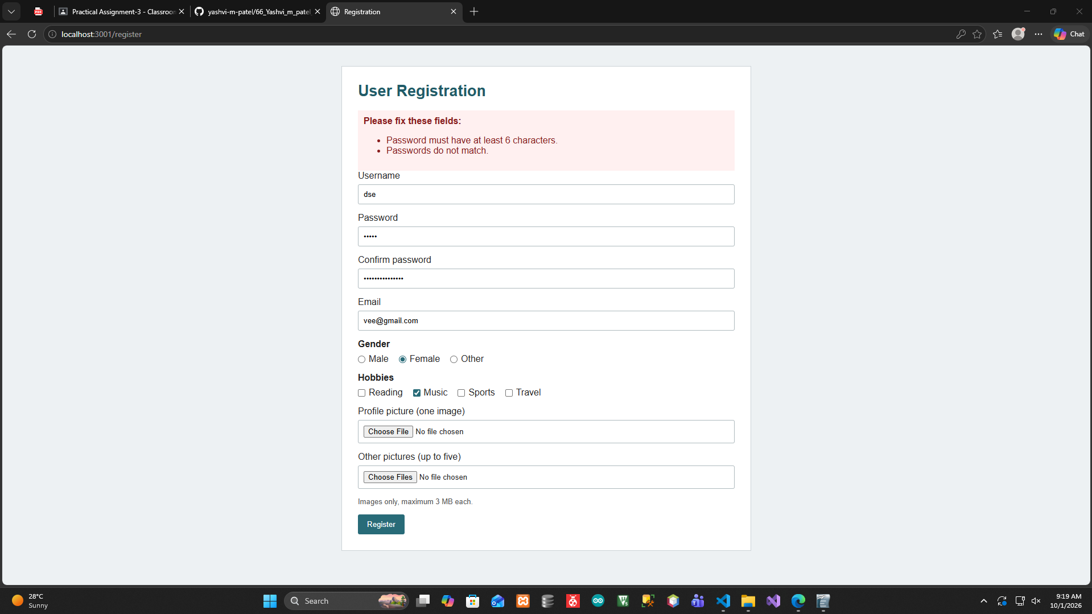
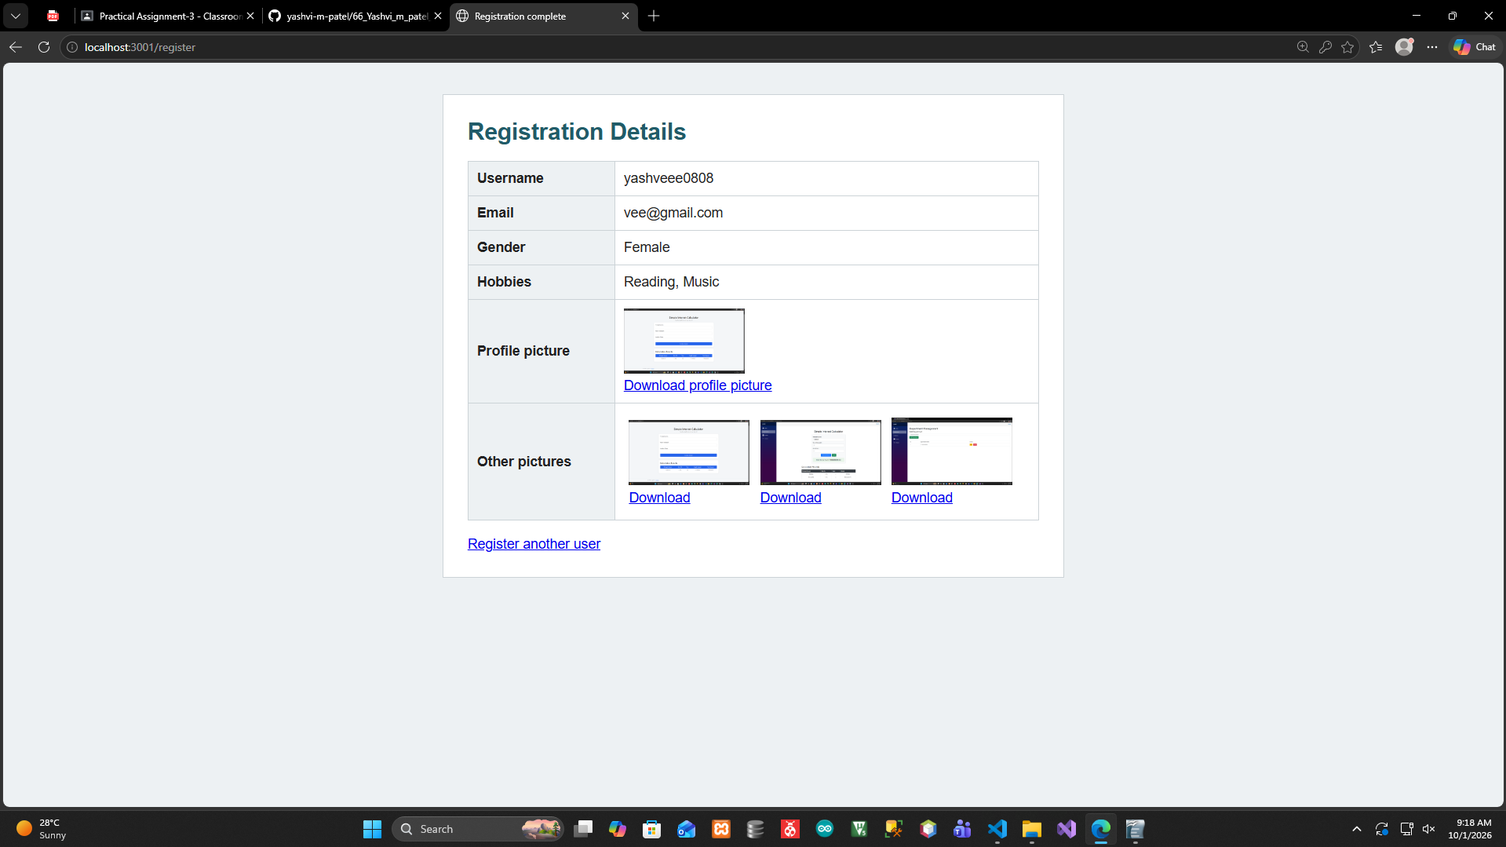

Express Login application with file session store. Functionalities are login, 2 protected routes, Logout.

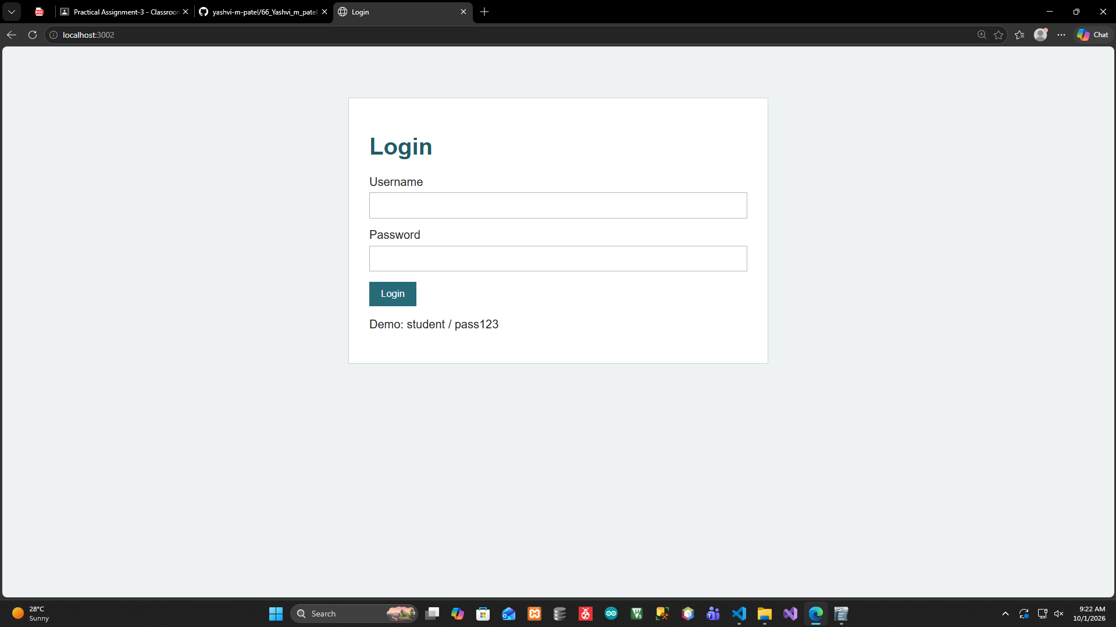
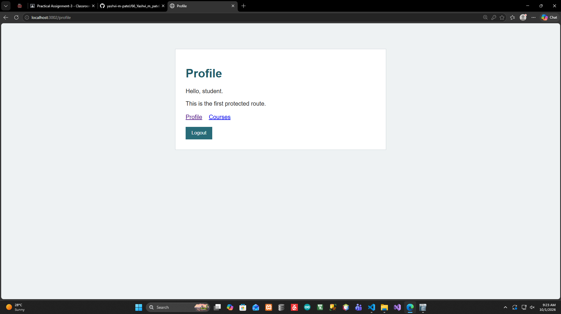

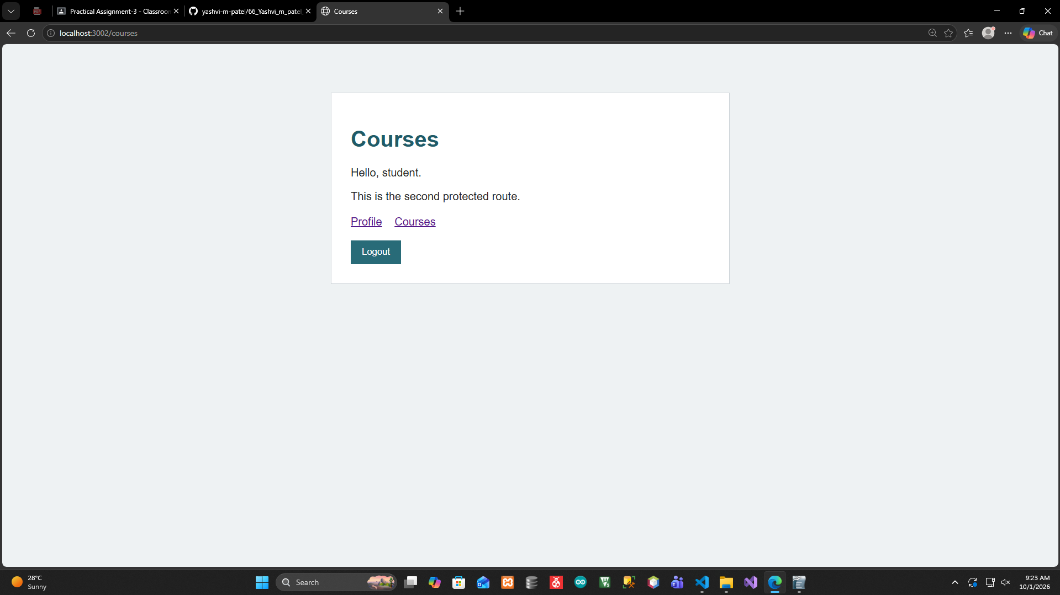

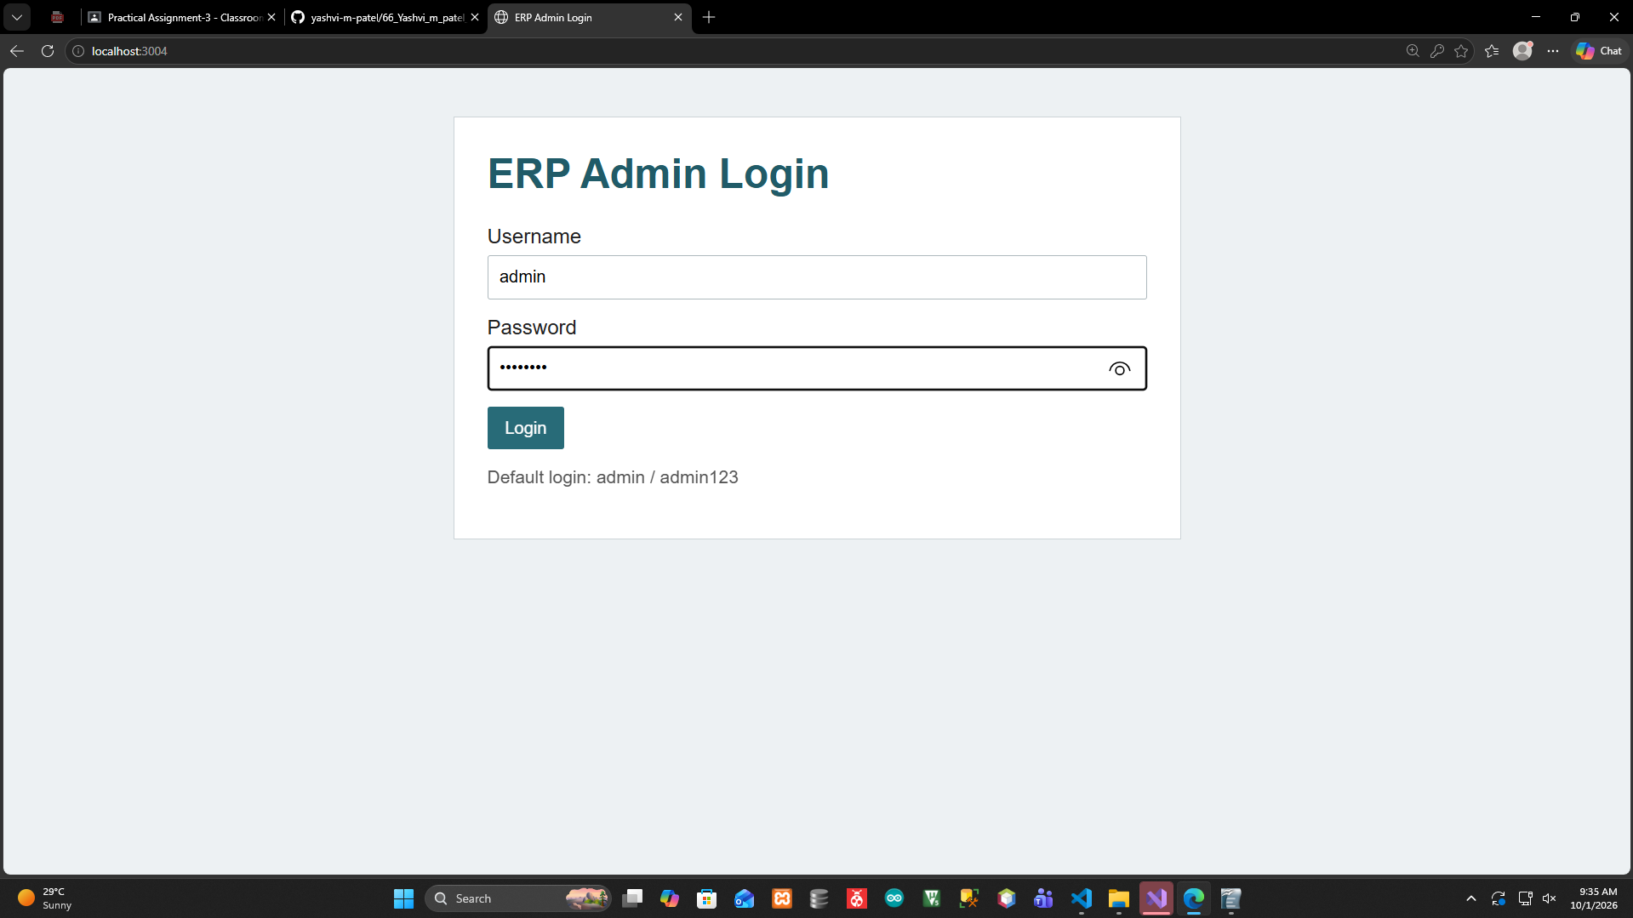
Develop login for an ADMIN panel of ERP system with session, CRUD operations for employees table (generate empid and password) with salary calculation with mongoose, express and EJS template engine. Send email to employee when inserted. Encrypt the password. Logout.

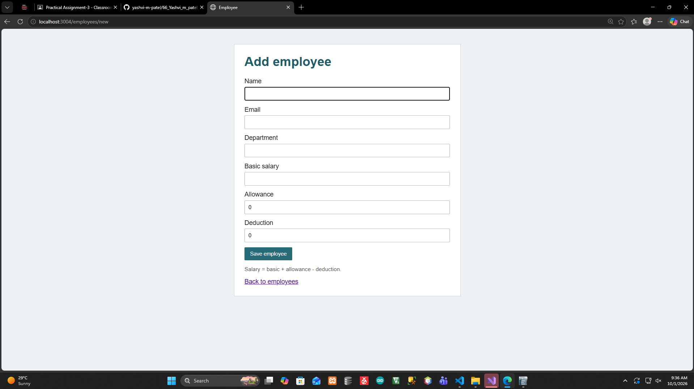

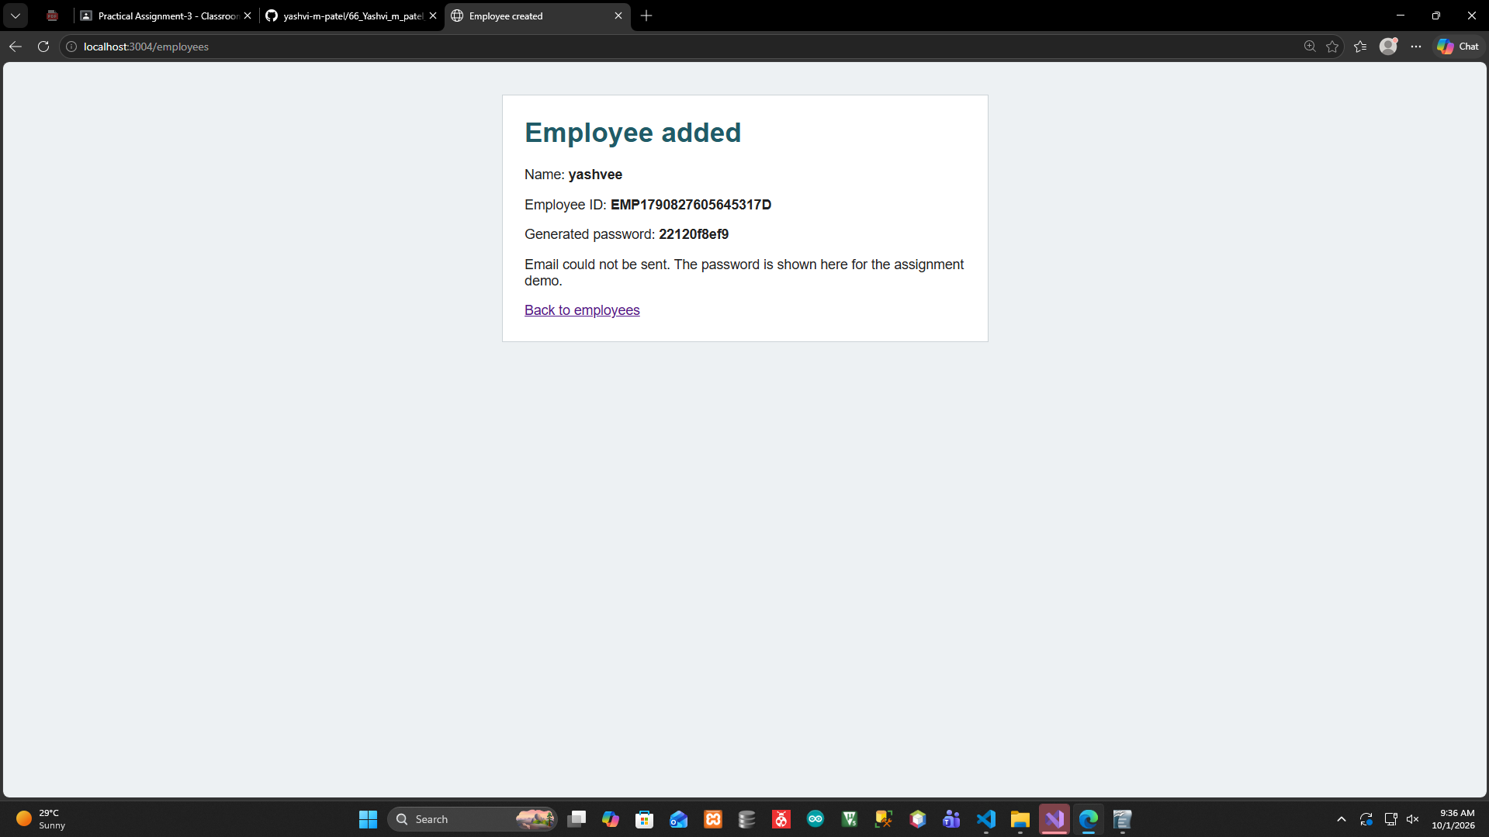

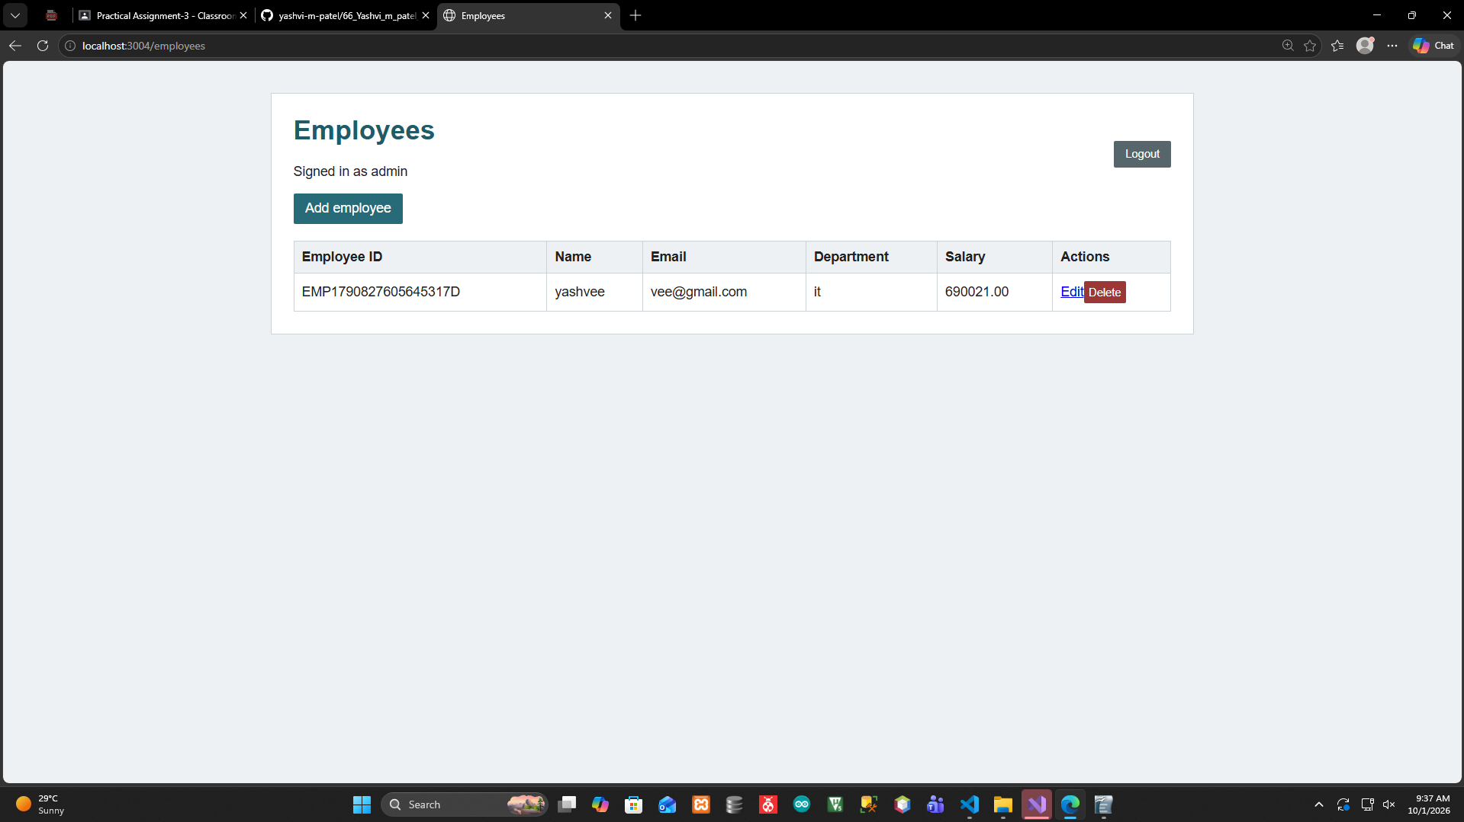

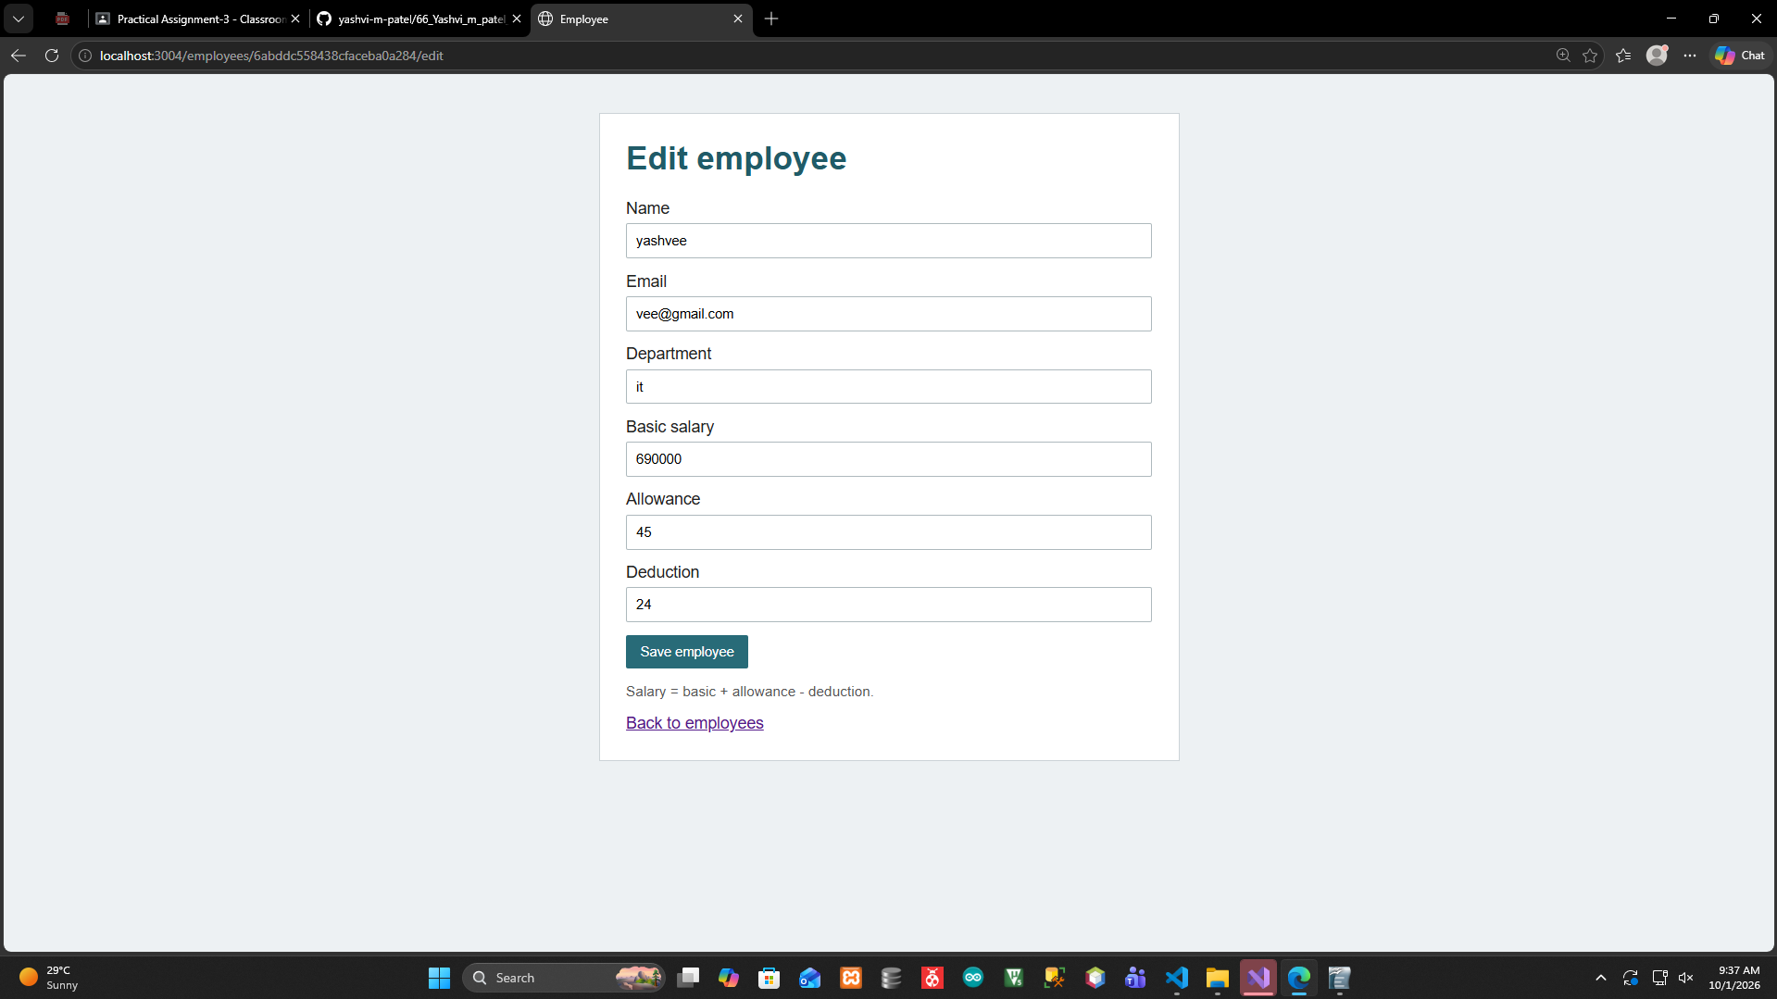

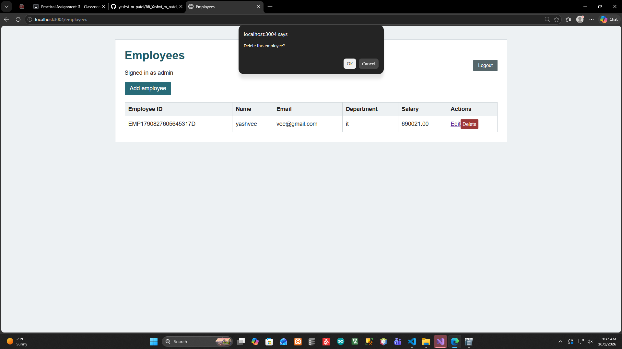

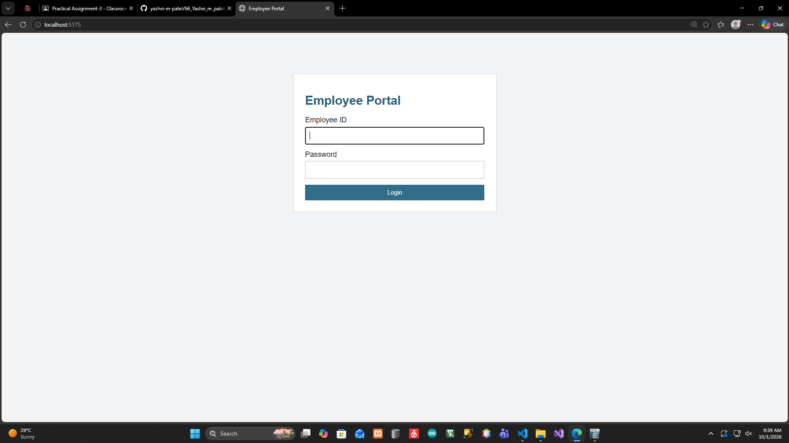
5)Develop employee site (refer Q4 ) login with JWT, for employees with mongoose, express and
React.js. Create a home page with following links:
-Page1)display employee profile .
-Page2) - Application for leave (fields date, reason, grant yes/no) Add, List – Logout.
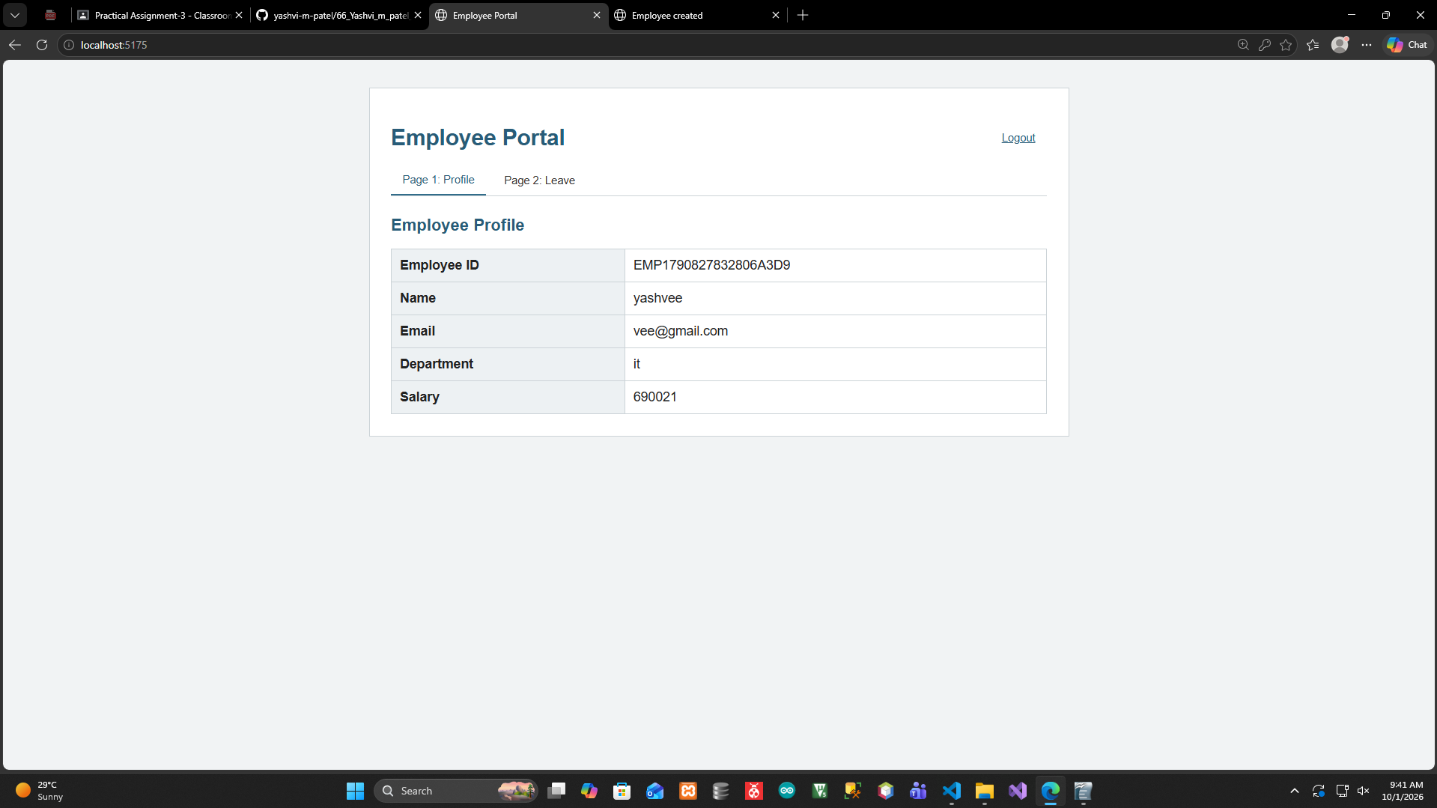

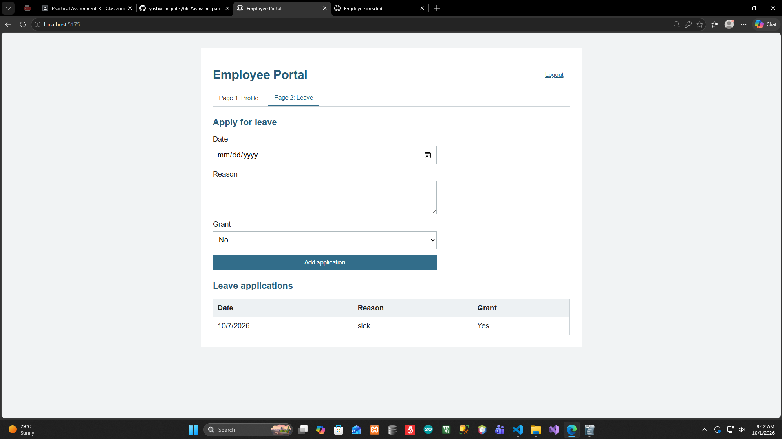

- Call any free api for a useful utility from frontend and backend.

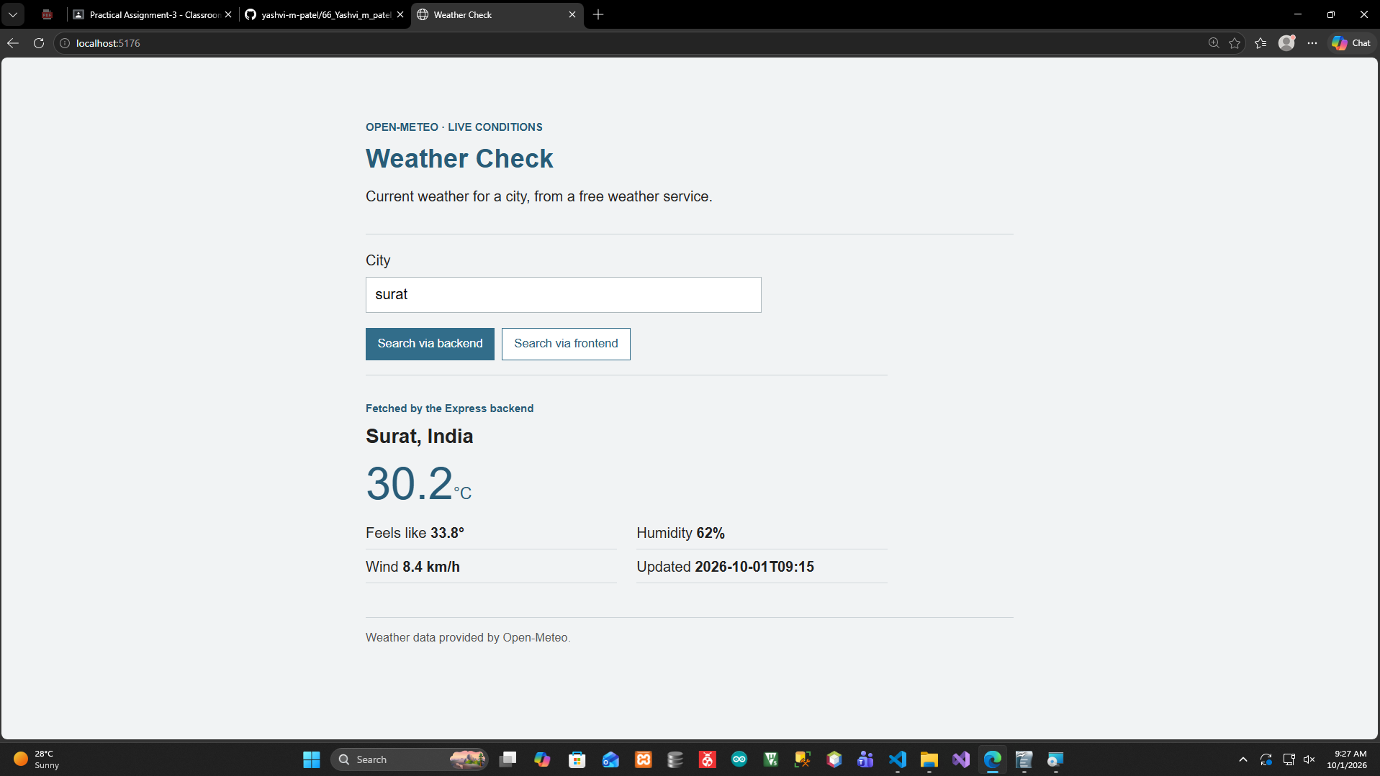

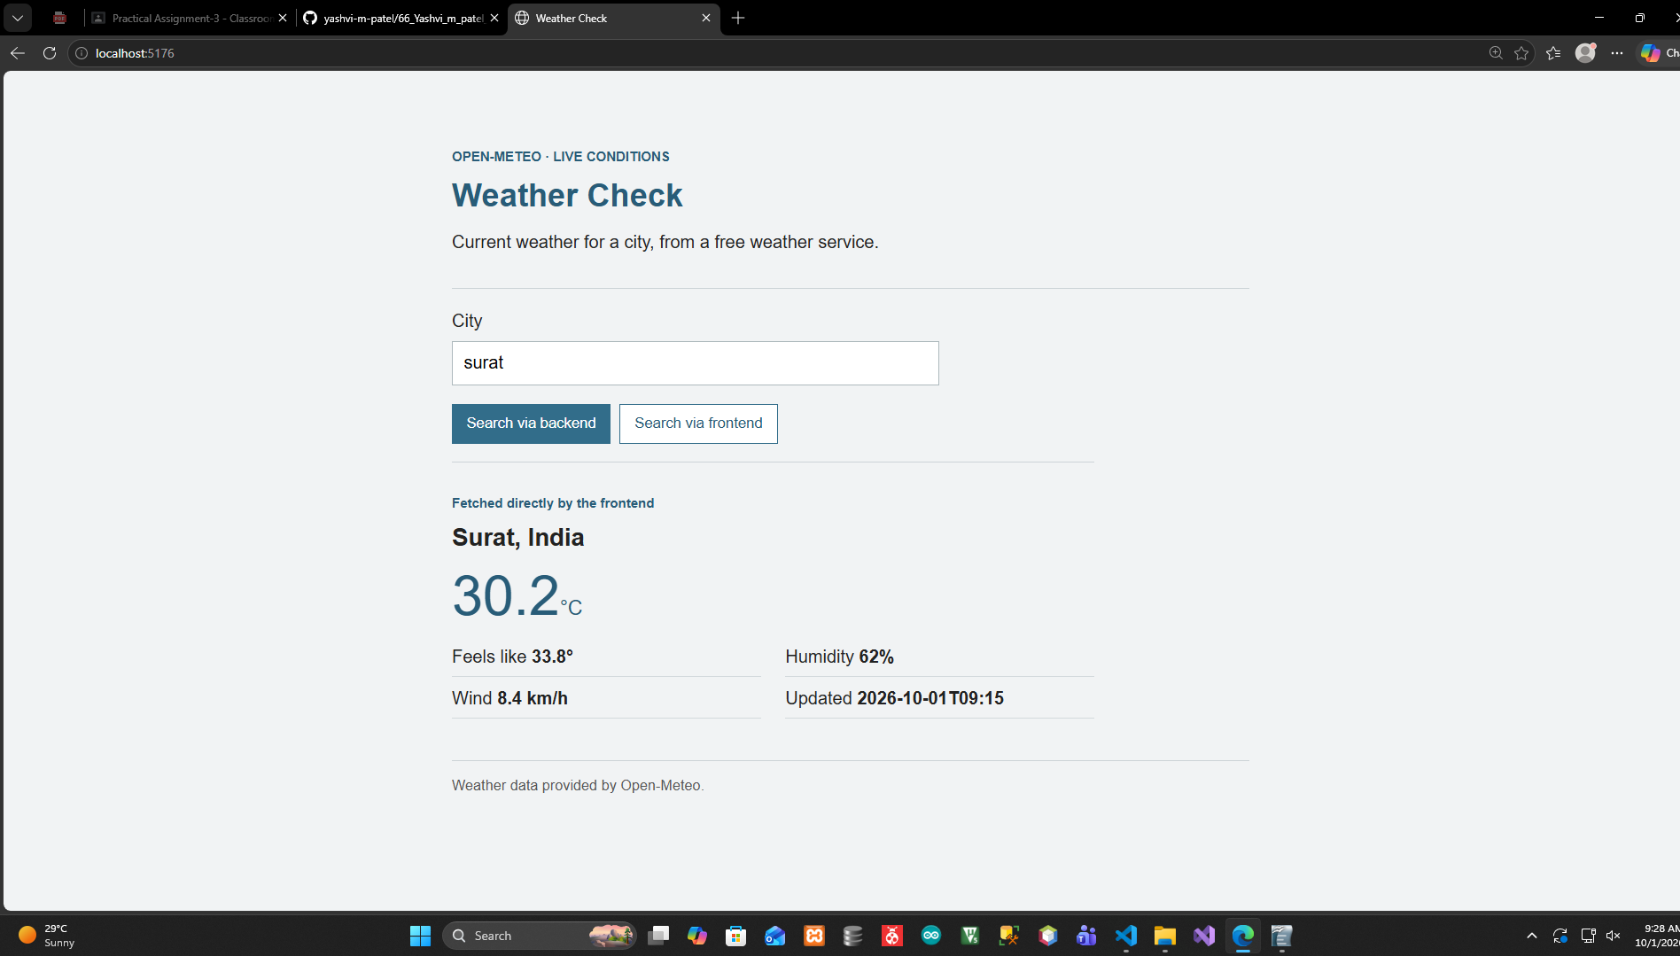

Shopping cart with admin site and user site with (2 level) Category and Products using MERN stack.
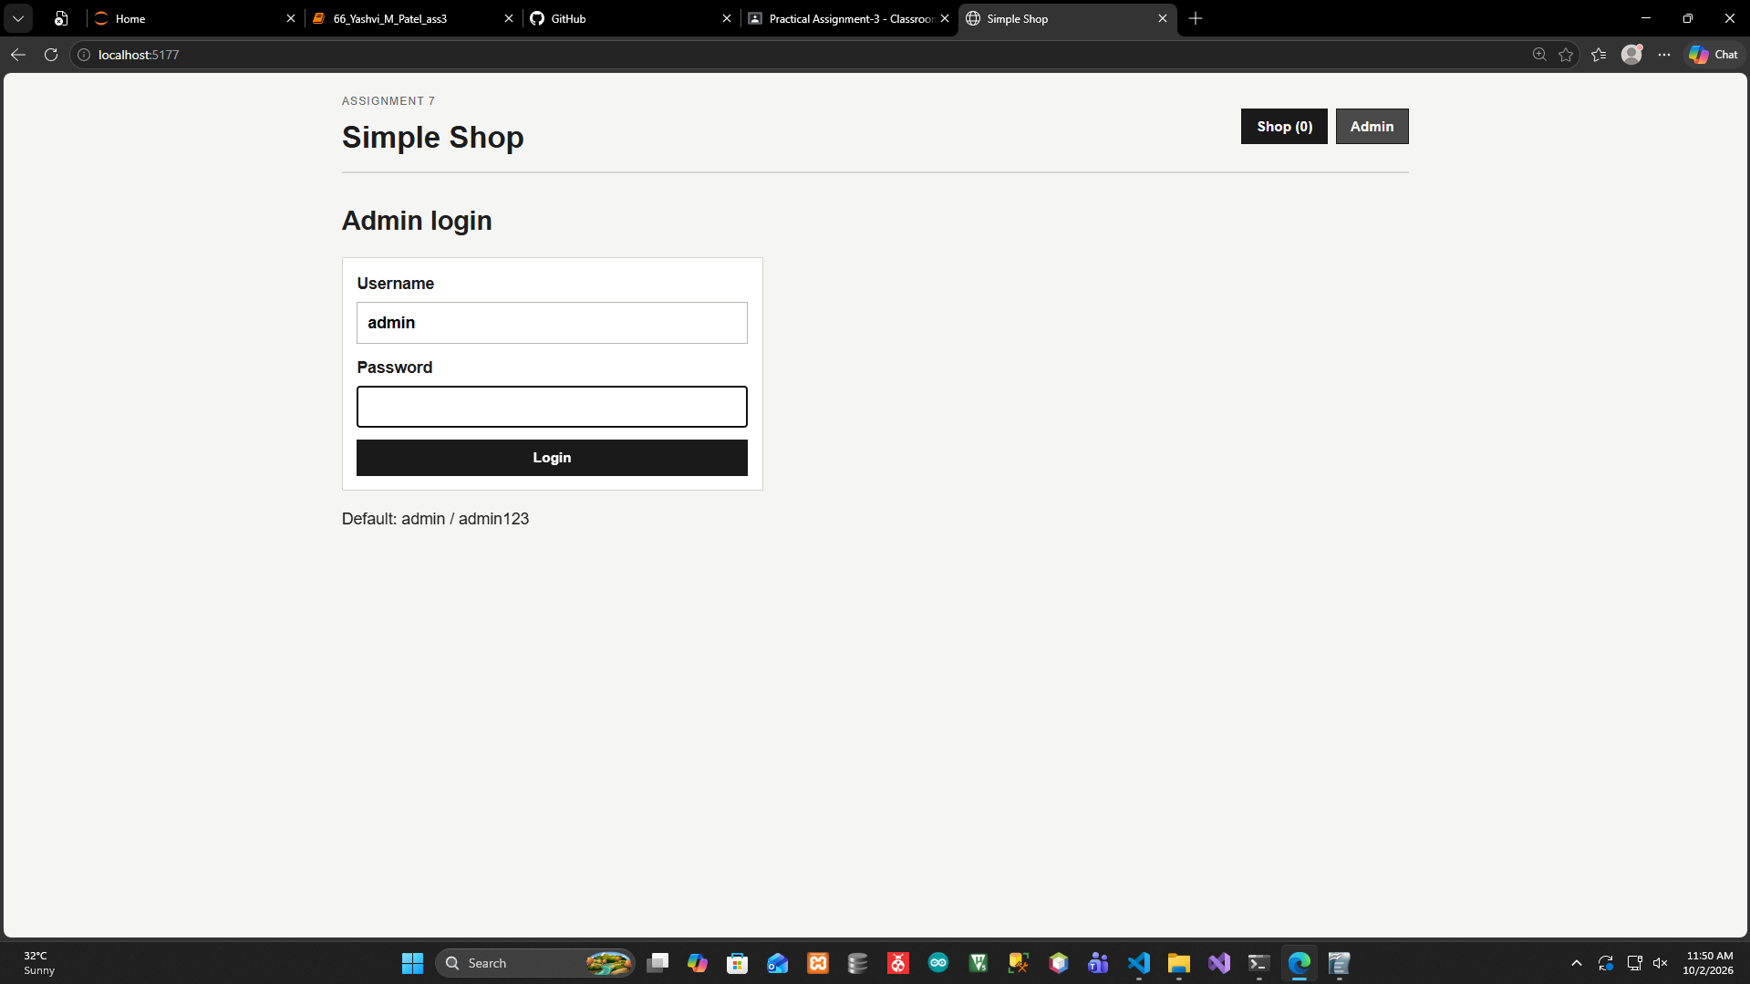

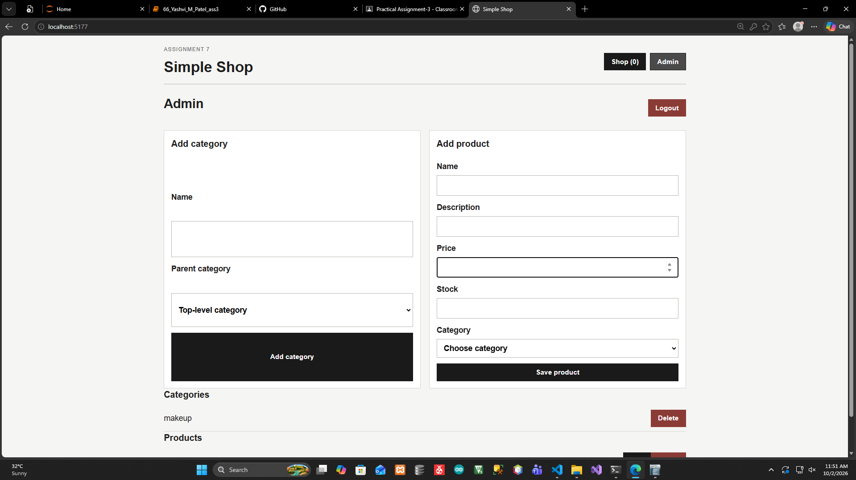

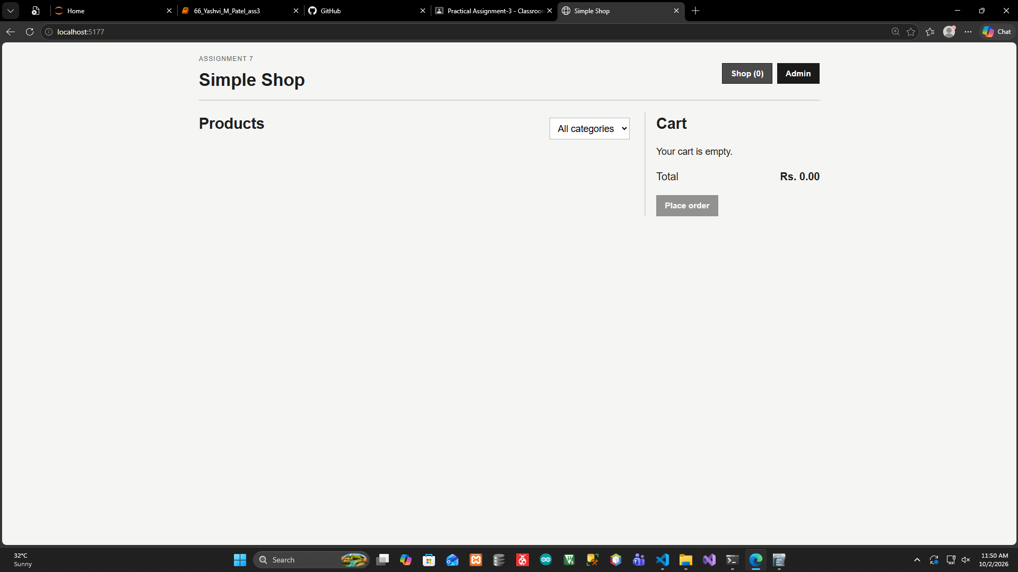

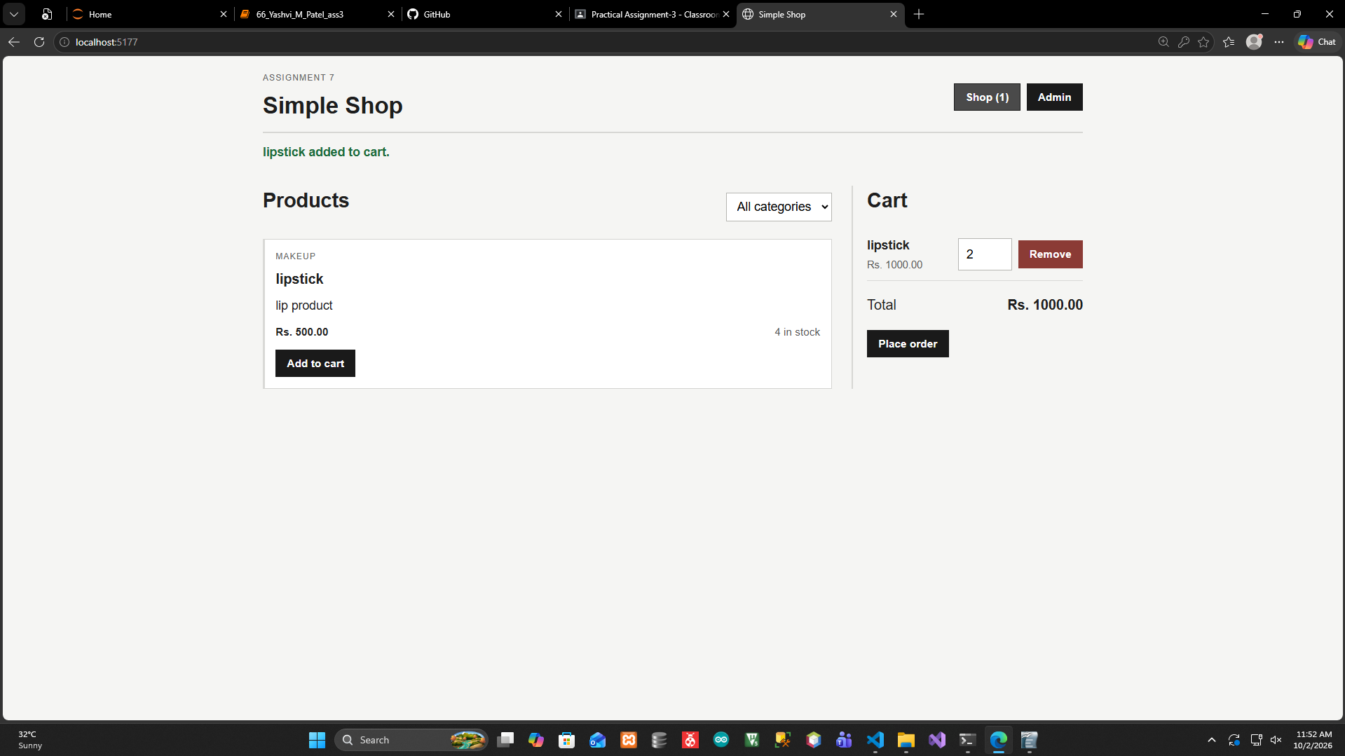

Crud operation for Student collection using Sequelize. (Express+ Sequelize + React)

