-- Q-1 – Create a database named employee, then import data_science_team.csv proj_table.csv and emp_record_table.csv into the employee database from the given resources.

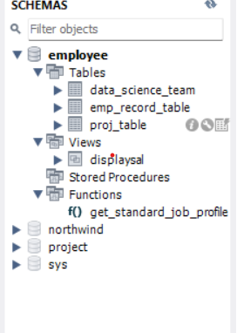

-- Q-2 – Create an ER diagram for the given employee database.

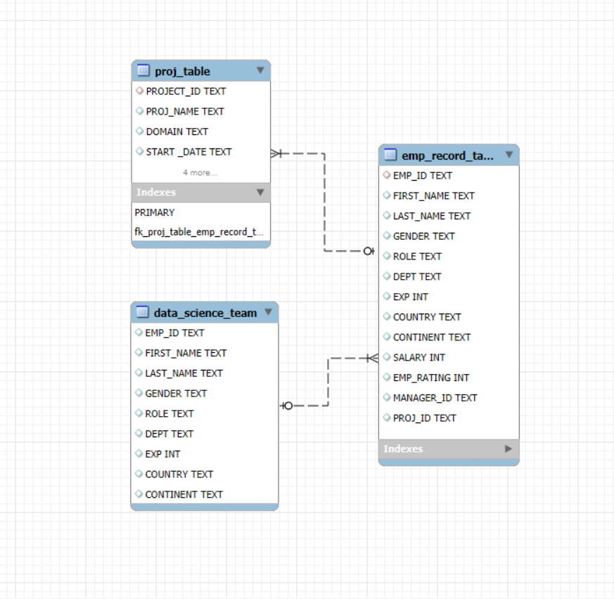

-- Q-3 – Write a query to fetch EMP_ID, FIRST_NAME, LAST_NAME, GENDER, and DEPARTMENT from the employee record table, and make a list of employees and details of their department.

select emp_record_table.EMP_ID,emp_record_table.FIRST_NAME,emp_record_table.LAST_NAME,

emp_record_table.GENDER,emp_record_table.DEPT from emp_record_table order by emp_record_table.DEPT;

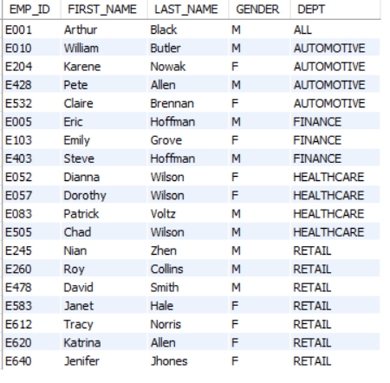

-- Q-4 -- Write a query to fetch EMP_ID, FIRST_NAME, LAST_NAME, GENDER, DEPARTMENT, and EMP_RATING if the EMP_RATING is: ● less than two ● greater than four ● between two and four

select emp_record_table.EMP_ID,emp_record_table.FIRST_NAME,emp_record_table.LAST_NAME,

emp_record_table.GENDER,emp_record_table.DEPT,emp_record_table.EMP_RATING,

case

when EMP_RATING <= 2 then 'less than or equal to 2'

when EMP_RATING > 2 and EMP_RATING < 4 then 'between 2 and 4'

else 'greater than or equal to 4'

end as rating from emp_record_table order by DEPT ;

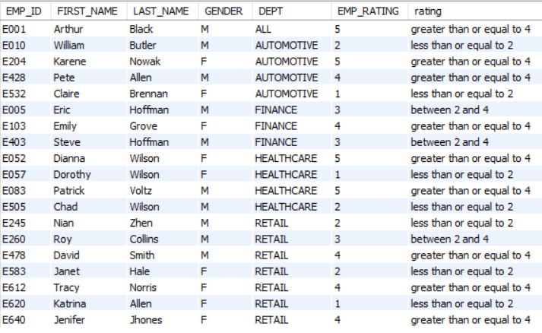

-- Q-5 -- Write a query to fetch EMP_ID, FIRST_NAME, LAST_NAME, GENDER, DEPARTMENT, and EMP_RATING if the EMP_RATING is: ● less than two ● greater than four ● between two and four

select concat(first_name,' ',last_name) as Name, DEPT from emp_record_table where DEPT='finance';

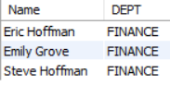

-- Q-6 -- Write a query to list only those employees who have someone reporting to them. Also, show the number of reporters (including the President).

select m.first_name as manager_name,count(*) no_emps_reporting from emp_record_table as e join emp_record_table as m on m.EMP_ID=e.MANAGER_ID group by manager_name having no_emps_reporting>0;

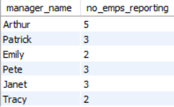

-- Q-7 -- Write a query to list down all the employees from the healthcare and finance departments using union. Take data from the employee record table.

select * from emp_record_table where dept="healthcare" union all

select * from emp_record_table where DEPT='finance';

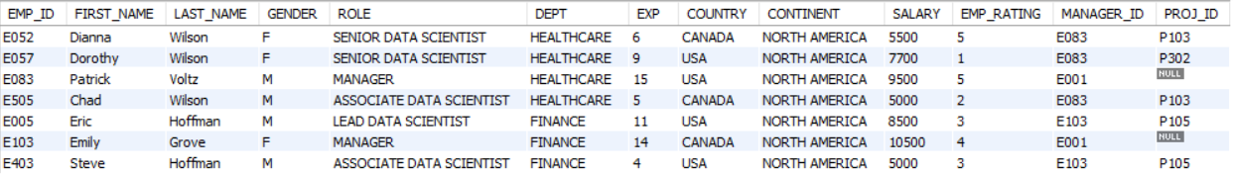

-- Q-8 -- Write a query to list down employee details such as EMP_ID, FIRST_NAME, LAST_NAME, ROLE, DEPARTMENT, and EMP_RATING grouped by dept. Also include the respective employee rating along with the max emp rating for the department.

select EMP_ID,FIRST_NAME,LAST_NAME,ROLE,DEPT,EMP_RATING, max(EMP_RATING) over(partition by dept) as maximum_rating_of_particular_dept from emp_record_table;

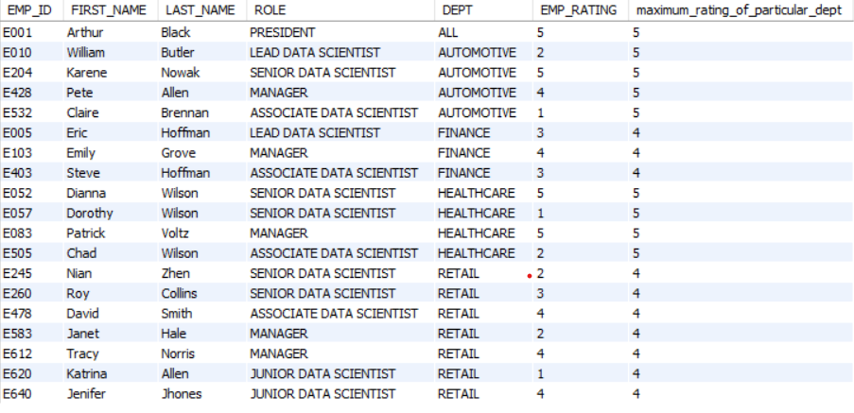

-- Q-9 -- Write a query to calculate the minimum and the maximum salary of the employees in each role. Take data from the employee record table.

* With group by clause

select ROLE,max(SALARY) as max_salary,min(SALARY) as min_salary from emp_record_table group by ROLE;

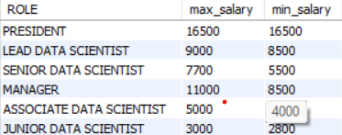

* Without group by clause

select EMP_ID,FIRST_NAME,LAST_NAME,ROLE,max(SALARY) over(partition by role) as max_salary,min(SALARY) over(partition by role) as min_salary from emp_record_table;

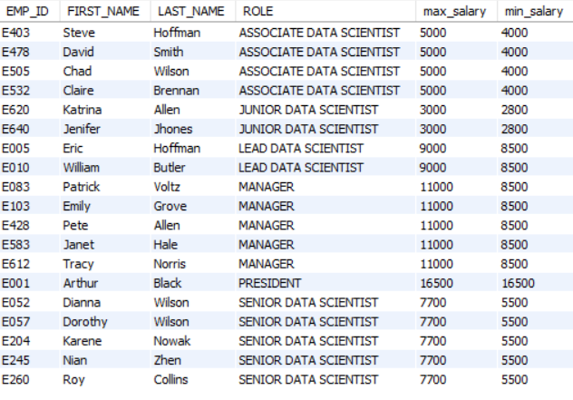

-- Q-10 -- Write a query to assign ranks to each employee based on their experience. Take data from the employee record table.

select EMP_ID,FIRST_NAME,LAST_NAME,EXP,rank() over(order by exp desc) as ranking from emp_record_table;

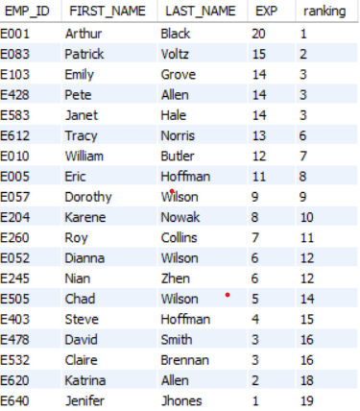

-- Q-11 -- Write a query to create a view that displays employees in various countries whose salary is more than six thousand. Take data from the employee record table

create or replace view displaysal as select EMP_ID,FIRST_NAME,LAST_NAME,country,salary from emp_record_table where salary>6000;

select * from displaysal;

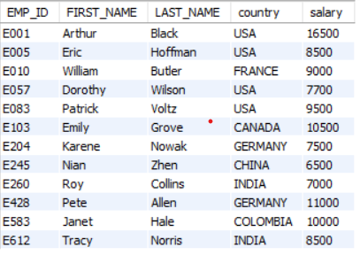

-- Q-12 -- Write a nested query to find employees with experience of more than ten years. Take data from the employee record table.

select * from emp_record_table where EMP_ID in

(select EMP_ID from emp_record_table where EXP>10);

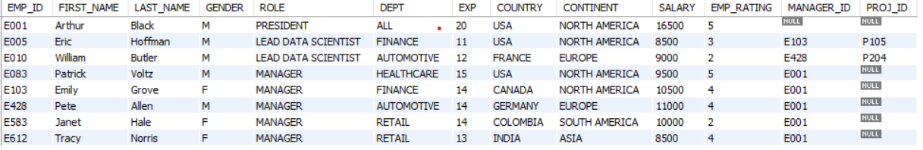

-- Q-13 -- Write a query to create a stored procedure to retrieve the details of the employees whose experience is more than three years. Take data from the employee record table.

USE `employee`;

DROP procedure IF EXISTS `empexpabove3`;

USE `employee`;

DROP procedure IF EXISTS `employee`.`empexpabove3`;

;

DELIMITER $$

USE `employee`$$

CREATE PROCEDURE `empexpabove3`()

BEGIN

select * from emp_record_table where exp>3;

END$$

DELIMITER ;

;

call empexpabove3;

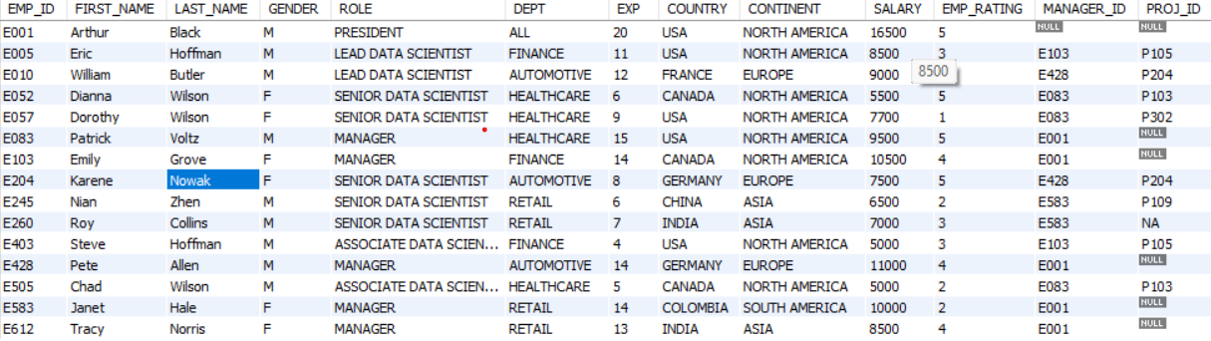

-- Q-14 – Create an index to improve the cost and performance of the query to find the employee whose FIRST_NAME is ‘Eric’ in the employee table after checking the execution plan.

create index idfname on emp_record_table(first_NAME(50));

select * from emp_record_table where FIRST_NAME='eric';



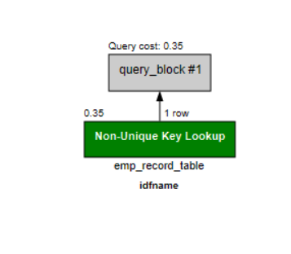

-- Q-15 -- .Write a query to calculate the bonus for all the employees, based on their ratings and salaries (Use the formula: 5% of salary * employee rating).

select *, SALARY * 0.05* EMP_RATING as bonus from emp_record_table;

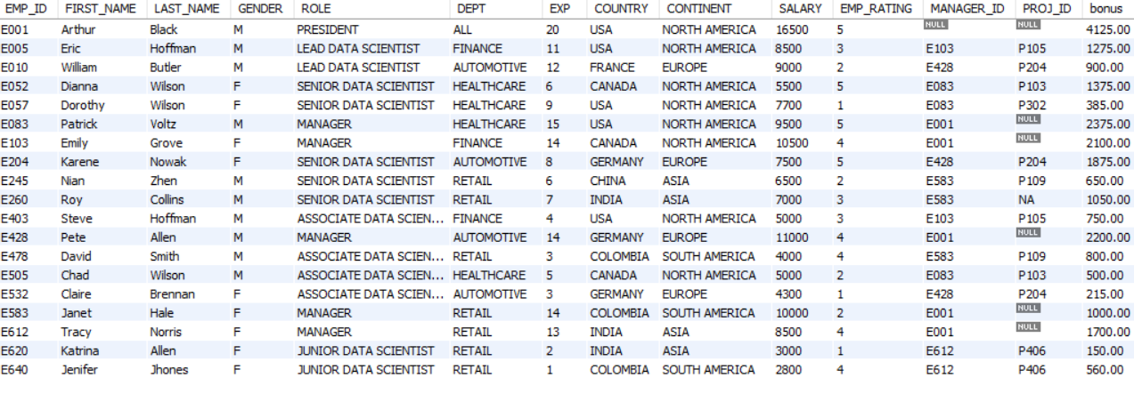

-- Q-16 -- Write a query to calculate the average salary distribution based on the continent and country. Take data from the employee record table.

select CONTINENT,COUNTRY,avg(SALARY) as average_salary from emp_record_table group by continent,country with rollup;

