Name: Gandhi Yashvi Jitendra
Roll no: 15
Subject: OpenSource Web Development
PHP PRACTICAL ASSIGNMENT-3
1. Develop a Shopping Cart in PHP with the following requirements
Admin Site:
1) Login
<?php
require __DIR__.'/../config.php';

$error = '';

if ($_SERVER['REQUEST_METHOD'] === 'POST') {
$stmt = $pdo->prepare(
'SELECT id, username, password_hash FROM admins WHERE username = ?'
);

$stmt->execute([trim($_POST['username'] ?? '')]);
$a = $stmt->fetch();

if ($a && ($_POST['password'] ?? '') === $a['password_hash']) {
session_regenerate_id(true);

$_SESSION['admin_id'] = $a['id'];
$_SESSION['admin_name'] = $a['username'];

header('Location: categories.php');
exit;
} else {
$error = 'Invalid username or password';
}
}
?>

<!doctype html>
<html>
<body>
<h1>Admin Login</h1>

<p style="color:red">
<?= h($error) ?>
</p>

<form method="post">
<label>
Username
<input name="username" required>
</label>
<br>

<label>
Password
<input type="password" name="password" required>
</label>
<br>

<button type="submit">Login</button>
</form>
</body>
</html>

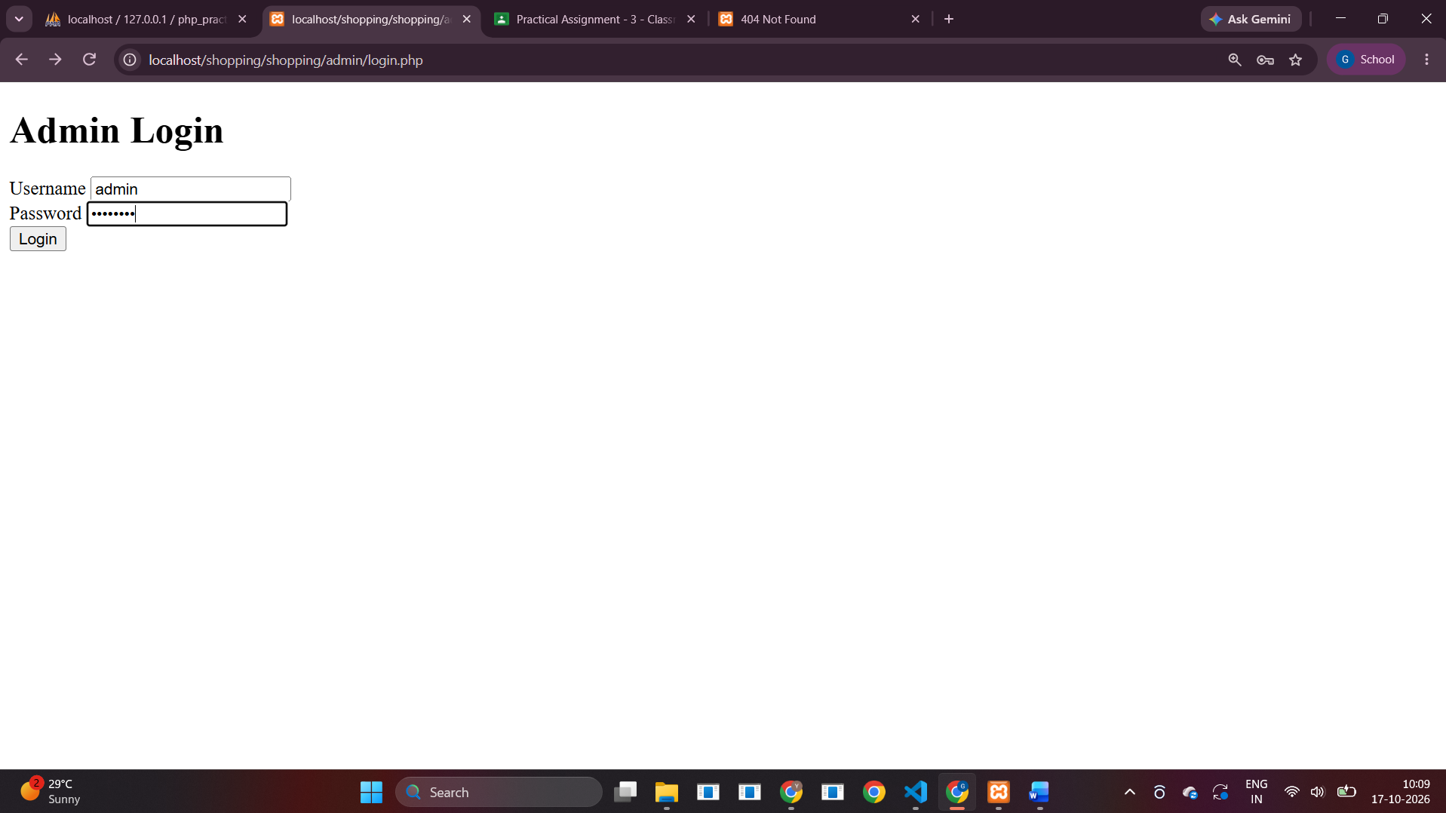
2) Manage Category (CRUD)
<?php
require __DIR__.'/../config.php'; require_admin();
if ($_SERVER['REQUEST_METHOD']==='POST') {
$name=trim($_POST['name'] ?? '');
if (isset($_POST['create']) && $name!=='') { $s=$pdo->prepare('INSERT INTO categories(name) VALUES(?)'); $s->execute([$name]); }
if (isset($_POST['update']) && $name!=='') { $s=$pdo->prepare('UPDATE categories SET name=? WHERE id=?'); $s->execute([$name,(int)$_POST['id']]); }
if (isset($_POST['delete'])) { $s=$pdo->prepare('DELETE FROM categories WHERE id=?'); $s->execute([(int)$_POST['id']]); }
header('Location: categories.php'); exit;
}
$edit=null;
if(isset($_GET['edit'])){$s=$pdo->prepare('SELECT * FROM categories WHERE id=?');$s->execute([(int)$_GET['edit']]);$edit=$s->fetch();}
$rows=$pdo->query('SELECT * FROM categories ORDER BY id DESC')->fetchAll();
?><!doctype html><html><body><nav><a href="categories.php">Categories</a> | <a href="products.php">Products</a> | <a href="logout.php">Logout</a></nav><h1>Manage Categories</h1>
<form method="post"><?php if($edit): ?><input type="hidden" name="id" value="<?= (int)$edit['id'] ?>"><?php endif; ?>
<input name="name" placeholder="Category name" required value="<?= h($edit['name'] ?? '') ?>">
<button name="<?= $edit?'update':'create' ?>"><?= $edit?'Update':'Add' ?></button><?php if($edit): ?><a href="categories.php">Cancel</a><?php endif; ?></form>
<table border="1" cellpadding="8"><tr><th>ID</th><th>Name</th><th>Actions</th></tr>
<?php foreach($rows as $r): ?><tr><td><?= (int)$r['id'] ?></td><td><?= h($r['name']) ?></td><td><a href="?edit=<?= (int)$r['id'] ?>">Edit</a>
<form method="post" style="display:inline" onsubmit="return confirm('Delete category and its products?')"><input type="hidden" name="id" value="<?= (int)$r['id'] ?>"><button name="delete">Delete</button></form></td></tr><?php endforeach; ?></table></body></html>

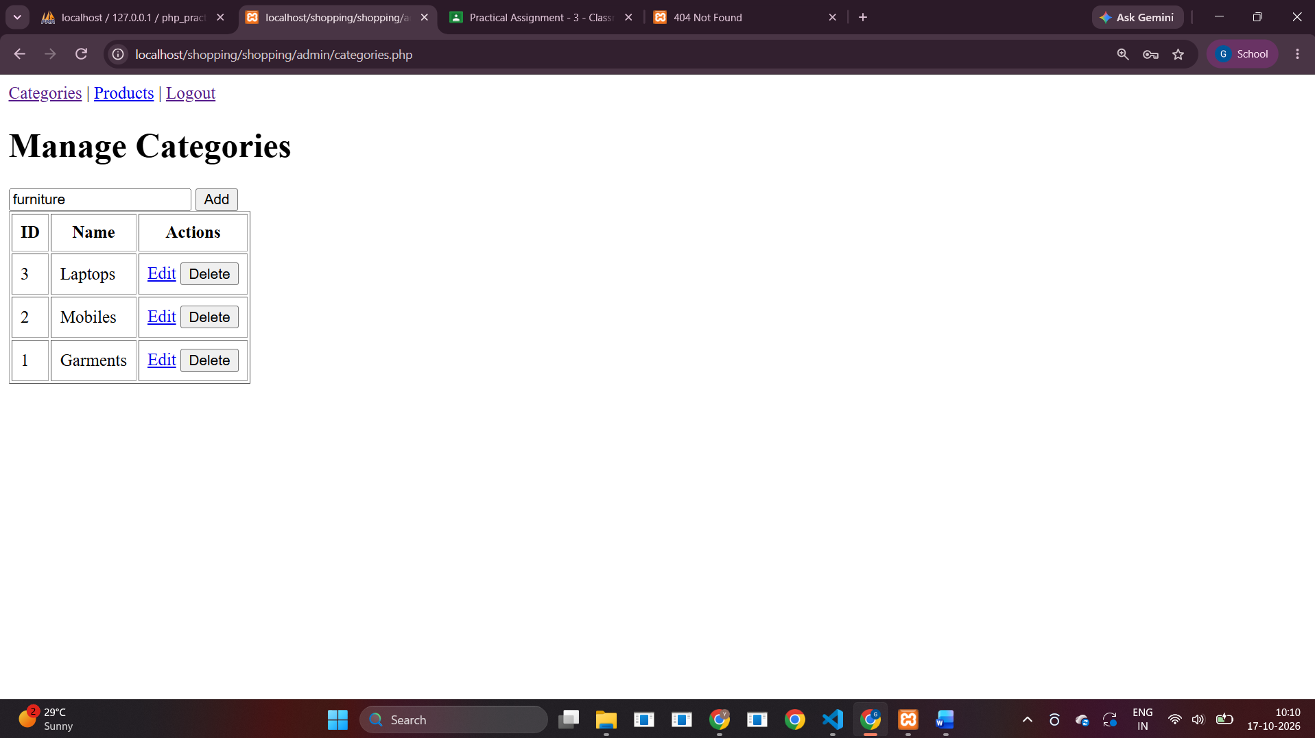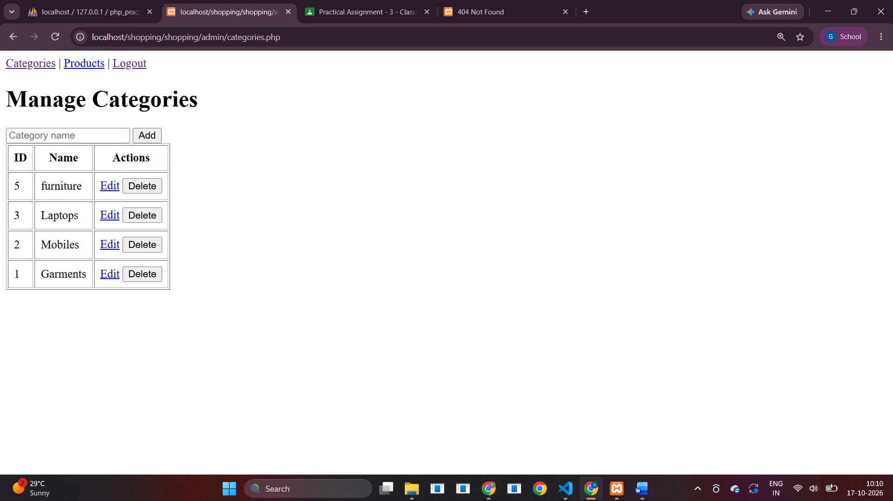
3) Manage Products with pictures (upload and resize images)
<?php
require __DIR__.'/../config.php'; require_admin();
$uploadDir=__DIR__.'/../uploads/';
if (!is_dir($uploadDir)) mkdir($uploadDir,0775,true);
function resizeImage($tmp,$dest,$mime,$maxW=600,$maxH=600) {
if ($mime==='image/jpeg') $src=@imagecreatefromjpeg($tmp);
elseif ($mime==='image/png') $src=@imagecreatefrompng($tmp);
elseif ($mime==='image/gif') $src=@imagecreatefromgif($tmp);
elseif ($mime==='image/webp' && function_exists('imagecreatefromwebp')) $src=@imagecreatefromwebp($tmp);
else return false;
if(!$src)return false;
$w=imagesx($src);$h=imagesy($src);$scale=min($maxW/$w,$maxH/$h,1);
$nw=max(1,(int)($w*$scale));$nh=max(1,(int)($h*$scale));
$out=imagecreatetruecolor($nw,$nh);
if($mime==='image/png'||$mime==='image/gif'||$mime==='image/webp'){imagealphablending($out,false);imagesavealpha($out,true);$trans=imagecolorallocatealpha($out,0,0,0,127);imagefilledrectangle($out,0,0,$nw,$nh,$trans);}
imagecopyresampled($out,$src,0,0,0,0,$nw,$nh,$w,$h);
$ok=match($mime){'image/jpeg'=>imagejpeg($out,$dest,85),'image/png'=>imagepng($out,$dest,6),'image/gif'=>imagegif($out,$dest),'image/webp'=>imagewebp($out,$dest,85),default=>false};
imagedestroy($src);imagedestroy($out);return $ok;
}
$error='';
if($_SERVER['REQUEST_METHOD']==='POST'){
$id=(int)($_POST['id']??0);$cid=(int)($_POST['category_id']??0);$name=trim($_POST['pname']??'');$price=(float)($_POST['price']??0);
$picture=$_POST['old_picture']??null;
if(isset($_POST['delete'])){
$s=$pdo->prepare('DELETE FROM products WHERE id=?');$s->execute([$id]);
if($picture && is_file($uploadDir.$picture)) @unlink($uploadDir.$picture);
header('Location: products.php');exit;
}
if($name===''||$cid<1||$price<0){$error='Enter valid product details.';}
else {
if(!empty($_FILES['picture']['name'])){
$tmp=$_FILES['picture']['tmp_name'];$info=@getimagesize($tmp);
$allowed=['image/jpeg'=>'jpg','image/png'=>'png','image/gif'=>'gif','image/webp'=>'webp'];
if(!$info || !isset($allowed[$info['mime']])) $error='Upload a valid JPG, PNG, GIF, or WEBP image.';
else {
$new=bin2hex(random_bytes(12)).'.'.$allowed[$info['mime']];
if(!resizeImage($tmp,$uploadDir.$new,$info['mime'])) $error='Image resize failed. Enable PHP GD extension.';
else { if($picture && is_file($uploadDir.$picture)) @unlink($uploadDir.$picture); $picture=$new; }
}
}
if(!$error){
if($id){$s=$pdo->prepare('UPDATE products SET category_id=?,pname=?,price=?,picture=? WHERE id=?');$s->execute([$cid,$name,$price,$picture,$id]);}
else{$s=$pdo->prepare('INSERT INTO products(category_id,pname,price,picture) VALUES(?,?,?,?)');$s->execute([$cid,$name,$price,$picture]);}
header('Location: products.php');exit;
}
}
}
$edit=null;if(isset($_GET['edit'])){$s=$pdo->prepare('SELECT * FROM products WHERE id=?');$s->execute([(int)$_GET['edit']]);$edit=$s->fetch();}
$cats=$pdo->query('SELECT * FROM categories ORDER BY name')->fetchAll();
$rows=$pdo->query('SELECT p.*,c.name category FROM products p JOIN categories c ON c.id=p.category_id ORDER BY p.id DESC')->fetchAll();
?><!doctype html><html><body><nav><a href="categories.php">Categories</a> | <a href="products.php">Products</a> | <a href="logout.php">Logout</a></nav><h1>Manage Products</h1><p style="color:red"><?= h($error) ?></p>
<form method="post" enctype="multipart/form-data">
<input type="hidden" name="id" value="<?= (int)($edit['id']??0) ?>"><input type="hidden" name="old_picture" value="<?= h($edit['picture']??'') ?>">
<label>Category <select name="category_id" required><?php foreach($cats as $c): ?><option value="<?= (int)$c['id'] ?>" <?= (($edit['category_id']??0)==$c['id'])?'selected':'' ?>><?= h($c['name']) ?></option><?php endforeach; ?></select></label>
<label>Product name <input name="pname" required value="<?= h($edit['pname']??'') ?>"></label>
<label>Price <input name="price" type="number" min="0" step="0.01" required value="<?= h($edit['price']??'') ?>"></label>
<label>Picture <input type="file" name="picture" accept="image/jpeg,image/png,image/gif,image/webp"></label>
<button><?= $edit?'Update':'Add Product' ?></button></form>
<table border="1" cellpadding="6"><tr><th>Image</th><th>Name</th><th>Category</th><th>Price</th><th>Actions</th></tr>
<?php foreach($rows as $r): ?><tr><td><?php if($r['picture']): ?><img width="70" src="../uploads/<?= h($r['picture']) ?>"><?php endif; ?></td><td><?= h($r['pname']) ?></td><td><?= h($r['category']) ?></td><td><?= h($r['price']) ?></td><td><a href="?edit=<?= (int)$r['id'] ?>">Edit</a>
<form method="post" style="display:inline" onsubmit="return confirm('Delete product?')"><input type="hidden" name="id" value="<?= (int)$r['id'] ?>"><input type="hidden" name="old_picture" value="<?= h($r['picture']) ?>"><button name="delete">Delete</button></form></td></tr><?php endforeach; ?></table></body></html>

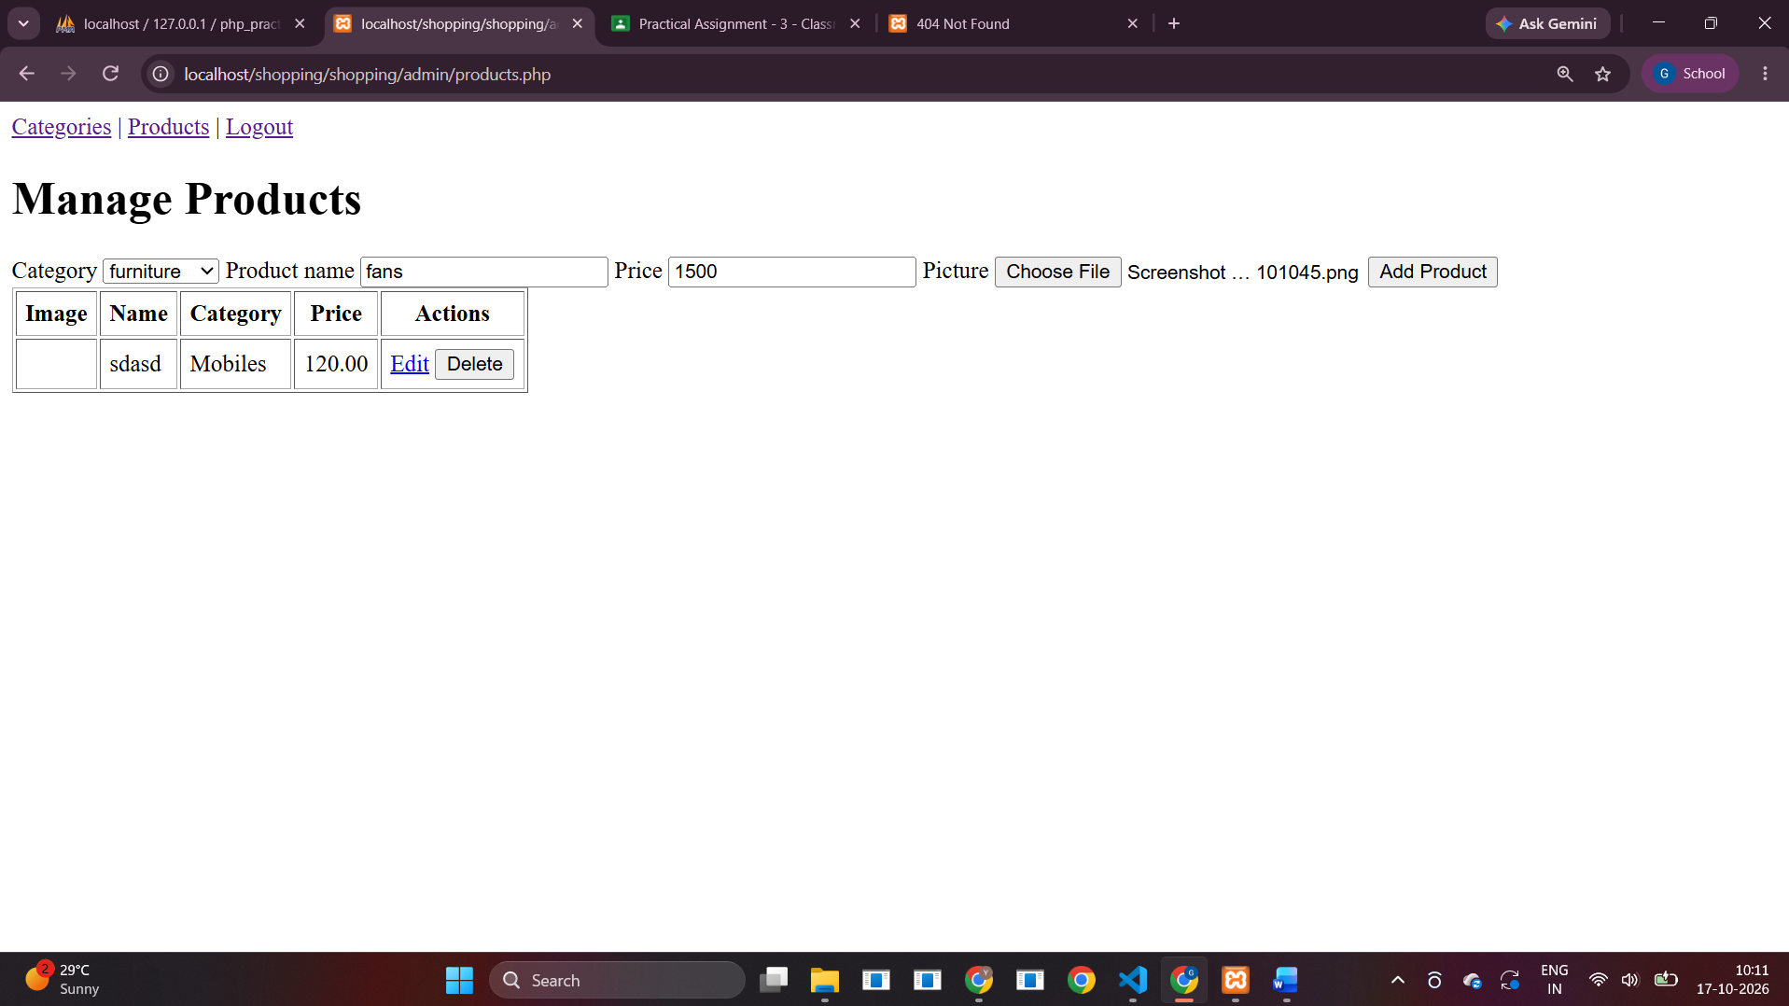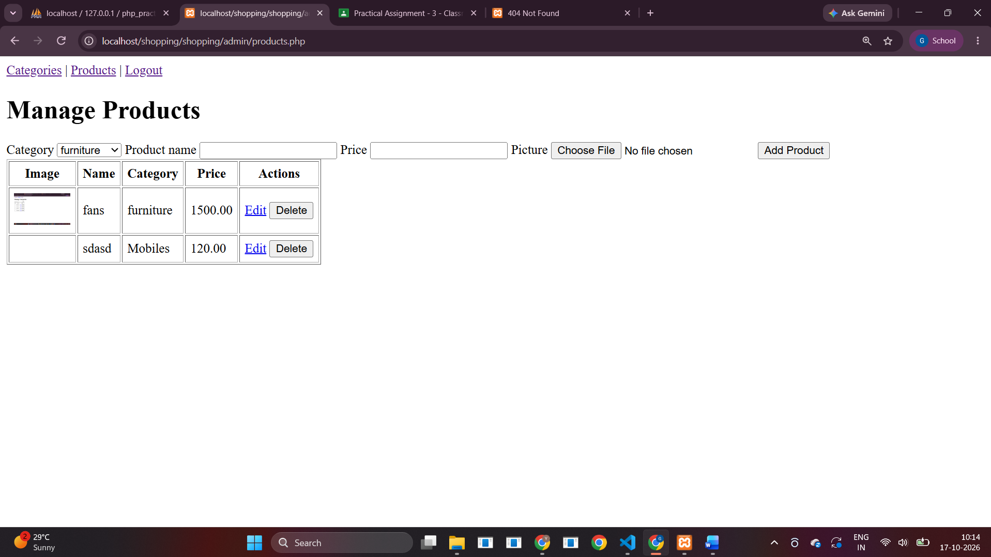
4) Logout
<?php
require __DIR__.'/../config.php';
unset($_SESSION['admin_id'],$_SESSION['admin_name']);
header('Location: login.php'); exit;

User Site:
1) List categories
2) Display products for the selected category with AJAX pagination
3) Register user using CAPTCHA
4) Login and add products to the cart
config.php
<?php
if (session_status() === PHP_SESSION_NONE) session_start();
$host = 'localhost';
$db = 'php_practical';
$user = 'root';
$pass = ''; // XAMPP default; change if your MySQL has a password
$charset = 'utf8mb4';
$dsn = "mysql:host=$host;dbname=$db;charset=$charset";
$options = [
PDO::ATTR_ERRMODE => PDO::ERRMODE_EXCEPTION,
PDO::ATTR_DEFAULT_FETCH_MODE => PDO::FETCH_ASSOC,
PDO::ATTR_EMULATE_PREPARES => false,
];
try { $pdo = new PDO($dsn, $user, $pass, $options); }
catch (PDOException $e) { http_response_code(500); exit('Database connection failed. Check config.php and MySQL.'); }
function h($value) { return htmlspecialchars((string)$value, ENT_QUOTES, 'UTF-8'); }
function require_admin() {
if (empty($_SESSION['admin_id'])) { header('Location: login.php'); exit; }
}
function require_user() {
if (empty($_SESSION['user_id'])) { header('Location: login.php'); exit; }
}
index.php – User product listing
<?php
require __DIR__.'/config.php';
$categories = $pdo->query('SELECT id,name FROM categories ORDER BY name')->fetchAll();
?>
<!doctype html><html><head><meta charset="utf-8"><title>Shopping Store</title>
<style>body{font-family:Arial;max-width:1000px;margin:25px auto;padding:0 15px}nav a{margin-right:14px}.cats a{display:inline-block;padding:10px;margin:5px;background:#eee;border-radius:5px}#products{display:grid;grid-template-columns:repeat(3,1fr);gap:15px}.product{border:1px solid #ddd;padding:12px}.product img{width:100%;height:160px;object-fit:contain}.pager button{margin:4px}</style></head><body>
<nav><a href="index.php">Home</a><a href="register.php">Register</a><a href="login.php">Login</a><a href="cart.php">Cart (<?= count($_SESSION['cart'] ?? []) ?>)</a></nav>
<h1>Shopping Cart</h1><h2>Categories</h2><div class="cats">
<?php foreach($categories as $c): ?><a href="#" class="category" data-id="<?= (int)$c['id'] ?>"><?= h($c['name']) ?></a><?php endforeach; ?>
</div><h2 id="heading">Products</h2><div id="products">Click a category to load products.</div><div id="pager" class="pager"></div>
<script>
let categoryId = 0;
async function loadProducts(page=1) {
if (!categoryId) return;
const res = await fetch('products_ajax.php?category_id='+categoryId+'&page='+page);
const data = await res.json();
document.getElementById('products').innerHTML = data.html || '<p>No products found.</p>';
document.getElementById('pager').innerHTML = data.pages > 1
? Array.from({length:data.pages},(_,i)=>`<button data-page="${i+1}">${i+1}</button>`).join('') : '';
document.querySelectorAll('#pager button').forEach(b=>b.onclick=()=>loadProducts(Number(b.dataset.page)));
}
document.querySelectorAll('.category').forEach(a=>a.addEventListener('click',e=>{
e.preventDefault(); categoryId=a.dataset.id; document.getElementById('heading').textContent=a.textContent; loadProducts(1);
}));
</script></body></html>
products_ajax.php – AJAX product pagination
<?php
require __DIR__.'/config.php';
header('Content-Type: application/json; charset=utf-8');
$cid = filter_input(INPUT_GET, 'category_id', FILTER_VALIDATE_INT) ?: 0;
$page = max(1, filter_input(INPUT_GET, 'page', FILTER_VALIDATE_INT) ?: 1);
$perPage = 6;
$count = $pdo->prepare('SELECT COUNT(*) FROM products WHERE category_id=?');
$count->execute([$cid]); $total = (int)$count->fetchColumn();
$pages = max(1, (int)ceil($total/$perPage)); $offset = ($page-1)*$perPage;
$stmt = $pdo->prepare('SELECT id,pname,price,picture FROM products WHERE category_id=? ORDER BY id DESC LIMIT ? OFFSET ?');
$stmt->bindValue(1,$cid,PDO::PARAM_INT); $stmt->bindValue(2,$perPage,PDO::PARAM_INT); $stmt->bindValue(3,$offset,PDO::PARAM_INT); $stmt->execute();
$html = '';
foreach($stmt as $p) {
$html .= '<div class="product">';
if ($p['picture']) $html .= '<img src="uploads/'.h($p['picture']).'" alt="">';
$html .= '<h3>'.h($p['pname']).'</h3><p>₹'.number_format((float)$p['price'],2).'</p>';
$html .= '<form method="post" action="cart.php"><input type="hidden" name="product_id" value="'.(int)$p['id'].'"><button name="add" value="1">Add to cart</button></form></div>';
}
echo json_encode(['html'=>$html,'pages'=>$pages,'total'=>$total]);
register.php – User registration and CAPTCHA
<?php
require __DIR__.'/config.php'; $error='';
if(empty($_SESSION['captcha'])) $_SESSION['captcha']=(string)random_int(1000,9999);
if($_SERVER['REQUEST_METHOD']==='POST'){
if(!hash_equals($_SESSION['captcha']??'',trim($_POST['captcha']??''))) $error='CAPTCHA is incorrect.';
else {
$name=trim($_POST['name']??'');$email=filter_var($_POST['email']??'',FILTER_VALIDATE_EMAIL);$pw=$_POST['password']??'';
if($name===''||!$email||strlen($pw)<6)$error='Enter valid details. Password must be at least 6 characters.';
else {try{$s=$pdo->prepare('INSERT INTO users(name,email,password_hash) VALUES(?,?,?)');$s->execute([$name,$email,password_hash($pw,PASSWORD_DEFAULT)]);unset($_SESSION['captcha']);header('Location: login.php?registered=1');exit;}catch(PDOException $e){$error='Email may already be registered.';}}
}
$_SESSION['captcha']=(string)random_int(1000,9999);
}
?><!doctype html><html><body><h1>Register</h1><p style="color:red"><?= h($error) ?></p>
<form method="post"><p>Name <input name="name" required></p><p>Email <input type="email" name="email" required></p><p>Password <input type="password" name="password" minlength="6" required></p>
<p>CAPTCHA: <strong><?= h($_SESSION['captcha']) ?></strong> <button type="button" onclick="location.reload()">Refresh</button></p><p>Enter CAPTCHA <input name="captcha" required></p><button>Register</button></form></body></html>

login.php – User login
<?php
require __DIR__.'/config.php';$error='';
if($_SERVER['REQUEST_METHOD']==='POST'){
$s=$pdo->prepare('SELECT * FROM users WHERE email=?');$s->execute([trim($_POST['email']??'')]);$u=$s->fetch();
if($u&&password_verify($_POST['password']??'',$u['password_hash'])){session_regenerate_id(true);$_SESSION['user_id']=$u['id'];$_SESSION['user_name']=$u['name'];header('Location: index.php');exit;}
$error='Invalid email or password.';
}
?><!doctype html><html><body><h1>User Login</h1><?php if(isset($_GET['registered']))echo '<p>Registration successful. Please log in.</p>'; ?><p style="color:red"><?= h($error) ?></p>
<form method="post"><p>Email <input type="email" name="email" required></p><p>Password <input type="password" name="password" required></p><button>Login</button></form></body></html>

cart.php – Shopping cart
<?php
require __DIR__.'/config.php';
if(isset($_POST['add'])){
$id=(int)($_POST['product_id']??0);$s=$pdo->prepare('SELECT id FROM products WHERE id=?');$s->execute([$id]);
if($s->fetch())$_SESSION['cart'][$id]=($_SESSION['cart'][$id]??0)+1;
header('Location: cart.php');exit;
}
if(isset($_POST['remove'])){unset($_SESSION['cart'][(int)$_POST['remove']]);header('Location: cart.php');exit;}
$cart=$_SESSION['cart']??[];$items=[];$total=0;
if($cart){$ids=array_map('intval',array_keys($cart));$marks=implode(',',array_fill(0,count($ids),'?'));$s=$pdo->prepare("SELECT * FROM products WHERE id IN ($marks)");$s->execute($ids);
foreach($s as $p){$p['qty']=$cart[$p['id']];$p['subtotal']=$p['price']*$p['qty'];$total+=$p['subtotal'];$items[]=$p;}}
?><!doctype html><html><body><a href="index.php">Continue shopping</a><h1>Your Cart</h1>
<?php if(!$items): ?><p>Cart is empty.</p><?php else: ?><table border="1" cellpadding="8"><tr><th>Product</th><th>Price</th><th>Qty</th><th>Subtotal</th><th></th></tr>
<?php foreach($items as $p): ?><tr><td><?= h($p['pname']) ?></td><td><?= h($p['price']) ?></td><td><?= (int)$p['qty'] ?></td><td><?= number_format($p['subtotal'],2) ?></td><td><form method="post"><button name="remove" value="<?= (int)$p['id'] ?>">Remove</button></form></td></tr><?php endforeach; ?></table><h3>Total: ₹<?= number_format($total,2) ?></h3><?php endif; ?></body></html>
Admin login
<?php
require __DIR__.'/../config.php';
$error='';
if ($_SERVER['REQUEST_METHOD']==='POST') {
$stmt=$pdo->prepare('SELECT id,username,password_hash FROM admins WHERE username=?');
$stmt->execute([trim($_POST['username'] ?? '')]); $a=$stmt->fetch();
if ($a && password_verify($_POST['password'] ?? '', $a['password_hash'])) {
session_regenerate_id(true); $_SESSION['admin_id']=$a['id']; $_SESSION['admin_name']=$a['username'];
header('Location: categories.php'); exit;
} else $error='Invalid username or password';
}
?><!doctype html><html><body><h1>Admin Login</h1><p style="color:red"><?= h($error) ?></p>
<form method="post"><label>Username <input name="username" required></label><br><label>Password <input type="password" name="password" required></label><br><button>Login</button></form></body></html>
Manage categories (CRUD)
<?php
require __DIR__.'/../config.php'; require_admin();
if ($_SERVER['REQUEST_METHOD']==='POST') {
$name=trim($_POST['name'] ?? '');
if (isset($_POST['create']) && $name!=='') { $s=$pdo->prepare('INSERT INTO categories(name) VALUES(?)'); $s->execute([$name]); }
if (isset($_POST['update']) && $name!=='') { $s=$pdo->prepare('UPDATE categories SET name=? WHERE id=?'); $s->execute([$name,(int)$_POST['id']]); }
if (isset($_POST['delete'])) { $s=$pdo->prepare('DELETE FROM categories WHERE id=?'); $s->execute([(int)$_POST['id']]); }
header('Location: categories.php'); exit;
}
$edit=null;
if(isset($_GET['edit'])){$s=$pdo->prepare('SELECT * FROM categories WHERE id=?');$s->execute([(int)$_GET['edit']]);$edit=$s->fetch();}
$rows=$pdo->query('SELECT * FROM categories ORDER BY id DESC')->fetchAll();
?><!doctype html><html><body><nav><a href="categories.php">Categories</a> | <a href="products.php">Products</a> | <a href="logout.php">Logout</a></nav><h1>Manage Categories</h1>
<form method="post"><?php if($edit): ?><input type="hidden" name="id" value="<?= (int)$edit['id'] ?>"><?php endif; ?>
<input name="name" placeholder="Category name" required value="<?= h($edit['name'] ?? '') ?>">
<button name="<?= $edit?'update':'create' ?>"><?= $edit?'Update':'Add' ?></button><?php if($edit): ?><a href="categories.php">Cancel</a><?php endif; ?></form>
<table border="1" cellpadding="8"><tr><th>ID</th><th>Name</th><th>Actions</th></tr>
<?php foreach($rows as $r): ?><tr><td><?= (int)$r['id'] ?></td><td><?= h($r['name']) ?></td><td><a href="?edit=<?= (int)$r['id'] ?>">Edit</a>
<form method="post" style="display:inline" onsubmit="return confirm('Delete category and its products?')"><input type="hidden" name="id" value="<?= (int)$r['id'] ?>"><button name="delete">Delete</button></form></td></tr><?php endforeach; ?></table></body></html>
Manage products and image upload/resize
<?php
require __DIR__.'/../config.php'; require_admin();
$uploadDir=__DIR__.'/../uploads/';
if (!is_dir($uploadDir)) mkdir($uploadDir,0775,true);
function resizeImage($tmp,$dest,$mime,$maxW=600,$maxH=600) {
if ($mime==='image/jpeg') $src=@imagecreatefromjpeg($tmp);
elseif ($mime==='image/png') $src=@imagecreatefrompng($tmp);
elseif ($mime==='image/gif') $src=@imagecreatefromgif($tmp);
elseif ($mime==='image/webp' && function_exists('imagecreatefromwebp')) $src=@imagecreatefromwebp($tmp);
else return false;
if(!$src)return false;
$w=imagesx($src);$h=imagesy($src);$scale=min($maxW/$w,$maxH/$h,1);
$nw=max(1,(int)($w*$scale));$nh=max(1,(int)($h*$scale));
$out=imagecreatetruecolor($nw,$nh);
if($mime==='image/png'||$mime==='image/gif'||$mime==='image/webp'){imagealphablending($out,false);imagesavealpha($out,true);$trans=imagecolorallocatealpha($out,0,0,0,127);imagefilledrectangle($out,0,0,$nw,$nh,$trans);}
imagecopyresampled($out,$src,0,0,0,0,$nw,$nh,$w,$h);
$ok=match($mime){'image/jpeg'=>imagejpeg($out,$dest,85),'image/png'=>imagepng($out,$dest,6),'image/gif'=>imagegif($out,$dest),'image/webp'=>imagewebp($out,$dest,85),default=>false};
imagedestroy($src);imagedestroy($out);return $ok;
}
$error='';
if($_SERVER['REQUEST_METHOD']==='POST'){
$id=(int)($_POST['id']??0);$cid=(int)($_POST['category_id']??0);$name=trim($_POST['pname']??'');$price=(float)($_POST['price']??0);
$picture=$_POST['old_picture']??null;
if(isset($_POST['delete'])){
$s=$pdo->prepare('DELETE FROM products WHERE id=?');$s->execute([$id]);
if($picture && is_file($uploadDir.$picture)) @unlink($uploadDir.$picture);
header('Location: products.php');exit;
}
if($name===''||$cid<1||$price<0){$error='Enter valid product details.';}
else {
if(!empty($_FILES['picture']['name'])){
$tmp=$_FILES['picture']['tmp_name'];$info=@getimagesize($tmp);
$allowed=['image/jpeg'=>'jpg','image/png'=>'png','image/gif'=>'gif','image/webp'=>'webp'];
if(!$info || !isset($allowed[$info['mime']])) $error='Upload a valid JPG, PNG, GIF, or WEBP image.';
else {
$new=bin2hex(random_bytes(12)).'.'.$allowed[$info['mime']];
if(!resizeImage($tmp,$uploadDir.$new,$info['mime'])) $error='Image resize failed. Enable PHP GD extension.';
else { if($picture && is_file($uploadDir.$picture)) @unlink($uploadDir.$picture); $picture=$new; }
}
}
if(!$error){
if($id){$s=$pdo->prepare('UPDATE products SET category_id=?,pname=?,price=?,picture=? WHERE id=?');$s->execute([$cid,$name,$price,$picture,$id]);}
else{$s=$pdo->prepare('INSERT INTO products(category_id,pname,price,picture) VALUES(?,?,?,?)');$s->execute([$cid,$name,$price,$picture]);}
header('Location: products.php');exit;
}
}
}
$edit=null;if(isset($_GET['edit'])){$s=$pdo->prepare('SELECT * FROM products WHERE id=?');$s->execute([(int)$_GET['edit']]);$edit=$s->fetch();}
$cats=$pdo->query('SELECT * FROM categories ORDER BY name')->fetchAll();
$rows=$pdo->query('SELECT p.*,c.name category FROM products p JOIN categories c ON c.id=p.category_id ORDER BY p.id DESC')->fetchAll();
?><!doctype html><html><body><nav><a href="categories.php">Categories</a> | <a href="products.php">Products</a> | <a href="logout.php">Logout</a></nav><h1>Manage Products</h1><p style="color:red"><?= h($error) ?></p>
<form method="post" enctype="multipart/form-data">
<input type="hidden" name="id" value="<?= (int)($edit['id']??0) ?>"><input type="hidden" name="old_picture" value="<?= h($edit['picture']??'') ?>">
<label>Category <select name="category_id" required><?php foreach($cats as $c): ?><option value="<?= (int)$c['id'] ?>" <?= (($edit['category_id']??0)==$c['id'])?'selected':'' ?>><?= h($c['name']) ?></option><?php endforeach; ?></select></label>
<label>Product name <input name="pname" required value="<?= h($edit['pname']??'') ?>"></label>
<label>Price <input name="price" type="number" min="0" step="0.01" required value="<?= h($edit['price']??'') ?>"></label>
<label>Picture <input type="file" name="picture" accept="image/jpeg,image/png,image/gif,image/webp"></label>
<button><?= $edit?'Update':'Add Product' ?></button></form>
<table border="1" cellpadding="6"><tr><th>Image</th><th>Name</th><th>Category</th><th>Price</th><th>Actions</th></tr>
<?php foreach($rows as $r): ?><tr><td><?php if($r['picture']): ?><img width="70" src="../uploads/<?= h($r['picture']) ?>"><?php endif; ?></td><td><?= h($r['pname']) ?></td><td><?= h($r['category']) ?></td><td><?= h($r['price']) ?></td><td><a href="?edit=<?= (int)$r['id'] ?>">Edit</a>
<form method="post" style="display:inline" onsubmit="return confirm('Delete product?')"><input type="hidden" name="id" value="<?= (int)$r['id'] ?>"><input type="hidden" name="old_picture" value="<?= h($r['picture']) ?>"><button name="delete">Delete</button></form></td></tr><?php endforeach; ?></table></body></html>
User logout
<?php
require __DIR__.'/config.php';
unset($_SESSION['user_id'],$_SESSION['user_name']);
session_regenerate_id(true);
header('Location: index.php');exit;
Admin logout
<?php
require __DIR__.'/../config.php';
unset($_SESSION['admin_id'],$_SESSION['admin_name']);
header('Location: login.php'); exit;

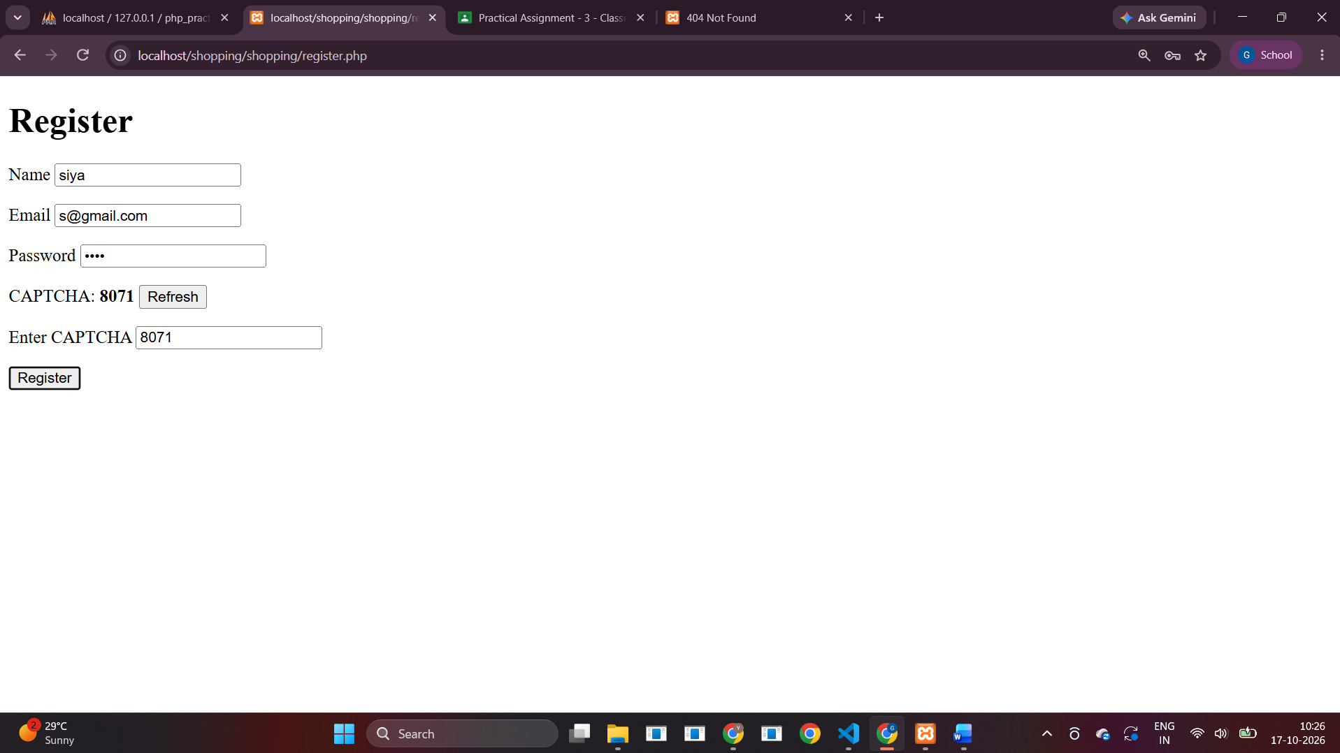
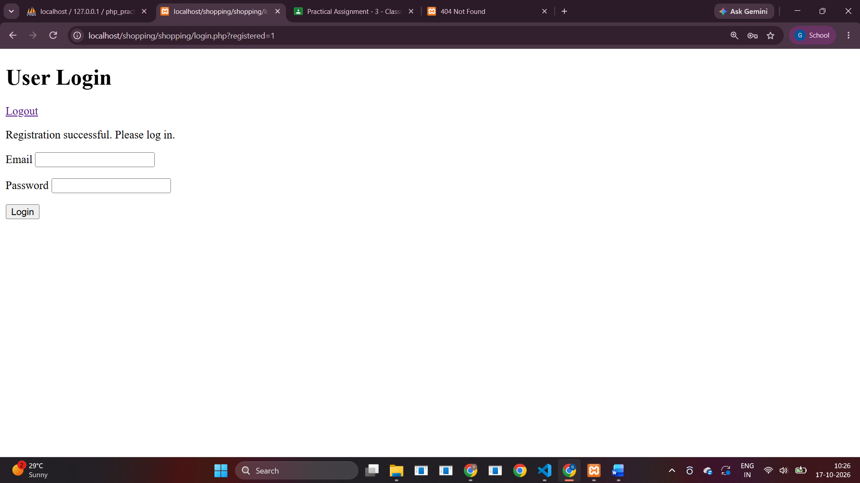
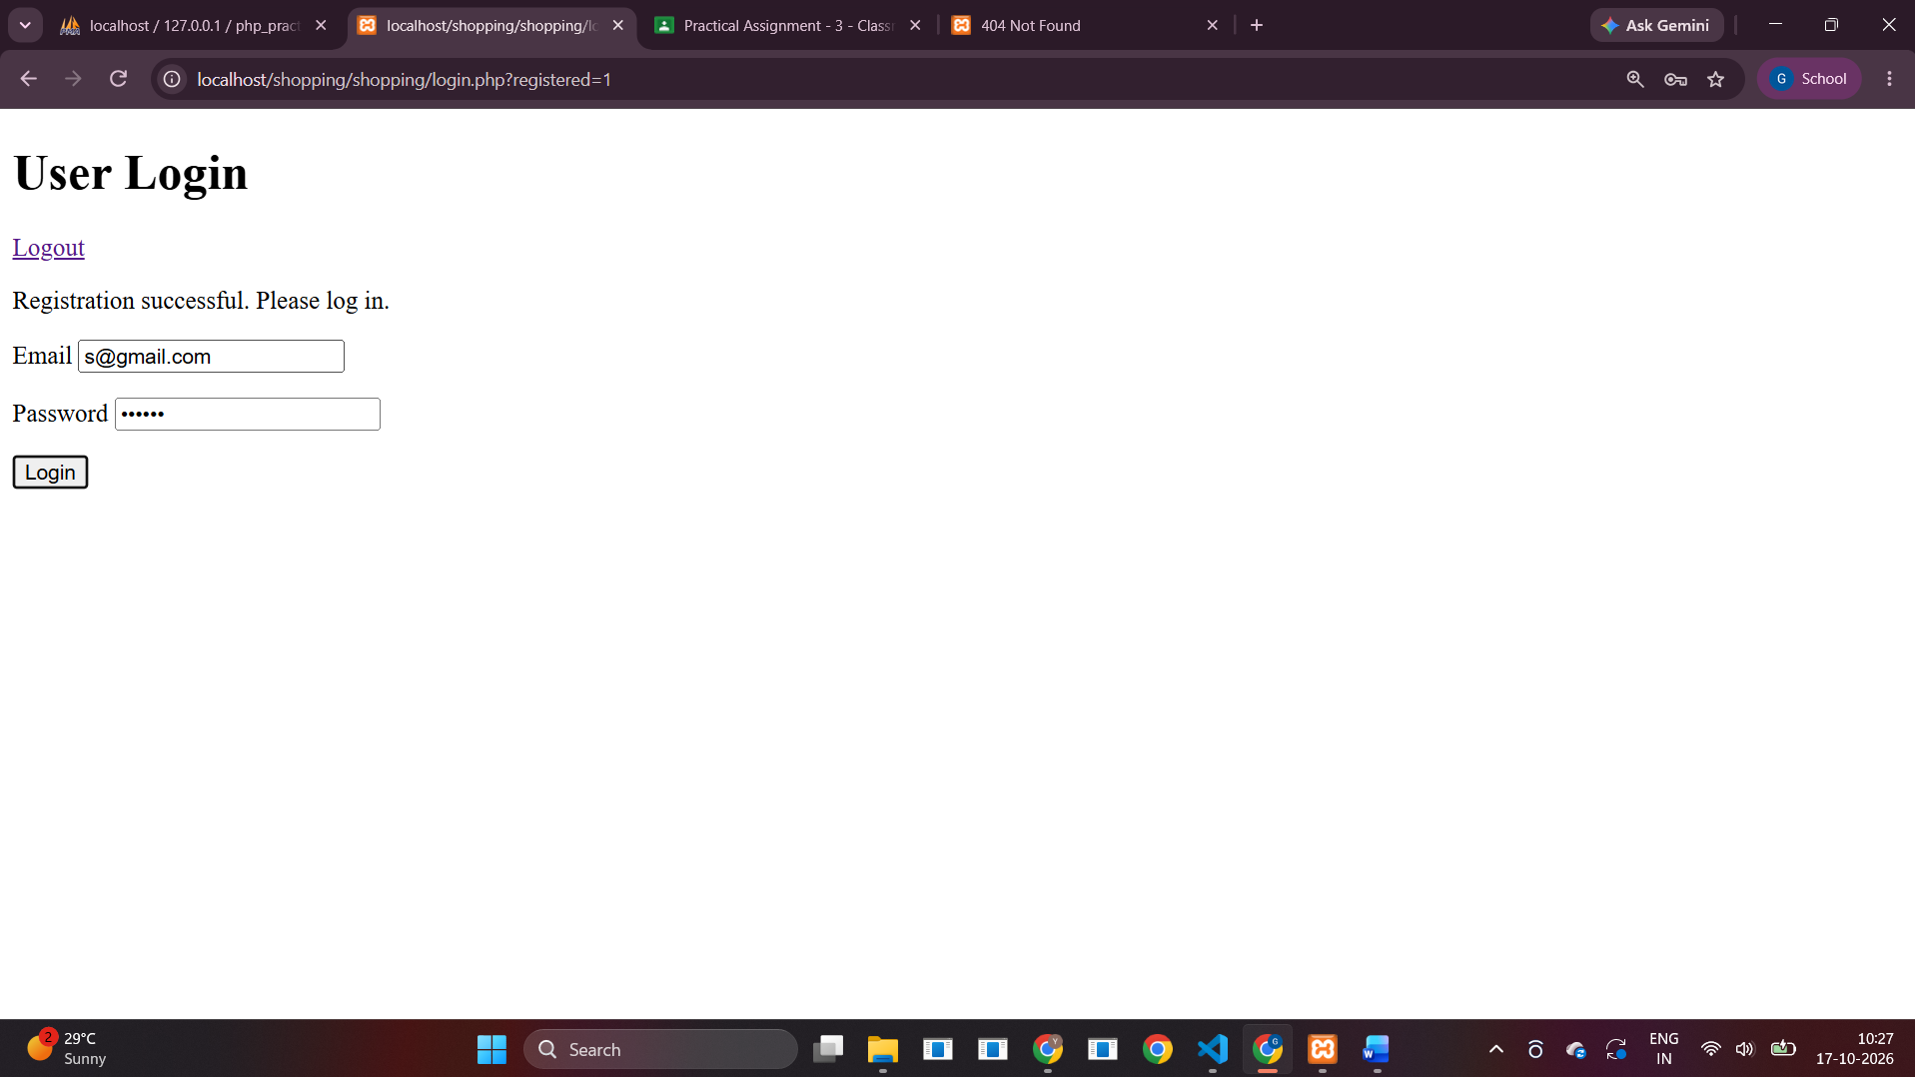
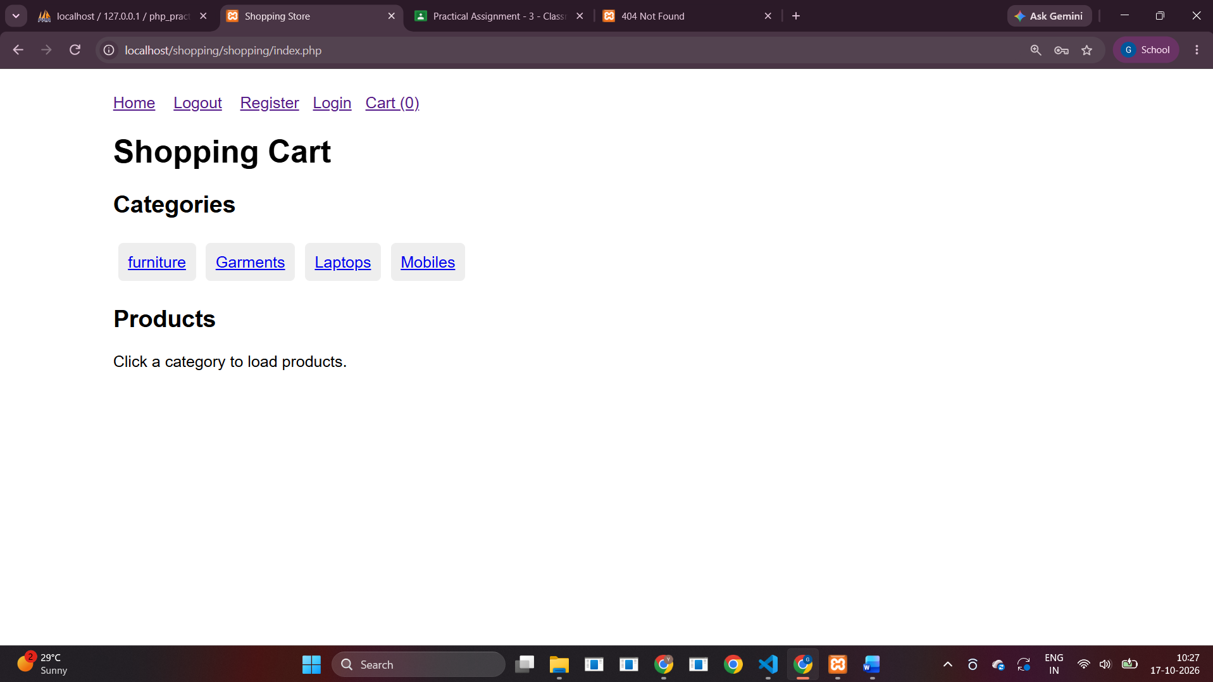
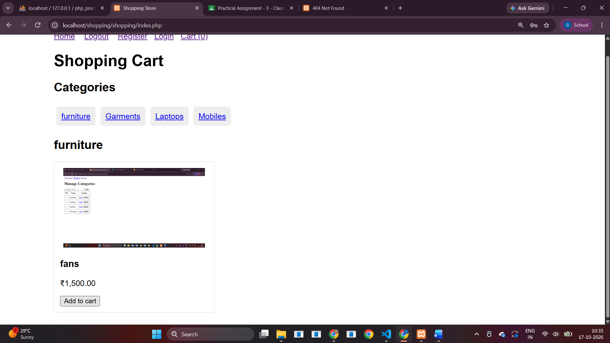
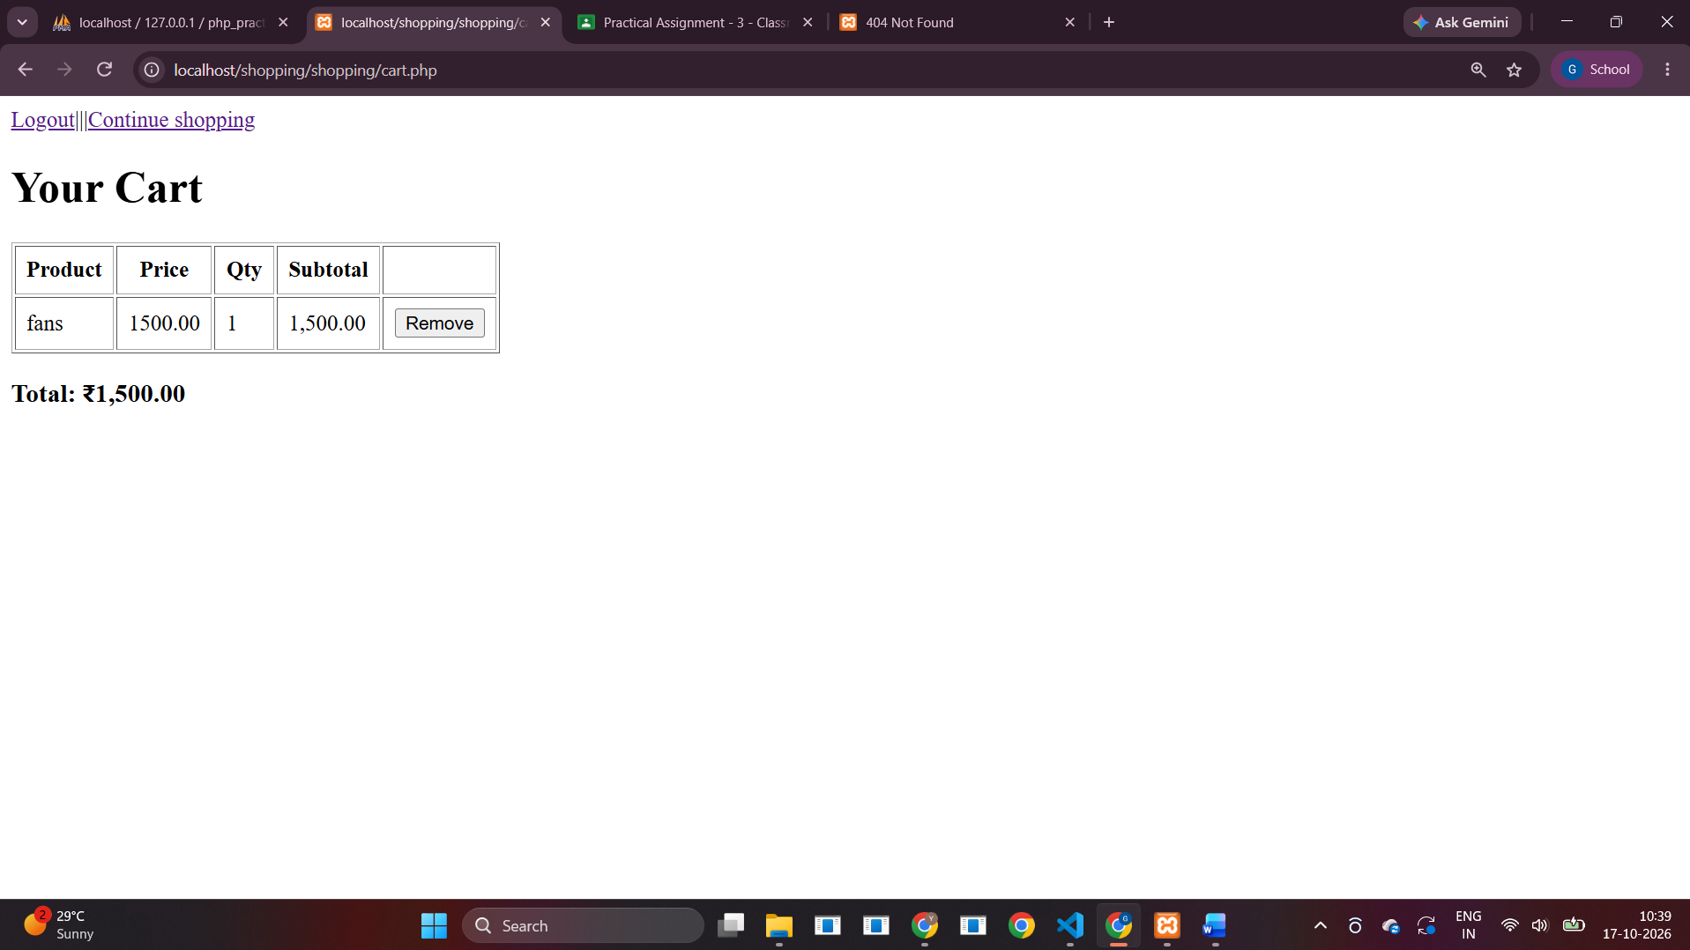
When I click on logout it does thus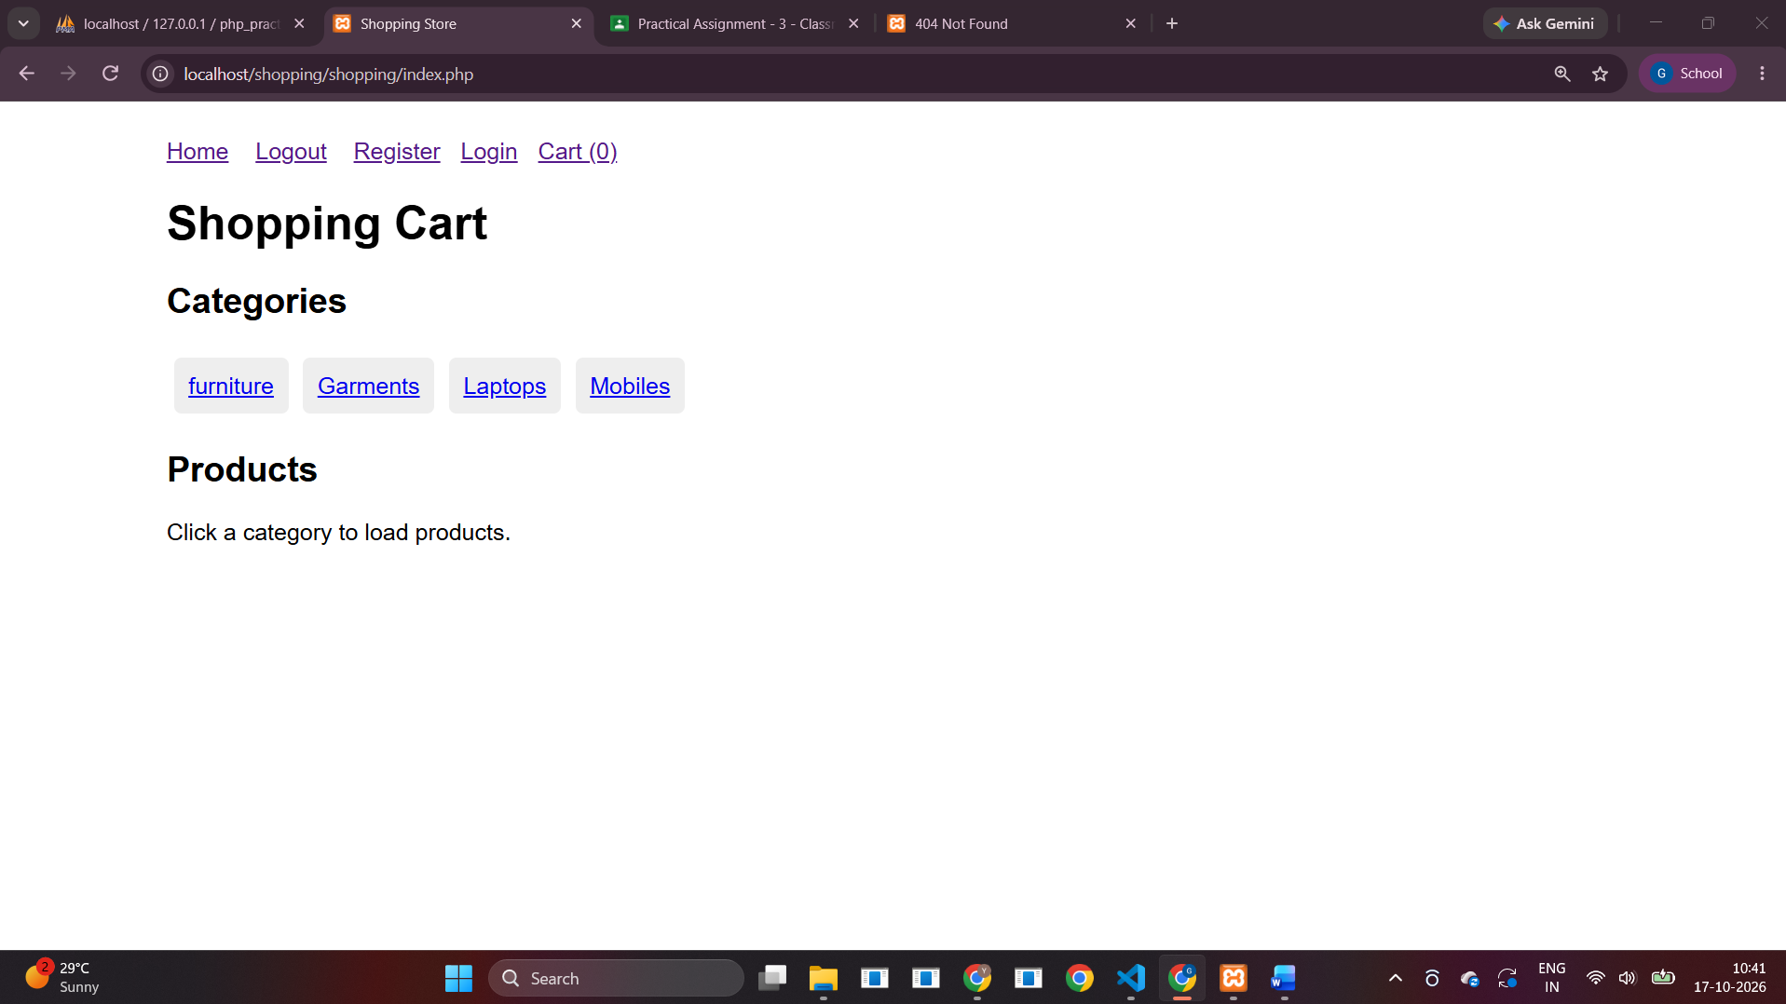
2. Read data from students.xml and store it in the MySQL students table
students.xml
<?xml version="1.0" encoding="UTF-8"?>
<students>
<student><name>Asha Patel</name><email>asha@example.com</email></student>
<student><name>Rahul Shah</name><email>rahul@example.com</email></student>
<student><name>Neha Desai</name><email>neha@example.com</email></student>
</students>
import.php
<?php
require __DIR__.'/../shopping/config.php';
$file=__DIR__.'/students.xml';
if(!file_exists($file))exit('students.xml not found');
libxml_use_internal_errors(true);$xml=simplexml_load_file($file);
if(!$xml)exit('Invalid XML file');
$insert=$pdo->prepare('INSERT INTO students(name,email) VALUES(?,?)');$count=0;
foreach($xml->student as $st){$name=trim((string)$st->name);$email=filter_var((string)$st->email,FILTER_VALIDATE_EMAIL);if($name!==''&&$email){$insert->execute([$name,$email]);$count++;}}
echo "Imported $count students into MySQL.";
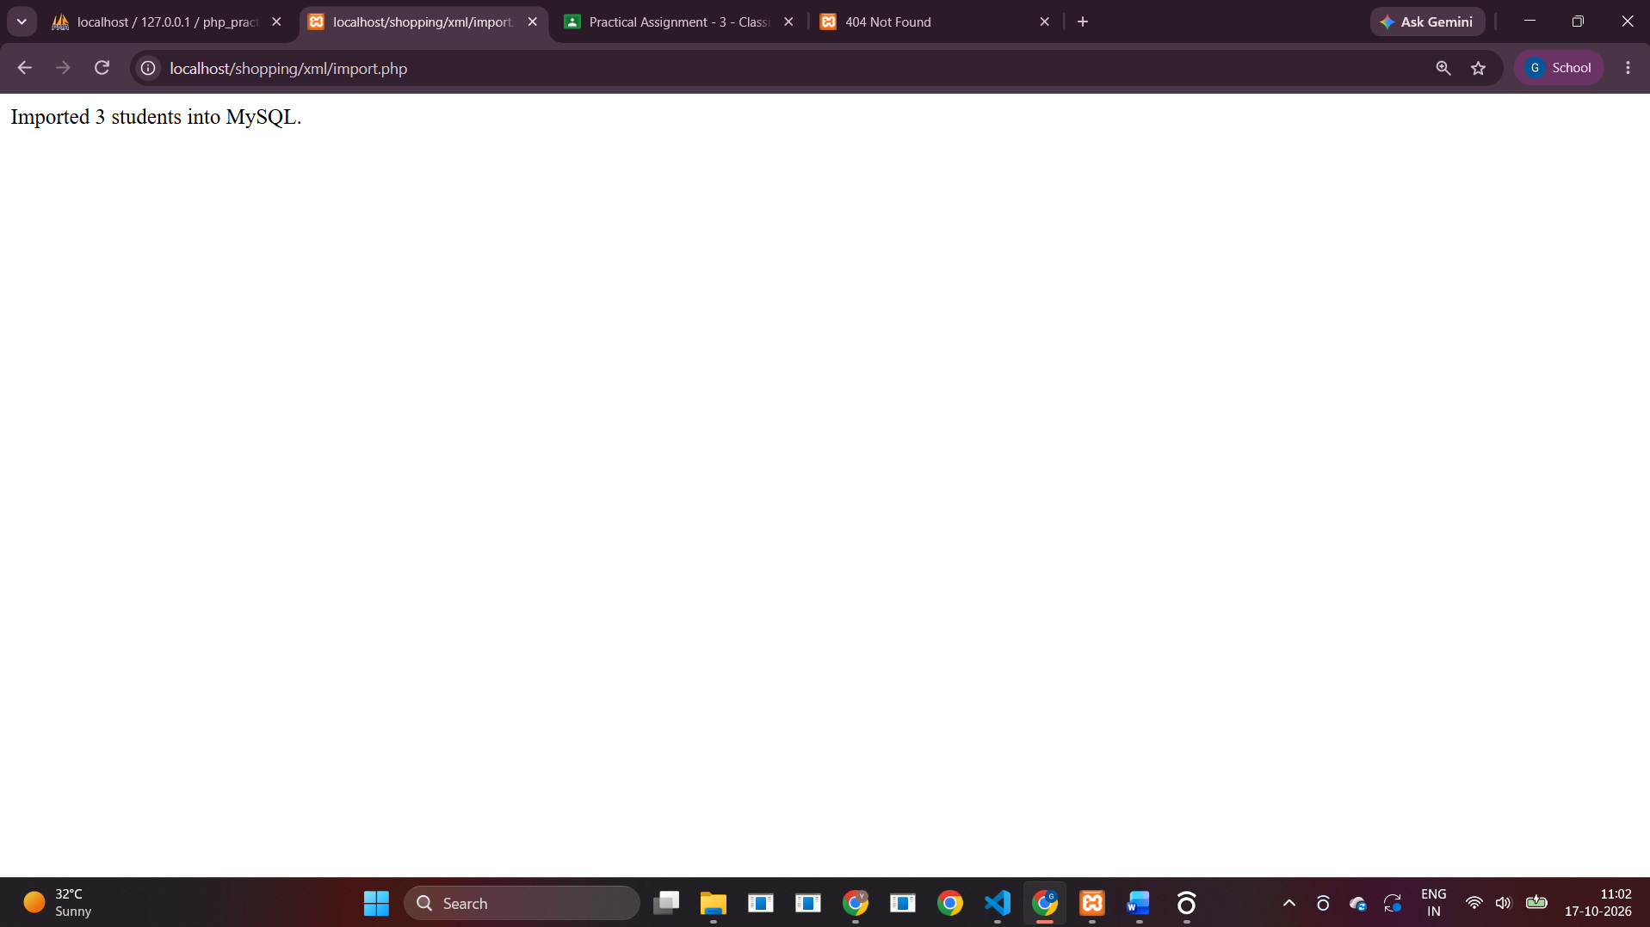

3. Read data from the MySQL students table and store it in students.xml
export.php
<?php
require __DIR__.'/../shopping/config.php';
$rows=$pdo->query('SELECT name,email FROM students ORDER BY id')->fetchAll();
$xml=new XMLWriter();$xml->openMemory();$xml->startDocument('1.0','UTF-8');$xml->setIndent(true);$xml->startElement('students');
foreach($rows as $r){$xml->startElement('student');$xml->writeElement('name',$r['name']);$xml->writeElement('email',$r['email']);$xml->endElement();}
$xml->endElement();$xml->endDocument();
header('Content-Type: application/xml; charset=utf-8');header('Content-Disposition: attachment; filename="students.xml"');echo $xml->outputMemory();
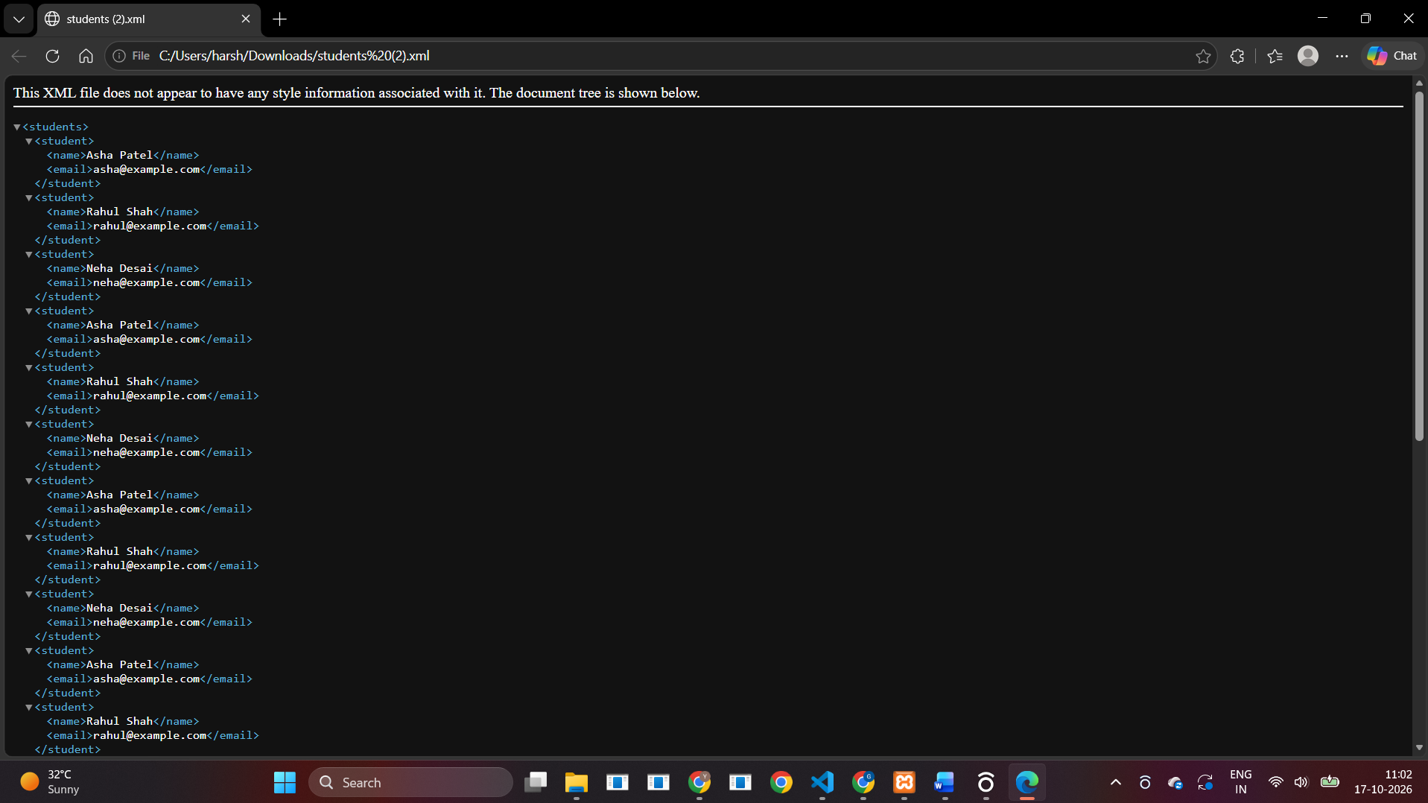
4. List files in a directory
list.php
<?php
$dir=__DIR__.'/sample';
if(!is_dir($dir))mkdir($dir,0775,true);
$entries=array_values(array_filter(scandir($dir),fn($x)=>$x!=='.'&&$x!=='..'));
?><!doctype html><html><body><h1>Files in <?= htmlspecialchars($dir) ?></h1>
<?php if(!$entries): ?><p>No files yet. Add some files to the sample directory.</p><?php else: ?><ul><?php foreach($entries as $entry): ?><li><?= htmlspecialchars($entry) ?> <?= is_dir($dir.'/'.$entry)?'(directory)':'(file)' ?></li><?php endforeach; ?></ul><?php endif; ?></body></html>
Additional test file: files/read.php (created and tested locally). 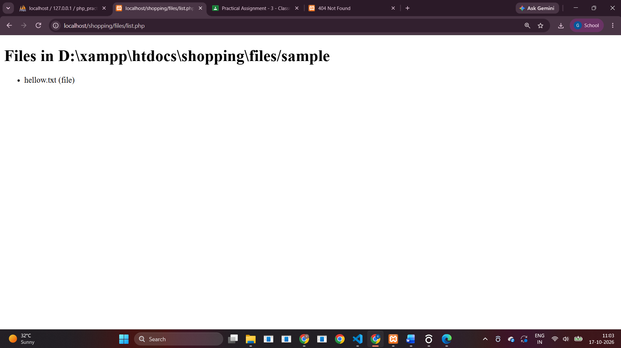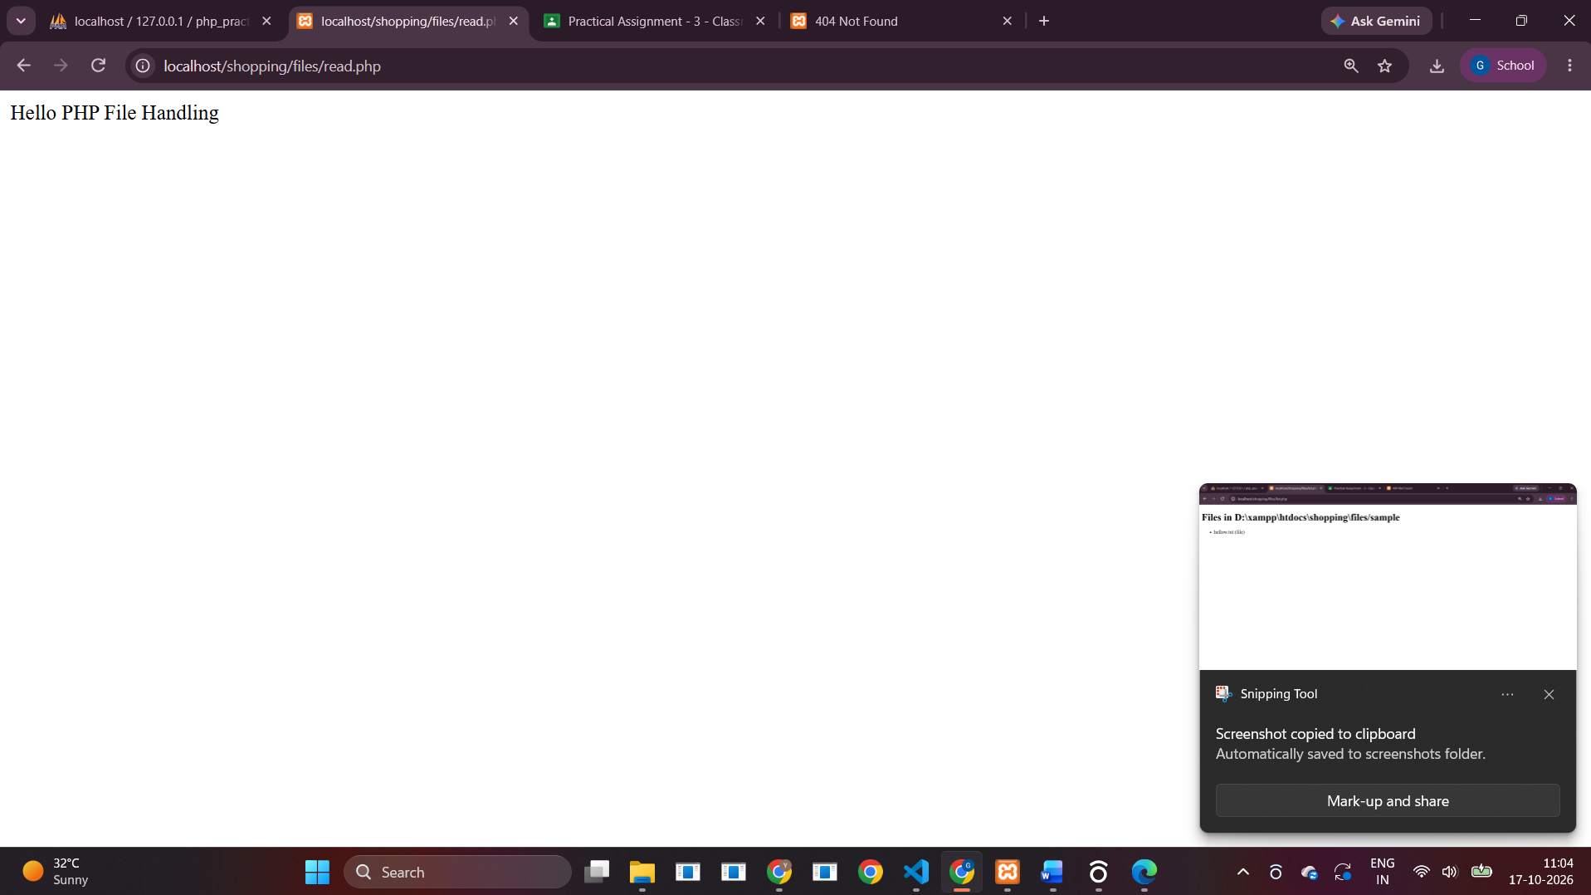
5. Call an Express REST API in PHP
express_client.php
<?php
$url='http://127.0.0.1:3000/api/message';
$payload=json_encode(['name'=>'PHP client','message'=>'Hello from PHP']);
$ch=curl_init($url);
curl_setopt_array($ch,[CURLOPT_RETURNTRANSFER=>true,CURLOPT_POST=>true,CURLOPT_HTTPHEADER=>['Content-Type: application/json'],CURLOPT_POSTFIELDS=>$payload,CURLOPT_TIMEOUT=>5]);
$response=curl_exec($ch);$error=curl_error($ch);$status=curl_getinfo($ch,CURLINFO_HTTP_CODE);curl_close($ch);
?><!doctype html><html><body><h1>PHP calling Express REST API</h1>
<?php if($response===false): ?><p>cURL error: <?= htmlspecialchars($error) ?></p><?php else: ?><p>HTTP status: <?= (int)$status ?></p><pre><?= htmlspecialchars($response) ?></pre><?php endif; ?></body></html>
Express API endpoint
const express = require('express');
const app = express();
app.use(express.json());
app.get('/api/message', (req, res) => {
res.json({ success: true, message: 'Hello from Express GET API', method: 'GET' });
});
app.post('/api/message', (req, res) => {
const { name = 'Unknown', message = '' } = req.body || {};
res.json({ success: true, receivedFrom: name, message, response: 'PHP called Express successfully' });
});
// Express calls PHP REST API. Apache must be running for this route.
app.get('/php-client', async (req, res) => {
try {
const response = await fetch('http://localhost/shopping/api/students.php');
const data = await response.json();
res.type('html').send('<h1>Express calling PHP REST API</h1><pre>' +
escapeHtml(JSON.stringify(data, null, 2)) + '</pre>');
} catch (err) {
res.status(502).send('Could not call PHP API. Is Apache running at http://localhost/shopping? ' + escapeHtml(err.message));
}
});
function escapeHtml(s) {
return String(s).replace(/[&<>"']/g, c => ({'&':'&amp;','<':'&lt;','>':'&gt;','"':'&quot;',"'":'&#39;'}[c]));
}
const PORT = 3000;
app.listen(PORT, () => console.log(`Express API running at http://localhost:${PORT}`));
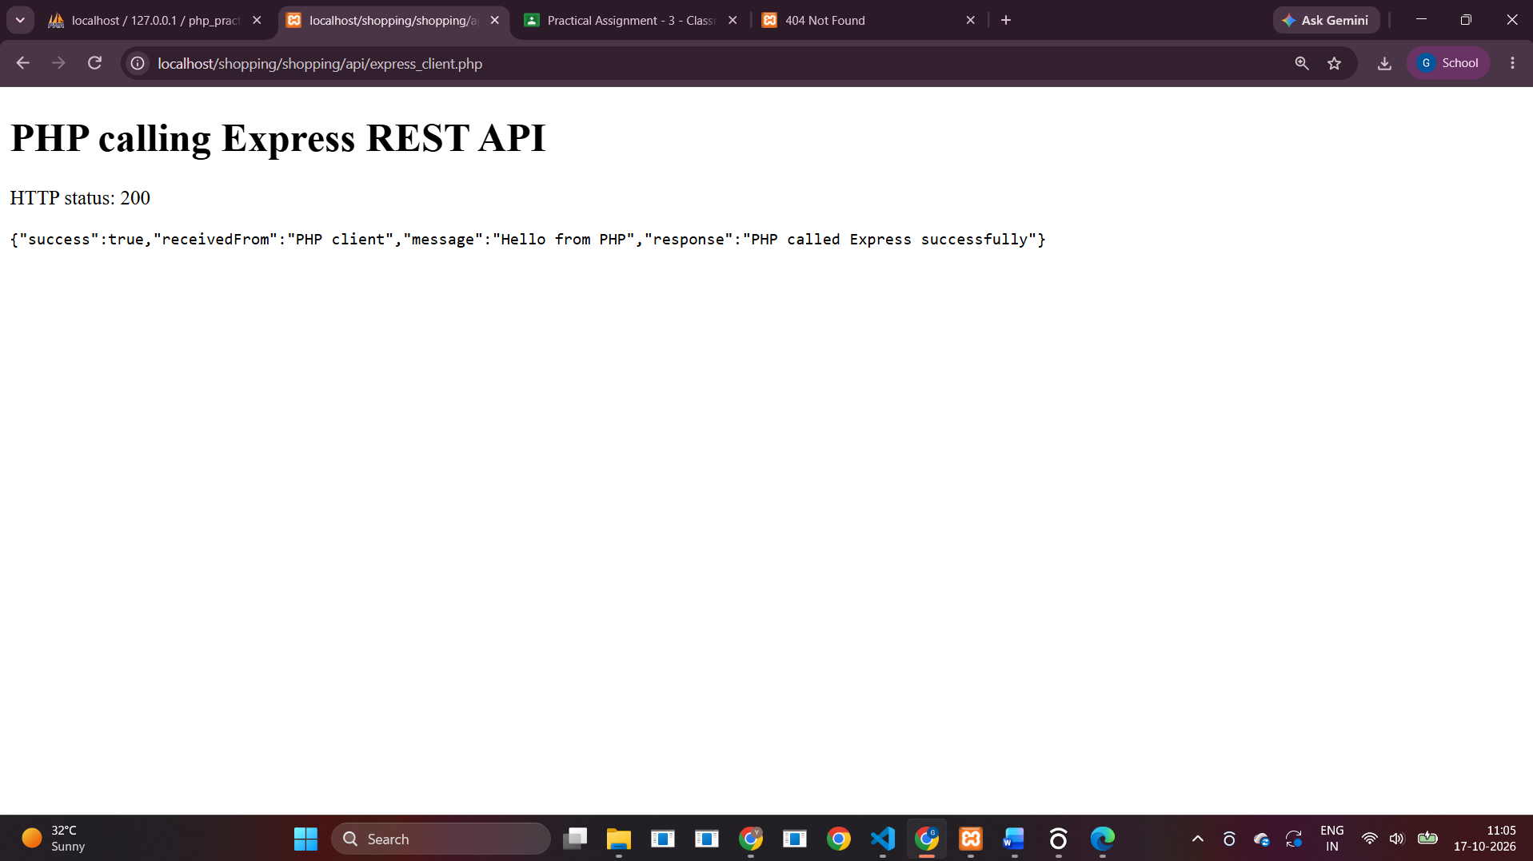
6. Call a PHP REST API in Express
students.php – PHP REST API
<?php
require __DIR__.'/../config.php';
header('Content-Type: application/json; charset=utf-8');
$method=$_SERVER['REQUEST_METHOD'];
if($method==='GET'){
$rows=$pdo->query('SELECT id,name,email FROM students ORDER BY id')->fetchAll();
echo json_encode(['success'=>true,'data'=>$rows]); exit;
}
if($method==='POST'){
$body=json_decode(file_get_contents('php://input'),true) ?? [];
$name=trim($body['name']??'');$email=filter_var($body['email']??'',FILTER_VALIDATE_EMAIL);
if($name===''||!$email){http_response_code(400);echo json_encode(['success'=>false,'message'=>'name and valid email required']);exit;}
$s=$pdo->prepare('INSERT INTO students(name,email) VALUES(?,?)');$s->execute([$name,$email]);
http_response_code(201);echo json_encode(['success'=>true,'id'=>(int)$pdo->lastInsertId()]);exit;
}
http_response_code(405);echo json_encode(['success'=>false,'message'=>'Method not allowed']);
Express application calling the PHP API
const express = require('express');
const app = express();
app.use(express.json());
app.get('/api/message', (req, res) => {
res.json({ success: true, message: 'Hello from Express GET API', method: 'GET' });
});
app.post('/api/message', (req, res) => {
const { name = 'Unknown', message = '' } = req.body || {};
res.json({ success: true, receivedFrom: name, message, response: 'PHP called Express successfully' });
});
// Express calls PHP REST API. Apache must be running for this route.
app.get('/php-client', async (req, res) => {
try {
const response = await fetch('http://localhost/shopping/api/students.php');
const data = await response.json();
res.type('html').send('<h1>Express calling PHP REST API</h1><pre>' +
escapeHtml(JSON.stringify(data, null, 2)) + '</pre>');
} catch (err) {
res.status(502).send('Could not call PHP API. Is Apache running at http://localhost/shopping? ' + escapeHtml(err.message));
}
});
function escapeHtml(s) {
return String(s).replace(/[&<>"']/g, c => ({'&':'&amp;','<':'&lt;','>':'&gt;','"':'&quot;',"'":'&#39;'}[c]));
}
const PORT = 3000;
app.listen(PORT, () => console.log(`Express API running at http://localhost:${PORT}`));
