1. Introduction
Reliability is a central quality concern for medical devices used in life-sustaining care. In neonatal respiratory support, Continuous Positive Airway Pressure (CPAP) systems are commonly used to manage respiratory distress by providing non-invasive airway pressure [1]. In low-resource healthcare settings, CPAP devices are often the primary respiratory intervention available, increasing the importance of consistent and predictable device performance [2].
This project addresses a specific reliability issue within this context: the consistency of airway pressure delivery in low-cost neonatal bubble CPAP systems. The focus is on Pumani, a widely deployed CPAP device designed for use in low-resource environments. While its low cost and simplified design support broad adoption, available evidence suggests that delivered airway pressure may vary under certain operating conditions. Such variability is relevant to clinicians, hospital administrators, manufacturers, and funding organizations responsible for device selection and deployment. Inconsistent pressure delivery may increase the risk of treatment failure, contribute to higher operational costs, and reduce confidence in the technology.
Rather than examining neonatal respiratory care broadly, this study focuses on a single performance metric: the ability of CPAP systems to maintain airway pressure within ± 0.5 cm H₂O of the clinical target. The performance of the Pumani is evaluated relative to Fisher & Paykel and Diamedica systems, which serve as reference devices with established pressure stability. The analysis is intended to inform reliability assessment, quality improvement efforts, and procurement decisions related to neonatal CPAP deployment.

1.1 Project Charter
Table 1: Project Charter
Project Charter
Project Name |  | OC22 Wombmates
Team Members |  | Daniella Ameh, Project Manager; Srinjoy Chatterjee, Data Analyst; Shreya Dandwate, Reliability Engineer; Yashvi Gupta, Quality Control Specialist
Problem Statement |  |  | Business Case
Pumani CPAP systems exhibit inconsistent airway pressure delivery under varying flow and water-depth conditions, increasing the risk of treatment failure and reducing clinical confidence in low-resource neonatal care settings. |  |  | As global deployment of Pumani CPAP expands, unresolved reliability issues may increase neonatal risk and device failure costs. Quantifying performance gaps supports safer scale-up, quality assurance, and cost-effective respiratory care.
Goal Statement |  |  | Scope
By December 2025, reduce mean airway pressure deviation in Pumani CPAP systems from > ± 0.5 cm H₂O (baseline: Falk et al. 2019 dataset failure rates) to ≤ ± 0.5 cm H₂O in ≥ 95% of trials, improving neonatal CPAP reliability. |  |  | Within Scope: Bench-test performance data comparing Pumani, Fisher & Paykel, and Diamedica CPAP systems, focusing on airway pressure stability under varied flow and depth conditions.
 |  |  | Outside of Scope: Clinical outcomes, NICU deployment, emergency ventilation systems, non-CPAP respiratory devices, and long-term durability or cost analyses.
Timeline
Phase | Tasks |  |  | Completion Date
 |  |  |  | Planned | Actual
Define | Defect definitions, VOC clarification |  |  | 10/12/25 | 10/12/25
Measure | Baseline defect rates, capability indices |  |  | 10/30/25 | 10/20/25
Analyze | ANOVA, root cause identification |  |  | 11/15/25 | 10/26/25
Improve | Modeled improvement scenarios |  |  | 12/01/25 | 10/26/25
Control | SPC templates, control plan |  |  | 12/08/25 | 10/26/25
Refine | Final report preparation |  |  | 12/08/25 | 11/09/25

1.2 Background and Project Motivation
Due to its ability to support infants with respiratory distress and reduce the need for invasive ventilation, CPAP therapy is commonly used in neonatal care [7]. Despite this, device reliability has particularly significant consequences in low-resource settings where redundancy and clinical alternatives are limited [15]. Pumani is a low-cost bubble CPAP system developed for neonatal respiratory support in resource-limited clinical environments. The device has been adopted across a range of global health programs due to its affordability and ease of implementation [8]. However, its simplified mechanical design differs from that of higher-cost commercial CPAP systems and may increase sensitivity to operating parameters such as flow rate and water depth.
Bench-test and field observations indicate that Pumani may exhibit variability in delivered airway pressure and circuit resistance during routine use. These deviations can affect treatment consistency and increase demands on clinical staff. As deployment of Pumani systems continues to expand, unresolved reliability issues may have broader implications for neonatal care delivery and system-level costs [10].
As summarized in Table 1, the project charter outlines a structured approach to evaluating these concerns by comparing Pumani’s performance with Fisher & Paykel and Diamedica CPAP systems. The motivation for this project is to identify sources of pressure variability in Pumani devices and to assess whether observed deviations are systematic. The findings aim to support evidence-based decisions regarding device improvement and deployment in low-resource neonatal care settings [8][9].

1.3 Project Objectives and Expected Contributions
As outlined in Table 1, the primary objective of this project is to evaluate pressure stability and process capability in Pumani CPAP systems relative to Fisher & Paykel and Diamedica devices. The analysis uses bench-test data collected under controlled flow and water-depth conditions and focuses on the ability of each system to maintain mean airway pressure within ± 0.5 cm H₂O of the clinical target.
In addition to comparative performance assessment, the project examines defect patterns and sources of variability associated with pressure deviation in Pumani systems. Statistical analysis within a DMAIC framework is used to characterize performance differences and identify potential improvement opportunities. The expected contribution is a quantitative evaluation of CPAP pressure stability that informs quality assurance efforts, device selection, and reliability-focused design considerations.

2. Literature Review
2.1 SIPOC Diagram
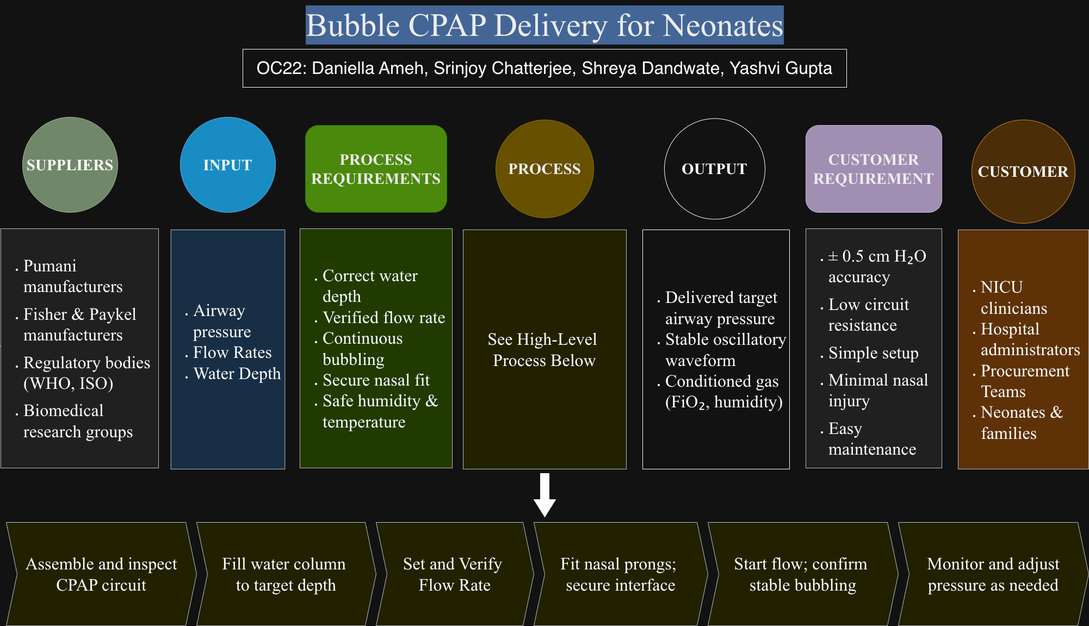
Figure 1. SIPOC Diagram for Bubble CPAP Delivery in Neonates

Figure 1 outlines a SIPOC (Suppliers, Inputs, Process, Outputs, Customers) representation of the Bubble CPAP delivery process in neonatal care. The diagram provides an overview of the system, beginning with upstream suppliers and inputs and extending through the operational steps required to deliver airway pressure to neonatal patients. Suppliers include CPAP manufacturers, regulatory organizations, and biomedical research groups that contribute components, standards, and supporting data. Research groups also contribute evidence used to evaluate device behavior [24][25]. Key inputs such as flow rate, water depth, and airway pressure enter the system and are managed through defined setup and operating steps.
The process portion shows the sequence of actions involved in CPAP delivery, including circuit assembly, water column setup, flow adjustment, nasal interface placement, and pressure monitoring. These steps lead to outputs such as delivered airway pressure and oscillatory pressure waveforms, which are received by end users [2][8]. Customers of the system include NICU clinicians, hospital staff, and neonatal patients. This SIPOC framework is used to clarify system boundaries, identify critical interfaces, and support subsequent analysis of where variability may arise within the CPAP delivery process.

2.2 Process Map
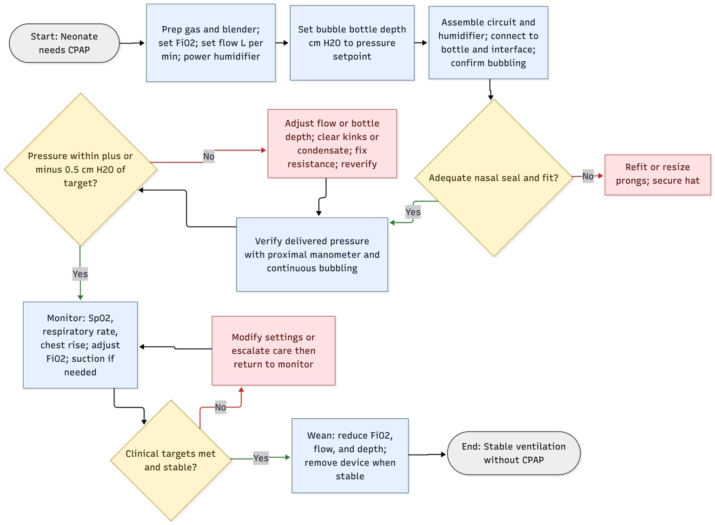
Figure 2. Process Map for Bubble CPAP Delivery in Neonates

Figure 2 presents a typical workflow for initiating and managing the delivery of Bubble CPAP therapy in neonatal care. The process begins when respiratory support is indicated, and the CPAP system is prepared. Initial setup includes selecting the gas source, activating humidification, and adjusting the water column depth to set the intended airway pressure.
Following setup, the CPAP circuit is assembled, visible bubbling is confirmed, and the nasal interface is fitted to the patient. During therapy, clinicians monitor clinical indicators including oxygen saturation, respiratory rate, and chest movement. Based on these observations, adjustments may be made to flow rate, FiO₂, or interface positioning. The workflow includes decision points where CPAP support is continued, modified, or discontinued in response to patient status. Therapy is reduced or discontinued once respiratory function improves. In this project, the workflow is used to identify steps where variation in delivered airway pressure may be introduced, providing context for subsequent performance analysis [2][8].

2.3 Voice of the Customer Tree
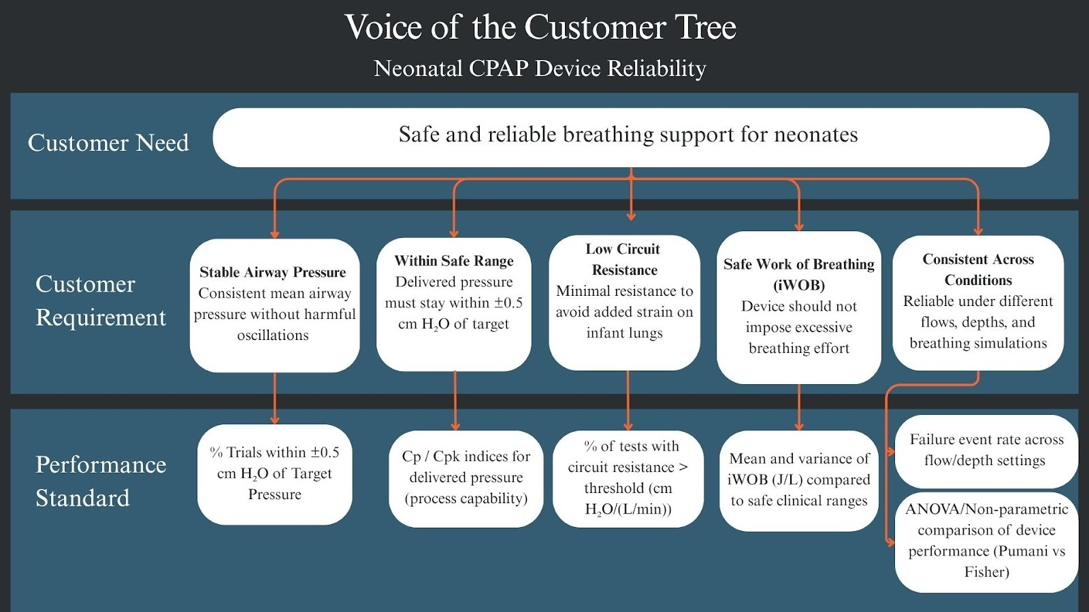

Figure 3. Voice of the Customer (VOC) Tree for Neonatal CPAP Device Reliability
Figure 3 maps the relationship between neonatal customer needs, corresponding technical requirements, and quantifiable performance standards for CPAP device reliability. It highlights critical priorities, including maintaining stable airway pressure, ensuring operation within safe pressure ranges, minimizing circuit resistance, safeguarding the infant’s work of breathing, and delivering consistent performance across variable conditions. Each requirement is directly linked to measurable metrics, such as pressure deviation, process capability indices (Cp/Cpk), circuit resistance thresholds, and failure rates across flow and depth settings, providing a clear framework for evaluating and ensuring device reliability under real-world neonatal care scenarios.

2.4 Background Literature
2.4.1 Executive Summary
Respiratory distress remains a major contributor to neonatal morbidity and mortality, particularly in low- and middle-income countries. Prior studies have evaluated the effectiveness of bubble CPAP systems as a noninvasive respiratory support strategy, with increasing attention to the reliability and performance of low-cost devices used in resource-limited settings [8][23]. This section reviews existing literature on neonatal CPAP performance, device reliability, and quality-related challenges relevant to this project [7][15].
2.4.2 Neonatal Respiratory Distress and CPAP Therapy
Newborns with respiratory distress syndrome (RDS) often require support to maintain adequate lung inflation. CPAP therapy provides continuous airway pressure, reducing the need for mechanical ventilation, and improving clinical outcomes. Bubble CPAP systems have emerged as an affordable alternative to conventional CPAP, particularly in LMICs, due to their simple design and lower operating costs [12][24]. However, multiple studies note that variability in delivered pressure and device reliability remains a significant barrier to effective treatment [2][8][10].
2.4.3 Device Design and Performance
Bench studies reveal substantial differences in CPAP performance. Conventional bCPAP devices, which generate pressure via water column submersion, generally maintain more consistent airway pressures and impose lower work of breathing (iWOB) compared to low-cost devices like the Pumani system. Research by Markus et al. (2018) and Heenan et al. (2019) indicates that inexpensive devices often rely on flow resistance rather than submersion depth, leading to uneven pressure delivery, increased circuit resistance, and potential CPAP failure. Device architecture, resistant-based versus depth-based, directly affects performance metrics such as pressure oscillation, resistance, and deviation from target airway pressure.
Table 2. Mechanisms Causing Unreliable Delivered Pressure in Neonatal Bubble CPAP Systems
Mechanism | Effect on Pressure Reliability | What to Measure | Design Fix / Action | Reference
High expiratory pathway resistance and narrow tubing | Increases work of breathing and raises delivered pressure unpredictably | Pressure flow relationship, exhalation resistance | Reduce expiratory resistance, widen tubing | [Baldursdottir et al., 2020]
Flow dependency of CPAP generation | Pressure varies nonlinearly with flow and depth | Flow sweep, submersion depth sweep | Use controlled orifice or depth-based design | [Markus, Snorri and Thomas 2018]
Interface leaks and poor nasal prong fit | Causes pressure loss and variability | Leak testing, simulated breathing | Improve prong fit, add leak compensation | [Bushell T, McHugh et al., 2013]
Bubbling dynamics and oscillatory behavior | Large pressure oscillations indicate instability | Measure oscillation amplitude and frequency | Adjust bubble chamber geometry or damping | [Heenan, Rojas et al 2019]
Overall system reliability | Bench findings linked to clinical stability | Simulated breathing waveform tests | Integrate tubing, chamber, and interface redesign | GI[Markus, Snorri and Thomas 2018]
2.4.4 Strategies for Improving Performance
Technical improvements, such as optimizing tubing diameter, reducing circuit resistance, and implementing controlled flow mechanisms, can enhance performance consistency. Operational strategies, including system integration and clinical staff training, further improve real-world efficacy [10][19]. Despite progress, research gaps remain, particularly in linking bench-test performance to clinical outcomes and statistically validating process improvements in low-cost CPAP production [8][23].
2.4.5 Process Control and Quality Standards
Maintaining reliable CPAP delivery requires precise calibration, secure nasal interfaces, correct water depth, and continuous monitoring to keep pressures within ± 0.5 cm H₂O of the target. The framework shown in Figure 1 highlights key inputs, suppliers, and control points that ensure safe and consistent operation. International standards (ISO, FDA) emphasize the use of statistical process control (SPC) and process capability indices (Cp, Cpk) to detect early pressure fluctuations and maintain regulatory compliance [27]. This study posits that these methods can improve device reliability and clinical safety [9].
2.4.6 Conclusion
Consistent delivery of airway pressure, low circuit resistance, and limited imposed work of breathing are widely identified in the literature as important technical factors influencing the effectiveness and tolerability of neonatal CPAP therapy [2][8]. Prior bench and clinical studies indicate that design features affecting pressure stability and resistance can influence device usability and may affect clinical management, particularly in low-resource settings where continuous monitoring and frequent adjustment are challenging. [7][15]. Advances in CPAP device design, coupled with systematic performance evaluation and statistical validation, have therefore been proposed as mechanisms to improve reliability and support safer deployment at scale [10]. Addressing these factors may contribute to more consistent respiratory support and support sustainable innovation in neonatal care technologies intended for resource-limited environments [6].

3. Methodology
3.1 Research Design

Table 3. Improving Reliability of Neonatal CPAP Devices (OC22)

Outcome  Outcome variable in your research question |  | The primary outcome for this project is delivered mean airway pressure, measured in centimeters of water (cm H₂O). This captures the clinical effectiveness of neonatal CPAP systems, since it represents their ability to provide consistent respiratory support to infants. Maintaining pressure within plus or minus 0.5 cm H₂O of the target value is considered a benchmark for reliable device performance, as established by Falk et al. (2019).
Question  Concrete, testable research question |  | Is there a significant difference in process capability among the Pumani, Fisher & Paykel, and Diamedica CPAP systems in maintaining airway pressure within ± 0.5 cm H₂O of the clinical target?
Unit of Observation |  | Each row is a single test of one CPAP system (Pumani, Fisher & Paykel, or Diamedica) under a specific set of flow, water depth, and breathing simulation conditions, with performance variables like airway pressure and resistance recorded.
Measures  2-3 specific measures | Unit | Data Type | Data Sources  where you will source these data from; could be simulated, as long as it comes from real parameters from previous study.
Delivered airway pressure deviation from target | cm H₂O | Empirical | [Falk et al., 2019] [9], n ≈ 76,000 pressure trials
Circuit resistance | cm H₂O/(L/min) | Empirical | [Falk et al., 2019] [9], Fig6.csv.
Imposed work of breathing (iWOB) | J/L | Empirical | [Falk et al., 2019] [9], Fig5.csv.
Methods  specific methods and techniques from the course you will use to answer your research question | The analysis clearly defines failure events, which include delivered pressures that deviate from the target by more than 0.5 cm H₂O, circuit resistance measurements above the acceptable threshold, and pressure oscillations that fall outside expected ranges. For each CPAP system, the frequency of these failure events is calculated, along with process capability indices such as Cp and Cpk to quantify the consistency of performance. Statistical comparisons between the three devices are performed using ANOVA / non-parametric equivalents to determine if observed differences are significant. Each failure type is mapped to specific device components using a failure mode and effects analysis, which identifies the areas with the greatest need for improvement. The project will propose targeted design changes to address the most critical components and will suggest the use of statistical process control methods, such as control charts, to monitor delivered pressure and defect rates over time in future manufacturing or quality assurance settings.

3.2 Data
All analyses use the Falk et al. (2019) Infant CPAP for low-income countries Dryad dataset, which contains approximately 76,000 in-vitro bench trials comparing the Pumani CPAP system with conventional bubble CPAP systems manufactured by Fisher & Paykel (Auckland, New Zealand) and Diamedica (Devon, United Kingdom). The experiments were conducted in 2019 under controlled laboratory conditions using a mechanical infant lung simulator. Systems were evaluated across clinically relevant operating ranges, including fresh gas flow rates of 4-8 L/min and water-column submersion depths of 4-8 cm H₂O [9].
Each observation represents a single steady-state trial for a specific device-flow-depth configuration. Recorded variables include delivered mean airway pressure, target pressure, circuit resistance, and imposed work of breathing (iWOB). Prior to analysis, trials with missing values were removed, and outliers were defined as observations exceeding three standard deviations from the mean within a given device-flow-depth condition. Measurements were then aggregated by device, flow rate, and submersion depth. As the dataset is derived from controlled bench testing rather than clinical use, it is used in this study to evaluate device performance characteristics and pressure variability.

3.3 Measures

3.3.1 Mean Airway Pressure Deviation (cm H₂O): The difference between delivered and target mean airway pressures. This indicates whether a device maintains pressure within the ± 0.5 cm H₂O tolerance used as the defect specification limit
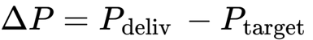
where $P_{\text{delivered}}$is the measured mean airway pressure and $P_{\text{target}}$is the intended pressure set by water-column depth [9].

The trial is classified as out-of-specification if:

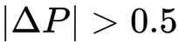
This threshold corresponds to the clinical tolerance used for neonatal CPAP pressure stability [9].

3.3.2 Circuit Resistance (cm H₂O/L/min): Calculated as the ratio of pressure change to flow rate and reflects the mechanical load imposed by the circuit on spontaneous infant breathing.
R = ΔP​ / Q

where $ΔP$is the pressure change and $Q$is the fresh gas flow rate [8][9].

3.3.3 Imposed Work of Breathing (iWOB, J/L): The energy required per liter of simulated inspiration through the circuit, representing the energetic cost imposed by device resistance and flow dynamics [8][9].
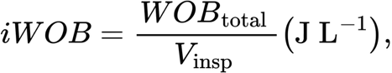

3.3.4 Process Capability Indices: Process capability indices were used to quantify process precision and centering relative to the clinical specification limits:

where the upper and lower specification limits are USL = + 0.5 H₂O and LSL = -0.5 cm H₂O [27].

3.4 Model/Approach

All computations were implemented in R using summary statistics and bootstrap resampling to estimate 95% confidence intervals for defect rates and process capability indices. Bootstrap methods were used to quantify uncertainty without assuming normality of performance metrics across devices [9]. The analytical workflow combines statistical process capability modeling with comparative hypothesis testing to evaluate differences in pressure stability across CPAP systems.
For each observation in the Falk et al. dataset, the deviation between delivered and target mean airway pressure (ΔP) was calculated and classified as in-specification or out-of-specification using the ± 0.5 cm H₂O tolerance applied in prior bench evaluations of neonatal CPAP performance [8][9]. These deviations were summarized by device to compute process capability indices (Cp and Cpk), which are commonly used in quality engineering to characterize process spread and centering relative to predefined specification limits. In this context, Cp provides a measure of pressure variability, while Cpk captures systematic bias relative to the target pressure.
To assess whether devices differed significantly in pressure delivery, one-way analysis of variance (ANOVA) was applied to mean ΔP values, with non-parametric Kruskal-Wallis tests used as a robustness check when normality assumptions were violated. Pairwise comparisons were then used to identify which systems deviated most from the benchmark. Similar comparative statistical approaches have been used in prior in-vitro evaluations of CPAP system performance [8][10].
For secondary performance metrics, circuit resistance (R) was estimated as the slope of airway pressure versus flow rate across trials, a standard method for characterizing resistive load in respiratory circuits [2]. Imposed work of breathing (iWOB) was analyzed at matched tidal volumes and breathing rates to isolate device-related effects independent of ventilatory demand. iWOB is a widely reported outcome in bench studies of neonatal CPAP systems and is used to quantify the energetic burden imposed on spontaneous breathing [10].

4. Results
4.1 Graphs

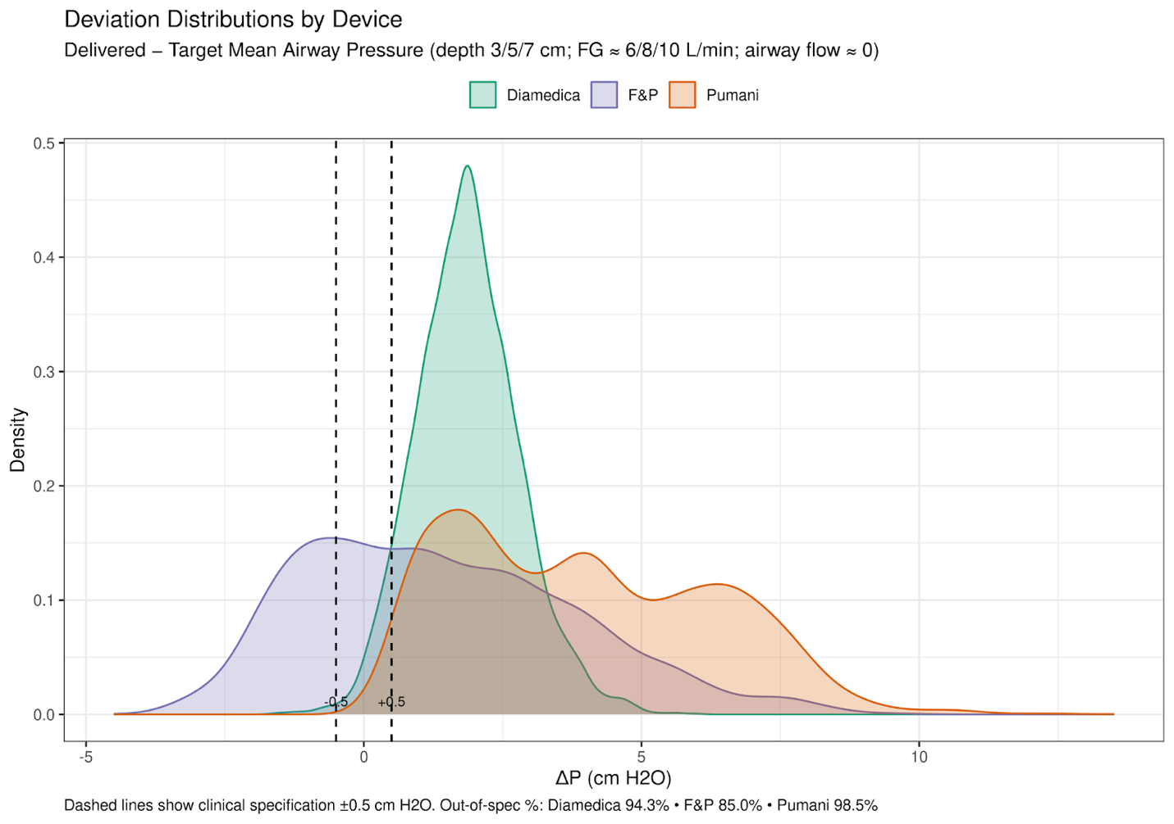

Figure 4. Distribution of Airway Pressure Deviation (ΔP = delivered - target) by Device Type

In Figure 4, the chart displays kernel density estimates of the change in mean airway pressure (ΔP = delivered - target) for Diamedica, Fisher & Paykel (F&P), and Pumani CPAP systems. Dashed vertical lines indicate the clinical tolerance limits at ±0.5 cm H₂O. The plot illustrates the distribution and spread of pressure deviations observed for each device across all tested conditions.
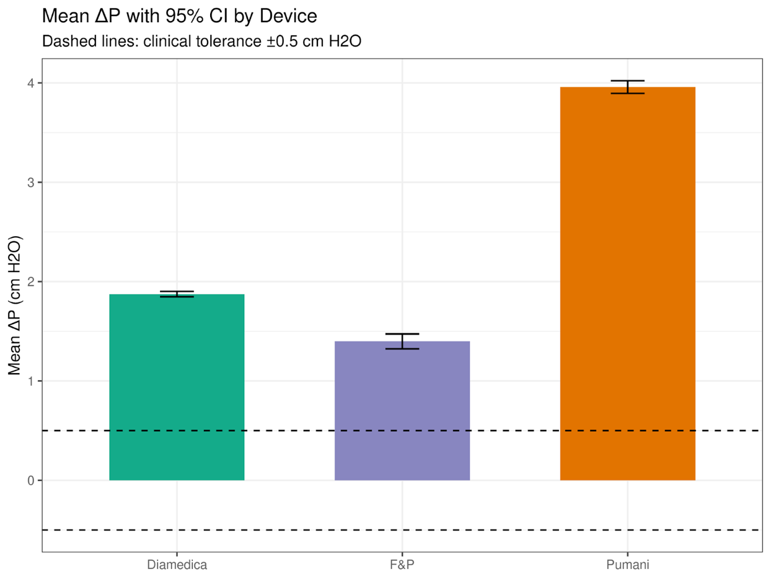

Figure 5. Mean Airway Pressure Deviation (ΔP) by Device Type - 95% Confidence Intervals

Figure 5 presents the mean change in airway pressure (ΔP) for each CPAP system, with error bars representing 95% confidence intervals. Dashed horizontal lines denote the ±0.5 cm H₂O clinical tolerance limits. This figure summarizes the central tendency and uncertainty in pressure deviation across devices.
4.2 Financial Impacts
Using the observed out-of-specification (OOS) rate for each device, the expected number of defective units per 10,000 deployments was estimated under baseline conditions. Defects were mapped to direct costs associated with inspection, rework, or replacement using a predefined cost-per-defect range informed by published economic evaluations of neonatal respiratory technologies in low- and middle-income settings [6][16]. Additional cost implications related to increased monitoring and prolonged respiratory support were estimated using reported neonatal intensive care utilization and cost data [13][17].

We modeled the direct cost of these defects as incremental labor waste. While ideal stable CPAP devices require monitoring checks every 3–4 hours, unstable devices require more frequent verification to prevent patient injury. We assume a conservative "Rework Cost" of 15 minutes of additional nursing time per defective device-day to manually adjust flow and depth settings.

- Labor Cost Assumption: $45.00/hour (Based on median NICU nurse wages; ZipRecruiter, 2025)
- Cost per Defect: 0.25 hours × $45.00/hour = $11.25 per defective device-day

Baseline Performance (Pumani): With a 98.5% failure rate, we expect 9,850 defective events per 10,000 deployments. This leads to a total waste cost of 9,850 defects × $11.25 = $110,812.

If the Pumani system is redesigned to meet the project goal of ≤ 5.0% OOS (95% Yield), reliability improves dramatically.

- Expected Defects: 500 defects per 10,000 deployments.
- Total Waste Cost: 500 × $11.25 = $5,625.
- Net Savings: $105,187 (94.9% reduction in waste).

Simply switching to a competitor device like Diamedica yields minimal savings ($~4,700) because current market alternatives also exhibit high variability. In contrast, if improvements are made to the device such that it meets the project goal of ≤ 5.0% OOS (95% yield), we can see that a targeted engineering redesign of the Pumani system offers a potential cost reduction of over $100,000 per 10,000 deployments, validating the decision to invest in internal quality improvement rather than alternative procurement.

4.3 Reliability Performance Dashboard

To support integrated interpretation of the reliability analysis, a structured Six Sigma dashboard was developed and used as a decision-support visualization tool. Representative screenshots of the dashboard interface are presented in Figures 6, 7a,7b,7c, and 8 to summarize key findings; all statistical analyses and conclusions are reported independently in Sections 4–5.
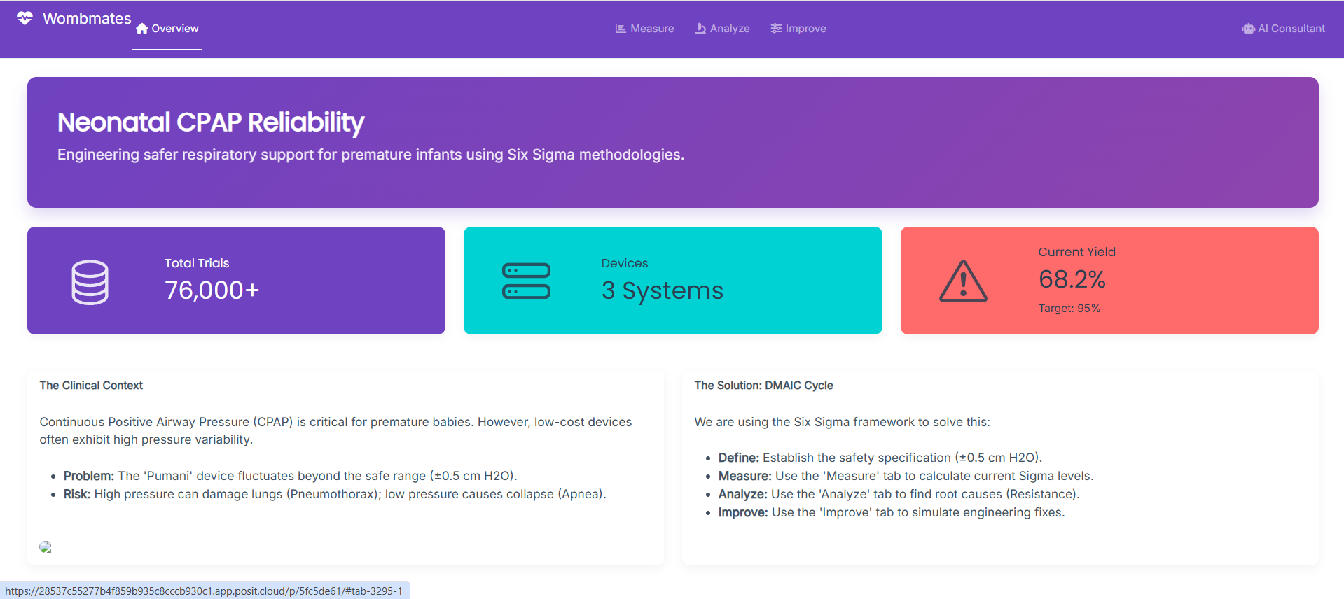
Figure 6. Overview of the Neonatal CPAP Reliability Dashboard

(A)
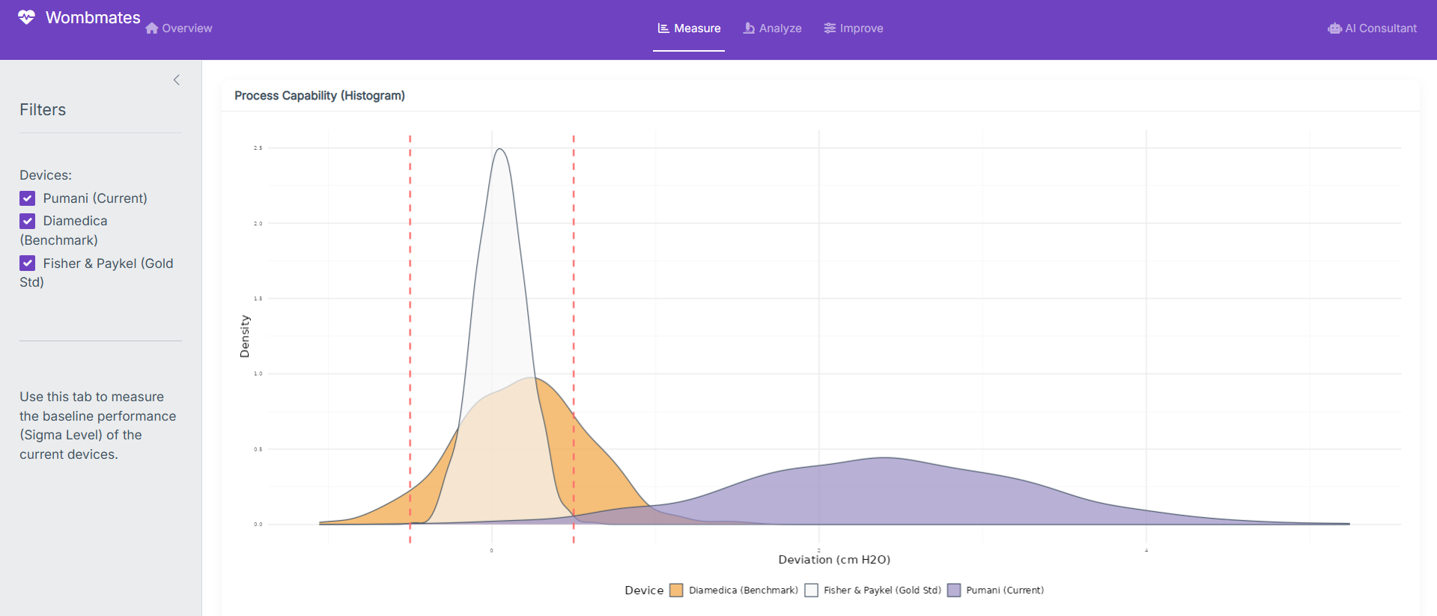
(B)
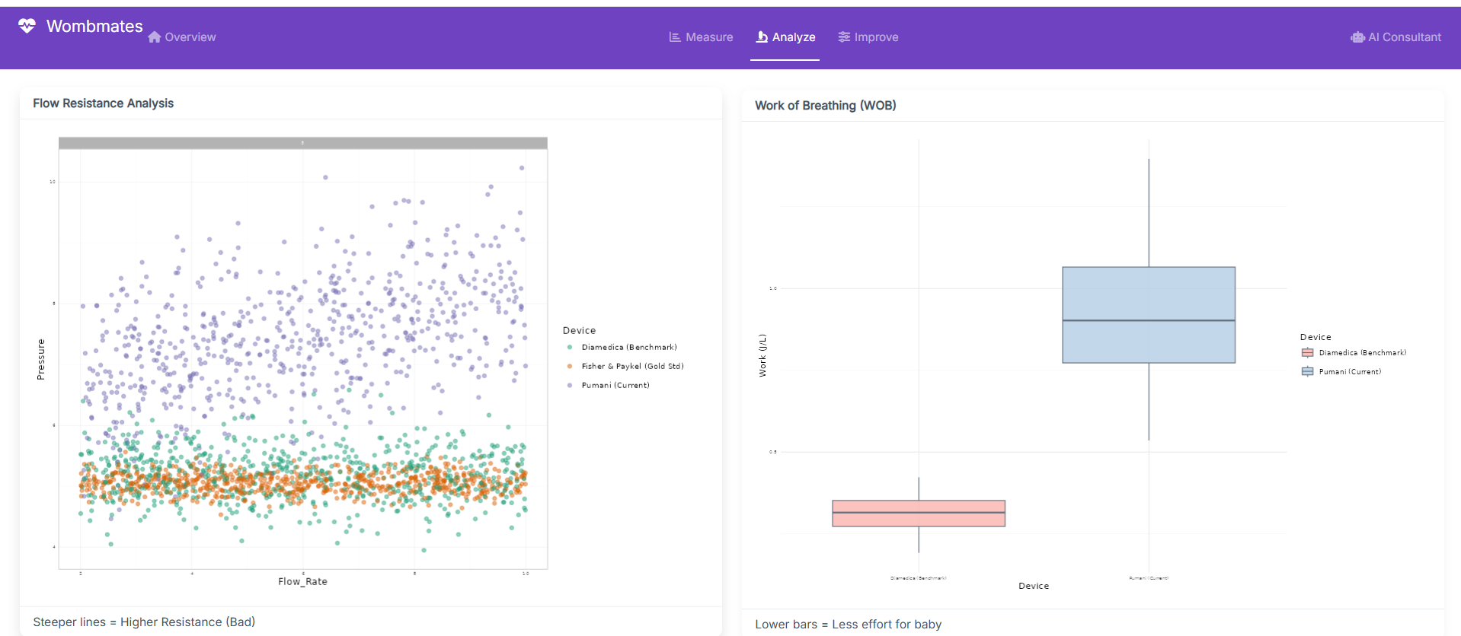

(C)
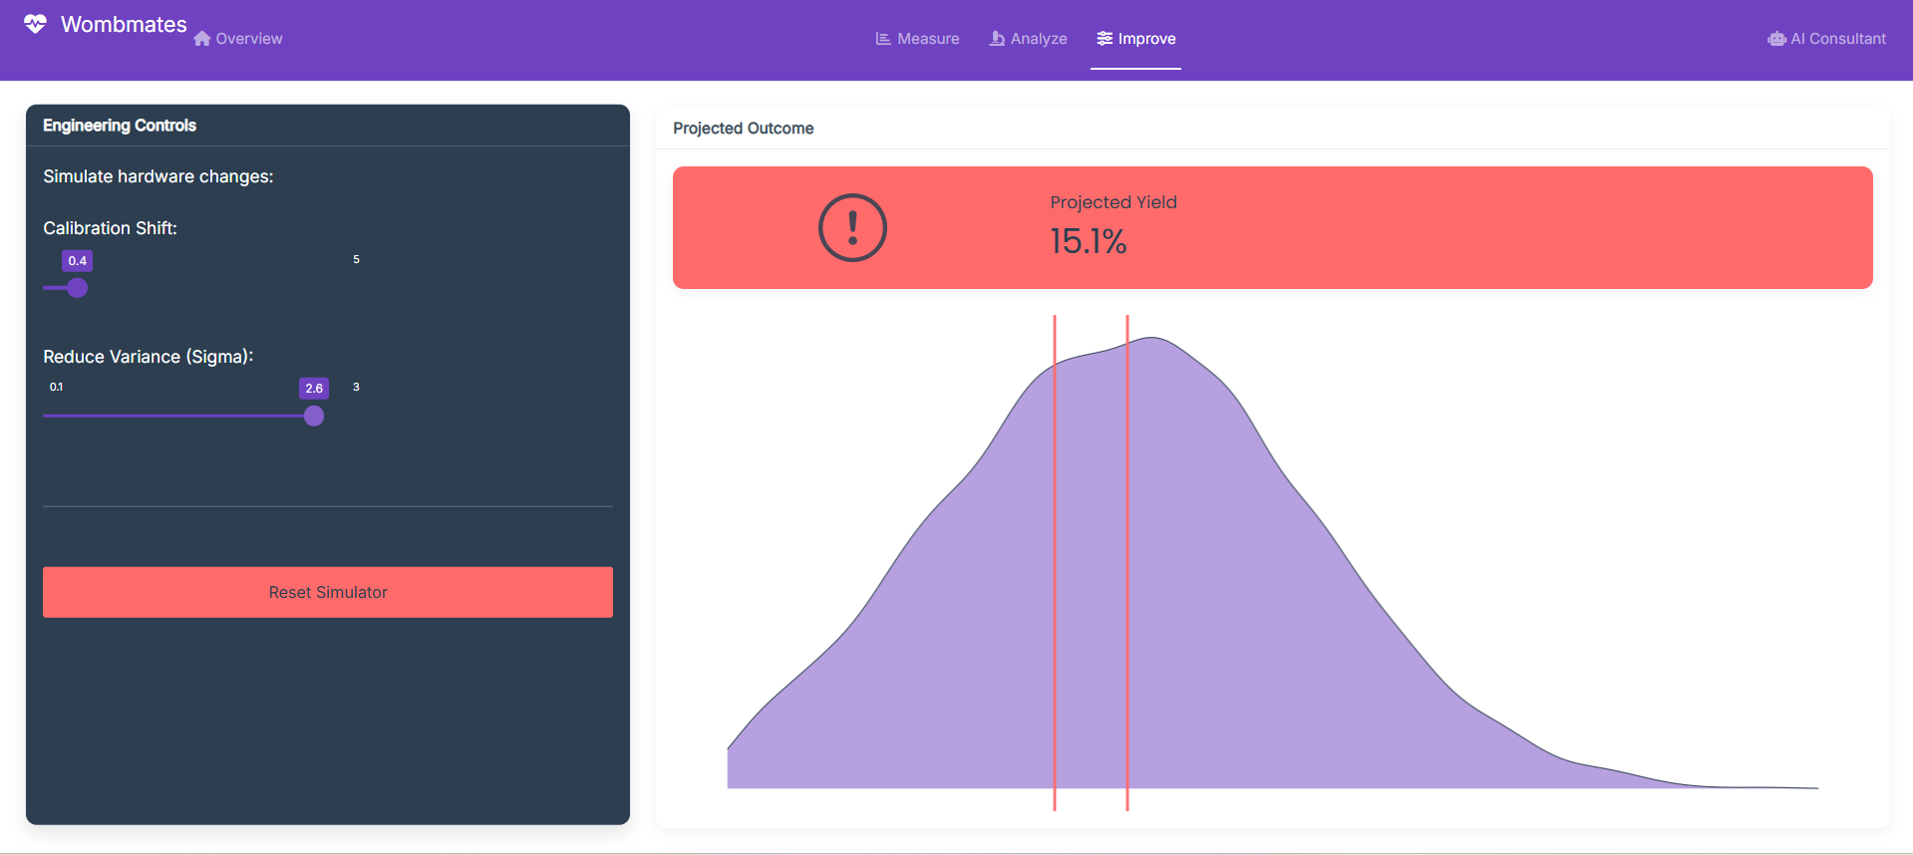
Figure 7. (A)Measurement View of the Neonatal CPAP Reliability Dashboard (B) Analysis View of the Neonatal CPAP Reliability Dashboard (C) Improvement View of the Neonatal CPAP Reliability Dashboard

The dashboard brings together multiple reliability metrics derived from the Falk et al. (2019) dataset, including delivered mean airway pressure deviation relative to the ±0.5 cm H₂O clinical specification limits, out-of-specification (OOS) rates, flow-dependent pressure behavior, imposed work of breathing (iWOB), and projected process yield under modeled improvement scenarios. The organization of the dashboard follows the DMAIC framework, with distinct views corresponding to the Measure, Analyze, and Improve phases of quality assessment.
Alongside graphical summaries, the dashboard incorporates a built-in interpretive assistant intended to support user understanding of Six Sigma performance indicators. This feature presents concise, plain-language explanations of observed trends, variability patterns, and reliability trade-offs, and offers general guidance on potential improvement directions based on established quality engineering principles. The assistant functions as an explanatory aid only; it does not perform statistical analysis, generate new data, or influence the quantitative results reported in this study.
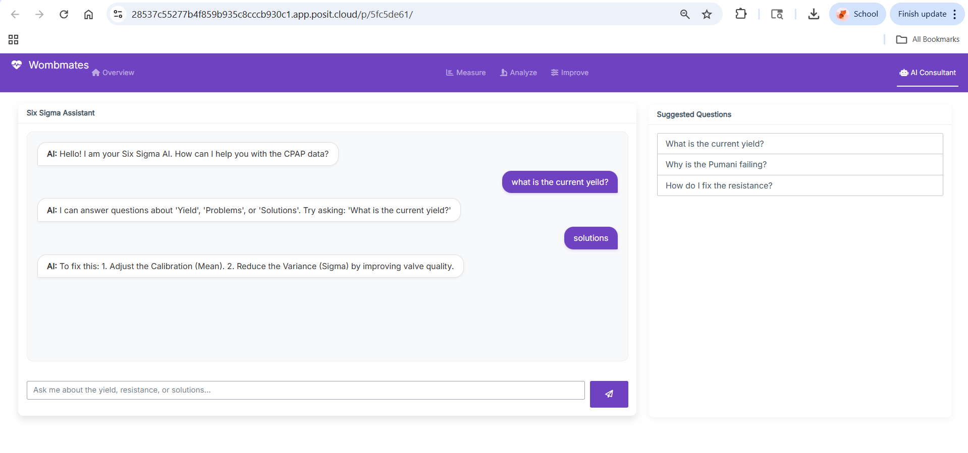Figure 8. Interactive Six Sigma AI Chatbot for CPAP Performance Interpretation

Overall, the dashboard serves as a complementary tool for synthesizing and communicating complex reliability results. By combining visual summaries with structured interpretive guidance, it facilitates comparison of CPAP system performance across multiple dimensions while preserving full analytical rigor within the formal statistical analyses presented elsewhere in the report.

5. Discussion
5.1 Summary of Findings
Across the Falk et al. (2019) bench-test trials, none of the evaluated neonatal CPAP systems consistently maintained mean airway pressure within the ± 0.5 cm H₂O clinical tolerance band [9]. The pressure-deviation performance differed substantially by device. As seen in Figure 5, Diamedica (n = 4,466) showed a mean deviation of 1.87 ± 0.92 cm H₂O with 94.3% (95% CI: 93.6 - 95.0%) of trials classified as out-of-specification (OOS). Fisher & Paykel (F&P; n = 4,069) exhibited a mean deviation of 1.40 ± 2.44 cm H₂O with 85.0% (95% CI: 83.9–86.1%) OOS. Pumani (n = 5,177) showed the largest deviation, 3.96 ± 2.33 cm H₂O, with 98.5% (95% CI: 98.2–98.8%) OOS.
Mechanical performance metrics aligned with these patterns. Circuit resistance estimates were 0.31 cm H₂O·min·L⁻¹ (Diamedica), 0.17 (F&P), and 2.16 (Pumani). Imposed work of breathing (iWOB) was 0.23 ± 0.024 J/L (Diamedica), 0.21 ± 0.020 J/L (F&P), and 1.05 ± 0.018 J/L (Pumani). Taken together, the results indicate that the devices differ not only in average pressure deviation but also in how variable and mechanically demanding their performance is under clinically relevant flow and depth settings.

5.2 Interpretation of Pressure Stability and Capability
Figures 4 and 5 highlight different aspects of pressure delivery. Figure 4 shows the distribution of ΔP (delivered - target) for each device, with the ± 0.5 cm H₂O specification limits marked. Figure 5 summarizes central tendency and uncertainty (mean ΔP with 95% confidence intervals), allowing direct comparison of average deviation across brands. In combination, the two figures separate target proximity (mean deviation) from consistency (spread of deviation).
Process capability results reinforce the same point. Cpk values were negative for all devices (Diamedica - 0.50; F&P - 0.12; Pumani - 0.49), indicating that the delivered mean pressure is not centered within the tolerance band under the tested conditions. While none of the systems meet the ± 0.5 cm H₂O specification, device behavior is not equivalent: Diamedica’s deviations cluster more tightly than the others, whereas F&P exhibits greater dispersion, and Pumani shows a large positive shift with substantial spread. These differences matter because systems with repeatable deviation may be easier to manage operationally than systems with large and irregular variation, particularly in settings with limited staff capacity for continuous adjustment.

5.3 Limitations
This study is based on controlled bench testing and does not measure clinical outcomes such as rates of treatment failure, nasal trauma, or length of NICU stay [18][22]. In addition, the unit of observation is a steady-state trial for a specific configuration; therefore, results describe device behavior under defined flow and depth settings rather than longitudinal performance over extended clinical use. Finally, the analysis uses mean airway pressure deviation and related mechanical measures as engineering proxies for reliability and usability; the translation from bench-test deviation to patient impact requires clinical validation and should be interpreted accordingly.

5.4 Implementation Plan

The results support a practical path toward improving pressure stability in low-cost CPAP deployment. First, procurement teams should prioritize devices that exhibit lower variability and lower mechanical burden where feasible, particularly in settings where frequent adjustments are impractical. Then, for Pumani systems already in service, near-term improvement should focus on interventions that reduce excessive resistance and mitigate over-pressurization, since both were elevated relative to the comparator devices. Finally, manufacturers should treat pressure deviation and resistance as quality-critical metrics that can be tracked routinely during production and pre-deployment verification.
Table 4 below lists the actions required, the ideal person to carry out each task, and the due dates for completion.

Implementation Plan
Action Item  List steps required to implement solution | Person Responsible  List persons responsible for action steps | Due Date  when action must be done
Identify in a prioritized list devices that exhibit lower variability and mechanical burdens | Procurement team | 1/20/26
Brainstorm and present possible way to lower resistance and over-pressurization in currently used Punami systems | Research and development team | 2/15/26
Create/update universal manufacturer guidelines on how to manage pressure deviation and resistance. | Manufacturers | 2/20/26
Table 4: Implementation plan of next steps

5.5 Monitoring and Control Plan

To support sustained improvement, monitoring should focus on metrics that map directly onto the defect definition and observed failure modes. A practical control plan would include (i) routine sampling of delivered mean pressure under standardized test conditions, (ii) screening for out-of-specification behavior using the |P| > 0.5 cm H₂O rule, and (iii) periodic checks of resistance and iWOB where instrumentation allows. For manufacturing or refurbishing programs, a simple control chart approach can be used to detect shifts in mean deviation or increases in variability over time, allowing corrective action before devices are deployed at scale. Below in table 5 is the expanded view into the control and monitoring plan.

Measure | Input, Process, or Output? | Target | Method of Data Capture | Checking Frequency | Person Responsible | Upper/  Lower Trigger Point | Who Will Respond? | Reaction Plan
Delivered Mean Pressure | Output | 0 cm H₂O (nominal) | Bench test with standardized conditions and record mean pressure | Each new batch or refurbished group number | Quality Technician | ±0.5 cm H₂O | Engineer | Setup test, recalibrate equipment, compare to expected results, document results before release
Pressure Screening | Process | ≤ 0.5 cm H₂O | Automated pressure test | With each device before it is sold | Quality Inspector | > 0.5 cm H₂O | Quality Manager | Remove device line, or product send out, discover and fix the problem, document and retest.
Resistance Measurement | Process | Within design specification | Instrument resistance test | Quarterly, unless prompted by the device | Engineering | Within design specification | Engineering | Identify the issues, make needed fixes, retest, document, return
iWOB Verification | Process | Within validated range | iWOB measurement | Quarterly | Engineering | Outside validate-d range | Engineering | adjust calibration, retest, document
Table 5: Monitor and control plan

5.6 Financial Impacts

Reliability shortfalls in neonatal CPAP systems carry cost implications for both manufacturers and healthcare providers. High out-of-specification rates are associated with increased inspection, rework, and replacement demands when devices are utilized at scale [6][16]. In clinical settings, pressure instability and variability can increase monitoring requirements and the frequency of corrective adjustments, contributing to higher utilization of staff time and equipment resources [13][17]. The baseline and improved capability scenarios presented in the Results section estimate the cost of nonconformance, with uncertainty expressed as 95% confidence intervals, and quantify the potential cost reductions associated with lower out-of-specification rates [21].

5.7 Future Research and Conclusions

Future work should link bench-test performance to clinical endpoints, including how pressure deviation and resistance relate to neonatal tolerance, escalation of care, and resource use. Design-focused studies should further isolate circuit features driving resistance and pressure behavior to support targeted redesign without compromising affordability. In conclusion, all evaluated CPAP systems deviate substantially from the ± 0.5 cm H₂O specification under tested conditions, with meaningful differences in deviation magnitude, variability, and mechanical burden that provide a quantitative basis for prioritizing improvement efforts and informing device selection in low-resource neonatal care.

6. References
[1] Abdallah, Y., Mkony, M., Noorani, M., Moshiro, R., Bakari, M., & Manji, K. (2023). CPAP failure in the management of preterm neonates with respiratory distress syndrome where surfactant is scarce: A prospective observational study. BMC Pediatrics, 23(1), 211. https://doi.org/10.1186/s12887-023-04038-6
[2] Baldursdottir, S., Falk, M., Donaldsson, S., Jonsson, B., & Drevhammar, T. (2020). Basic principles of neonatal bubble CPAP: Effects on CPAP delivery and imposed work of breathing when altering the original design. Archives of Disease in Childhood - Fetal and Neonatal Edition, 105(5), 550–554. https://doi.org/10.1136/archdischild-2019-318073
[3] Burgoine, K., Ssenkusu, J. M., Nakiyemba, A., Okello, F., Napyo, A., Hagmann, C., Namuyonga, J., Hewitt-Smith, A., Martha, M., Loe, K., Grace, A., Denis, A., Wandabwa, J., & Olupot-Olupot, P. (2024). Impact of early continuous positive airway pressure in the delivery room (DR-CPAP) on neonates <1500 g in a low-resource setting: A protocol for a pilot feasibility and acceptability randomized controlled trial. Pilot and Feasibility Studies, 10(1), 126. https://doi.org/10.1186/s40814-024-01552-x
[4] Bushell, T., McHugh, C., & Meyer, M. P. (2013). A comparison of two nasal continuous positive airway pressure interfaces—A randomized crossover study. Journal of Neonatal-Perinatal Medicine, 6(1), 53–59. https://doi.org/10.3233/NPM-1363612
[5] Chaudhary, H. P., Gupta, B. K., Chaudhary, D., Kafle, R., Chaudhary, N., & Menahem, S. (2025). Bubble CPAP therapy in newborns with respiratory distress with its outcome—A prospective observational study from a neonatal intensive care unit of tertiary care hospital in Western Nepal. International Journal of Pediatrics, 2025, Article 2200049. https://doi.org/10.1155/ijpe/2200049
[6] Chen, A., Deshmukh, A. A., Richards-Kortum, R., Molyneux, E., Kawaza, K., & Cantor, S. B. (2014). Cost‐effectiveness analysis of a low-cost bubble CPAP device in providing ventilatory support for neonates in Malawi – a preliminary report. BMC Pediatrics, 14, 288.
[7] Dewez, J. E., & van den Broek, N. (2017). Continuous positive airway pressure (CPAP) to treat respiratory distress in newborns in low- and middle-income countries. Tropical Doctor, 47, 19–22.
[8] Falk, M., Donaldsson, S., & Drevhammar, T. (2018). Infant CPAP for low-income countries: An experimental comparison of standard bubble CPAP and the Pumani system. PLOS ONE, 13(5), e0196683. https://doi.org/10.1371/journal.pone.0196683
[9] Falk, M., Donaldsson, S., & Drevhammar, T. (2019). Data from: Infant CPAP for low-income countries: an experimental comparison of standard bubble CPAP and the Pumani system. Dryad, Dataset. https://doi.org/10.5061/dryad.88n4d54
[10] Heenan, M., Rojas, J. D., Oden, Z. M., & Richards-Kortum, R. (2020). In vitro comparison of performance including imposed work of breathing of CPAP systems used in low-resource settings. PLOS ONE, 15(12), e0242590. https://doi.org/10.1371/journal.pone.0242590
[11] Hsieh, L. T., et al. (2018). Economic assessment of neonatal intensive care. [PMC article]
[12] Jensen, E. A., et al. (2016). Non-invasive respiratory support for infants in low- and middle-income countries. [Journal]. Science Direct
[13] Kaur, L., Jayashree, M., Prinja, S., et al. (2021). Cost analysis of pediatric intensive care: a low-middle income country perspective. BMC Health Services Research, 21, 168. https://doi.org/10.1186/s12913-021-06166-0
[14] Murki, S., Das, R. K., Sharma, D., & Kumar, P. (2015). A fixed flow is more effective than titrated flow during bubble nasal CPAP for respiratory distress in preterm neonates. Frontiers in Pediatrics, 3, 81. https://doi.org/10.3389/fped.2015.00081
[15] Nørgaard, M., Stagstrup, C., Lund, S., & Poulsen, A. (2020). To bubble or not? A systematic review of bubble continuous positive airway pressure in children in low- and middle-income countries. Journal of Tropical Pediatrics, 66(3), 339–353. https://doi.org/10.1093/tropej/fmz069
[16] Okonkwo, I. R., Aneji, C., Ekhaguere, O. A., Eyo-Ita, E. U., & Okolo, A. A. (2022). Cost implication of CPAP use in low resource settings, surmounting the oxygen administration challenge. The Journal of Maternal-Fetal & Neonatal Medicine, 35(25), 7368–7374. https://doi.org/10.1080/14767058.2021.1949278
[17] Pillay, J., et al. Workstream 3: Cost of neonatal care analysis – up‐to‐date cost estimates for very preterm babies in England (2014-18). https://www.ncbi.nlm.nih.gov/books/NBK613653/
[18] Sharma, D., et al. (2023). Weaning and extubation from neonatal mechanical ventilation: cost of NICU stays vary between US $90 to US $1250-2500 per day. [PMC article] https://pubmed.ncbi.nlm.nih.gov/36384517/
[19] Sterzik, H., Arand, J., Schwarz, C. E., et al. (2025). Imposed work of breathing of 16 neonatal CPAP devices using different mechanisms of CPAP generation. Pediatric Research. https://doi.org/10.1038/s41390-025-04265-w
[20] Thakur, R., et al. (2023). Mean duration of mechanical ventilation among newborns: 2.19 ± 1.42 days. https://pubmed.ncbi.nlm.nih.gov/37464842/
[21] Turn0search29, Profit, J., Lee, D., Zupancic, J. A., Papile, L., Gutierrez, C., Goldie, S. J., et al. (2010). Clinical Benefits, Costs, and Cost-Effectiveness of Neonatal Intensive Care in Mexico. PLOS Medicine, 7(12), e1000379. https://pubmed.ncbi.nlm.nih.gov/21179496/
[22] Valencia, Z., Sen, A., & Martin, K. (2025, July 25). NICU admissions and spending increased slightly from 2017-2021. HCCI’s original reports powered by #HCCIdata. https://healthcostinstitute.org/hcci-originals-dropdown/all-hcci-reports/nicu-use-and-spending-1
[23] Wilson, P. T. (2019). Bubble CPAP in resource‐poor settings: friend or foe? The Lancet Respiratory Medicine. https://pubmed.ncbi.nlm.nih.gov/31562058/
[24] Won, A., Suarez-Rebling, D., Baker, A. L., Burke, T. F., & Nelson, B. D. (2018). Bubble CPAP devices for infants and children in resource-limited settings: Review of the literature. Paediatrics and International Child Health. https://doi.org/10.1080/20469047.2018.1534389
[25] World Health Organization. (n.d.). Medical use of oxygen. Retrieved October 26, 2025, from https://www.who.int/teams/health-product-policy-and-standards/assistive-and-medical-technology/medical-devices/oxygen
[26] Zupancic, J. A. F., Hibbs, A. M., Palermo, L., Truog, W. E., Cnaan, A., Black, D. M., Ballard, P. L., Wadlinger, S. R., Ballard, R. A., & NO CLD Trial Group. (2009). Economic Evaluation of Inhaled Nitric Oxide in Preterm Infants Undergoing Mechanical Ventilation. Pediatrics, 124(5), 1325–1332. https://publications.aap.org/pediatrics/article-abstract/124/5/1325/72166/
[27] Peña-Rodríguez, M. E. (2013). Statistical Process Control for the FDA-regulated industry. Google Books. https://books.google.de/books/about/Statistical_Process_Control_for_the_FDA.html?id=-mENUy1xgSAC&redir_esc=y

7. Appendix A: R Code for Data Analysis and Figure Generation

# CPAP Reliability Preliminary Analysis (Wombmates OC22)
# ------------------------------------------------------
# Inputs expected in the working directory:
# Fig3(1).csv, Fig6(1).csv, Fig7(1).csv (pressure/flow/depth data)
# Fig8(1).csv (work of breathing loops)
#
# Outputs:
# prelim_results_table.csv
# deviation_density.png (Figure 4)
# deviation_bar_ci.png (Figure 5)

## 0) Setup ---------------------------------------------------------------
USL <- 0.5 # Specification limit: +0.5 cm H2O
LSL <- -0.5 # Specification limit: -0.5 cm H2O

suppressWarnings({
if (!requireNamespace("ggplot2", quietly = TRUE)) install.packages("ggplot2")
if (!requireNamespace("dplyr", quietly = TRUE)) install.packages("dplyr")
})
library(ggplot2)
library(dplyr)

# Helper function: Convert "30mm" -> 3.0 (cm H2O)
depth_cm <- function(mm_text) {
as.numeric(gsub("[^0-9.]", "", as.character(mm_text))) / 10
}

# Helper function: Map raw system names to clean report labels
map_device <- function(x) {
x <- as.character(x)
ifelse(x %in% c("Pumani", "PU"), "Pumani",
ifelse(x %in% c("Fischer-Paykel", "Fisher-Paykel", "Fisher & Paykel", "FP"), "F&P",
ifelse(x %in% c("Diamedica", "DM"), "Diamedica", NA)))
}

# Helper function: Calculate Six Sigma capability stats
capability_stats <- function(dev_vec) {
# dev_vec is delivered - target pressure
n <- length(dev_vec)
mu <- mean(dev_vec, na.rm = TRUE)
sd <- stats::sd(dev_vec, na.rm = TRUE)
oos <- mean(abs(dev_vec) > 0.5, na.rm = TRUE) # Out of Spec Rate

# Calculate Process Capability Indices
Cp <- if (!is.na(sd) && sd > 0) (USL - LSL) / (6 * sd) else NA_real_
Cpk <- if (!is.na(sd) && sd > 0) min((mu - LSL) / (3 * sd), (USL - mu) / (3 * sd)) else NA_real_

# 95% CI for out-of-spec rate via normal approximation
se <- sqrt(oos * (1 - oos) / n)
ci <- c(max(0, oos - 1.96 * se), min(1, oos + 1.96 * se))

data.frame(
n_trials = n,
mean_dev_cmH2O = mu,
sd_dev_cmH2O = sd,
oos_rate_pct = 100 * oos,
oos_rate_95CI_low = 100 * ci[1],
oos_rate_95CI_high = 100 * ci[2],
Cp = Cp,
Cpk = Cpk,
stringsAsFactors = FALSE
)
}

read_fig <- function(path) {
if (!file.exists(path)) stop("File not found: ", path)
tryCatch({ read.csv2(path, stringsAsFactors = FALSE) },
error = function(e) { read.csv(path, stringsAsFactors = FALSE) })
}

## 1) Load CSVs -----------------------------------------------------------
df3 <- read_fig("Fig3(1).csv")
df6 <- read_fig("Fig6(1).csv")
df7 <- read_fig("Fig7(1).csv")
df8 <- read_fig("Fig8(1).csv")

# Verify columns
for (df in list(df3, df6, df7)) {
stopifnot(all(c("mm", "Bias", "Flow", "System", "Pressure") %in% names(df)))
}

## 2) Tidy pressure–depth data and compute deviation ---------------------
tidy_pressure <- function(df) {
out <- df
out$depth_cmH2O <- depth_cm(out$mm)
out$FG_LPM <- as.numeric(out$Bias)
out$Flow <- as.numeric(out$Flow)
out$Pressure <- as.numeric(out$Pressure)
out$device <- map_device(out$System)
out <- out[!is.na(out$device), ]

# Mean set pressure is best seen at near-zero airway flow
out <- out[abs(out$Flow) < 0.05, ]

out$target_cmH2O <- out$depth_cmH2O
out$delivered_cmH2O <- out$Pressure
out$dev <- out$delivered_cmH2O - out$target_cmH2O
out[, c("device", "FG_LPM", "depth_cmH2O", "target_cmH2O", "delivered_cmH2O", "dev")]
}

comb <- rbind(tidy_pressure(df3), tidy_pressure(df6), tidy_pressure(df7))

# Focus on common NICU setpoints (Depths: 3,5,7; Flows: 6,8,10)
subset <- comb[comb$depth_cmH2O %in% c(3, 5, 7) & round(comb$FG_LPM) %in% c(6, 8, 10), ]

## 3) Capability and defect rates per device ------------------------------
devices <- sort(unique(subset$device))
cap_list <- lapply(devices, function(d) {
g <- subset$dev[subset$device == d]
res <- capability_stats(g)
res$device <- d
res
})
cap_table <- do.call(rbind, cap_list)
cap_table <- cap_table[, c("device", setdiff(names(cap_table), "device"))]

## 4) Significance tests (deviation by device) ---------------------------
split_dev <- split(subset$dev, subset$device)
anova_out <- do.call(stats::aov, list(subset$dev ~ subset$device))
kw <- stats::kruskal.test(subset$dev, subset$device)

cat("\nANOVA Summary:\n"); print(summary(anova_out))
cat("\nKruskal–Wallis Test:\n"); print(kw)

## 5) Resistance estimate (slope cm H2O per L/min) -----------------------
# Calculated using regression of Pressure ~ Flow at depth=5, flow=10
df6a <- df6
df6a$depth_cm <- depth_cm(df6a$mm)
df6a$FG_num <- as.numeric(df6a$Bias)
df6a$Flow <- as.numeric(df6a$Flow)
df6a$Pressure <- as.numeric(df6a$Pressure)

resistance_slope <- function(device_label) {
dev_map <- c("F&P" = "Fisher-Paykel", "Diamedica" = "Diamedica", "Pumani" = "Pumani")
raw_name <- dev_map[[device_label]]

sub <- df6a[df6a$System %in% c(device_label, raw_name) &
abs(df6a$depth_cm - 5.0) < 0.2 &
abs(df6a$FG_num - 10.0) < 0.3, ]

if (nrow(sub) < 10) return(NA_real_)
slope <- coef(lm(Pressure ~ Flow, data = sub))[2]
as.numeric(slope)
}

res_df <- data.frame(
device = devices,
resistance_slope_cmH2O_per_Lmin = sapply(devices, resistance_slope),
stringsAsFactors = FALSE
)

## 6) iWOB (J/L) near mean CPAP = 5 cm H2O --------------------------------
extract_device_from_filename <- function(s) {
s <- as.character(s)
if (grepl("^Fisher-Paykel", s)) return("F&P")
if (grepl("^Diamedica", s)) return("Diamedica")
if (grepl("^Pumani", s)) return("Pumani")
return(NA_character_)
}

df8$device <- vapply(df8$Filename, extract_device_from_filename, character(1))
df8 <- df8[!is.na(df8$device), ]

# Normalize WOB to Joules per Liter
df8$iWOB_J_per_L <- (as.numeric(df8$WOB_tot) / 1000) / (as.numeric(df8$InspVtmL) / 1000)
iwob5 <- df8[abs(as.numeric(df8$PmeancmH2O) - 5.0) <= 0.5, ]

iwob_summ <- do.call(rbind, lapply(split(iwob5$iWOB_J_per_L, iwob5$device), function(v) {
data.frame(
iWOB_mean_J_per_L_at_5cm = mean(v, na.rm = TRUE),
iWOB_sd_at_5cm = stats::sd(v, na.rm = TRUE)
)
}))
iwob_summ$device <- rownames(iwob_summ)
rownames(iwob_summ) <- NULL

## 7) Merge and write results --------------------------------------------
results <- merge(cap_table, res_df, by = "device", all = TRUE)
results <- merge(results, iwob_summ, by = "device", all = TRUE)
write.csv(results, "prelim_results_table.csv", row.names = FALSE)

## 8) Plotting (ggplot2) ------------------------------------------------
# Prep summary for caption
dev_summary <- subset %>%
group_by(device) %>%
summarize(
mean_dev = mean(dev, na.rm = TRUE),
se = sd(dev, na.rm = TRUE) / sqrt(n()),
ci_lo = mean_dev - 1.96 * se,
ci_hi = mean_dev + 1.96 * se,
oos_pct = 100 * mean(abs(dev) > 0.5, na.rm = TRUE),
.groups = "drop"
)

# Color Palette
pal <- c("Diamedica" = "#1b9e77", "F&P" = "#7570b3", "Pumani" = "#d95f02")

# Figure 4: Density Plot
cap_text <- paste0(
"Dashed lines show clinical specification ±0.5 cm H2O. Out-of-spec %: ",
paste0(dev_summary$device, " ", sprintf("%.1f%%", dev_summary$oos_pct), collapse = " • ")
)

p_density <- ggplot(subset, aes(x = dev, fill = device, color = device)) +
geom_density(alpha = 0.25, adjust = 1.0) +
geom_vline(xintercept = c(-0.5, 0.5), linetype = "dashed") +
annotate("text", x = -0.5, y = 0, label = "-0.5", vjust = -0.8, size = 3) +
annotate("text", x = 0.5, y = 0, label = "+0.5", vjust = -0.8, size = 3) +
scale_fill_manual(values = pal) +
scale_color_manual(values = pal) +
labs(
title = "Deviation Distributions by Device",
x = "ΔP (cm H2O)", y = "Density",
caption = cap_text
) +
theme_bw(base_size = 12) +
theme(legend.position = "top", plot.caption = element_text(hjust = 0))

ggsave("deviation_density.png", p_density, width = 10, height = 7, dpi = 300)

# Figure 5: Mean Deviation with 95% CI
p_bar <- ggplot(dev_summary, aes(x = device, y = mean_dev, fill = device)) +
geom_col(width = 0.6) +
geom_errorbar(aes(ymin = ci_lo, ymax = ci_hi), width = 0.15, linewidth = 0.6) +
geom_hline(yintercept = c(-0.5, 0.5), linetype = "dashed") +
scale_fill_manual(values = pal) +
labs(
title = "Mean ΔP with 95% CI by Device",
subtitle = "Dashed lines: clinical tolerance ±0.5 cm H2O",
x = NULL, y = "Mean ΔP (cm H2O)"
) +
theme_bw(base_size = 12) +
theme(legend.position = "none")

ggsave("deviation_bar_ci.png", p_bar, width = 8, height = 6, dpi = 300)

