

Foundations of Programming
Assignment No. : 9

PROBLEM STATEMENT:
Write a program in C to check whether the given number is an Armstrong number or not.
An Armstrong number is an integer with three digits such that the sum of the cubes of its digits is equal to the number itself.
Example: 371

OBJECTIVE:
• To understand the concept of Armstrong numbers.
• To practice arithmetic operations in C.
• To develop logical thinking using loops and conditional statements.

THEORY:
An Armstrong number (also called a narcissistic number) is a number that is equal to the sum of the cubes of its digits. For a three-digit number abc, it is an Armstrong number if:
a³ + b³ + c³ = abc
For example, 371 is an Armstrong number because:
3³ + 7³ + 1³ = 27 + 343 + 1 = 371.

PLATFORM:
Linux

ALGORITHM:
Step 1: Start
Step 2: Declare variables n, temp, sum, digit, count as integers
Step 3: Input the numbers from the user
Step 4: Store the value of n in temp
Step 5: Initialize count = 0
Step 6: Find the number of digits using while loop.
while (temp >0)
count = count + 1
temp = temp/10
Step 7: Set temp = 0 again.
Step 8: Set sum = 0
Step 9: Calculate Armstrong Sum using while loop
while (temp > 0)
digit = temp % 10
sum = sum + (digit ^ count)
temp = temp / 10
Step 10: Compare sum with n
if (sum = = n)
print "Amstrong Number
else
print "Not on Armstrong number"
Step 11: Stop

C PROGRAM:
#include<stdio.h>
int main() {
int num,digit,sum=0;
printf("Enter a number: ");
scanf("%d",&num);
{
int temp=num;
while(temp!=0) {
digit=temp%10;
sum = sum+(digit*digit*digit);
temp=temp/10;
}
{
if (sum==num)
printf("\n Amstrong");
else
printf("\n Not Amstrong");
}
}
}

FLOWCHART:
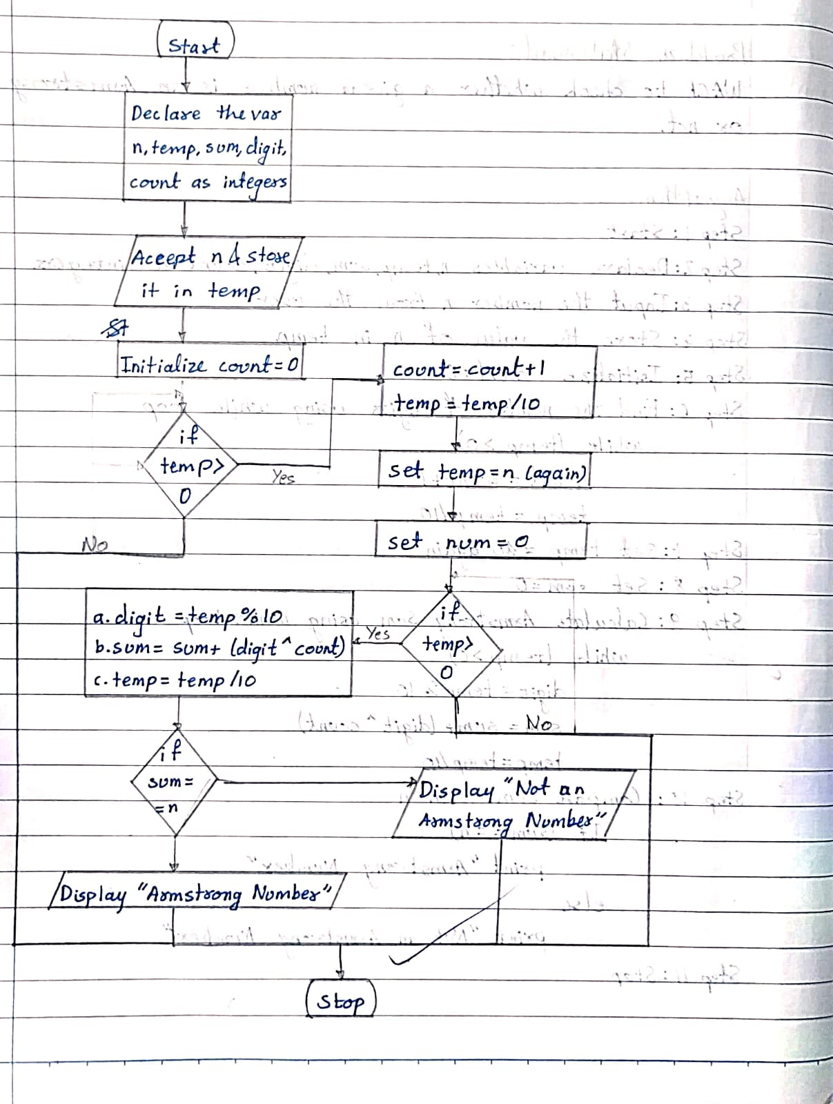

INPUT:
Enter a three-digit number.
Example Input:
371
Paste Screen Shot of Input

OUTPUT:
Example Output:
371 is an Armstrong number.
Paste Screen Shot of Output
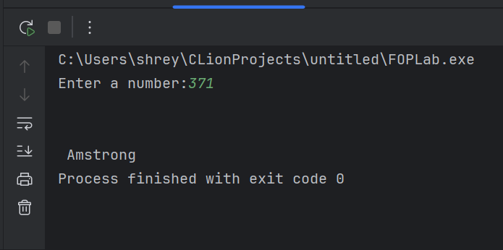

CONCLUSION:
Thus, we have successfully written a C program to check whether a given number is an Armstrong number using loops and arithmetic operations.

FAQs:
1. What is an Armstrong number?
2. Why is the Armstrong number concept important in programming?
3. How does this program work step by step?

