

Foundations of Programming
Assignment No. : 10

PROBLEM STATEMENT:
Write a program in C to simulate a simple calculator that performs basic arithmetic operations such as addition, subtraction, multiplication, and division. The calculator should also perform special operations like computing xʸ (power) and x! (factorial).

OBJECTIVE:
• To understand the use of switch-case statements in C.
• To perform basic arithmetic and special mathematical operations.
• To enhance problem-solving skills using menu-driven programs.

THEORY:
A calculator is a basic computing device used to perform arithmetic operations. In C programming, a simple calculator can be implemented using conditional or switch-case statements. Arithmetic operations like addition, subtraction, multiplication, and division are fundamental operations. Special operations such as power (xʸ) and factorial (x!) require loops for repeated calculations.

PLATFORM:
Linux

ALGORITHM:
Step 1: Start
Step 2: Declare variables x,y, result as float and choice as integer
Step 3: Display the menu:
1. Addition
2. Subtraction
3. Multiplication
4. Division
5. Power (x^y)
6. Factorial (x!)
Step 4: Input user's choice.
Step 5: If the choice is 1 to 5, input two numbers x and y.
If the choice is 6, input one number, x
Step 6: Use switch-case on choice.
Case 1: result = x+y
Case 2: result = x-y
Case 3: result x*y
Case 4: If (y==0)
display "N.D."
else
result = x/y
Case 5: result = x^y
Case 6: Set fact=1
Repeat from 1 to ex
fact = fact* i
Case 7: Display "invalid choice"
Step 7: Display the result
Step 8: Stop

FLOWCHART:
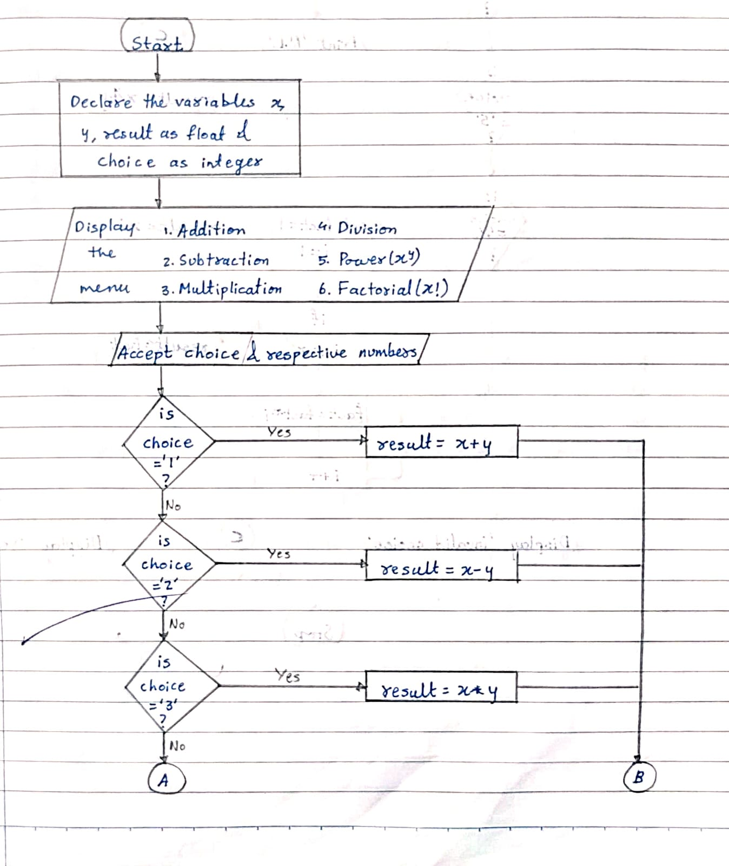
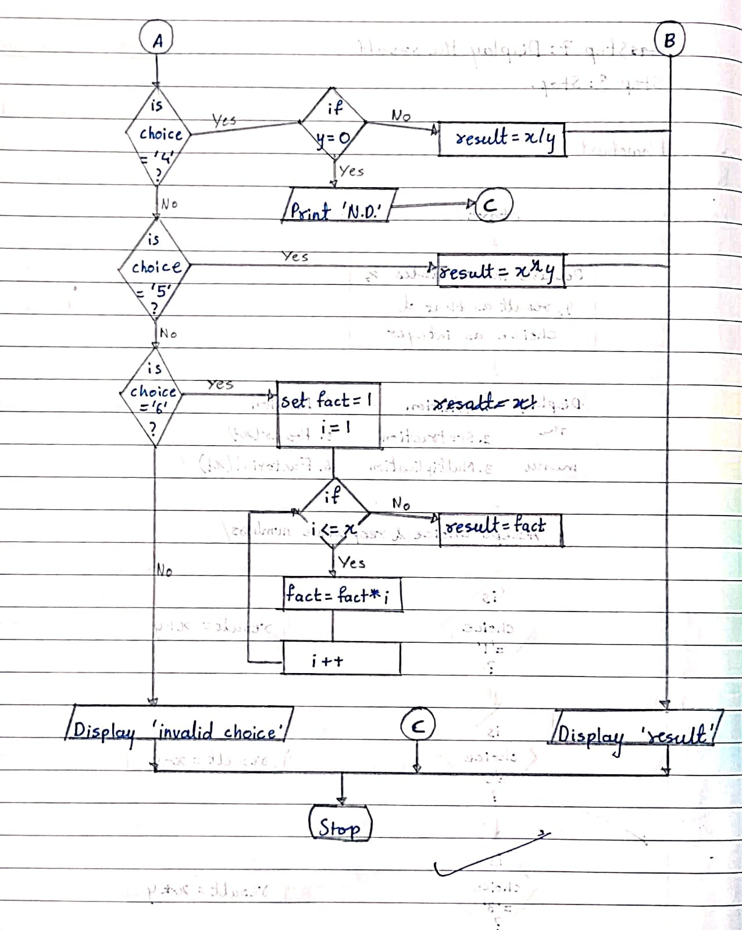

C PROGRAM:
#include <stdio.h>
#include <math.h>
int main() {
float x, y, result;
int choice, i;
int fact = 1;

printf("Simple Calculator\n");
printf("1. Addition\n");
printf("2. Subtraction\n");
printf("3. Multiplication\n");
printf("4. Division\n");
printf("5. Power (x^y)\n");
printf("6. Factorial (x!)\n");

printf("Enter your choice: ");
scanf("%d", &choice);
if(choice >= 1 && choice <= 5) {
printf("Enter two numbers: ");
scanf("%f %f", &x, &y);
}
else if(choice == 6) {
printf("Enter a number: ");
scanf("%f", &x);
}
switch(choice) {
case 1:
result = x + y;
printf("Result = %.2f", result);
break;
case 2:
result = x - y;
printf("Result = %.2f", result);
break;

case 3:
result = x * y;
printf("Result = %.2f", result);
break;
case 4:
if (y == 0)
printf("N.D.");
else {
result = x / y;
printf("Result = %.2f", result);
}
break;
case 5:
result = pow(x, y);
printf("Result = %.2f", result);
break;

case 6:
if(x < 0)
printf("Factorial not defined for negative numbers");
else {
for(i = 1; i <= (int)x; i++)
fact = fact * i;
printf("Factorial = %d", fact);
}
break;

default:
printf("Invalid choice");
}

return 0;
}

INPUT:
User selects an operation from the menu and enters required values.
Example Input:
Choice: 1
Numbers: 10 20
Screen Shot of Input

OUTPUT:
Example Output:
Result = 30.00
Screen Shot of Output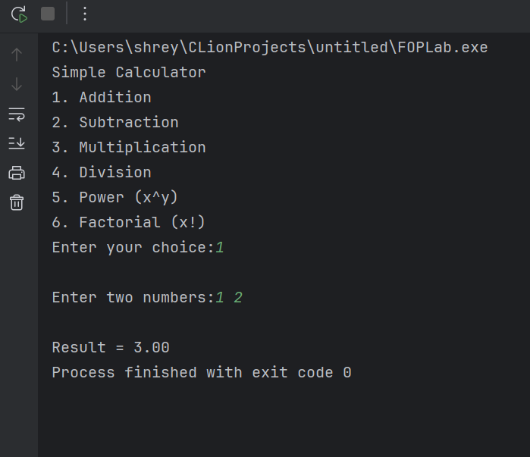

CONCLUSION:
Thus, a simple calculator program was successfully implemented using C programming. The program demonstrates the use of switch-case statements, loops, and arithmetic operations.

FAQs:
- What is a simple calculator program?
- Why is switch–case preferred in calculator programs?
- How does the program handle division by zero?
- How is the power operation (xʸ) implemented without using math library functions?
- What is factorial and how is it calculated using loops in C?

