

Foundations of Programming

Assignment No.: 12

PROBLEM STATEMENT:
Write a program in C to accept two numbers from the user and compute:
The smallest common divisor of the two numbers (other than 1, if any)
The Greatest Common Divisor (GCD) of the two numbers

OBJECTIVE:
• To understand the use of mathematical operations in C.
• To implement loops and conditional statements
• To perform number-based computations.
• To enhance logical thinking using menu-driven programs.

THEORY:
Divisors and the Greatest Common Divisor (GCD) are fundamental concepts in number theory. The smallest common divisor of two numbers is the smallest positive integer greater than 1 that divides both numbers. The GCD of two numbers is the largest positive integer that divides both numbers without leaving a remainder. In C programming, these operations can be efficiently implemented using loops and the Euclidean algorithm, which repeatedly applies the modulo operation until the remainder becomes zero.

PLATFORM:
Linux

ALGORITHM:
Step 1: Start
Step 2: Declare the variables a,b, min, temp as integer.
Step 3: Input two integers a and b

Step 4: Find the smaller of the two members and store it in min
if a>b
min = b
else
min = a
Step 5: Repeat for i=2 to min
if (a%i==0 and b%i==0)
Display i as the smallest common divisor
exit the loop

Step 6: If no such value of i is found, display 'no common divisor other than 1’
Step 7: Find GCD using while loop.
while b! = 0
Store b in temp.
set b=a%b
set a = temp

Step 8: when the loop ends, a contains the GCD
Step 9: Display the SCD and GCD
Step 10: Stop

FLOWCHART:
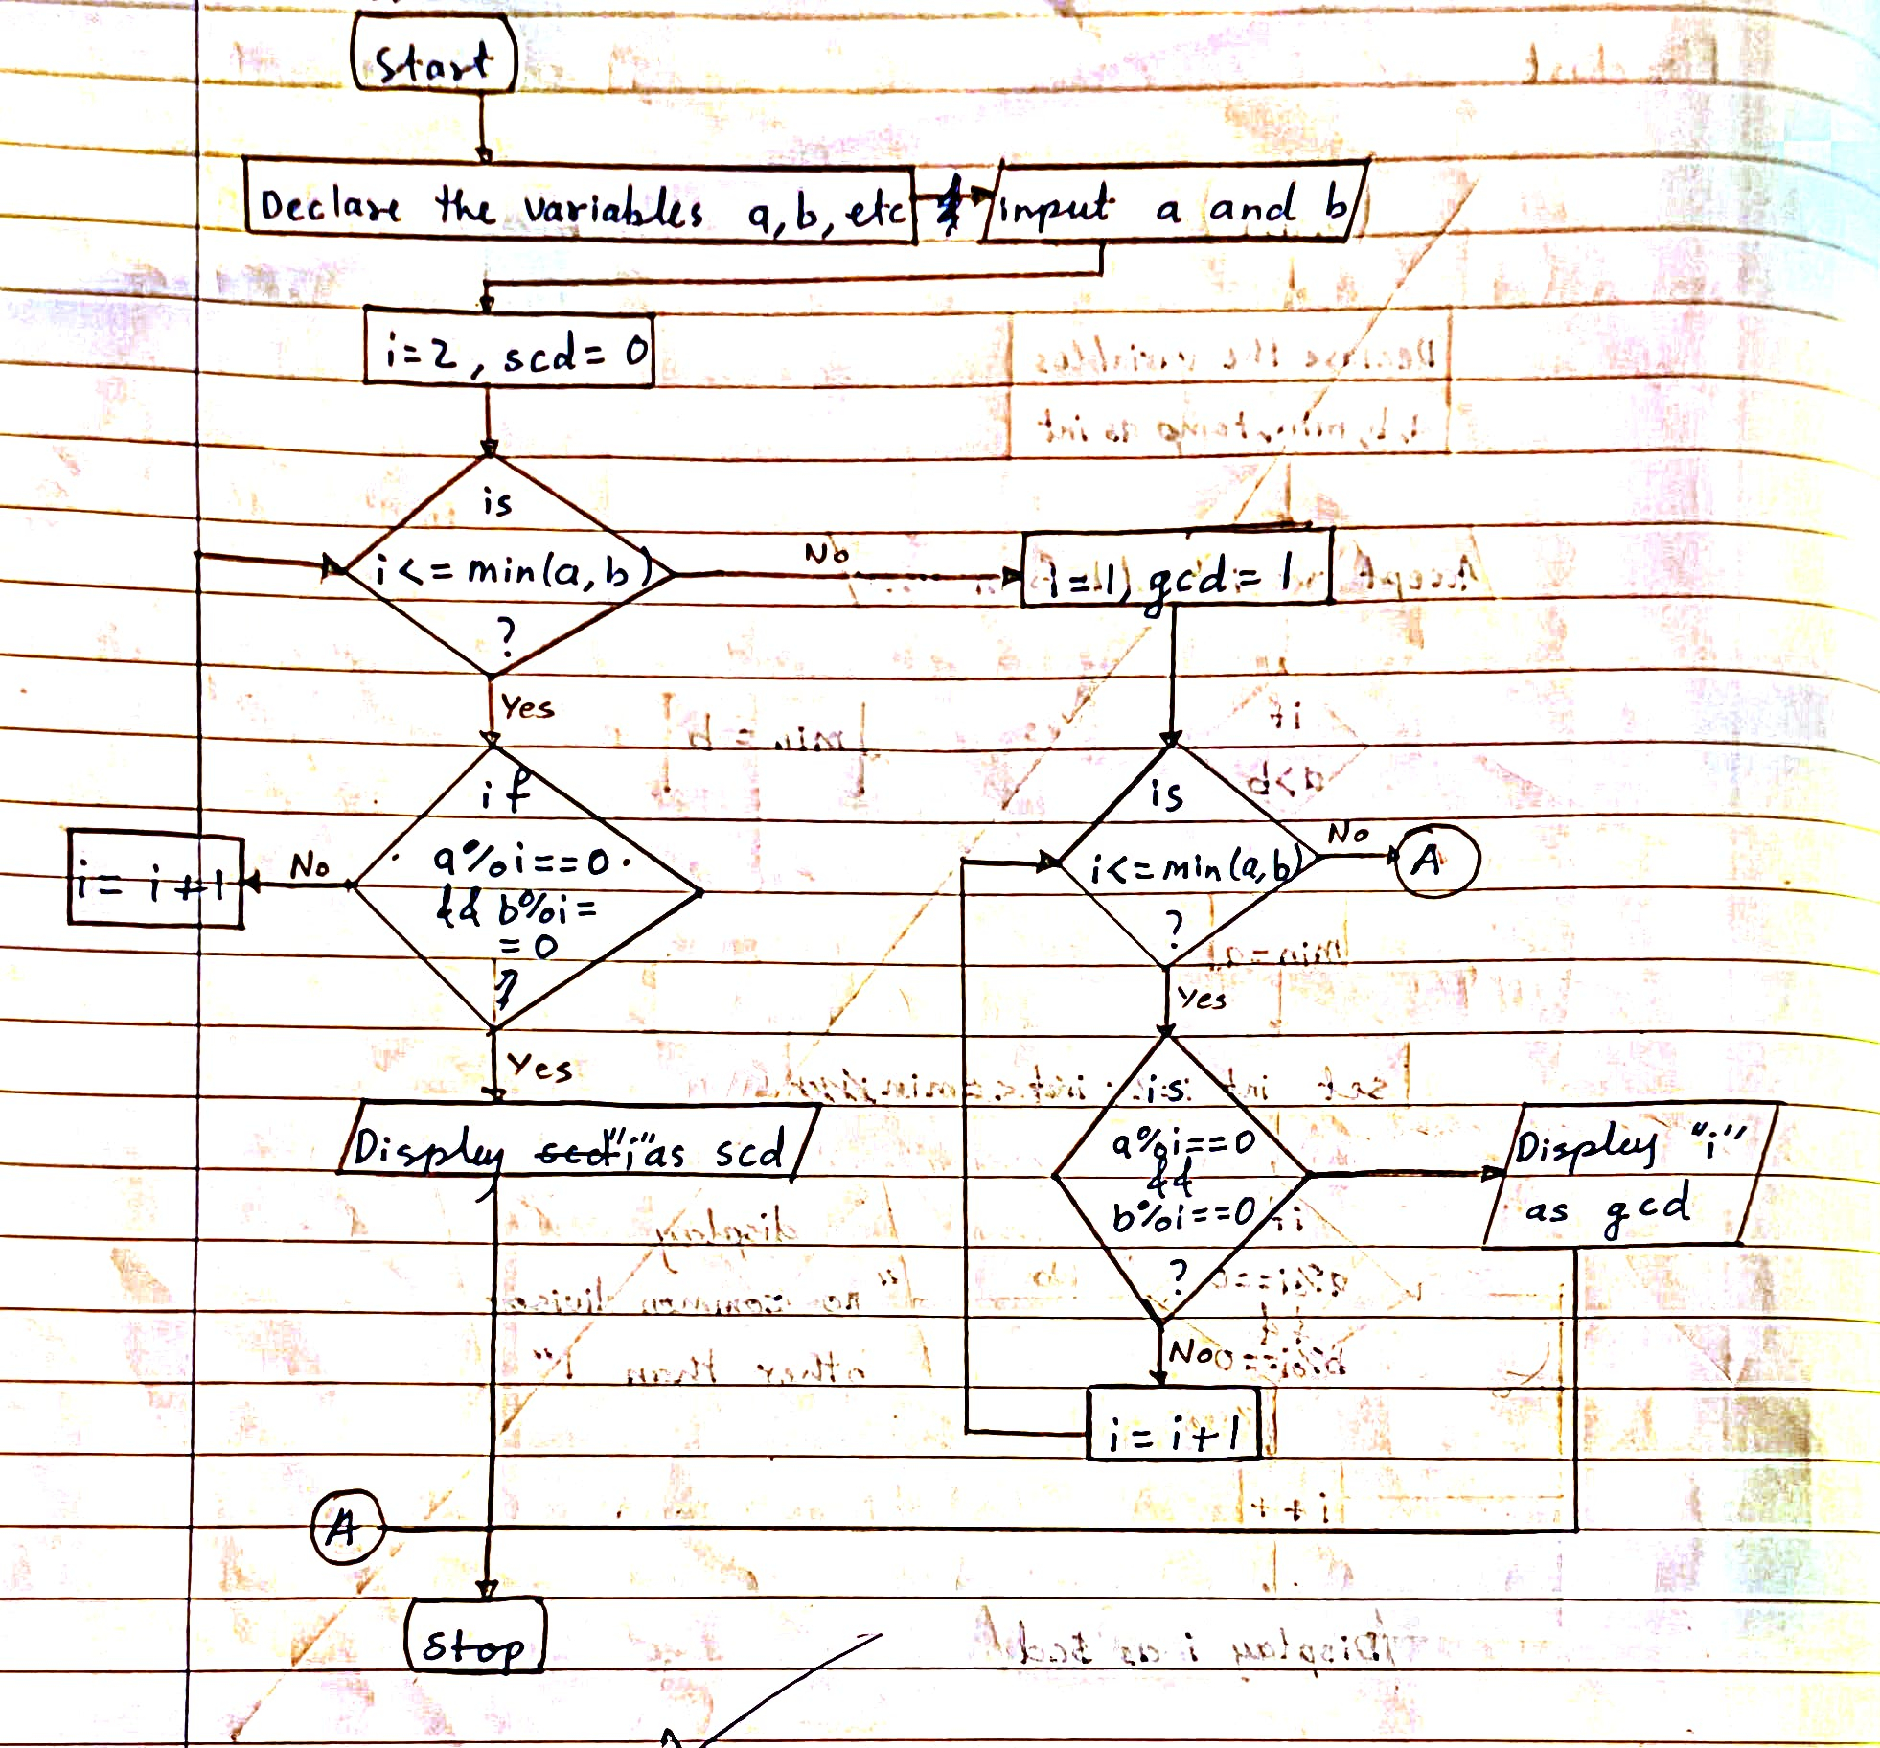

PROGRAM:
#include <stdio.h>

int main() {
int a, b, i, gcd = 1, scd = 1;
char ch;

printf("Enter two numbers: ");
scanf("%d %d", &a, &b);

printf("Enter choice:\n");
printf("g - GCD\n");
printf("s - SCD\n");
scanf(" %c", &ch);

switch(ch) {
case 'g': // GCD
for(i = 1; i <= a && i <= b; i++) {
if(a % i == 0 && b % i == 0)
gcd = i;
}
printf("GCD = %d", gcd);
break;

case 's': // SCD
for(i = 2; i <= a && i <= b; i++) {
if(a % i == 0 && b % i == 0) {
scd = i;
break;
}
}
printf("SCD = %d", scd);
break;

default:
printf("Invalid choice");
}

return 0;
}

INPUT:
The user enters two integer numbers.
Example Input: Number 1: 24 Number 2: 36

Paste Screen Shot of Input

OUTPUT:
The program displays the smallest common divisor and the GCD of the two numbers.
Example Output: Smallest Common Divisor: 2 Greatest Common Divisor (GCD): 12

Paste Screen Shot of Output
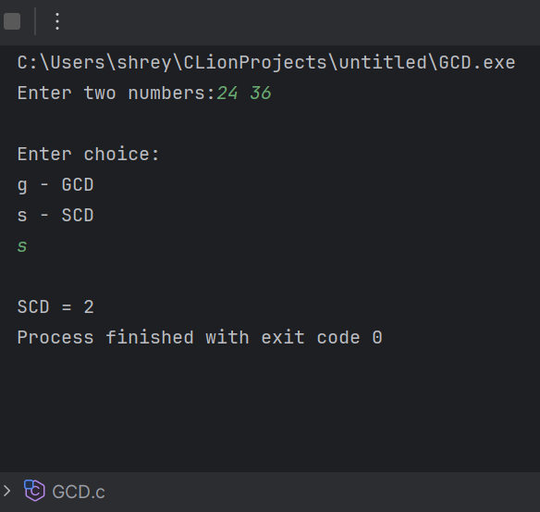
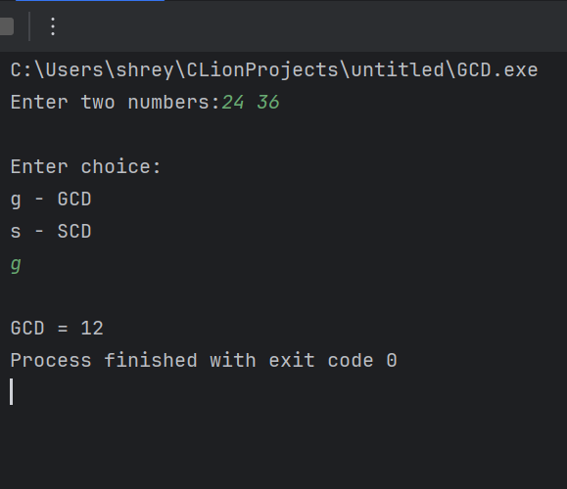

CONCLUSION:
Thus, the program to find the smallest common divisor and the Greatest Common Divisor of two numbers was successfully implemented using C programming. This program demonstrates the use of loops, conditional statements, and the Euclidean algorithm.

FAQs:
- What is meant by the Greatest Common Divisor (GCD)?
- Why does the Euclidean algorithm efficiently compute the GCD?
- How can this program be modified to handle negative numbers?
- What changes are required to compute the Least Common Multiple (LCM) using the GCD?
- How can this program be extended to find the LCM of two numbers?

