

Foundations of Programming

Assignment No. : 13

PROBLEM STATEMENT:
Write a program in C to accept a number from the user and print the digits of the number in reverse order.

OBJECTIVE:
- To understand number manipulation using loops
- To learn the use of modulo (%) and division (/) operators.
- To implement logic for reversing digits of a number.
- To improve problem-solving skills using iterative structures.

THEORY:
- To understand number manipulation using loops.
- To learn the use of modulo (%) and division (/) operators.
- To implement logic for reversing digits of a number.
- To improve problem-solving skills using iterative structures.

PLATFORM:
Linux

ALGORITHM:
Step 1: Start
Step 2: Declare variables n, rev, dig as integers
Step 3: Accept n from the user
Step 4: Set rev=0
Step 5: Repeat while n>0
a. dig = n%10
b. rev = (rev * 10) + dig
c. n=n/10
Step 6: Display rev as the reversed number
Step 7: Stop

FLOWCHART:
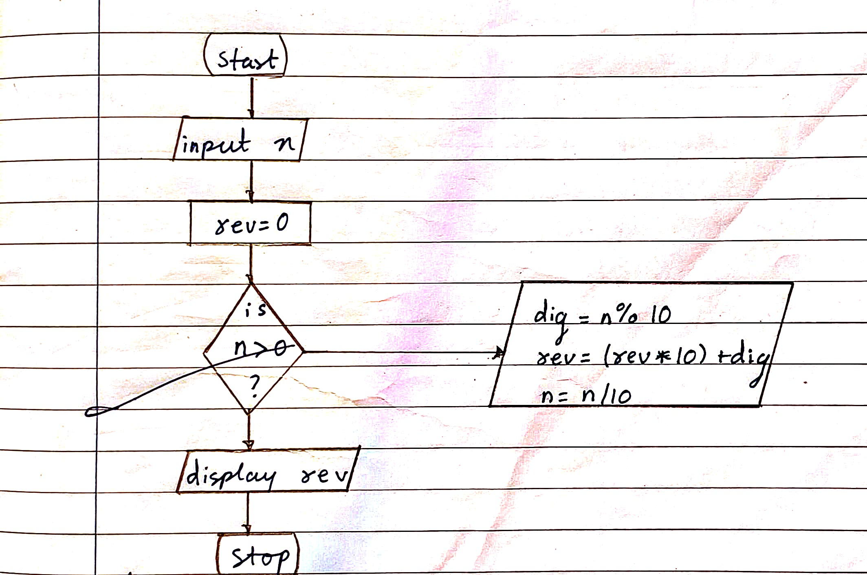

PROGRAM:
#include <stdio.h>

int main() {
int n, rev, dig;

printf("Enter a number: ");
scanf("%d", &n);
rev = 0;

while (n > 0) {
dig = n % 10;
rev = (rev * 10) + dig;
n = n / 10;
}

printf("Reversed number = %d", rev);

return 0;
}

INPUT:
The user enters an integer number.
Example Input: Number: 4567

Paste Screen Shot of Input

OUTPUT:
The program prints the digits of the number in reverse order.
Example Output: Digits in reverse order: 7 6 5 4

Paste Screen Shot of Output
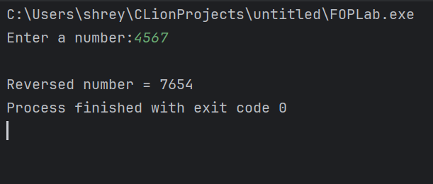

CONCLUSION:
Thus, the program to print the digits of a number in reverse order was successfully implemented using C programming. The program demonstrates the effective use of loops, modulo operator, and division operator.

FAQs:
- Why is the modulo operator (%) used in this program?
- Why is division by 10 used after extracting each digit?
- What happens if the input number is zero?
- How will the program behave for negative numbers?
- Why is a while loop preferred for this operation?

